Original: English

Proposal for a decision to provide flexibility on the room layout options for the annual Commission meeting
(submitted by the STACFAD Chair)

Context and discussions during the intersessional period

During the intersessional period, the Virtual Working Group on a Sustainable Financial Position for ICCAT (VWG-SF) discussed options to reduce the cost of organizing the ICCAT annual meetings.

In past years, it has been increasingly difficult to find CPCs to host the annual Commission meeting and one of the blocking elements for potential host countries is to find a single room large enough to host the entire attendance as organized in the traditional U-shape table.

Therefore, discussion during the intersessional period included the need to provide flexibility to host country regarding the layout of delegate tables in the meeting room for the annual Commission meeting.

One meeting document was produced to support the discussion: “Analysis of room layout scenarios” (VWG-SF_JUN_06/2026) which is reproduced below in Appendix 1, and presents the benefits and disadvantages of different room layouts for the annual Commission meeting.

During the meeting of the VWG-SF, it was identified that:

- The current U-shape layout with all delegates in one single room requires a very large meeting room, which does not necessarily exist or is available in all cities, and often is quite expensive.
- Different types of layout options are possible for intergovernmental meetings:

  - Current U-shaped configuration in a single meeting room;
  - Current U-shaped configuration with a reduced number of delegates in the main room and an overflow room;
  - UN-style seating arrangement in a single meeting room;
  - UN-style seating arrangement with a reduced number of delegates in the main room and an overflow room.

- Every type of layout option presents benefits and disadvantages, which should be mitigated.
- There is no single layout that is suitable for all venues and therefore it is not necessarily possible or necessary to decide on a specific mandatory seating arrangement to be imposed on host CPC.
- Rather than imposing a mandatory room layout, the host country could be offered a range of layout options and work with the Secretariat to assess the feasibility of each configuration. The final layout could then be adapted to the specific characteristics of the venue, while taking into account relevant factors such as comfort, safety, speaking rights, visibility, participation and social interaction.

Decisions to be taken by the STACFAD

- Agree not to impose a U-shape layout, while confirming that U-shape remains the preferred set-up where feasible and appropriate;

- Allow flexibility for the host country to choose the room layout, taking into account the need to:

- provide an appropriate level of comfort for delegates;
- ensure a minimum level of safety, including adequate evacuation routes;
- prevent any impediment to the right of head delegates and accredited observers to take the floor;
- ensure that head delegates receive enough support from their delegation in the main room;
- promote the social integration of all participants during breaks and social events.

- Apply this flexibility on a case-by-case basis, with the expertise and support of the Secretariat, ensuring that any alternative layout still supports the meeting’s objectives and an inclusive, effective discussion.

Appendix 1

Analysis of room layout scenarios (VWG-SF_JUN_06/2026)
(document prepared by the ICCAT Secretariat)

Based on the agreements reached at the First Meeting of the Virtual Working Group on a Sustainable Financial Position for ICCAT (VWG-SF), held on 31 March 2026, this document presents a comparative analysis of different room configurations for holding annual meetings of the Commission, assessing operational, spatial, technical and audiovisual aspects.

The various options raised seek to strike a balance between:

- capacity and comfort for participants,
- technical feasibility,
- cost optimization,
- participation experience for delegates and observers.

It should be noted that all proposals are indicative and depend directly on the architectural characteristics of each venue, as well as on the available furniture and the specific requirements of each event. Furthermore, all include a presidential table of 12 people.

Scenario 1 – Status quo (Single room in a U-shape, two people per delegation in a central U)

This layout involves a single room arranged in a U-shape, bringing delegates and observers together in the same space to encourage interaction and the smooth running of meetings. This would require a room measuring approximately at least 35 x 35 metres, with an estimated floor area of between 1,065 and 1,225 m², a maximum of 3 people per table, and a capacity for 112 delegates (two people per delegation), up to 520 attendees, and additional areas set aside for simultaneous interpreting, technical support, circulation and security.

Its main advantages include:

- cost savings through the use of a single room,
- centralisation of the audiovisual and technical systems,
- greater visibility and interaction among participants,
- lower technical and organisational complexity.

However, this option requires:

- a large room with specific characteristics,
- it may present certain difficulties regarding the layout of the space and the movement of attendees,
- its feasibility depends largely on having a suitable and sufficiently spacious audiovisual facilities.

Conclusion: This is the most balanced option in terms of the participatory experience and institutional cohesion, although it depends on the availability of a suitable and sufficiently spacious room.

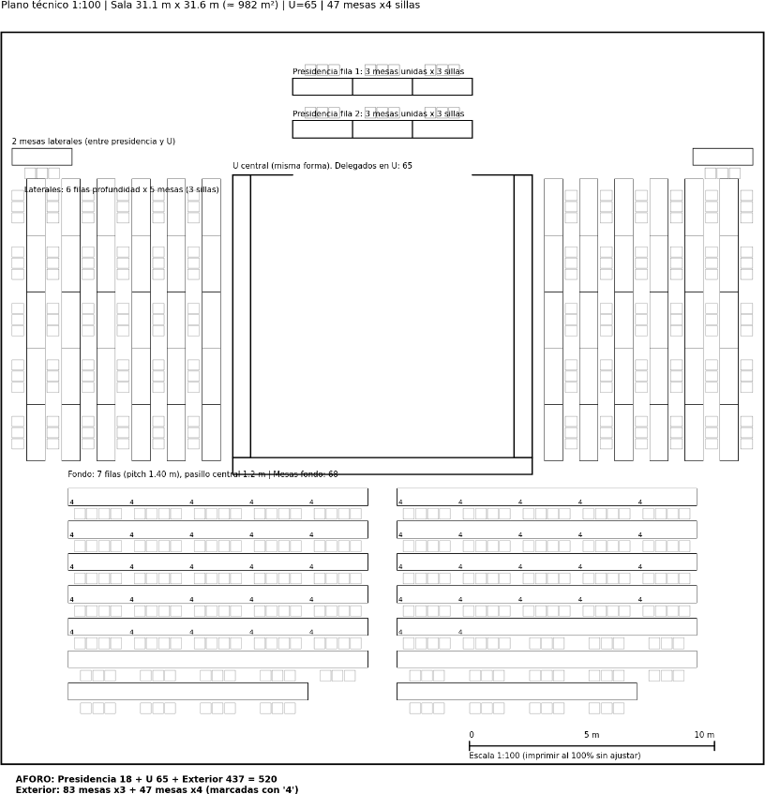

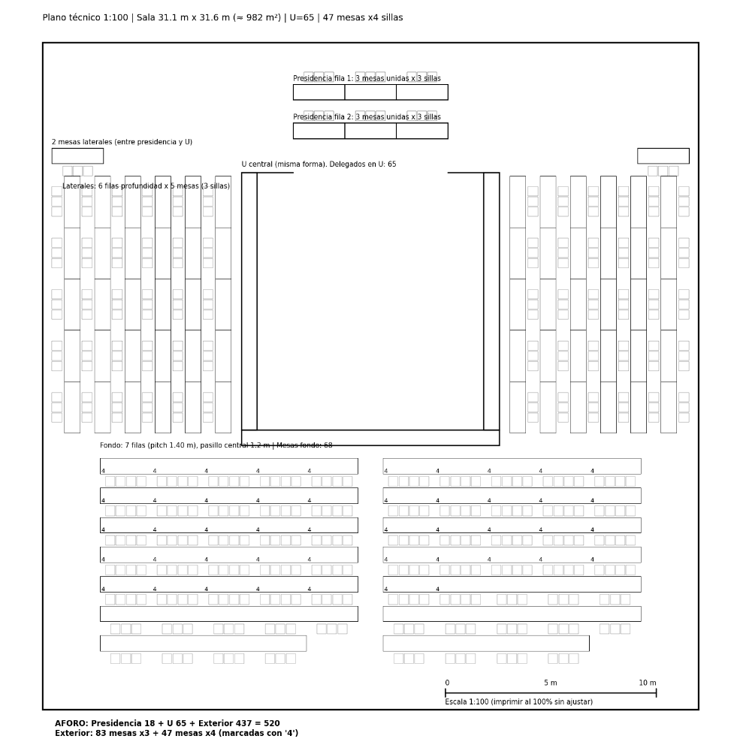

Scenario 2 – Option 1, Variant 1 (Single room in a U-shape, one person per delegation in the central U)

This option retains a single room for the meeting and reorganises the overall layout with the aim of partially reducing the space required (reducing the inner space of the U).

The proposed layout would require a room measuring approximately 32 x 32 metres, with an estimated minimum floor area of between 982 and 1,024 m², a central U-shape for 56 participants (one person per delegation), a maximum of three people per table and additional capacity for up to 520 attendees. It would also be necessary to provide additional spaces for simultaneous interpreting, technical control, access and circulation.

The main advantages of this alternative include:

- the retention of a single meeting space,
- it promotes integration among participants,
- it simplifies certain organisational aspects,
- it allows for a partial reduction in space requirements compared to other, larger layouts.

However, this option still requires a large room and presents certain limitations due to:

- an increase in the number of rows and people per table,
- it may affect comfort, visibility and direct communication between participants,
- it increases audiovisual and technical requirements to ensure the smooth running of the sessions.

Conclusion: This is a compromise solution that allows for partial optimisation of the space required, although this entails a reduction in comfort and greater technical and audiovisual complexity.

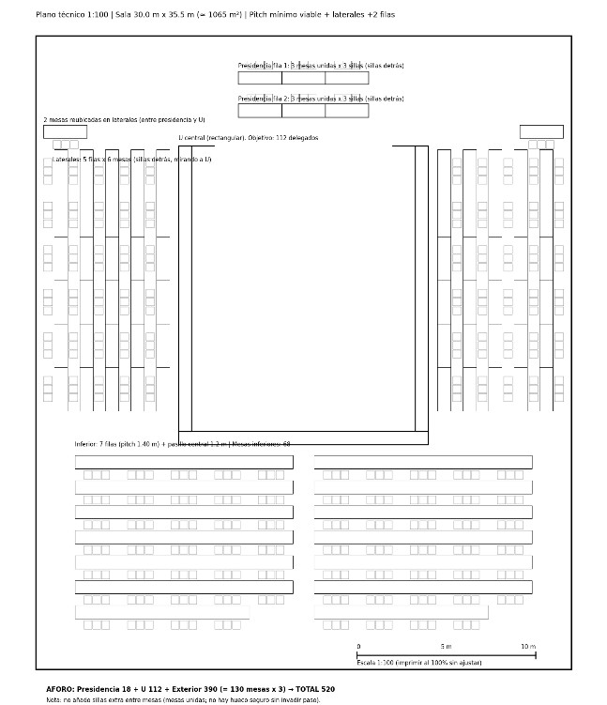

Scenario 3 – Option 1, variant 2 (U-shaped layout with an annex room: a main room for the Chair and Head Delegates, and an annex room for observers and other delegation members)

The main room would require dimensions of approximately 23 x 17 metres, with an estimated floor area of between 373 and 391 m², a U-shaped layout with capacity for 56 participants (one person per delegation) and a maximum of three people per table. The annex room, meanwhile, would need to measure approximately 25 x 29 metres and have an estimated floor area of between 695 and 725 m², with a capacity for up to 520 attendees.

The main advantages of this option include:

- a significant reduction in the size required for the main room,
- easier identification of suitable venues,
- improved access, circulation and comfort for participating delegations,
- a more functional layout of the main workspace.

However, this option entails the need to:

- hire a second room,
- a significant increase in technical and audiovisual costs, as it is necessary to partially duplicate the sound, simultaneous interpreting and video broadcasting systems,
- the physical separation of attendees could create a perception of reduced integration during the meetings.

Conclusion: This alternative is a particularly viable solution from an operational and space-utilisation perspective, especially in venues with architectural or capacity constraints. However, the physical separation between Head Delegates, their delegations and observers may result, amongst other things, in a partial loss of the experience of joint participation and overall integration during the meetings.

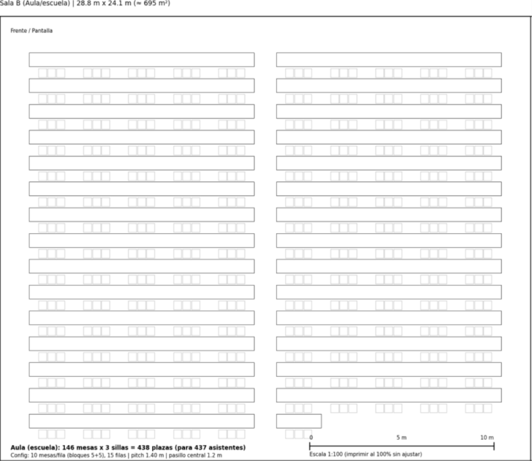
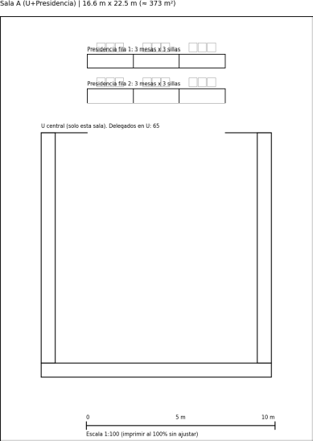

Scenario 4 – Option 2, variant 1 (United Nations-style layout, in a single room)

This proposal envisages a more enclosed and immersive layout, keeping all participants together in a single room with the aim of reinforcing the sense of unity and interaction during meetings.

Implementation would require a room measuring approximately 43.3 x 39.8 metres, with an estimated floor area of 1,723 m². The layout would include a central arrangement for 39 participants in the front row and additional capacity for up to 522 attendees, with a maximum of three people per table. Furthermore, this option would require the installation of additional technical structures, such as tiered seating or raised platforms, large-format screens and advanced audiovisual systems.

Its main advantages include:

- keeping all attendees together in a single space,
- promoting a more cohesive participatory experience,
- the proposed layout enhances the aesthetic and visual appeal of the venue,
- it helps to reduce the feeling of empty spaces in large-capacity rooms.

However, this alternative requires/involves:

- a very large hall,
- high technical and organisational complexity,
- the need to incorporate additional structures, such as stands or platforms, as well as advanced audiovisual systems,
- a significant increase in costs and logistical requirements,
- the potential use of curved screens, a greater number of cameras and monitors, and a heavy reliance on the furniture and equipment available on site.

Conclusion: This is a visually appealing option, albeit technically complex and costly, and is recommended only for suitably equipped venues.

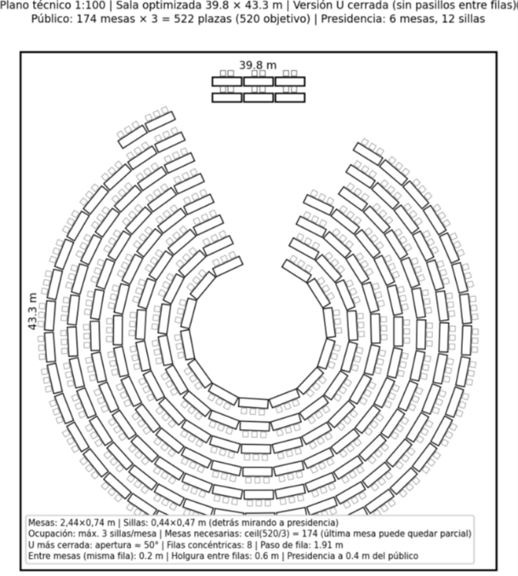

Scenario 5 – Option 2, variant 2 (United Nations-style layout with an annex room)

This configuration combines a United Nations-style layout in the main hall with seating for attendees in annex rooms, linked via technical and audiovisual systems.

The main room would measure approximately 23.3 x 26.5 metres, with an estimated floor area of 617 m² and a central layout for 33 participants in the front row. The annex room, meanwhile, would require dimensions of approximately 25.5 x 25.5 metres, with an estimated floor area of 650 m² and capacity for up to 408 attendees.

Its main advantages are:

- a reduction in the required size of the main room, which facilitates adaptation to specific venues,
- improved circulation and access,
- visual optimisation of the space allocated to the main meeting.

However, this alternative entails the need for:

- additional rooms,
- a more complex audiovisual setup, including enhanced communication and visibility systems,
- a reduction in direct interaction between participants,
- an increase in technical and operational costs.

Conclusion: This is one of the most complex configurations, as it combines the inherent limitations of a more enclosed layout with the need for additional spaces, resulting in a less favourable cost-benefit ratio compared to other options.

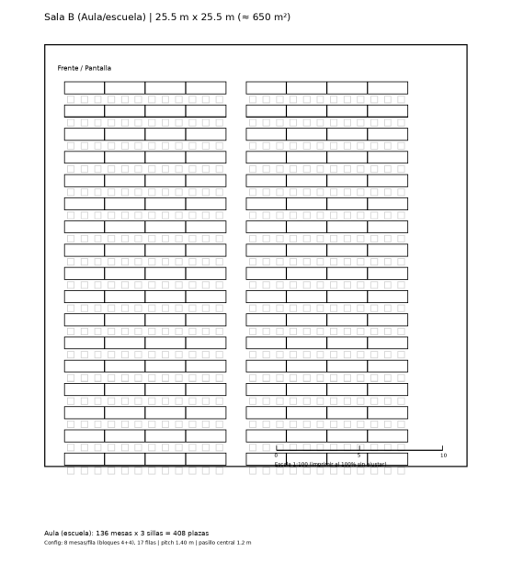
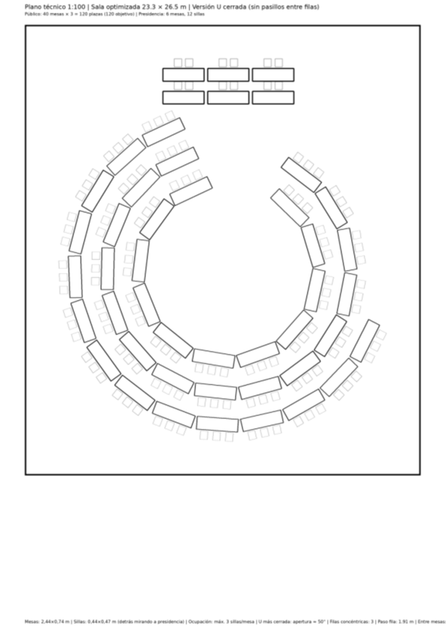

General conclusions

There is no single layout that is suitable for all venues and events, as each space has different architectural, operational and technical characteristics that determine the feasibility of each proposal.

The final decision must be made taking into account factors such as the room’s dimensions and architecture, the availability of furniture, the specific operational requirements of each meeting and the available budget.

Generally speaking, configurations set up in a single room favour:

- greater integration among participants and a more consistent experience of participation,
- require larger spaces with characteristics suitable for this type of layout.

Conversely, configurations involving annex rooms offer/entail:

- greater operational flexibility,
- easier adaptation to venues with space constraints,
- greater technical and audiovisual complexity,
- a partial reduction in the sense of shared participation among all attendees.

In all cases, it is considered essential to carry out a preliminary technical visit to validate the actual feasibility of the selected configuration and adapt the final layout to the specific characteristics of each venue.

