Original: Spanish

Explanatory note on the draft ICCAT budget for financial year 2027

(submitted by ICCAT Secretariat)

In accordance with the provisions contained in Article X.1 and X.3 of the ICCAT Convention and in Regulation 2 of the Financial Regulations, the Secretariat must submit the draft budget for the next financial year, 2027, to the Commission for its consideration and adoption. At its 29th Regular Meeting (17-24 November 2025, Seville, Spain) the Commission adopted the budget for 2026 and decided to review this year the draft budget for 2027.

The purpose of this note is to present the main lines of the proposed draft budget for 2027, the structure, the elements included in the different headings and the impact on the contributions of ICCAT members.

This budget for the next financial year considers the Commission's decision to continue regularising activities that have been financed through the Working Capital Fund in the ICCAT budget, with a view to reducing extra-budgetary expenditure. In this regard, it should be noted that at 31/12/2025, the balance of the Working Capital Fund corresponded to 49.91% of the 2025 annual budget, noting that according to the recommendation of the Working Group on Finance and Administration at its meeting held on 29, 30 November and 1 December 1971, in Madrid, it should represent 15%. It is calculated that at year-end of this financial year it will represent 19.04% of the current budget.

The following tables are attached for study:

- Table 1 - The Commission's draft budget for 2027, which presents a detailed breakdown of the estimated increases and decreases by chapter.
- Table 2 - Basic information for calculation of the Contracting Parties' contributions for 2027.
- Table 3 - Contracting Parties' 2027 contributions.
- Table 4 - 2027 contributions by group, which reflects the percentage of the budget financed by each member of each group as per the Madrid Protocol.
- Table 5 - The Contracting Parties' catch and canning figures (in metric tonnes).

Annex with table legends.

- Proposed expenditure budget

The Secretariat’s proposed budget contains an increase of 9.78% for financial year 2027 with respect to the budget that was approved for financial year 2026 at the previous 2025 regular Annual Meeting held in Seville, as detailed in Table 1.

Below is a description of the chapters and sub-chapters contained in this budget.

Chapter 1 – Salaries

Chapter 1 includes the permanent staff salaries. Furthermore, a table with detailed information on the number of staff in each of the categories of professional and general services is included, including grade and step.

The total requested for this chapter amounts to €4,853,657.79, reflecting an increase of 8.38% compared to the budget approved for 2026.

Salaries for Secretariat staff are set in line with the United Nation salary and pension scales applicable for Professional and Higher Categories and for General Service & Related Categories in Madrid, which are adjusted annually by the International Civil Service Commission (ICSC).

For staff in the Professional or higher category, the United Nations salary and pension scale effective in 2026 includes an increase of 2.5% based on the increase estimate for 2027 as it has not yet been published by ICSC. The amounts include net salary and contribution to the agreed pension fund. For internationally recruited staff members and as appropriate, the corresponding estimate for Education grant (Article 16 of the Staff Regulations and Rules), Home leave (Article 27 of the Staff Regulations and Rules) and Non-resident staff allowance (Article 14 of the Staff Regulations and Rules) has also been included.

For staff in the General Service category, the United Nations salary and pension scale effective in 2026 includes an increase of 2.5% based on the increase estimate for 2027 as it has not yet been published by ICSC. The amounts shown include net salary, contribution to the Spanish public Social Security system and taxes on earned income, in accordance with Article 10 of the Staff Regulations and Rules.

Furthermore, the Scientific Committee recommended that the Commission strengthen the Secretariat’s capacity by creating a full-time post entitled “MSE Technical Coordinator”. The holder of this permanent post within the Secretariat would work specifically with the various Species Groups to coordinate and facilitate the development of, and provide technical support for, the MSE processes carried out within the framework of ICCAT. Further details are available in the 2026 SCRS Report.

- Permanent staff

This table reflects staff employed by ICCAT what are funded entirely through the regular budget, broken down into Professional and General Services categories.

Category | Grade | Step | No. of staff members
Professional or higher | D-1 | IX | 1
Professional or higher | P-5 | XI | 1
Professional or higher | P-4 | XIII | 1
Professional or higher | P-4 | VII | 3
Professional or higher | P-4 | V | 2
Professional or higher | P-3 | VIII | 1
Professional or higher | P-3 | VII | 1
Professional or higher | P-3 | IV | 1
Professional or higher | P-3 | III | 3
Professional or higher | P-2 | X | 1
Professional or higher | P-2 | VIII | 5
Professional or higher | P-2 | VII | 2
Professional or higher | P-2 | VI | 4
Professional or higher | P-2 | IV | 2
Professional or higher | P-1 | IV | 1
General services | GS-7 | XII | 1
General services | GS-7 | VIII | 1
General services | GS-6 | VII | 1
General services | GS-5 | XII | 1
General services | GS-5 | VIII | 1
General services | GS-5 | IV | 1
General services | GS-4 | XII | 1
General services | GS-3 | XII | 1
General services | GS-3 | X | 1
General services | GS-1 | V | 1
* Additional information related to the total annual salaries will be provided in the CPCs folder.
MSE Coordinator:

(MSE Coordinator) - Category | Grade | Step | No. of staff members
Professional or higher | P-4 | VIII | 1

- Other staff members not supported by the regular budget

This table shows the staff belonging to ICCAT programmes that are funded by other sources, namely the GBYP or the European Union (IOMS grant agreement), with the remainder being funded by the balance of the IOMS fund, and when exhausted, through the Working Capital Fund.

Research programmes- Category | Grade | Step | No. of staff members
Professional or higher | P-4 | IX | 1

IOMS (EU) - Category | Grade | Step | No. of staff members
Professional or higher | P-2 | II | 1
* Additional information related to the total annual salaries will be provided in the CPCs folder.

Chapter 2 - Travel

Chapter 2 includes the information on travel costs, related to ICCAT Secretariat participation in different fora, and to ICCAT staff, ICCAT/SCRS Chairs, ICCAT Officers from developing Contracting Parties participation in ICCAT meetings and the expenses of the Special Meeting Participation Fund (MPF).

The proposed total for this chapter reflects an increase of 5.13% compared to the budget approved for 2026.

Given that the ICCAT meeting schedule for 2027 has not yet been approved, the proposal is based on a schedule similar to recent years, both in terms of the number and duration of the meetings, as well as the schedule requested by the Scientific Committee at the last SCRS meeting. Flight and per diem costs have been estimated based on a best-guess for the general location of each meeting but may vary based on the final venues.

- Representation of ICCAT in other fora: Attendance of meetings of international organizations and regional and/or international fisheries management organizations. The estimate for this sub-chapter is a reduction of 22.86%.

Meetings (location and days) | No. persons | Travel | Hotel | Per diem | Ground transportation | Total | Financing
ICSP-19 (New York, 3 days) | 1 | €3,000.00 | €1,679.04 | €413.95 | €250.00 | €5,342.99 | Chapter 2.a)
BBNJ COP (New York, 5 days) | 1 | €3,000.00 | €2,518.56 | €579.53 | €250.00 | €6,348.09 | Chapter 2.a)
Global Fisheries Enforcement Training Workshop (GFETW) - IMCS Network + Tuna Compliance Network (Bali, 5 days) | 1 | €4,850.00 | €1,734.81 | €1,021.36 | €120.00 | €7,726.17 | Chapter 2.a)
Sixth Meeting of the Parties (MoP) to the PSMA (Paris, France, 5 days) | 1 | €450.00 | €0.00 | €928.72 | €120.00 | €1,498.72 | Chapter 2.a)
Meeting 5 (example FIRMS/CWP) (EU, 5 days) | 2 | €900.00 | €2,536.44 | €1,740.96 | €240.00 | €5,417.40 | Chapter 2.a)
Meeting 6 (ABNJ Tuna) (Rome, 4 days) | 1 | €450.00 | €1,071.60 | €889.24 | €120.00 | €2,530.84 | Chapter 2.a)
Unforeseen (EU, 5 days) | 1 | €450.00 | €1,268.22 | €870.48 | €120.00 | €2,708.70 | Chapter 2.a)
Financing Chapter 2.a) |  |  |  |  |  | €31,572.91

- ICCAT Meetings (staff) Attendance of ICCAT annual and intersessional meetings by Secretariat staff that are held outside the Secretariat headquarters. The estimate in this sub-chapter is an increase of 29.37%.

Meetings (location and days) | No. persons | Travel | Hotel | Per diem | Ground transportation | Total | Financing
COM Meeting (IMM)  (Montreal, Canada,  5 days + 1 day preparation, TBC) | 7 | €18,900.00 | €9,880.44 | €5,890.26 | €840.00 | €35,510.71 | Chapter 2.b)
COC + 2027 Commission meeting (EU, 2 + 8 days + 2 preparatory days) | 21 | €9,450.00 | €53,265.24 | €35,154.00 | €2,520.00 | €100,389.24 | Chapter 2.b)
Small Tunas Data Preparatory Meeting (Malaga, Spain, 3 days) | 2 | €200.00 | €1,248.00 | €985.23 | €240.00 | €2,673.23 | Chapter 2.b)
Second Intersessional Meeting of the Bluefin Tuna Species Group (hybrid, Croatia (TBD, 5 days) | 2 | €900.00 | €2,536.44 | €1,740.96 | €240.00 | €5,417.40 | Chapter 2.b)
BSH-MD Data Preparatory Meeting (including North and South blue shark MSE) (hybrid, EU (TBD), 5 days) | 2 | €900.00 | €2,536.44 | €1,740.96 | €240.00 | €5,417.40 | Chapter 2.b)
BSH-MD Data Preparatory Meeting (including North and South blue shark MSE) (hybrid, EU (TBD), 5 days) | 2 | €900.00 | €2,536.44 | €1,740.96 | €240.00 | €5,417.40 | Chapter 2.b)
Unforeseen (EU, 5 days) | 2 | €900.00 | €2,536.44 | €1,740.96 | €240.00 | €5,417.40 | Chapter 2.b)
Financing Chapter 2.b) |  |  |  |  |  | €160,242.78

- Commission/SCRS Chairs:

The estimate for this sub-chapter is a reduction of 15.84%.

Meetings (location and days) | No. persons | Travel | Hotel | Per diem | Total
Small Tunas Data Preparatory Meeting  (Malaga, Spain, 3 days) | 1 | €1,450.00 | €787.65 | €547.35 | €2,785.00
BSH-MD Data Preparatory Meeting (including North and South blue shark MSE)  (hybrid, EU (TBD), 5 days) | 1 | €1,450.00 | €1,479.59 | €937.44 | €3,867.03
Eastern Skipjack Data Preparatory Meeting (including MSE) (Madrid, Spain, 4 days) | 1 | €1,450.00 | €1,504.44 | €883.56 | €3,838.00
Meeting of the Working Group on Stock Assessment Methods (Madrid, Spain, 4 days) | 1 | €1,450.00 | €1,504.44 | €883.56 | €3,838.00
Meeting Subcommittee on Ecosystems and Bycatch (Madrid, Spain, 5 days) | 1 | €1,450.00 | €1,755.18 | €1,030.82 | €4,236.00
BSH-MD Data Preparatory Meeting (including North and South blue shark MSE) (hybrid, EU (TBD), 5 days) | 1 | €1,450.00 | €1,479.59 | €937.44 | €3,867.03
Second Intersessional Meeting of the Bluefin Tuna Species Group (hybrid, Croatia (TBD, 5 days) | 1 | €1,450.00 | €1,479.59 | €937.44 | €3,867.03
Eastern Skipjack Stock Assessment Meeting (including MSE) (Madrid, Spain, 5 days) | 1 | €1,450.00 | €1,755.18 | €1,030.82 | €4,236.00
Species Groups, Subcommittee on Statistics and SCRS Plenary Meetings (Madrid, Spain, 12 days) | 1 | €1,450.00 | €3,510.36 | €2,061.64 | €7,022.00
Compliance Meeting and 2027 Commission Meeting (EU, 2 + 8 days) | 1 | €1,450.00 | €2,536.44 | €1,607.04 | €5,593.48
Compliance Meeting and 2027 Commission Meeting (EU, 2 + 8 days) | 1 | €500.00 | €2,536.44 | €1,607.04 | €4,643.48
Total – Financing Chapter 2.c) |  |  |  |  | €47,793.05

- COM and SCRS Officers (from developing ICCAT Contracting Parties):

The estimate in this sub-chapter is for an increase of 3.89%, due to the increase of the number of Officers from developing countries. It has been assumed that they will attend all the meetings, as well as of the average costs of their attendance at the scheduled meetings.

Meetings (location and days) | No. persons | Travel | Hotel | Per diem | Total
Small Tunas Data Preparatory Meeting (Malaga, Spain, 3 days) | 1 | €1,450.00 | €787.65 | €547.35 | €2,785.00
BSH-MD Data Preparatory Meeting (including North and South blue shark MSE)  (hybrid, EU (TBD), 5 days) | 1 | €1,450.00 | €1,479.59 | €937.44 | €3,867.03
Eastern Skipjack Data Preparatory Meeting (including MSE) (Madrid, Spain, 4 days) | 1 | €1,450.00 | €1,504.44 | €883.56 | €3,838.00
Meeting of the Working Group on Stock Assessment Methods (Madrid, Spain, 4 days) | 1 | €1,450.00 | €1,504.44 | €883.56 | €3,838.00
Meeting of the Subcommittee on Ecosystems and Bycatch (Madrid, Spain, 5 days) | 1 | €1,450.00 | €1,755.18 | €1,030.82 | €4,236.00
BSH-MD Stock Assessment Meeting (including North and South blue shark MSE)  (hybrid, EU (TBD), 5 days) | 1 | €1,450.00 | €1,479.59 | €937.44 | €3,867.03
Eastern Skipjack Stock Assessment Meeting (including MSE) (Madrid, Spain, 5 days) | 1 | €1,450.00 | €1,755.18 | €1,030.82 | €4,236.00
Species Groups, Subcommittee on Statistics and SCRS Plenary Meetings  (Madrid, Spain, 12 days) | 10 | €14,500.00 | €35,103.60 | €20,616.40 | €70,220.00
Compliance Meeting and 2027 Commission Meeting (EU, 2 + 8 days) | 3 | €4,350.00 | €7,609.32 | €4,821.12 | €16,780.44
Total – Financing Chapter 2.d) |  |  |  |  | €113,667.50

- Special Meeting Participation Fund (MPF)

This subchapter corresponds to the annual contribution of ICCAT to the Special Meeting Participation Fund.

The proposed total for this chapter is level with the budget approved for 2027 and reflects a contribution of €257,500.00 from the regular budget and, within the framework of the biennial budget adopted in 2025, and exceptionally, the amount of €126,870.80 from the Working Capital Fund. Financing from the Working Capital Fund is transitional and exceptional. This total is based on the estimated cost according to the list of scheduled ICCAT meetings and the trends of recent requests, as shown below:

Meetings (location and days) | No. persons | Travel | Hotel | Per diem | Total
Small Tunas Data Preparatory Meeting (Malaga, Spain, 3 days) | 7 | €10,150.00 | €5,513.55 | €3,831.45 | €19,495.00
BSH-MD Data Preparatory Meeting (including North and South blue shark MSE) (hybrid, EU (TBD), 5 days) | 5 | €7,250.00 | €7,397.95 | €4,687.20 | €19,335.15
Eastern Skipjack Data Preparatory Meeting (including MSE) (Madrid, Spain, 4 days) | 7 | €10,150.00 | €10,531.08 | €6,184.92 | €26,866.00
Meeting of the Working Group on Stock Assessment Methods (Madrid, Spain, 4 days) | 3 | €4,350.00 | €4,513.32 | €2,650.68 | €11,514.00
Meeting of the Subcommittee on Ecosystems and Bycatch (Madrid, Spain, 5 days) | 4 | €5,800.00 | €7,020.72 | €4,123.28 | €16,944.00
BSH-MD Stock Assessment Meeting (including North and South blue shark MSE) (hybrid, EU (TBD), 5 days) | 4 | €5,800.00 | €5,918.36 | €3,749.76 | €15,468.12
Second Intersessional Meeting of the Bluefin Tuna Species Group (hybrid, Croatia (TBD, 5 days) | 3 | €4,350.00 | €4,438.77 | €2,812.32 | €11,601.09
Eastern Skipjack Stock Assessment Meeting (including MSE) (Madrid, Spain, 5 days) | 8 | €11,600.00 | €14,041.44 | €8,246.56 | €33,888.00
Species Groups, Subcommittee on Statistics Meetings (Madrid, Spain, 6 days) | 4 | €5,800.00 | €8,023.68 | €4,712.32 | €18,536.00
SCRS plenary session (Madrid, Spain, 5 days) | 3 | €4,350.00 | €5,265.54 | €3,092.46 | €12,708.00
Species Groups, Subcommittee on Statistics and SCRS Plenary Meetings (Madrid, Spain, 12 days) | 14 | €20,300.00 | €49,145.04 | €28,862.96 | €98,308.00
Intersessional Meeting of Panel 2 (Madrid, Spain, 3 days) | 6 | €8,700.00 | €7,522.20 | €4,417.80 | €20,640.00
COM Meeting (IMM) (EU, 5 days) | 8 | €11,600.00 | €20291.52 | €12,856.32 | €44,747.84
Compliance Meeting and 2027 Commission Meeting (EU, 2 + 8 days) | 20 | €1,450.00 | €50,728.80 | €3,140.80 | €84,319.60
Total |  |  |  |  | €434,370.80
Financing Chapter 2.e) |  |  |  |  | €257,500.00
Estimated balance of MPF (31 December 2026) |  |  |  |  | €50,000.00
Financing Working Capital Fund |  |  |  |  | €126,870.80

In this case, the amount to be charged to the Working Capital Fund would be €126,870.80, representing 68.69% of the budget allocated to this chapter for 2026.

With a view to regularising the MPF within the framework of the ordinary budget, an alternative scenario is proposed whereby the allocation under subchapter 2.e) would be increased to €300,000.00.

Total |  |  |  |  | €434,370.80
Financing Chapter 2.e) |  |  |  |  | €300,000.00
Estimated balance of MPF  (31 December 2026) |  |  |  |  | €50,000.00
Financing Working Capital Fund |  |  |  |  | €84,370.80

In November 2025, STACFAD agreed that, on a trial basis, funding could be granted for two representatives from each Contracting Party that met the eligibility criteria to attend the Commission’s 2026 Annual Meeting, subject to funds being available. Consequently, based on the principles set out in the table above, expenses have been estimated for 2027 taking this agreement into account, as shown below:

Meetings (location and days) | No. persons | Travel | Hotel | Per diem | Total
Small Tunas Data Preparatory Meeting (Malaga, Spain, 3 days) | 7 | €10,150.00 | €5,513.55 | €3,831.45 | €19,495.00
BSH-MD Data Preparatory Meeting (including North and South blue shark MSE) (hybrid, EU (TBD), 5 days) | 5 | €7,250.00 | €7,397.95 | €4,687.20 | €19,335.15
Eastern Skipjack Data Preparatory Meeting (including MSE)  (Madrid, Spain, 4 days) | 7 | €10,150.00 | €10,531.08 | €6,184.92 | €26,866.00
Meeting of the Working Group on Stock Assessment Methods  (Madrid, Spain, 4 days) | 3 | €4,350.00 | €4,513.32 | €2,650.68 | €11,514.00
Meeting Subcommittee on Ecosystems and Bycatch (Madrid, Spain, 5 days) | 4 | €5,800.00 | €7,020.72 | €4,123.28 | €16,944.00
BSH-MD Stock Assessment Meeting (including North and South blue shark MSE) (hybrid, EU (TBD), 5 days) | 4 | €5,800.00 | €5,918.36 | €3,749.76 | €15,468.12
Second Intersessional Meeting of the Bluefin Tuna Species Group  (hybrid, Croatia (TBD, 5 days) | 3 | €4,350.00 | €4,438.77 | €2,812.32 | €11,601.09
Eastern Skipjack Stock Assessment Meeting (including MSE)  (Madrid, Spain, 5 days) | 8 | €11,600.00 | €14,041.44 | €8,246.56 | €33,888.00
Species Groups, Subcommittee on Statistics Meetings  (Madrid, Spain, 6 days) | 4 | €5,800.00 | €8,023.68 | €4,712.32 | €18,536.00
SCRS plenary session  (Madrid, Spain, 5 days) | 3 | €4,350.00 | €5,265.54 | €3,092.46 | €12,708.00
Species Groups, Subcommittee on Statistics and SCRS Plenary Meetings (Madrid, Spain, 12 days) | 14 | €20,300.00 | €49,145.04 | €28,862.96 | €98,308.00
Intersessional Meeting of Panel 2 (Madrid, Spain, 3 days) | 6 | €8,700.00 | €7,522.20 | €4,417.80 | €20,640.00
COM Meeting (IMM) (EU, 5 days) | 8 | €11,600.00 | €20,291.52 | €12,856.32 | €44,747.84
Compliance Meeting and 2027 Commission Meeting (EU, 2 + 8 days) | 40 | €1,450.00 | €101,457.60 | €64,281.60 | €167,189.20
Total |  |  |  |  | €517,240.40
Financing Chapter 2.e) |  |  |  |  | €257,500.00
Estimated balance of MPF (31 December 2026) |  |  |  |  | €50,000.00
Financing Working Capital Fund |  |  |  |  | €209,740.40

In this case, the amount to be charged to the Working Capital Fund would be €209,740.40, which represents 100.87% of the budget allocated to this chapter for year 2026.
As in the previous case, and with a view to regularising the MPF within the framework of the ordinary budget, an alternative scenario is presented whereby the allocation under subchapter 2.e) would be increased to €300,000.00.

Total |  |  |  |  | €517,240.40
Financing Chapter 2.e) |  |  |  |  | €300,000.00
Estimated balance of MPF  (31 December 2026) |  |  |  |  | €50,000.00
Financing Working Capital Fund |  |  |  |  | €167,240.40

The Special Meeting Participation Fund is a trust fund that has been financed by ICCAT and voluntary contributions from ICCAT CPCs. It has a separate set of accounts from the Working Capital Fund, which enables a balance to be accumulated annually that is intended solely and exclusively to cover the travel expenses of managers and scientists from developing countries, in accordance with Rec. 20-09. The breakdown of the revenue and expenses, as well as the balance can be consulted in the Financial Report. The current balance (at 30 September 2026) amounts to €208,780.36. Once the expenses have been forecast based on the requests received for the 2026 Commission meeting, at 30 September 2026, it is estimated that the balance at year-end would amount to approximately €50,000.00. This amount, together with €257,500.00 from the ICCAT budget and €126,870.80 from the Working Capital Fund for the first table of estimated expenses, would result in a total available balance of €434,370.80 for the MPF in 2027. For the second, the amount to be charged to the Working Capital Fund would be €209,740.40, giving an available balance of €517,240.40 for financial year 2027.

The evolution of MPF revenue and expenses in recent years is shown below:

MPF | 30 September 2026 |  |  | 2025 |  |  | 2024
Balance |  |  | €65,245.61 |  |  | €205,497.81 |  |  | €308,692.94
REVENUE
ICCAT budget |  |  | €250,000.00 |  |  | €250,000.00 |  |  | €250,000.00
Canada
European Union |  |  |  |  |  |  |  |  | €90,000.00
United States
Working Capital Fund |  |  | €185,000.00
Total revenue |  |  | €435,000.00 |  |  | €250,000.00 |  |  | €340,000.00
EXPENSES | No. |  | Amount | No. |  | Amount | No. |  | Amount
Data preparatory | 7 | SWO | €27,697.66 | 3 | SMA | €9,378.72 | 6 | BUM | €17,467.04
Assessment | 4 | SWO | €13,903.36 | 4 | SMA | €15,194.27 | 7 | BUM | €21,050.16
Data preparatory | 5 | ALB | €16,404.75 | 5 | WHM | €17,627.42 | 8 | YFT | €26,501.77
Assessment | 1 | ALB | €3,112.41 | 3 | WHM | €11,225.41 | 12 | YFT | €40,741.04
Data preparatory |  |  |  | 6 | BET | €29,039.11 | 2 | ALB-MD | €5,869.04
Assessment | 0 | SMA | €0.00 | 5 | BET | €17,613.30 | 2 | ALB-MD | €5,869.04
WGSAM | 3 |  | €9,707.97 | 2 |  | €6,176.60 | 3 |  | €7,047.66
Species group | 5 | TROP | €14,376.07 | 1 | BFT | €2,013.93 | 2 | BFT | €5,440.69
Species group | 3 | BFT | €7,991.61 | 7 | SMT | €13,239.26 | 2 | SWO | €4,766.31
Species group
Subcommittee on Ecosystems and Bycatch | 3 |  | €10,281.84 | 2 |  | €5,869.71 | 7 |  | €18,524.34
SCRS Science Strategic Plan |  |  |  | 8 |  | €18,232.85 | 10 |  | €23,735.42
SWGSM | 3 |  | €9,707.97 | 9 |  | €10,929.88
Panel 1 | 9 |  | €19,592.63 |  |  |  | 11 |  | €29,448.18
Panel 2 | 6 |  | €13,835.56 | 5 |  | €12,682.32 | 6 |  | €15,537.68
COC/CDS/EMS/IMM | 8 |  | €28,080.23 | 9 |  | €25,897.62 | 7 |  | €21,176.68
SG-STATS | 18 |  | €60,862.49 | 14 |  | €44,850.58 | 16 |  | €52,498.51
SCRS | 17 |  | €55,360.28 | 16 |  | €54,371.82 | 17 |  | €55,652.88
Commission Meeting | 7 |  | €10,258.39 | 24 |  | €95,909.40 | 21 |  | €97,737.73
Total expenses |  |  | €291,465.25 |  |  | €390,252.20 |  |  | €443,195.13
BALANCE |  |  | €208,780.36 |  |  | €65,245.61 |  |  | €205,497.81

Chapter 3 – Meetings

This chapter includes the expenses for meeting preparations such as: interpretation in the three official languages; rental and shipping of equipment to meeting venue (e.g. meeting and work rooms); coffee breaks/lunches; welcome cocktail event; simultaneous interpretation equipment; audio, video and Wi-Fi systems; and security.

The proposed total for this chapter reflects an increase of 1.58% compared to the budget approved for 2026.

- Commission annual meeting

The proposed budget for this sub-chapter reflects an increase of 3% and any additional amount necessary will be charged to the Working Capital Fund. Financing from the Working Capital Fund is transitional and exceptional; should it drop considerably in 2027, a revision will be presented for the next budget.

The 2027 estimate is based on the forecast costs for 2026 and assumes that the 2027 meeting would be held in Europe with the same number of days and level of participation as 2026. The forecast expense is broken down below:

Interpreters | €72,675.00
Travel Interpreters | €37,262.97
Simultaneous interpreting equipment and audiovisuals | €114,009.89
Rooms | €99,620.45
Coffee breaks / lunches | €314,044.40
Internet | €15,247.08
Hostesses | €22,489.44
Total | €712,196.34
Financing Chapter 3.a) | €216,300.00
Financing Working Capital Fund | €495,896.34

See Appendix 3 for details on the expenses and evolution over the last 4 years.

- Commission intersessional meetings

The proposed total for this sub-chapter maintains the same level of funding for the budget approved for 2026, this subchapter being wholly financed through the Working Capital Fund. This amount would probably be partly co-financed by the European Union (€62,500.00) and Canada. At the time of writing no information is available on the amount of co-financing by Canada; consequently, the amount to be used from the Working Capital Fund will be reduced in line with these contributions.

The table below presents an estimate for the Commission intersessional meetings expenses based on the proposals from the SCRS Plenary sessions.

Meetings  (location and days) | Interpreters | Travel Interpreters | Simultaneous interpreting equipment and audiovisuals | Rooms | Coffee breaks | Total | Financing
CDS  (online, 1 day) | €4,455.00 | €0.00 | €1,318.90 | €0.00 | €0.00 | €5,773.90 | WCF
WG-ORT  (online, 2 days) | €8,910.00 | €0.00 | €2,376.44 | €0.00 | €0.00 | €11,286.44 | WCF
Panel 2 (ICCAT Secretariat, 3 days inc. MSE) | €13,365.00 | €0.00 | €7,637.52 | €0.00 | €2,000.00 | €23,002.52 | WCF
Panel 4  (online, 2 day) | €8,910.00 | €0.00 | €2,376.44 | €0.00 | €0.00 | €11,286.44 | WCF
Panel 3-MSE (online, 1 day) | €4,455.00 | €0.00 | €1,318.90 | €0.00 | €0.00 | €5,773.90 | WCF
Panel 1  (online, 1 days) | €4,455.00 | €0.00 | €1,318.90 | €0.00 | €0.00 | €5,773.90 | WCF
VWG-SF  (online, 1 day) | €4,455.00 | €0.00 | €1,318.90 | €0.00 | €0.00 | €5,773.90 | WCF
EMS/CDS/IMM (Montreal, Canada, 5 days, TBC) | €30,375.00 | €29,229.16 | €12,608.20 | €16,050.00 | €11,400.00 | €99,662.36 | WCF
Panel 3-MSE (online, 1 day) | €4,455.00 | €0.00 | €1,318.90 | €0.00 | €0.00 | €5,773.90 | WCF
WCF |  |  |  |  |  | €111,607.66
Voluntary contribution from the EU |  |  |  |  |  | €62,500.00
Total – Chapter 3.b |  |  |  |  |  | €174.107,26

See Appendix 3 for details on the expenses and evolution over the last 4 years.

- SCRS annual meeting

The proposed total for this sub-chapter includes an increase of 8.46% more than the budget approved for 2026 based on the forecast expenses for 2026:

Meetings (location and days) | Interpreters | Travel Interpreters | Simultaneous interpreting equipment and audiovisuals | Rooms | Coffee breaks | Internet | Total | Financing
SCRS annual meeting (Madrid, Spain, 5 days) | €26,475.00 | €0.00 | €16,012.46 | €20,896.56 | €13,039.04 | €1,000.00 | €77,423.06 | Chapter 3.c)

See Appendix 3 for details on the expenses and evolution over the last 4 years.

- SCRS intersessional meetings

The amount incurred under this sub-chapter covers interpretation for the SCRS meetings and the rental of equipment and microphones for hybrid meetings, as well as the rental of meeting rooms for the Species Groups meeting and coffee break service.

In accordance with the attached table, and taking into account the scheduled meetings, as well as the expenses for financial year 2026, the proposed amount is €247,822.88. This amount would probably be partly cofinanced by the European Union (€62,500.00). Therefore, the proposed total for this subchapter reflects a decrease of 1.56% of the budget approved for financial year 2026, partly explained by the number of meetings and days proposed by the SCRS for 2027.

The scheduled meetings are shown in the table below:

Meetings (location and days) | Interpreters | Travel Interpreters | Simultaneous interpreting equipment and audiovisuals | Rooms | Coffee breaks | Total | Financing
1st Intersessional Meeting of the Albacore Species Group on southern albacore MSE (online, 1 day) | €0.00 | €0.00 | €0.00 | €0.00 | €0.00 | €0.00 | Chapter 3.d)
Small Tunas Data Preparatory Meeting (hybrid, Malaga (TBD), Spain, 3 days) | €0.00 | €0.00 | €0.00 | €0.00 | €0.00 | €0.00 | Chapter 3.d)
Intersessional Meeting of the Billfish Species Group (online, 3 days) | €13,365.00 | €0.00 | €3,433.98 | €0.00 | €0.00 | €16,798.98 | Chapter 3.d)
BSH-MD Data Preparatory Meeting (including North and South blue shark MSE) (hybrid, Madrid (TBD), 5 days) | €22,275.00 | €1,130.44 | €18,710.27 | €0.00 | €0.00 | €56,115.71 | Chapter 3.d)
Eastern Skipjack Data Preparatory Meeting (including MSE) (Madrid, Spain, 4 days) | €17,820.00 | €0.00 | €5,794.09 | €0.00 | €1,300.00 | €24,914.09 | Chapter 3.d)
1st Intersessional Meeting of the Bluefin Tuna Species Group (online, 2 days) | €0.00 | €0.00 | €0.00 | €0.00 | €0.00 | €0.00 | Chapter 3.d)
Intersessional Meeting of the Swordfish Species Group (online, 3 days) | €0.00 | €0.00 | €0.00 | €0.00 | €0.00 | €0.00 | Chapter 3.d)
Cont. 1st Intersessional Meeting of the Bluefin Tuna Species Group (online, 2 days) | €0.00 | €0.00 | €0.00 | €0.00 | €0.00 | €0.00 | Chapter 3.d)
Meeting of the Working Group on Stock Assessment Methods (Madrid, Spain, 4 days) | €0.00 | €0.00 | €0.00 | €0.00 | €1,040.00 | €1,040.00 | Chapter 3.d)
Meeting of the Subcommittee on Ecosystems and Bycatch (Madrid, Spain, 5 days) | €22,275.00 | €0.00 | €6,666.80 | €0.00 | €2,600.00 | €31,541.80 | Chapter 3.d)
2nd Intersessional Meeting of the Albacore Species Group on southern albacore MSE (online, 1 day) | €0.00 | €0.00 | €0.00 | €0.00 | €0.00 | €0.00 | Chapter 3.d)
BSH-MD Stock Assessment Meeting (including North and South blue shark MSE) (hybrid, EU (TBD), 5 days) | €22,275.00 | €15,130.44 | €18,710.27 | €0.00 | €0.00 | €56,115.71 | Chapter 3.d)
Second Intersessional Meeting of the Bluefin Tuna Species Group (hybrid, Croatia (TBD, 5 days) | €0.00 | €0.00 | €0.00 | €0.00 | €0.00 | €0.00 | Chapter 3.d)
Eastern Skipjack Stock Assessment Meeting (including MSE) (Madrid, Spain, 5 days) | €22,275.00 | €0.00 | €6,666.80 | €0.00 | €1,625.00 | €30,566.80 | Chapter 3.d)
Species Groups, Subcommittee on Statistics Meetings (Madrid, Spain, 6 days) | €26,730.00 | €0.00 | €19,214.95 | €31,638.00 | €15,646.85 | €93,229.80 | Chapter 3.d)
Financing  Chapter 3.d) |  |  |  |  |  | €247,822.88
Voluntary contribution from the EU |  |  |  |  |  | €62,500.00
Total – Chapter 3.d |  |  |  |  |  | €310,322.88

See Appendix 3 for details on the expenses and evolution over the last 4 years.

Chapter 4- Publications

This chapter corresponds to the expenses incurred for producing and printing documents, rental costs of the photocopiers, the publication of port inspection and flag reports, as well as any other publications such as posters, calendars, etc.

The proposed total for this chapter reflects an increase of 3% with respect to the budget approved for financial year 2026, based on the forecast expenses for 2026.

Chapter 5 - Office equipment

This chapter corresponds to the furniture of the Secretariat (sets of desk drawers, chairs for staff, shelves and cupboards, etc.).

The proposed total for this chapter maintains the same amount with respect to the budget approved for financial year 2026, based on the forecast expenses for 2026.
Chapter 6 - Operating costs

The proposed total for this chapter is 0.36% less with respect to the budget approved for financial year 2026.

- General expenses: Office material; expenses for communications, i.e. mailing of official correspondence, telephone service, bank charges; insurance; office maintenance; office cleaning; other expenses such as garage rental; representation expenses and miscellaneous.

The proposed amount reflects an increase of 3% with respect to the budget approved for financial year 2026, based on the forecast expenses for 2026.

- Software licences and cloud resources: Annual license renewals and cloud services. It also includes maintenance of the high-performance storage station, specific software, security copies service, maintenance of the servers and maintenance of the ICCAT email.

The proposed amount reflects an increase of 4% compared to the budget approved for 2026 to extend the planned purchase of software to strengthen the protection of ICCAT information against potential computer attacks and some improvements to its computer infrastructure.

- Computer hardware: Acquisition of computers, memory expansion, servers, and purchase of different computer material.

The proposed amount is 23.67% less than the budget approved for 2026, due to the reduced need for computer replacements in 2027.

The forecast renewal of hardware for the next four years is shown below:

 | 2027 | 2028 | 2029 | 2030
Computers | €17,082.24 | €14,493.92 | €30,567.32 | €15,559.04
Monitors | €1,008.00 | €1,008.00 | €1,008.00 | €1,008.00
Keyboards, mouses and dock | €784.00 | €784.00 | €784.00 | €784.00
Ipad/tablet |  | €4,251.91
Telephones | €2,315.40 | €2,256.65 | €841.39
Firewall |  |  | €1,663.20
Contingencies | €4,000.00 | €4,000.00 | €4,000.00 | €4,000.00
Total | €25,189.64 | €26,794.49 | €38,863.91 | €21,351.04

- Phone line-Internet domain Internet line expenses.

The proposed total for this chapter is 40.00% less compared to the budget approved for financial year 2026.

Chapter 7 - Science envelope (ICCAT research programmes)

This chapter corresponds to the information on the Science Envelope, namely the funding needed to develop the ICCAT research programmes. It includes a summary table with the funding requests of the SCRS according to the main budgetary lines of activities, detailed information on the existing balance, as well as on voluntary contributions and their respective sources. Finally, summary tables with relevant information on the use of available funds over the past 5 years are provided in Appendix 1. The full and detailed list of activities to be developed during the budgetary period is contained in Appendix 2.

The proposed contribution from the regular budget for this chapter is €275,332.12 for 2027. The proposed amount is 10.13% more compared to the budget approved for financial year 2026.

The Science Envelope is funded through the contribution from the regular budget and any voluntary contributions from ICCAT CPCs to science trust funds. The revenue and expenses of this fund are detailed in the Financial Report. The Science Envelope also includes a reserve offset of around 10% of the annual budget of the previous year, to cover underbudgeted activities or other SCRS activities to meet Commission requests made during the intersessional period. The forecast balance at year-end amounts to €388,122.20 (excluding the GBYP, since it is financed from the specific voluntary contributions of this programme), which will be applied to SCRS science activities for the budgetary year 2027.

Estimated balance of the Science Envelope at 01/01/2027:

Balance (01/01/2026) | €166,927.03
Revenue from the regular budget | €250,000.00
Forecast revenue from voluntary contributions #1 (European Union) | €742,000.00
Forecast revenue from voluntary contributions #2 (United States) | €215,655.99
Revenue from voluntary contributions #3 (Canada) | €35,756.85
Revenue from voluntary contributions #4 (China (P.R.)) | €38,402.96
Revenue from voluntary contributions #5 (Chinese Taipei) | €5,000.00
2026 science budget expenses – 30/09/2026 | (€643,329.74)
2026 science budget expenses – foreseen from 01/10/2026 until 31/12/2026 (signed contracts) | (€493,079.37)
Scientific budget reserve for 2026 | €107,607.90
Expenses charged to 2026 scientific reserve (SWO electronic tags) | (€30,819.41)
Expenses charged to 2026 scientific reserve foreseen until 31/12/2026 | (€6,000.00)
Estimated balance at 31 December 2026 | €388,122.20

Funds requested by the SCRS to carry out its activities (Appendix 2.1) | 2027
Financing | €1,133,971.00
Estimated balance at 31 December | €388,122.20
Voluntary contribution from Canada (approx. 62,000.00 CAD) | €35,756.85
Voluntary contribution from China - China (P.R.) Special Data Fund | €40,000.00
Voluntary contribution from United States - United States Special Data Fund | €152,656.93
Voluntary contribution from the United States- 25. United States Fund for Caribbean “Deepwater Horizon” Restoration | €37,500.00
Voluntary contribution from the European Union | €318,000.00
Revenue - Chapter 7 - Science envelope (ICCAT research programmes) | €275,332.12
Expenses:
Scientific budget reserve for 2026 | (€113,397.10)
Balance necessary to carry out all activities requested by the SCRS | €0.00

Atlantic-wide Research Programme for Bluefin Tuna (GBYP)

To date, this programme has been financed exclusively by voluntary contributions, therefore the amount contained in Chapter 7 will not fund any GBYP activity.

Estimated balance of the GBYP at 31/12/2026 is shown below:
Opening balance (01/01/2026) | €571,362.76
Voluntary contribution from the European Union - earlier phases | €80,000.00
Voluntary contribution from the United Kingdom - earlier phases | €2,257.11
Voluntary contribution from Albania | €3,504.31
Voluntary contribution from Algeria | €18,722.88
Voluntary contribution from Canada | €19,666.27
Voluntary contribution from Korea (Rep.) | €2,826.70
Voluntary contribution from Egypt | €4,206.37
Voluntary contribution from China (P.R.) | €2,192.45
Voluntary contribution from Japan | €27,271.77
Voluntary contribution from Morocco | €33,554.97
Voluntary contribution from Panama | €480.15
Voluntary contribution from the United Kingdom | €1,766.52
Voluntary contribution from Senegal | €421.40
Voluntary contribution from Türkiye | €23,709.30
Voluntary contribution from Tunisia | €20,990.00
Voluntary contribution from the European Union* | €525,000.00
Voluntary contribution from Chinese Taipei | €3,000.00
GBYP expenses - 30/09/2026 | -€488,586.11
Forecast expenses from 01/10/2026 until 31/12/2026 | -€207,958.51
Reserve balance | €77,500.00
Estimated balance at 31 December 2026 | €721,888.34

 | 2027
Funds requested by the SCRS to carry out its bluefin tuna activities (Appendix 2.2) | €775,000.00
Financing
Estimated balance at 31 December 2026 | €472,500.00
Revenue from voluntary contributions (EU) | €225,000.00
Revenue from other CPCs | €155,000.00
Expenses:
GBYP budget reserve for 2026 | (€77,500.00)
Revenue - Chapter 7 - Science envelope (ICCAT research programmes) | €0.00

The Science Envelope also includes a reserve set at around 10% of the annual budget of the GBYP, to cover underbudgeted activities or other GBYP activities and to meet Commission requests made during the intersessional period.

The SCRS provided its final recommendations for research programmes and the related requested budget for 2027.
The following tables include the costs from 2027, given the need to support the tasks of other Species Groups, the GBYP Coordinator will dedicate 60% of his time to the GBYP, and 40% to the coordination of other programmes, to assist the ICCAT Research Programme management team. Accordingly, his salary will be supported by the GBYP and Science balance.

- Science budget for financial year 2027 - The table below summarizes the Science budget for financial year 2027, by major budgetary line of activity and research programme. Additional detailed information is provided in Appendices 2.1 and 2.2.

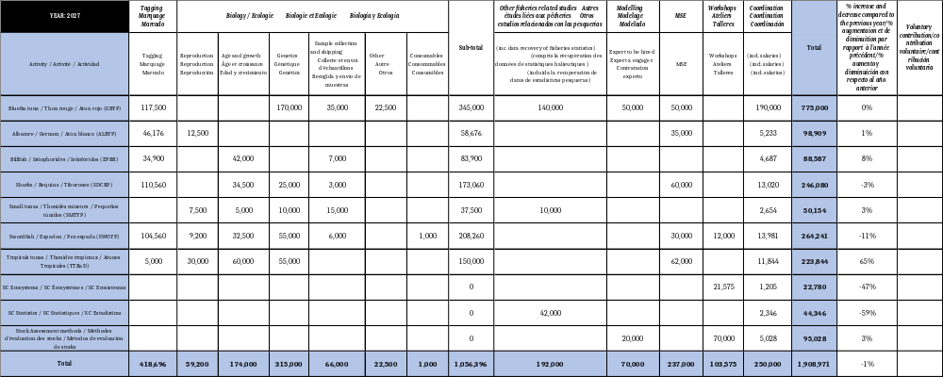

This estimation reflects a decrease of 1% compared to the budget approved for 2026. This adjustment continues to include: 1) the need to outsource a considerable number of activities; 2) the additional workload associated with existing and new MSEs, as the roadmap includes the new processes for North and South Atlantic blue shark; 3) the need to purchase a significant number of PSAT electronic tags.

- Science budget for financial year 2028 - The table below summarizes the Science budget for financial year 2028, by major budgetary line of activity and research programme. Additional detailed information is provided in Appendix 2 (Tables 2.1 and 2.2).

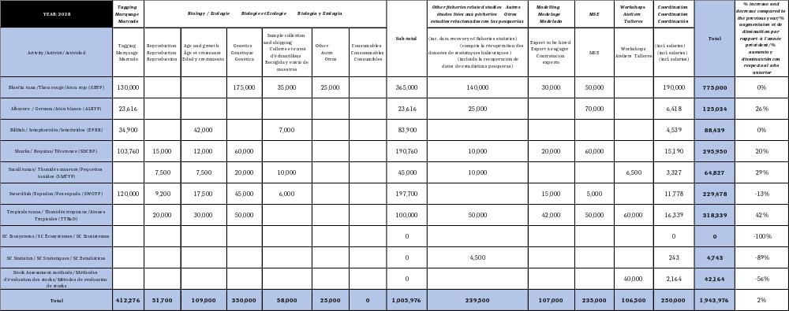

Science budget for financial year 2029 - The table below summarizes the Science budget for financial year 2029, by major budgetary line of activity and research programme. Additional detailed information is provided in Appendix 2 (Tables 2.1 and 2.2).

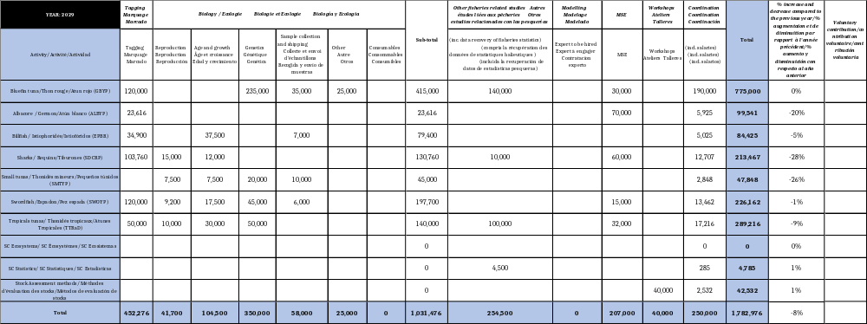

Chapter 8 - External consultancies/services

This chapter includes the specialized external consultancy/services, such as the legal and tax advice, external translation during meetings and part of the holiday period of the Translators, development of the ICCAT IT security policy, the contract for services for maintenance of the ICCAT VMS system, audit, administration, etc. In addition, this year the estimated amount for carrying out the third performance review has been included in the regular budget.

The proposed amount is 116.04% more compared to the budget approved for financial year 2026, largely due to the third performance review.

Chapter 9 - Separation from Service Fund

This chapter corresponds to the annual contribution of ICCAT to the Separation from Service Fund. The Separation from Service Fund is an ICCAT trust fund that has a separate set of accounts from the Working Capital Fund. This enables a balance to be accumulated annually that is intended solely and exclusively to cover the expenses for separation from service of the ICCAT staff, such as repatriation expenses, indemnities and other expenses of the same nature. The activity of this fund can be consulted in item 3 of the Financial Report.

The proposed amount is 3% more compared to the budget approved for financial year 2026.

Chapter 10 - Contingencies

This chapter includes the budget for contingencies.

The proposed amount is 3% more compared to the budget approved for financial year 2026.

2. Revenue budget proposal

The annual contributions in respect of the 2027 budget are set out in Table 3, in accordance with Regulation 4 of the Financial Regulations - Provision of Funds, taking into account the expenses proposal in item 1.

The budget for 2027 provides for the inclusion of Togo as a new Contracting Party, and in Panels 1 and 4, and of Montenegro in Panels 2 and 4.

Finally, it should be noted that the contributions of the Contracting Parties will be reviewed during the 2026 Annual Meeting of the Commission to incorporate any further changes in the membership of the various Panels, if any, and to update the United Nations exchange rate used for the calculation (the exchange rate for September 2026 has been used).

Appendix 1

Overview of the use of the available funds by the different ICCAT SCRS data collection and research programmes during the past 5 years (2021-2025) and by major budgetary item
Albacore Species Group (Atlantic Albacore Year Programme, ALBYP): General overview of the use of the available funds by the Albacore Species Group (associated research programme), by year (2021-2025) and major budgetary item.

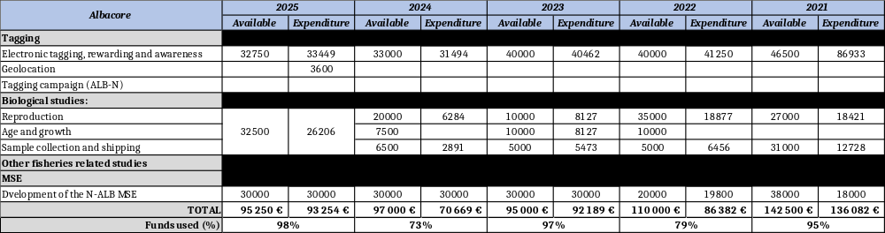

Bluefin Tuna Species Group (Atlantic-Wide Research Programme for Bluefin Tuna, GBYP): General overview of the use of the available funds by the Bluefin Tuna Species Group (associated research programme), by year (2021-2025) and major budgetary item.

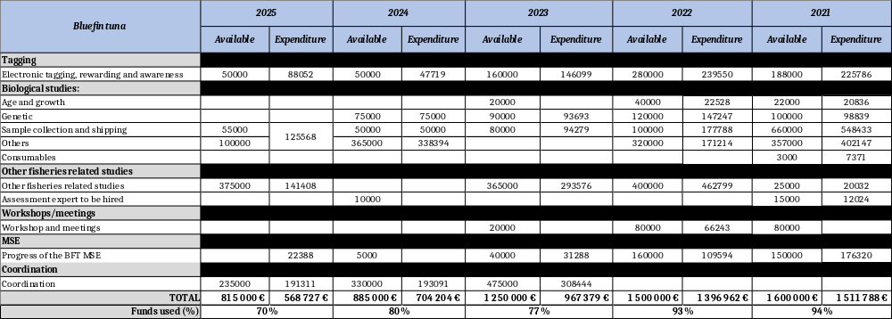

Billfish Species Group (Enhanced Programme for Billfish Research, EPBR): General overview of the use of the available funds by the Billfish Species Group (associated research programme), by year (2021-2025).

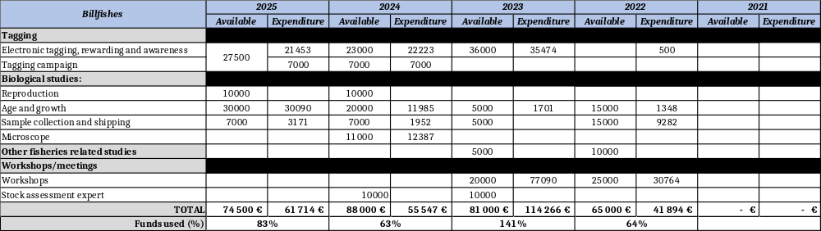

Small Tunas Species Group (Small Tuna Year Program, SMTYP): General overview of the use of the available funds by the Small Tuna Species Group (associated research programme), by year (2021-2025) and major budgetary item.

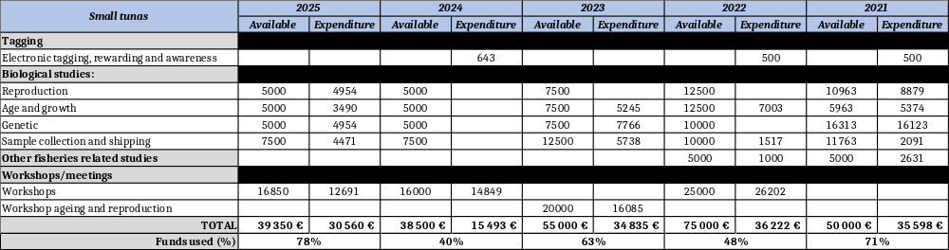

Sharks Species Group (Shark Research and Data Collection Programme, SRDCP): General overview of the use of the available funds by the Sharks Species Group (associated research programme), by year (2021-2025) and major budgetary item.

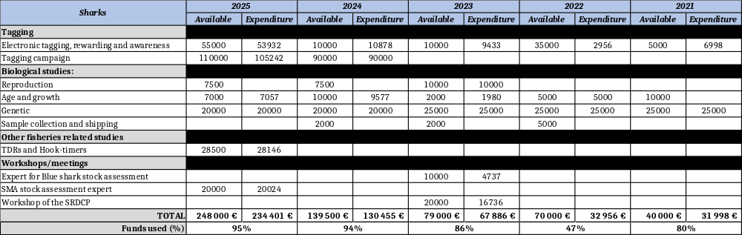

Swordfish Species Group (Swordfish Year Programme, SWOYP): General overview of the use of the available funds by the Swordfish Species Group (associated research programme), by year (2021-2025) and major budgetary item.

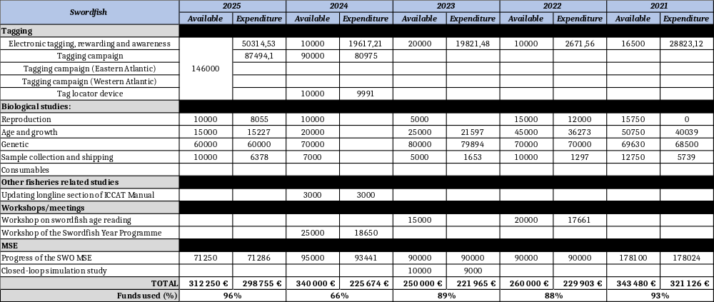

Tropical Tunas Species Group (Tropical Tuna Research and Data Collection Program, TTRaD): General overview of the use of the available funds by the Tropical Tunas Species Group (associated research programme), by year (2021-2025) and major budgetary item.

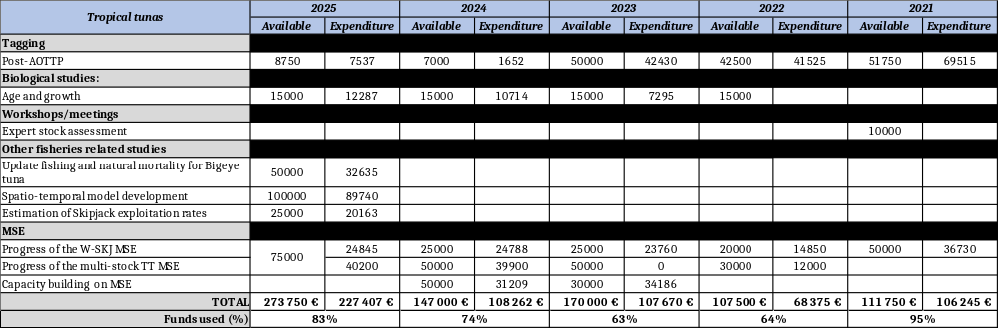

Working Group on Stock Assessment Methods (WGSAM): General overview of the use of the available funds by the Working Group on Stock Assessment Methods (WGSAM), by year (2021-2025) and major budgetary item.

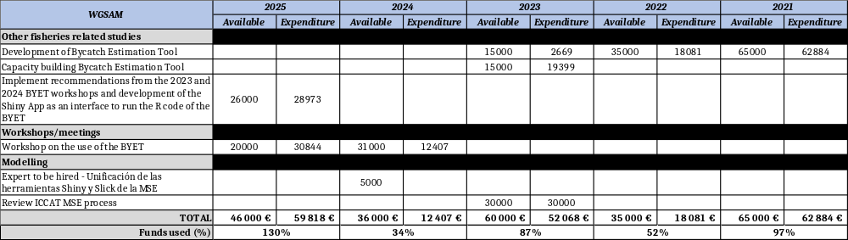

Subcommittee on Ecosystems and Bycatch: General overview of the use of the available funds by the Subcommittee on Ecosystems and Bycatch, by year (2021-2025) and major budgetary item.

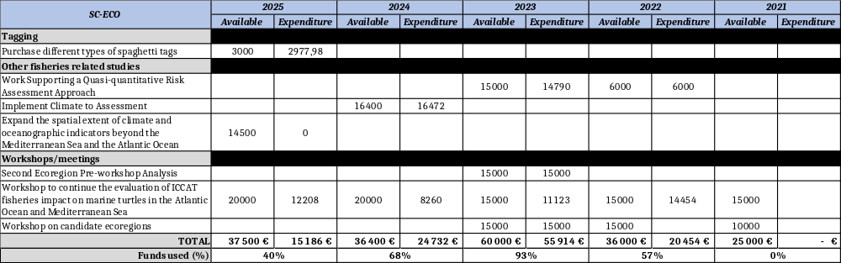

Subcommittee on Statistics (SC-STAT): General overview of the use of the available funds by the Subcommittee on Statistics for year 2025 and major budgetary item. From 2021 to 2024, the Subcommittee on Statistics had no Science Funds allocated and incurred no expenses.

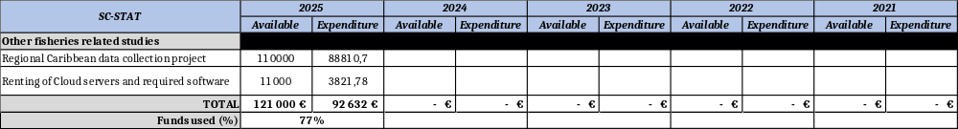

Appendix 2

SCRS requested funds for carrying out its activities

Detailed list of activities to be developed within the different data collection and research programmes of the SCRS and respective allocated funds for the one-year period 2027 is presented below in Tables A2.1 (Other research programmes) and A2.2 (GBYP), as secured funds.

Table A2.1. List of activities, respective costs and secured funding for the ICCAT Research Programmes except GBYP for the one-year period 2027. The total cost related to coordination is provided at the bottom of the table.

Group | Budget item | Description | 2027 | 2028 | 2029 | Explanations | Secured funding (€)
 |  |  |  |  |  |  | 2027 | Source
SC-Ecosystems & Bycatch | Workshops / meetings | Workshop on ECOcard | 21,575 |  |  | Objective is to advance the work on different aspects of the EcoCard in 2027. Funding aims for the attendance of up to 11 experts at the 5-day workshop.
SC-Ecosystems & Bycatch |  | Subtotal | 21,575 | 0 | 0
SC-STATS | Other fisheries related studies | Continue Phase II and III of Caribbean Project | 37,500 |  |  | The project aims to improve reporting and data analysis of fishery data of fleets capturing blue marlin and yellowfin tuna in the region. The U.S. has already committed to fully fund this activity, which shall be concluded in 2027. | 37,500 | EE. UU.
SC-STATS | Other fisheries related studies | Cloud infrastructure | 4,500 | 4,500 | 4,500 | Monthly renting of Cloud servers with the required software, with potential to scale it up as required.
SC-STATS |  | Subtotal | 42,000 | 4,500 | 4,500
Albacore (ALBYP) | Tagging | Tags (ALB-S) | 6,000 |  |  | There are 11 tags available from previous years. Only one additional PSAT will be purchased.
Albacore (ALBYP) | Tagging | Tags (ALB-N) | 7,680 | 7,680 | 7,680 | Purchase ~12 internal archival tags per year. Western Atlantic priority. | 6,144.00 | UE
Albacore (ALBYP) | Tagging | Rewarding, awareness, satellite and tagging material | 2,560 |  |  | Rewards for recoveries, satellite, tagging material associated to PSATs deployed. | 2,048.00 | UE
Albacore (ALBYP) | Tagging | Rewarding, awareness, geolocation and tagging material | 6,936 | 6,936 | 6,936 | Rewards for recoveries, geolocation, tagging material associated to internal archival tags deployed. | 5,548.80 | UE
Albacore (ALBYP) | Tagging | Tagging campaign (ALB-N) | 9,000 | 9,000 | 9,000 | Cost of the fish and charters. | 7,200.00 | UE
Albacore (ALBYP) | Tagging | Tagging campaign (ALB-S) | 14,000 |  |  | Cost for controlled fishing operations on commercial longline vessels.
Albacore (ALBYP) | Biological studies: | Reproduction  (ALB-S) | 12,500 |  |  | Further processing and analysis of additional samples from the South Atlantic, aiming the conclusion of the reproductive biology study by 2027. | 1,200 | UE
Albacore (ALBYP) | Other fisheries related studies | Joint index of abundance juvenile (NE ALB) |  | 25,000 |  | Joint NE Atlantic juvenile albacore index of abundance prior to next benchmark assessment. Expert for data analysis and meetings with data providers.
Albacore (ALBYP) | Modelling: | ALB-N MSE | 35,000 | 35,000 | 35,000 | Implement the ICCAT MSE roadmap and workplan. | 28,000.00 | EU
Albacore (ALBYP) | Modelling: | ALB-S MSE |  | 35,000 | 35,000 | Implement the ICCAT MSE roadmap. External funding for 2026-2027 is already secured.
Albacore (ALBYP) |  | Subtotal | 93,676 | 118,616 | 93,616
Billfishes (EPBR) | Tagging | Tags | 22,200 | 22,200 | 22,200 | Acquisition of miniPAT tags for the tagging campaign and opportunistic tagging (from other ICCAT tagging campaigns). | 22,200.00 | USA
Billfishes (EPBR) | Tagging | Rewarding, awareness, satellite and tagging material | 2,700 | 2,700 | 2,700 | Rewarding, e-tags related services of data transmission (satellite) and tagging material. | 2,700.00 | USA
Billfishes (EPBR) | Tagging | Tagging campaign | 10,000 | 10,000 | 10,000 | Main priority area is the NE Atlantic (southern Portugal) with dedicated tagging campaigns. The Committee will evaluate the priority areas in 2027 for next biennial period. | 8,000.00 | EU
 |  |  |  |  |  |  | 2000.00 | USA
Billfishes (EPBR) | Biological studies: | Age and growth | 42,000 | 42,000 | 37,500 | The plans from 2027 and beyond include: continue processing new samples; analyse current and new data; continue the development and/or complete the age and growth models. The annual costs related to age and growth include: processing and analysis (€17,000) and age validation (€25,000).  Specifically, for age validation (bomb-radiocarbon), age validation for white marlin was started in 2026 and is expected to be completed by 2028 followed by sailfish in 2028-2030. | 33,600.00 | EU
 |  |  |  |  |  |  | 8,400.00 | USA
Billfishes (EPBR) | Biological studies: | Sample collection and shipping | 7,000 | 7,000 | 7,000 | Additional samples to be collected for ageing and growth, collection of samples will focus on BUM, WHM, and SFA. | 7,000.00 | USA
Billfishes (EPBR) |  | Subtotal | 83,900 | 83,900 | 79,400
Sharks (SRDCP) | Tagging | Tags and tagging material | 81,400 | 44,400 | 44,400 | New tags (20 in 2026; 22 in 2027) to be acquired for the tagging campaigns and opportunistic tagging. Also includes value for acquiring tagging materials. Tags acquisition for 2028/2029 is more reduced (12 per year) with focus on other areas. | 65,120.00 | EU
 |  |  |  |  |  |  | 16,280.00 | CAN
Sharks (SRDCP) | Tagging | Rewarding, awareness and satellite | 17,160 | 9,360 | 9,360 | Value to cover rewarding, awareness and satellite transmissions | 13,728.00 | EU
 |  |  |  |  |  |  | 1,598.43 | CAN
Sharks (SRDCP) | Tagging | Tagging campaign | 12,000 | 50,000 | 50,000 | Dedicated tagging campaigns for the priority areas in the SW and NW Atlantic (2027) and other priority areas in 2028/2029. These data support stock mixture analysis and habitat suitability modelling for priority pelagic sharks. | 9,600.00 | EU
Sharks (SRDCP) | Biological studies: | Reproduction |  | 15,000 | 15,000 | From 2028 onwards, continue the study on the reproductive biology of North Atlantic shortfin mako quantifying reproductive hormone concentrations from muscle tissue samples to determine maturity and reproductive status. | 12,000.00 | EU
Sharks (SRDCP) | Biological studies: | Age and growth | 12,000 | 12,000 | 12,000 | Continue the study on age and growth for the priority shark species. Species priorities are longfin mako in 2027, and another of the priority sharks (TBD) in 2028/2029. This line of work contributes with biological information, that can be used in any future assessments or other risk analysis for sharks. | 9,600.00 | EU
Sharks (SRDCP) | Biological studies: | Age validation | 22,500 |  |  | An age-validation study for shortfin mako using bomb radiocarbon started in 2026 with existing samples, with particular focus on validating the early growth and defining growth band periodicity throughout the lifespan. Work is expected to be concluded in 2027. This will contribute to clarify uncertainties in the life history that have a strong influence in the stock assessments. | 18,000.00 | EU
Sharks (SRDCP) | Biological studies: | Genetics | 25,000 |  |  | Apply the approach used in the kinship analysis to investigate the genetic population structure of porbeagle. Previous years focused on the southern porbeagle and for 2027 there is the inclusion of the North porbeagle as well. New samples collected from four areas in the Atlantic, as well as adjacent regions, will be analyzed. The budget will cover sequencing, equipment, reagents, computer devices, and other related costs. | 20,000.00 | EU
Sharks (SRDCP) | Biological studies: | CKMR |  | 60,000 |  | Funds are requested in 2028 to conduct a feasibility study of using CKMR for shortfin mako. A previous study was conducted in 2019 with the previous stock assessment results, and the purpose is to update this study with the new stock assessment. In 2027, the Committee will contact national scientists that might have a possibility to sample shortfin mako, to evaluate the sampling numbers that could be achieved.
Sharks (SRDCP) | Biological studies: | Sample collection and shipping | 3,000 |  |  | Continue sampling effort on priority shark species, including values for sample shipping. | 2,400.00 | EU
Sharks (SRDCP) | Other fisheries related studies | TDRs |  | 10,000* | 10,000* | Acquisition of TDRs (long-term study, requested by Rec. 21-09).  * To be reviewed once the results of the experiments become available.
Sharks (SRDCP) | Modelling: | MSE | 60,000 | 60,000 | 60,000 | Value related with the blue shark MSE for North and South Atlantic stocks. The process will start in 2026 with preliminary work, and will be intensified in the 2027/2029 period to be completed in that three-year timeframe. Budget is requested for this period to support coding with the technical team. This item addresses the Commission Rec. 23-10 and Rec. 23-11 on blue shark MSE. | 48,000.00 | EU
Sharks (SRDCP) | Modelling: | MSE code review |  | 20,000 |  | The Committee requests funds in 2028 for an external revision of the blue shark MSE code that has been developed.
Sharks (SRDCP) |  | Subtotal | 233,060 | 280,760 | 200,760
Small tuna (SMTYP) | Biological studies: | Reproduction | 7,500 | 7,500 | 7,500 | Monthly sampling of gonads is essential for studying the reproductive biology of the different species in order to determine size at first maturity and the spawning season. Size frequencies have shown the absence of individuals in certain size classes during some months of the year, which represents a significant bias, although some size gaps have been filled in, others still remain. On a regional scale, it is therefore essential to maintain the monthly collection of gonadal samples (in order or priority: 1. BON; 2. LTA; 3. WAH; 4. BLT; 5. FRI) fill these knowledge gaps (refer to the reference table).  These funds will go towards finalizing ongoing reproduction studies in the same order of priority indicated above.
Small tuna (SMTYP) | Biological studies: | Age and growth | 5,000 | 7,500 | 7,500 | The collection of dorsal spines and otoliths for BON (large samples and small samples), LTA (large specimens to conclude studies in 2027), WAH (small and large fish), BLT and FRI remains a top priority to close key knowledge gaps on small tuna age and growth.  WAH: Major discrepancies between spines and otoliths highlight the need for standardized processing and better-quality images before reference sets can be finalized.  BLT and FRI: Processed samples exist (e.g. Portugal), but most of the available material from other regions requires processing and genetic validation, with gaps in larger individuals.
Small tuna (SMTYP) | Biological studies: | Genetics | 10,000 | 20,000 | 20,000 | The main goal genetic studies is to differentiate species and analyze stock structure. The current focus is on LTA, with additional samples being collected for BLT and FRI. Collecting tissue samples to fill knowledge gaps for these three species is a top priority. This work is ongoing and receives annual updates. The genetic studies on LTA, BLT, and FRI are to be completed by the end of 2029. As concerns the potential LTA differentiation, the Group will continue the genetic analyses and it would be necessary to also collect detailed meristic data also, according to the scheme provided by FAO for the tuna species.
Small tuna (SMTYP) | Biological studies: | Sample collection and shipping  (all species and research areas) | 15,000 | 10,000 | 10,000 | The sampling to be carried out must follow a rigorous protocol to complete the studies already underway. This protocol aims to ensure representative temporal coverage, thereby limiting seasonal effects. This approach will yield more reliable data for analysis.
Small tuna (SMTYP) | Other fisheries related studies | Historical data collection and data recovery | 10,000 | 10,000 |  | Data from the Northwest Atlantic is entirely absent from the minor tuna species database. CPCs with historical data on SMT are encouraged to provide this information to ICCAT. This study will be essential for improving the quality of existing statistical data. In addition, a contract should be issued to carry out additional historical data collection and data recovery mining activities in selected countries/regions.
Small tuna (SMTYP) | Workshops | Capacity-building workshop |  | 6,500 |  | Support the participation of one expert and a limited number of selected participants (total of 6-7)
Small tuna (SMTYP) |  | Subtotal | 47,500 | 61,500 | 45,000
Swordfish (SWOYP) | Tagging | Tags and tagging material | 44,400 | 120,000 | 120,000 | New tags (12) to be acquired for the tagging campaign and opportunistic tagging. Also includes some value for acquiring tagging materials | 35,520.00 | EU
Swordfish (SWOYP) | Tagging | Rewarding, awareness and satellite | 5,160 | 120,000 | 120,000 | Value to cover rewarding, awareness and satellite transmission costs. | 4,128.00 | EU
Swordfish (SWOYP) | Tagging | Tagging campaign | 55,000 | 120,000 | 120,000 | Dedicated annual tagging campaigns for priority areas. In 2027, the priority area will be the NE Atlantic (stock mixing area). In subsequent years, tagging efforts will focus on priority areas in the South Atlantic and Mediterranean Sea. Tagging data supports stock mixing analysis, habitat suitability modelling, and CPUE standardization. | 44,000.00 | EU
 |  |  |  |  |  |  | 17,878.42 | CAN
Swordfish (SWOYP) | Biological studies: | Reproduction | 9,200 | 9,200 | 9,200 | Continue processing gonad samples, and data analysis for reproduction work. Aim to produce baseline maturity ogives by 2027 and then start a regular monitoring program for 2028 onwards to monitor changes in population dynamics. This work supports spawning stock biomass assumptions in the assessment model. | 7,360.00 | EU
Swordfish (SWOYP) | Biological studies: | Age and growth | 32,500 | 17,500 | 17,500 | Processing and analysis of spines and otoliths; data analysis and growth modelling by stock, that support data inputs into the assessment models. Aim to produce baseline growth curves for Atlantic stocks by 2027 and then start a regular monitoring program from 2028 onwards to monitor changes in population dynamic. Age validation sample compilation will continue for analysis in 2027. | 26,000.00 | EU
Swordfish (SWOYP) | Biological studies: | Genetics | 55,000 | 45,000 | 45,000 | Continued population analysis for stock differentiation using double digest restriction-site associated DNA (ddRAD); continuation of the study on epigenetic ageing using Reduced Representation Bisulfite Sequencing (RRBS-SEQ). Further identification of SNPs for cost effective stock identification. Epigenetic ageing for age structure analysis and identification of maturity, that will be linked to the ageing studies. An analysis on stock boundaries and mixing will be presented in 2027. The program will then begin transition to monitoring for changes in population dynamics e.g. stock structure, epigenetic ageing, epigenetic maturity etc., to support assessment inputs. | 44,000.00 | EU
Swordfish (SWOYP) | Biological studies: | Sample collection and shipping | 6,000 | 6,000 | 6,000 | Continue sampling effort on priority and missing areas/sizes as defined in the project summary. Also includes value for sample shipping and tissue biopsy darts. | 4,800.00 | EU
Swordfish (SWOYP) | Biological studies: | Consumables | 1,000 |  |  | Vials for the collection of gonads samples and shipping to the laboratories. | 800.00 | EU
Swordfish (SWOYP) | Modelling: | Absolute abundance estimation:  CKMR/Gene tagging |  | 15,000 |  | Conduct a feasibility study that evaluates the cost, benefits and logistics of conducting CKMR and gene tagging for SWO-N, SWO-S and SWO-MD in order to provide estimates of absolute stock abundance/estimates of exploitation rate for use in population models.
Swordfish (SWOYP) | Modelling: | MSE | 30,000 | 5,000 | 15,000 | Value for the continue work on MSE, to support work requested in Rec. 25-10 related to Climate Change and assessing the effectiveness of minimum size limits, and support the evaluation of ECs. Includes funds for work in advance of the MSE review scheduled for 2030. In 2026, PA4 requested additional analyses on the effects of trapline gear on application of the MP. The revision to the 2027 MSE budget reflects this request.
Swordfish (SWOYP) | Workshop | Workshop to conclude Atlantic and Mediterranean SWO ageing studies | 12,000 |  |  | Technical workshop for age readers to conclude ageing calibration and among readers for Atlantic and Mediterranean stocks. Costs related to travel and subsistence of three experts. | 9,600.00 | EU
Swordfish (SWOYP) |  | Subtotal | 250,260 | 217,700 | 212,700
Tropical tuna (TTRaD) | Tagging | Tags and tagging material |  |  | 45,000* | Tags procured for new campaign (check validity of stock unit).
Tropical tuna (TTRaD) | Tagging | Rewarding, awareness and satellite | 5,000 |  | 5,000* | Funding for tagging offices (2027). *Cost in 2029 is an estimate and subject to revision based on results from the tagging workshop in 2028. | 5,000.00 | USA
Tropical tuna (TTRaD) | Biological studies | Reproduction | 30,000 | 20,000 | 10,000 | SKJ updates (2027). BET updates (2028 & 2029). Conduct a feasibility study for maturation indicators to support the development of less invasive methods to assess maturity (2027). | 30,000.00 | CHN
Tropical tuna (TTRaD) | Biological studies | Age and growth | 60,000 | 30,000 | 30,000 | Annual sample collection and update of parameters for all three species based on gaps. Age validation for SKJ (2027). | 60,000.00 | USA
Tropical tuna (TTRaD) | Biological studies | Genetics | 55,000 | 50,000* | 50,000* | Feasibility and costing for epigenetic study (€15,000), and CKMR (€40,000) in 2027.  *Sample collection in 2028 and 2029 estimated and subject to revision based on results from feasibility in 2027.
Tropical tuna (TTRaD) | Other fisheries related studies | Environmental habitat definition |  | 50,000* | 100,000* | Changes in productivity and distribution of tropical tunas in relation to the environment and climate (including an update to environmental habitat definition using available tag data). Species and budgets to be defined and revised based on outcomes from SEAPODYM in 2027.
Tropical tuna (TTRaD) | MSE | SKJ-W MSE | 12,000 |  |  | Implement ICCAT MSE roadmap for SKJ-W as set by the Commission. | 12,000.00 | USA
Tropical tuna (TTRaD) | MSE | Enhance communication of MSE |  | 12,000 | 12,000 | Enhance communication of the tropical tunas MSE processes.
Tropical tuna (TTRaD) | MSE | Multi-stock tropical tunas MSE | 50,000 | 50,000 | 20,000 | Implement ICCAT MSE roadmap for multi-stocks as set by the Commission. | 40,000.00 | EU
 |  |  |  |  |  |  | 10,000.00 | USA
Tropical tuna (TTRaD) | MSE | External review multi-stock MSE |  | 30,000
Tropical tuna (TTRaD) | Workshop | Workshop to advance age and growth studies |  | 50,000 |  | Age-growth-reproduction workshop (funding to support the participation of relevant scientists).
Tropical tuna (TTRaD) | Workshop | Coordination tagging programme |  | 10,000 |  | Workshop to coordinate new tagging campaign with funds to support expert attendance (2028).
Tropical tuna (TTRaD) |  | Subtotal | 212,000 | 302,000 | 272,000
WGSAM | Workshops / Meetings | Training workshops for the BYET* | 30,000 |  |  | It is estimated new training workshops are needed to further develop CPCs capacity building to use BYET to comply with report requirements on bycatch.
WGSAM | Workshops / Meetings | Training workshops for advanced/ intermedial technical MSE* | 40,000 | 40,000 | 40,000 | It is estimated new advanced and intermedial technical workshops are needed to further develop SCRS capacity building on MSE development. | 32,000.00 | EU
WGSAM | Modelling | Further development of the BYET | 20,000 |  |  | To incorporate possible feedback from the training workshop held in 2025. | 18,898.00 | USA
WGSAM |  | Subtotal | 90,000 | 40,000 | 40,000
TOTAL |  |  | 1,073,971 | 1,108,976 | 947,976 |  | 789,851.65
Group | Budget item | Description | 2027 | 2028 | 2029 | Explanations | Secured funding (€)
 |  |  |  |  |  |  | 2027 | Source
Other research programs |  | Science coordination | 60,000 | 60,000 | 60,000 | Total coordination costs estimated at €60,000 in 2027. | 45,541.07 | Scientific balance
 |  |  |  |  |  |  | 4,458.93 | USA
 |  |  |  |  |  |  | 10,000.00 | CHN
Other research programs |  | Subtotal | 60,000 | 60,000 | 60,000 |  | 60,000.00
OVERALL TOTAL |  |  | 1,133,971 | 1,168,976 | 1,007,976 |  | 849,851.65

Table A2.2. List of activities, respective costs and secured funding for the GBYP for the one-year period 2027. The total cost related to coordination is provided at the bottom of the table.

Group | Budget item | Description | 2027 | 2028 | 2029 | Explanations | Secured funding (€)
 |  |  |  |  |  |  | 2027 | Source
Bluefin tuna (GBYP) | Tagging | Tags and tagging material | 90,000 | 80,000 | 80,000 | Electronic tags of different types. | 4,666.27 | CAN
 |  |  |  |  |  |  | 85,333.73 | GBYP balance + CPCs with a share on BFT-E TAC (proportional to the share)
Bluefin tuna (GBYP) | Tagging | Rewarding, awareness and satellite | 17,500 | 30,000 | 30,000 | Advertisements, physical tag recovery, rewards. | 17,500.00
Bluefin tuna (GBYP) | Tagging | Development and maintenance of an electronic tagging database | 10,000 | 10,000 | 10,000 | Finishing developing the tagging database, fix most urgent issues, then yearly maintenance. | 10,000.00
Bluefin tuna (GBYP) | Tagging | Tagging campaign |  | 10,000 |  | Eastern Mediterranean tagging support.
Bluefin tuna (GBYP) | Biological studies | Genetic | 135,000 | 150,000 | 210,000 | Epigenetic clock on different tissues providing aging that will be used for stock status determination and future MSE reviews (Rec. 23-07). Provision starting in 2028 if genetic tools for aging become operational. Genotyping of archived samples for stock of origin to support the MSE with priority given for Japan longline samples and others to support the MSE. | 135,000.00
Bluefin tuna (GBYP) | Biological studies | Stock ID for eTags | 20,000 | 10,000 | 10,000 | Assign genetic stock of origin to e-tags for use in the MSE. | 20,000.00
Bluefin tuna (GBYP) | Biological studies | BFT-W genotyping | 15,000 | 15,000 | 15,000 | Genotyping of BFT-W samples. | 15,000.00 | CAN
Bluefin tuna (GBYP) | Biological studies | Sample collection and shipping | 35,000 | 35,000 | 35,000 | Field sample collection, shipping and preservation of samples. | 35,000.00 | GBYP balance + CPCs with a share on BFT-E TAC (proportional to the share)
Bluefin tuna (GBYP) | Biological studies | Other (sample bank) | 22,500 | 25,000 | 25,000 | Tissue bank archiving and curation. | 22,500.00
Bluefin tuna (GBYP) | Other fisheries related studies | Aerial surveys | 105,000 | 120,000 | 120,000 | Yearly aerial survey over the Balearic area field operations. | 105,000.00
Bluefin tuna (GBYP) | Other fisheries related studies | Aerial survey index provision | 35,000 | 20,000 | 20,000 | Yearly index provision to the Working Group for EC assessment (Rec. 23-07). Improving standardization of the index. | 35,000.00
Bluefin tuna (GBYP) | Modelling: | MSE | 50,000 | 50,000 |  | MSE review starting in 2026 (Rec. 23-07). The aim of the review is to ensure the MP is performing as expected and to determine whether there are conditions that justify its continuation, or that warrant: reconditioning the MSE OMs; retuning the existing MP; including new indices into a new MP; and/or considering alternate candidate MPs or development of a new MSE framework. | 50,000.00
Bluefin tuna (GBYP) | Modelling: | External expert for MSE | 50,000 | 30,000 | 30,000 | Development and implementation of a multi-stock assessment model that can incorporate mixing, movement and multi-stock dynamics. Continued support for MSE management procedure development and MSE expert support. | 50,000.00
Subtotal |  |  | 585,000 | 585,000 | 585,000 |  | 585,000.00
Science coordination |  |  | 190,000 | 190,000 | 190,000 | Salary of program coordinator (part-time, 60% in 2027 and beyond); Salary of the Steering Committee (SC) external expert; travelling related to coordination activities (e.g. attendance to SC meetings and ICCAT meetings; participation on field work; etc.). | 190,000.00 | GBYP balance
OVERALL TOTAL |  |  | 775,000 | 775,000 | 775,000 |  | 775,000.00

Appendix 3

Commission and intersessional meeting expenses (last four years)

- Commission meetings (annual)

EXPENSES FOR THE ANNUAL MEETING OF THE COMMISSION | 2022 | 2023 | 2024 | 2025
Meeting preparation | €2,595.42 | €21,018.61 | €2,127.08 | €3,274.27
Secretariat
Travel | €3,802.91 | €21,594.91 | €16,022.88 | €3,268.19
Hotel | €25,645.00 | €47,530.86 | €55,260.00 | €44,252.00
Per diem | €23,283.00 | €38,022.68 | €23,602.16 | €31,672.08
Transport costs | €890.80 | €1,401.82 | €1,622.49 | €838.10
Overtime | €15,840.13 | €16,893.50 | €10,274.67 | €8,731.33
Interpreters
Fees | €54,426.00 | €63,802.50 | €52,830.00 | €48,750.00
Travel | €1,541.75 | €2,802.81 | €3,442.29 | €939.94
Hotel | €6,900.00 | €10,124.92 | €12,960.00 | €9,768.00
Per diem | €6,208.80 | €8,283.30 | €5,535.36 | €7,038.24
Arabic Interpreters
Fees | €21,180.00 | €21,258.00 | €20,790.00 | €20,535.00
Travel | €1,050.00 | €1,754.27 | €1,621.76 | €1,471.96
Hotel | €3,105.00 | €3,656.22 | €4,860.00 | €3,996.00
Per diem | €2,793.96 | €2,991.19 | €2,075.76 | €2,879.28
Shipping of material | €4,480.50 | €3,852.23 | €2,875.37 | €2,341.35
Hotel venues
Meeting and work rooms | €136,419.64 |  | €82,662.50 | €46,395.00
Simultaneous interpretation | €78,072.51 |  | €20,575.55 | €94,813.10
Coffee breaks / lunches | €165,500.00 |  | €324,380.00 | €149,448.00
Coffee breaks | €66,600.00 |  |  | €86,400.00
Cocktail reception | €21,500.00 |  | €16,340.00 | €17,200.00
Gala dinner |  |  | €2,450.00
Others: water service, masks, furniture, agency service | €15,195.24 |  | €25,320.50 | €1,366.88
Audiovisual/sound | €81,855.00 |  | €80,261.76
Photocopiers | €21,121.00
Internet/Wi-Fi | €22,977.84 |  | €128,413.93 | €36,073.05
Equipment, servers, PC, printers | €8,852.53 | €1,030.70 | €28,007.61
Security/ hostesses/ agency service | €71,032.59 |  | €13,920.00 | €19,416.53
TOTAL | €862,869.62 | €266,018.52 | €938,231.67 | €640,868.30
FINANCING | 2022 | 2023 | 2024 | 2025
ICCAT budget | €233,010.66 | €238,314.62 | €117,667.03 | €350,000.00
Working Capital Fund | €29,858.96 | €27,703.90 | €29,347.52 | €290,868.30
Financing host country | €600,000.00 |  | €791,217.12
TOTAL | €862,869.62 | €266,018.52 | €938,231.67 | €640,868.30

- Commission intersessional meetings

EXPENSES COMMISSION INTERSESSIONAL MEETINGS | 2022 | 2023 | 2024 | 2025
Meeting preparation | €2,071.10 |  | €7,873.55
Secretariat
Travel | €3,973.28 | €28,946.41 | €33,697.93 | €2,327.64
Hotel | €5,440.00 | €10,606.73 | €15,353.08 | €7,700.00
Per diem | €3,005.12 | €12,060.72 | €8,020.47 | €4,568.87
Transport costs | €527.18 | €1,990.88 | €1,203.67 | €486.57
Overtime |  | €1,299.42 | €461.37
Interpreters
Fees | €163,575.00 | €182,642.02 | €120,156.00 | €37,632.00
Travel | €2,980.48 | €21,560.89 | €25,327.33
Hotel | €2,760.00 | €7,355.03 | €10,428.05
Per diem | €2,153.04 | €8,471.94 | €5,485.62
Hotel venues
Meeting and work rooms | €7,835.00 | €55,919.80 | €23,045.25
Simultaneous interpretation | €48,513.74 | €78,659.20 | €31,947.00 | €14,908.41
Coffee breaks | €4,395.00 | €21,385.00 | €8,819.00 | €1,980.00
Cocktail reception | €1,875.00 | €12,089.00 | €7,020.00 | €2,075.00
Others: water service, masks, furniture, etc. | €940.00 | €4,078.00 | €748.00
Audio / sound | €42,930.00 | €11,442.00 | €26,543.40
Equipment, servers, PC, printers | €3,645.13 | €3,996.00 | €3,918.45
Internet/Wifi | €2,750.00 | €5,211.50
Security/ hostesses/ agency service | €6,518.36 | €10,018.00 | €12,584.57
TOTAL | €305,887.43 | €477,732.54 | €342,632.74 | €71,678.49
FINANCING | 2022 | 2023 | 2024 | 2025
ICCAT budget
Working Capital Fund | €98,322.52 | €477,732.54 | €342,632.74 | €66,323.14
Financing host country | €207,564.91 |  |  | €5,355.35
TOTAL | €305,887.43 | €477,732.54 | €342,632.74 | €71,678.49

- SCRS annual meeting

EXPENSES SCRS ANNUAL MEETING | 2022 | 2023 | 2024 | 2025
Meeting preparation
Secretariat
Travel
Hotel
Per diem
Transport costs | €1,879.42 | €1,854.11 | €1,815.14 | €932.19
Overtime | €3,124.47 | €3,478.42 | €1,319.37
Interpreters
Fees | €27,607.80 | €26,522.10 | €23,616.00 | €25,116.00
Travel
Hotel
Per diem
Shipping of material | €1,512.50 | €1,512.50 | €1,512.50
Hotel venues
Meeting and work rooms | €18,119.71 | €17,184.65 | €16,849.25 | €19,305.00
Simultaneous interpretation | €23,182.39 | €14,348.40 | €12,988.80 | €12,988.80
Coffee breaks / lunches | €373.30 | €230.45 | €504.70 | €155.00
Coffee breaks | €4,986.00 | €5,800.00 | €10,035.00 | €11,655.00
Cocktail reception | €3,832.00 | €3,912.00 | €4,680.00 | €4,860.00
Gala dinner
Others: water service, masks, furniture, agency service | €1,386.95
Audiovisual/sound |  |  |  | €2,512.13
Photocopiers | €4,325.15
Internet/Wi-Fi | €442.59 | €442.59 | €450.48 | €379.55
Equipment, servers, PC, printers
Security/ hostesses/ agency service | €1,570.25 | €2,319.86 | €2,292.54 | €2,925.00
TOTAL | €92,342.53 | €77,605.08 | €76,063.78 | €80,828.65
FINANCING | 2022 | 2023 | 2024 | 2025
ICCAT budget | €92,342.53 | €77,605.08 | €76,063.78 | €80,828.65
Working Capital Fund
Financing host country
TOTAL | €92,342.53 | €77,605.08 | €76,063.78 | €80,828.65

- SCRS intersessional meetings

EXPENSES SCRS INTERSESSIONAL MEETINGS | 2022 | 2023 | 2024 | 2025
Meeting preparation
Secretariat
Travel |  | €3,344.18 | €5,610.82 | €2,168.16
Hotel |  | €1,992.72 | €4,640.83 | €6,008.48
Per diem |  | €2,533.20 | €3,010.92 | €5,218.46
Transport costs |  | €471.66 | €194.11 | €1,707.36
Overtime
Interpreters
Fees |  | €72,830.16 | €135,657.00 | €146,733.00
Travel |  |  |  | €1,374.27
Hotel |  |  |  | €10,799.50
Per diem |  |  |  | €8,632.40
Hotel venues
Meeting and work rooms | €28,713.30 | €24,454.10 | €28,755.65 | €32,801.23
Simultaneous interpretation | €18,770.73 | €43,716.84 | €56,550.82 | €73,021.51
Coffee breaks | €10,280.10 | €12,509.45 | €20,682.60 | €30,546.97
Cocktail reception
Others: water service, masks, furniture, etc.
Audio / sound | €2,395.80 | €2,178.00 | €6,019.76 | €24,332.85
Equipment, servers, PC, printers
Internet/Wi-Fi | €531.11 | €531.11 | €540.58 | €455.45
Security/ hostesses/ agency service | €2,117.23 | €3,326.83 | €3,317.36 | €3,981.26
TOTAL | €62,808.27 | €167,888.25 | €264,980.44 | €347,780.92
FINANCING | 2022 | 2023 | 2024 | 2025
ICCAT budget | €7,121.44 | €167,888.25 | €264,980.44 | €308,526.84
Working Capital Fund | €55,686.83 |  |  | €6,497.83
Financing host country |  |  |  | €32,756.25
TOTAL | €62,808.27 | €167,888.25 | €264,980.44 | €347,780.92

Appendix 4

Evolution of the expenses by chapters of the new budget, grouped by major categories, over the last four years
Évolution des dépenses par chapitres du nouveau budget, regroupées par grandes catégories, au cours des quatre dernières années
Evolución de los gastos por capítulos del nuevo presupuesto, agrupados por categorías principales, en los cuatro últimos años

Chapters |  | 2022 | 2023 | 2024 | 2025
Chapitres |  | ANNÉE 2022 | ANNÉE 2023 | ANNÉE 2024 | ANNÉE 2025
Capítulos |  | AÑO 2022 | AÑO 2023 | AÑO 2024 | AÑO 2025
1. | Salaries / Salaires / Salarios | 3,501,373.09 | 3,658,538.11 | 3,936,665.63 | 4,201,067.46
2. | Travel / Voyages / Viajes
 | a) Representation of ICCAT in other fora / Représentation de l'ICCAT dans d’autres enceintes / Representación de ICCAT en otros foros | 26,659.17 | 26,394.16 | 42,999.68 | 30,250.50
 | b) ICCAT meetings (staff) / Réunions de l’ICCAT (membres du personnel) / Runiones ICCAT (personal) | 58,697.04 | 152,631.34 | 128,005.57 | 97,863.45
 | c) Commission/SCRS Chairs / Présidents de la Commission/du SCRS / Presidentes de ICCAT y SCRS | 32,874.72 | 42,001.88 | 40,222.89 | 64,955.84
 | d) COM and SCRS Officers (from developing ICCAT Contracting Parties) / Mandataires de la Commission et du SCRS (des Parties contractantes en développement de l’ICCAT) / Cargos de ICCAT (Partes contratantes en desarrollo de ICCAT) | 30,306.19 | 34,101.48 | 65,798.01 | 78,285.50
 | e) Special Meeting Participation Fund / Fonds spécial pour la participation aux réunions / Fondo especial para la participación en reuniones | 40,000.00 | 170,000.00 | 250,000.00 | 250,000.00
 | Sub-total Chapter 2 / Sous-total Chapitre 2 / Subtotal Capítulo 2 | 188,537.12 | 425,128.86 | 527,026.15 | 521,355.29
3. | Meetings / Réunions / Reuniones
 | a) Commission annual meeting / Réunion annuelle de la Commission / Reunión anual de la Comisión | 159,230.91 | 87,442.92 | 81,718.23 | 257,964.03
 | b) Commission intersessional meetings / Réunions intersessions de la Commission / Reuniones intersesiones de la Comisión | 0.00 | 0.00 | 0.00 | 0.00
 | c) SCRS annual meeting / Réunion annuelle du SCRS / Reunión anual del SCRS | 86,993.35 | 78,433.11 | 81,064.19 | 88,908.18
 | d) SCRS intersesional meeting / Réunions intersessions du SCRS / Reuniones intersesiones del SCRS | 4,833.08 | 155,811.12 | 241,858.44 | 286,464.15
 | Sub-total Chapter 3 / Sous-total Chapitre 3 / Subtotal Capítulo 3 | 251,057.34 | 321,687.15 | 404,640.86 | 633,336.36
4. | Publicationes / Publications / Publicaciones | 15,510.85 | 9,336.03 | 13,411.72 | 12,203.44
5. | Office Equipment / Équipement de bureau / Equipo de oficina | 1,643.40 | 691.41 | 10,661.45 | 1,928.99
6. | Operating costs / Frais de fonctionnement / Costes operativos
 | a) General expenses / Frais généraux / Gastos generales | 127,620.23 | 125,288.40 | 102,541.44 | 112,496.85
 | b) Software licences and cloud resources / Licences de logiciels et ressources en nuage / Licencias de software y recursos en la nube | 93,113.89 | 100,984.47 | 140,715.66 | 158,560.66
 | c) Computer hardware / Matériel informatique / Hardware informático | 23,159.30 | 27,418.08 | 31,056.63 | 43,315.19
 | d) Phone line-Internet domain / Ligne téléphonique – Domaine Internet / Línea telefónica-Dominio de Internet | 7,080.96 | 7,541.99 | 7,353.58 | 5,911.80
 | Sub-total Chapter 6 / Sous-total Chapitre 6 / Subtotal Capítulo 6 | 250,974.38 | 261,232.94 | 281,667.31 | 320,284.50
7. | Science Envelope (ICCAT research programmes) / Enveloppe scientifique (programmes de recherche de l'ICCAT) / Dotación para la ciencia (programas de investigación de ICCAT) | 404,500.00 | 416,635.00 | 45,000.00 | 0.00
8. | Consultations/services externes / Consultations/services externes / Consultorías/servicios externos | 87,435.05 | 134,385.49 | 145,374.44 | 109,419.52
9. | Separation from Service Fund / Fonds de cessation de service / Fondo separación de servicio | 63,561.30 | 65,468.14 | 65,468.14 | 65,468.14
10. | Contingencies / Contingences / Contingencias | 0.00 | 93.70 | 0.00 | 0.00
TOTAL BUDGET / BUDGET TOTAL / PRESUPUESTO TOTAL |  | 4,764,592.53 | 5,293,196.83 | 5,429,915.70 | 5,865,063.70

