Original: English

Discussion paper on the next steps for the development of an electronic port State measures information exchange system for ICCAT fisheries
(Discussion paper submitted by the United Kingdom)

Summary

This paper builds on the discussions held at the 19th Meeting of the Working Group on Integrated Monitoring Measures (IMM) on the development of an ICCAT electronic port State measures information exchange system, which was centred around the UK’s discussion paper IMM_07/i2026 and the Secretariat’s information paper IMM_18/i2026. Those discussions demonstrated support in moving ICCAT towards a more modern, efficient and interoperable approach to port State measures information exchange.

Two options for the foundations of an electronic information exchange system received the strongest support from CPCs at the IMM:

- adapting the existing IOTC e‑PSM system, or
- using directly or customising a copy of the FAO Agreement on port State measures (PSMA) Global Information Exchange System (GIES).

The paper invites the PWG to decide:

- which option should be taken forward for further development, and
- the key principles that should guide the Secretariat and IMM/PWG in the next phase of work.

A decision on these matters at this stage will provide the Secretariat and IMM/PWG with a clear mandate for the next phase of work, consistent with the objectives of Recommendation 25‑11.

Note that this paper is intended to be read in conjunction with the Secretariat’s analysis of the two options in document PWG_411/2026. Furthermore, this paper is not intended to resolve the detailed technical, operational, governance, confidentiality, data-sharing or system design arrangements associated with implementation of an electronic information exchange system. These matters will be explored further through technical analysis and discussion at the 2027 IMM meeting, with recommendations brought back to the PWG in November 2027 as appropriate.

Background

Recommendation 25‑11 strengthened ICCAT's port State measures framework by requiring CPCs to cooperate and exchange information with the aim of reducing the risk of IUU-caught fish entering markets through CPCs’ ports. The Recommendation also recognises the role of electronic communication mechanisms, including GIES where appropriate, and tasks the Secretariat with examining options to access and/or share relevant information electronically to improve information exchange and avoid duplicating reporting requirements.

The development of an ICCAT electronic information exchange system presents an opportunity to modernise the exchange of information currently submitted under Recommendation 25‑11 by supporting the transition from manual information exchange to a more efficient and standardised electronic process. The aims of developing an ICCAT electronic information exchange system would be to allow the timely exchange of information between relevant authorities, improve the availability of information needed for port State decision-making, and facilitate interoperability with GIES where appropriate, particularly for CPCs that are Parties to the PSMA and wish to share relevant information electronically and avoid duplication.

Information exchanged under the ICCAT Port Inspection Scheme would also be made available electronically, including:

- access to relevant contact points, confirmation of designated ports
- the submission and sharing of Advance Requests for Port Entry (ARPEs)
- denials of port entry or port use, and Port Inspection Reports

For CPCs that are Parties to the PSMA, relevant information would be shared automatically with GIES, helping them to meet PSMA information-sharing obligations while reducing duplicate reporting requirements. Annex 1 provides an illustrative example of how information would flow within an ICCAT application.

At IMM in June 2026, CPCs expressed broad support for an approach that builds on existing solutions where possible, avoids unnecessary duplication, minimises costs and supports interoperability with existing systems. CPCs also expressed the need for ICCAT to have sole ownership over the future electronic information exchange system. Subsequent discussions with the FAO and IOTC Secretariats have helped refine the available approaches and identify the two options presented in this paper for PWG’s consideration.

Options and principles
Table 1 summarises the two options identified through IMM discussions and engagement with the FAO and IOTC Secretariats.

Table 1. Comparison of the two options for PWG consideration.

Option | What this would look like | Main points for consideration
Option 1: Adapt the IOTC e-PSM application | ICCAT would use the existing IOTC e-PSM application source code as the foundation for an ICCAT system. The electronic information exchange system would need to be tailored to ICCAT requirements and workflows. | - This would build on an existing RFMO system and provide a practical route to implementation.  - Further work would be needed on adaptation, maintenance costs, hosting, and interoperability with GIES.
Option 2: Adapt/directly use the FAO GIES-application | ICCAT would explore the direct use of GIES OR the customisation of a copy of the FAO GIES to develop its own electronic information exchange system. | - This would support close alignment with PSMA/GIES processes.  - Further work would be needed to understand customisation, governance, use by ICCAT CPCs, and how much control ICCAT would have over future changes.

A fuller consideration and comparison of each of these options is provided in a paper developed by the Secretariat and submitted for this PWG meeting (PWG_411/2026). In selecting one of the two options for further development, the following principles should underpin the Secretariat’s and IMM/PWG’s work:

- The system should support the effective implementation of Recommendation 25-11, support the effective implementation of relevant PSMA information-sharing requirements, and contribute to efforts to prevent, deter and eliminate IUU fishing.
- The system should avoid duplication of reporting requirements for CPCs, including through interoperability and information exchange with the FAO PSMA GIES.
- Relevant information should be accessible to the port State, flag State and ICCAT Secretariat, with detailed access arrangements to be considered through future work.
- The system should support the recording and exchange of key port State measures information, including ARPEs, inspection outcomes and port decisions.
- The system should support timely information exchange to assist port State decision-making and follow-up action by relevant authorities.
- The source code of the system should be fully transferred to ICCAT which will have sole ownership of it. This would allow ICCAT to modify the system without the involvement of a third party (i.e. the IOTC or the FAO).

Decision requested from the PWG

The PWG is requested to agree the preferred implementation pathway for an ICCAT electronic information exchange system by selecting one of the following options:

- Option 1: Adaptation of the existing IOTC e‑PSM application; or
- Option 2: Direct use or adaptation of a FAO GIES application.

As well as selecting one of these options, the PWG is also requested to endorse the above six high-level principles to guide the Secretariat's and IMM/PWG’s future work. The selected option, together with the agreed principles, will provide the basis for the detailed technical, governance and implementation work to be undertaken during 2027.

Next steps

Following a PWG decision on the preferred implementation pathway, the following actions are proposed:

- The Secretariat is requested to continue engagement with the relevant organisations (FAO and IOTC).
- The Secretariat is requested to develop a clearer outline of what would be required to adapt the preferred option for ICCAT use, including likely technical support, costs and maintenance considerations.
- CPCs will discuss the detailed design questions at IMM in 2027, including what information would be collected, what would be shared with GIES, who would have access, and how confidentiality would be managed.
- A further paper is brought to IMM in 2027 setting out the proposed system design, implementation requirements and any recommendation or decision needed to progress development.
Issues for discussion at IMM 2027
The detailed discussion at IMM 2027 regarding this matter could cover:
- the information categories to be included in an ICCAT application;
- how the system would avoid duplicate reporting for CPCs;
- how information would be exchanged with GIES;
- access rights for flag States, port States and other relevant authorities;
- data confidentiality and data-sharing rules;
- technical support, costs, hosting and maintenance arrangements; and
- whether any changes are needed to ICCAT Recommendations or procedures.

Annex 1

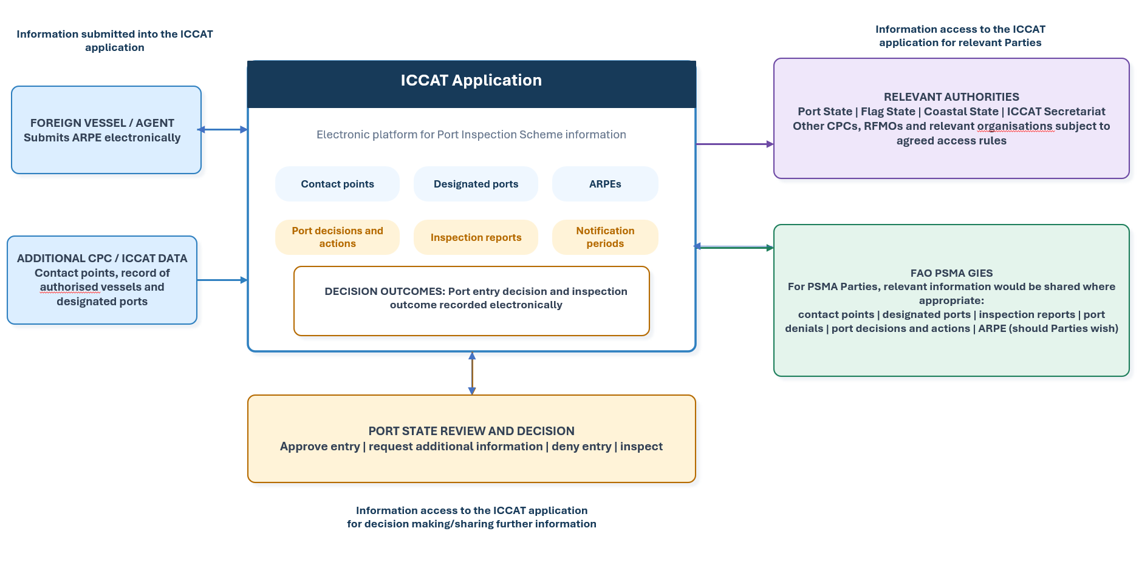Port Inspection Scheme forms which would be available electronically

- Form for reporting authorised ports, contact points and notification periods
- Advance Request for Port Entry (ARPE)
- ICCAT Port Inspection Report
- Authorization/Denial of port entry
- Request for additional information
- Denials of port use

