Original: English

Appendix 1

A summary of the ICCAT Regional Observer Programme 2025 Report
(submitted by ROP-Transhipment implementing consortium)

- Introduction

In 2006 ICCAT adopted Rec. 06-11, most recently updated by Rec. 24-15, to establish a Programme for Transhipment in response to concerns that at-sea transhipment operations constituted a gap in the enforcement scheme of the Commission. MRAG Ltd. and Capricorn Fisheries Monitoring cc (the Consortium) has been implementing the Regional Observer Program (ROP) since its inception in April 2007.

The ICCAT Regional Observer Programme (ROP) aims to address Member State concerns regarding laundering of Illegal, Unregulated and Unreported (IUU) tuna catches by monitoring transhipments at sea from large-scale pelagic longline fishing vessels (LSPLVs) operating in the Convention area. Rec. 24-15 states that all tuna, tuna like species and other species caught in association with these species in the Convention area must be transhipped in port. However, at sea transhipments can be authorised by Contracting Parties provided the Carrier Vessel (CV) has vessel monitoring system (VMS) capabilities and a trained ICCAT observer on board to monitor the process.

- Deployments

This report provides a summary of the ROP’s nineteenth year, covering transhipments that occurred between the 1 January 2025 and 31December 2025. This spanned transhipments across deployments 300/24 to 314/25. One deployment (309/25) was cancelled, deployment 301/24 started and ended in 2024, and deployment 313/25 started on 31/12/2025 and had no transhipments in 2025. The data from these deployments are not included in this report. The figures include all other deployments, vessel transhipments, fish transhipped, and PNCs reported over this time period.

2.1 Summary of deployments

A total of 279 at-sea transhipments took place across 12 trips; all were monitored accounting for 882 sea days with an average deployment length of 74 days. The total observed weight of fish transhipped over the period was 19,282.548 tonnes. A summary of key figures from all deployments is given in Table 1.

Of the 279 transhipments, 47.67% were from Chinese Taipei flagged vessels, 25.81% were from Japanese flagged vessels, 25.09% were from Chinese flagged vessels, and 1.43% were from Korean flagged vessels (Figure 1). The location of transhipments conducted by vessels under the ROP are displayed in Figure 2. Transhipments were mainly located in the central Atlantic along the equator, with many around the EEZ of Ascension Island, and distributed along the length of the west coast of Africa.

Table 1. Summary of deployments 300/24 – 314/25 and weight of fish transhipped in 2025.
No. | Vessel Name | Observer Name | On Date | Off Date | Port On | Port Off | Days | No. of T/S | Observed (tonnes) | Declared (tonnes)
300 | Harima | Levent Ali Erkal | 15-Nov-24 | 12-Jan-25 | Port Louis | IOTC Cross Over | 59 | 5 | 196.89 | 194.96
302 | Bao Win | Julio Ocon | 05-Dec-24 | 02-Apr-25 | Singapore | Cape Town | 119 | 25 | 2,029.58 | 1,972.60
303 | Yachiyo | Devon Clive Hunt | 21-Dec-24 | 26-Mar-25 | Cape Town | Singapore | 96 | 35 | 2,373.26 | 2,380.42
304 | Taisei Maru No.24 | Tony Dimitrov | 15-Dec-24 | 02-Feb-25 | Cape Town | IOTC Cross Over | 50 | 13 | 740.77 | 725.32
305 | Lady Tuna | Abdullah Gezimisoglu | 01-Feb-25 | 26-Mar-25 | Sarande | Singapore | 54 | 8 | 823.14 | 818.88
306 | Ibuki | Llewellyn Lewis | 18-Mar-25 | 08-Jun-25 | Cape Town | Singapore | 83 | 42 | 3,257.17 | 3,310.17
307 | Harima | Huseyin Batuhan Cagil | 18-May-25 | 30-Jun-25 | Cape Town | IOTC Cross Over | 44 | 33 | 2,501.49 | 2,498.27
308 | Taisei Maru No.24 | Peet Botes | 07-Jun-25 | 04-Jul-25 | Cape Town | Cape Town | 28 | 17 | 1,046.65 | 1,218.93
310 | Yachiyo | Marius Kapp | 05-Aug-25 | 11-Oct-25 | Cape Town | IOTC Cross Over | 68 | 47 | 3,195.69 | 3,202.90
311 | Harima | Abdullah Gezimisoglu | 23-Oct-25 | 04-Feb-26 | Cape Town | Cape Town | 105 | 24 | 1,051.38 | 1,056.78
312 | Chitose | Sami Yildiz | 24-Nov-25 | 11-Mar-26 | Cape Town | Cape Town | 108 | 21 | 1,477.60 | 1,466.61
314 | Taisei Maru No.24 | Johan Beets | 13-Dec-25 | 18-Feb-26 | Cape Town | Singapore | 68 | 9 | 588.93 | 587.78
*Some deployments started prior to or ended after 2025, however the figures shown here are only representative of transhipments that took place during this reporting period.
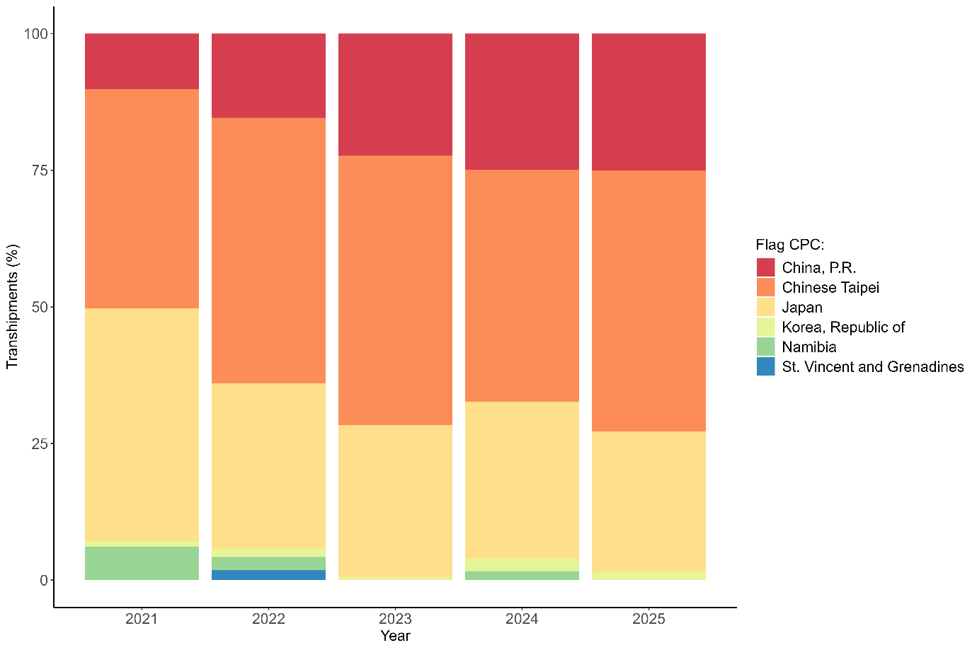

Figure 1. The percentage of transhipments during 2025 compared to the previous 4 years by LSPLV Flag.

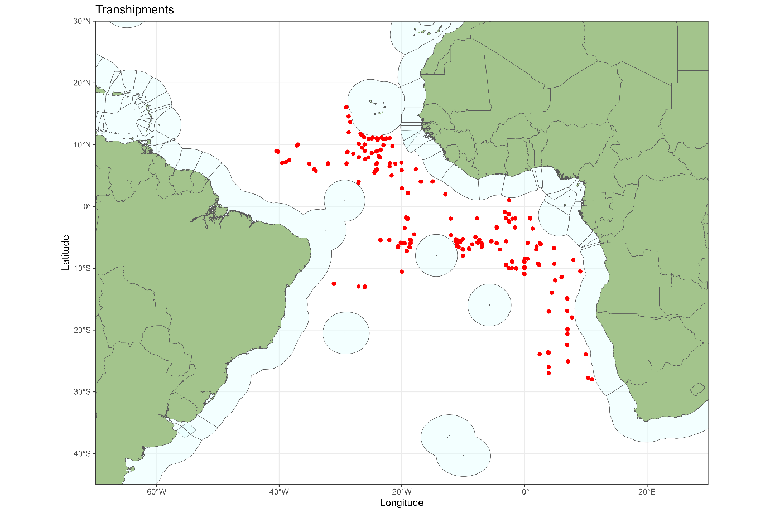

Figure 2. Locations of transhipments during 2025.

A summary of the number of ROP deployments by month for 2025 is shown in Figure 3. Figure 4 indicates the number of transhipments and the total weight transhipped each month. Figure 5, Figure 6 and Figure 7 show the duration of transhipments, the quantity of products transferred, and the rates of products transhipped per hour, respectively, and they remain similar to previous years. There was a series of incidents in deployment 302/24 in which it was reported that large quantities of floating sargassum were interfering with the CV’s freezer system, which resulted in several delays during transhipment as they waited for the sargassum to drift away. This accounts for most the transhipments over 20 hours in duration, as can be seen in Figure 5.

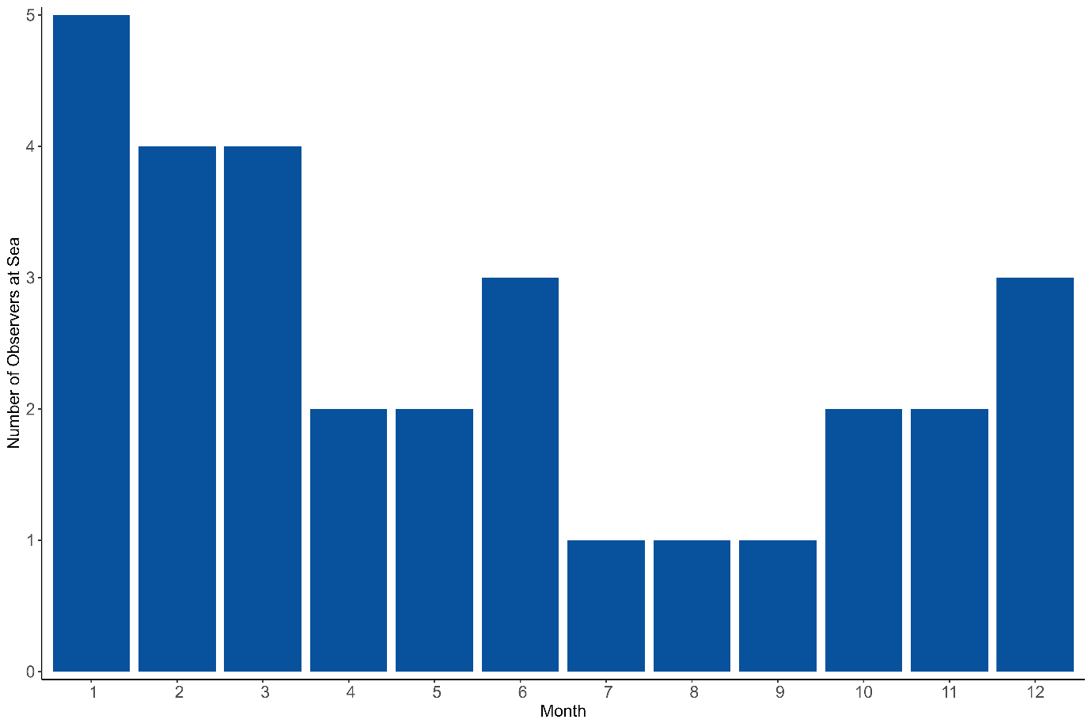
Figure 3. Number of observers at sea by month.
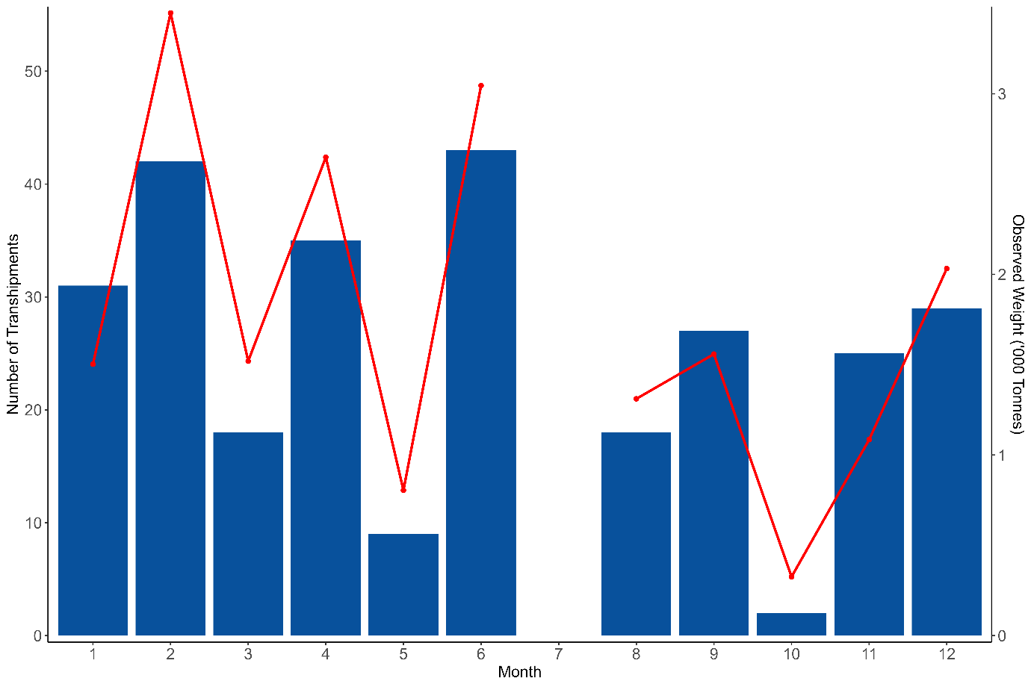
Figure 4. Number of transhipments and weights transferred (all fish, red line) by month.

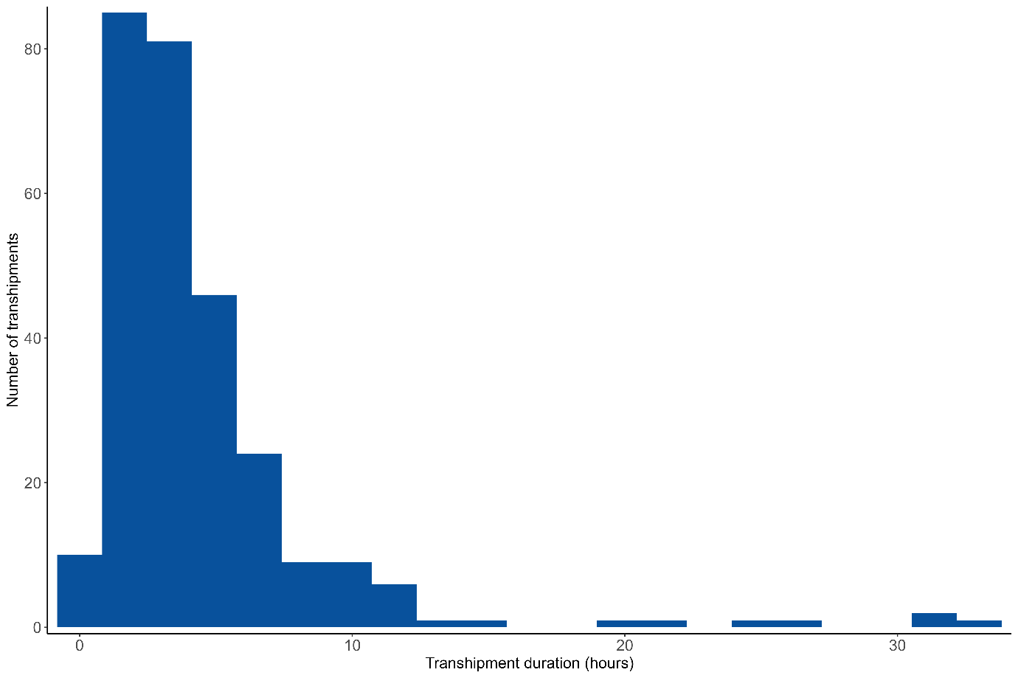

Figure 5. Duration of Transhipments (hours).
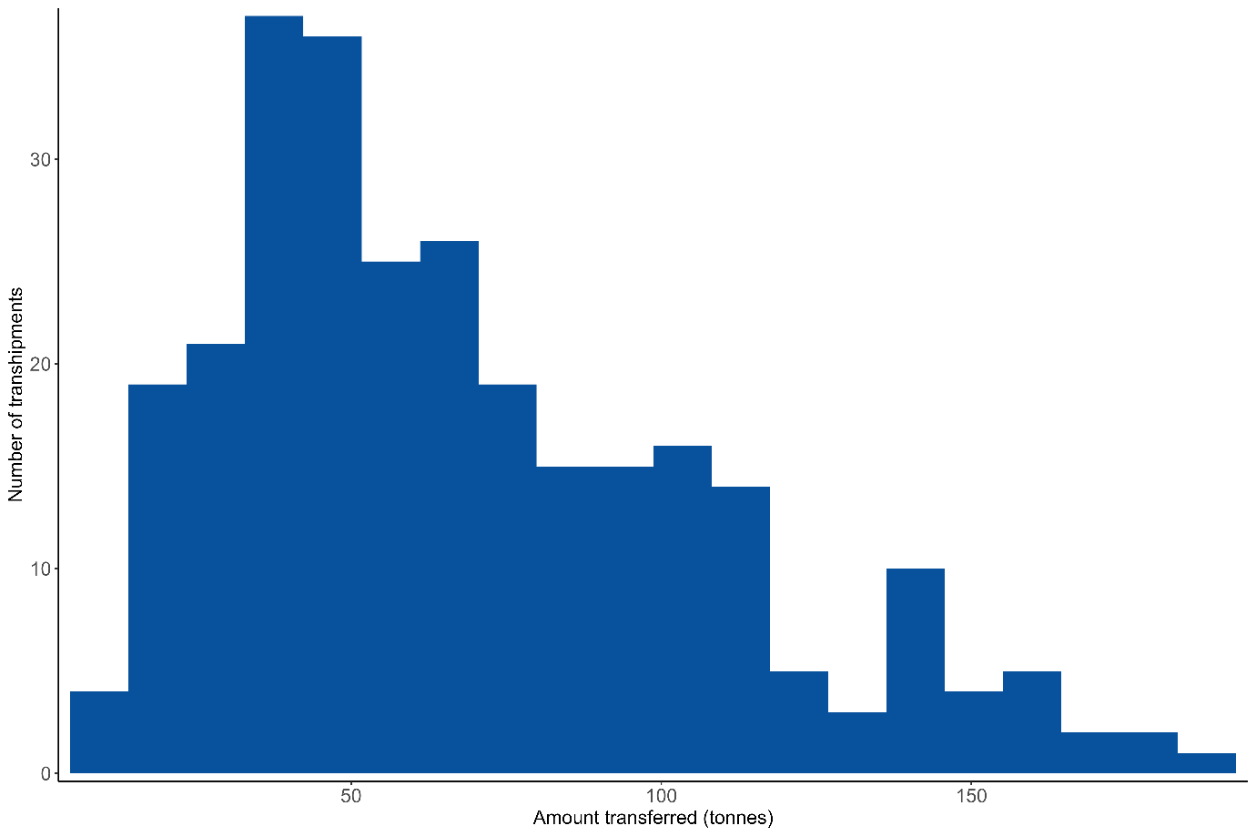

Figure 6. Quantities transferred per transhipment (tonnes).

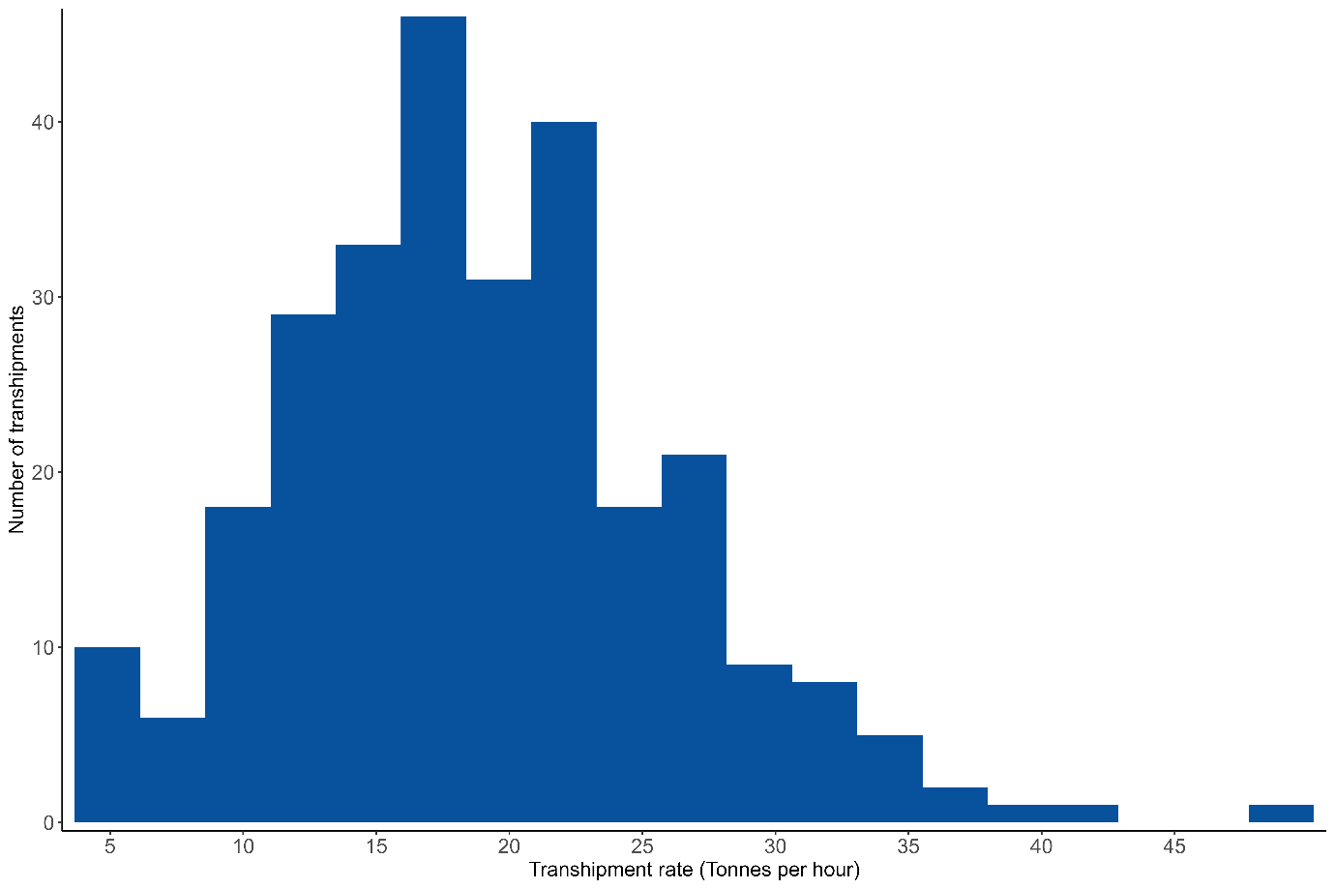

Figure 7. Rate of Products Transhipped.

  - Transhipments within EEZs

No transhipments were observed to be made within EEZs.

  - Procedures and logistics

The deployment request procedure has remained the same as previously described by the Consortium in annual reviews of the ICCAT ROP.

During the period covered by this report, four vessels crossed over from the Atlantic Ocean into the Indian Ocean on to an IOTC deployment without stopping at an Atlantic port first.

3. Species identification

The methods used by observers for species identification and reporting procedures have remained the same and are detailed in previous reports (Anon., 2011).

4. Southern bluefin tuna

Since the adoption of the Resolution on the Implementation of a CCSBT Catch Documentation Scheme on 1st January 2010, any southern bluefin tuna (Thunnus maccoyii) transferred must be accompanied by a catch monitoring form (CMF) which should be countersigned by the observer. During the period covered by this report southern bluefin tuna were transhipped on 8 occasions on 2 deployments, with a total of 748.114 tonnes observed (Table 2). Observers prepare a separate report for CCSBT on any trips where southern bluefin tuna are transhipped.

Table 2. Transhipments of southern bluefin tuna (Thunnus maccoyii) during 2025.
No. | CV | CV ICCAT No | T/S No | Date | Obs. Wt. (tonnes) | No. fish
307 | Harima | AT000SGP00007 | 1 | 23/05/2025 | 95.97 | 2,816
307 | Harima | AT000SGP00007 | 25 | 12/06/2025 | 94.83 | 2,782
307 | Harima | AT000SGP00007 | 32 | 23/06/2025 | 151.16 | 3,906
307 | Harima | AT000SGP00007 | 33 | 28/06/2025 | 72.38 | 1,814
308 | Taisei Maru No. 24 | AT000JPN00571 | 1 | 11/06/2025 | 73.80 | 2,241
308 | Taisei Maru No. 24 | AT000JPN00571 | 2 | 12/06/2025 | 78.16 | 2,425
308 | Taisei Maru No. 24 | AT000JPN00571 | 4 | 13/06/2025 | 96.92 | 2,928
308 | Taisei Maru No. 24 | AT000JPN00571 | 5 | 14/06/2025 | 84.89 | 2,477

5. In-Port Fish Transhipments

In 2022 ROP observers began monitoring offloading of the products from the CV at the end of each trip, where possible. As specified in Rec. 24-15, Appendix 2, Paragraph 6.2 i, observers must:

‘…observe and estimate quantities of product by species when offloaded in the port where the observer is disembarked to verify consistency with quantities received during at sea transhipment operations.’

The ROP consortium is still facing ongoing issues with the implementation of these requirements. All offloading events that occur mid-deployment are monitored; however, the consortium does not receive any information of offloading locations from the CV operators and currently observers are never disembarked in the landing port.

It may be possible to arrange for observers to remain on board the CV to monitor the final offload, however this would usually require observers to remain on board for an additional 3-4 weeks, which would incur additional costs to the programme.

No in-port offloading was monitored in 2025.

Observers have been monitoring transhipments in port between vessels. This is normally midway through the deployment; these are shown in Table 3.

Table 3. Transhipments occurring in port in 2025.
Port | Port State | Carrier Vessel Name | Carrier Vessel Flag | Number of Transhipments
San Vincent | Cape Verde | Taisei Maru No.24 | Japan | 18
Sao Vicente | Cape Verde | Yachiyo | Panama | 2

6. Weight estimation

The methodology used by observers for estimating transhipment weights remains the same as those previously described by the Consortium (Anon., 2011).

7. Observer Training

Currently there are around 50 active ICCAT ROP observers, although not all are available all the time due to other commitments. Due to natural turnover of personnel, it is important to maintain training on a regular basis. 6 observers were trained in 2025 (Table 4).

With prior agreement from ICCAT, IOTC and CCSBT, observers trained under any of the programmes are available to work under all three RFMOs. This reduces costs and ensures a high standard of data integrity. It also allows observers to remain on the vessel if it crosses between RFMO areas in order to save on deployment costs.

To reflect this arrangement, observers are issued with a unique observer number and identification card, which is valid for all three RFMOs.

Table 4. ROP transhipment training conducted in 2025.
Observer name | Training location
Barbara Safiro Alvarez Ereipa | Ankara, Türkiye
Ridvan Kaan Gurses | Ankara, Türkiye
Nicholas Idowu | Ankara, Türkiye
Koray Kabadayiogullari | Ankara, Türkiye
Athanasios Schoinas | Ankara, Türkiye
Esin Yalcin Kaplama | Ankara, Türkiye

8. Observer programme databases

The database continues to be updated as required and up to the end of 2025 contains data on 8,543 transhipments.

9. Potential Non-Compliances (PNCs)

Since 2012 ICCAT have required observers to board LSPLVs to carry out checks on vessels against various ICCAT Recommendations. Any potential non-compliances (PNCs) are then submitted to the Flag State by the observer through the Consortium. The Flag State then has the opportunity to respond. PNC codes and descriptions are summarised in Appendix 1.

Since the Recommendation came into force, 1057 PNCs have been reported by observers over 110 deployments, these are shown in Figure 8. It shows a steep decline in PNCs since 2014. Nine PNCs were issued during 2025 (Table 5), all of which were reported to the flag state at the time that the PNCs were issued, the flag States responded accordingly.

The Consortium faced repeated issues with inspecting a new VMS unit (ORBCOMM ST6100-SXX) during vessel boardings on a number of LSPLVs. This new unit does not have a power light on the control unit, meaning it is not possible for observers to confirm whether the unit is receiving power at the time of transhipment. Currently the consortium is contacting the flag CPC each time the LSPLVs using the new unit tranship, to receive confirmation that the unit was transmitting at the time of transhipment, however this is an inefficient and time-consuming process.

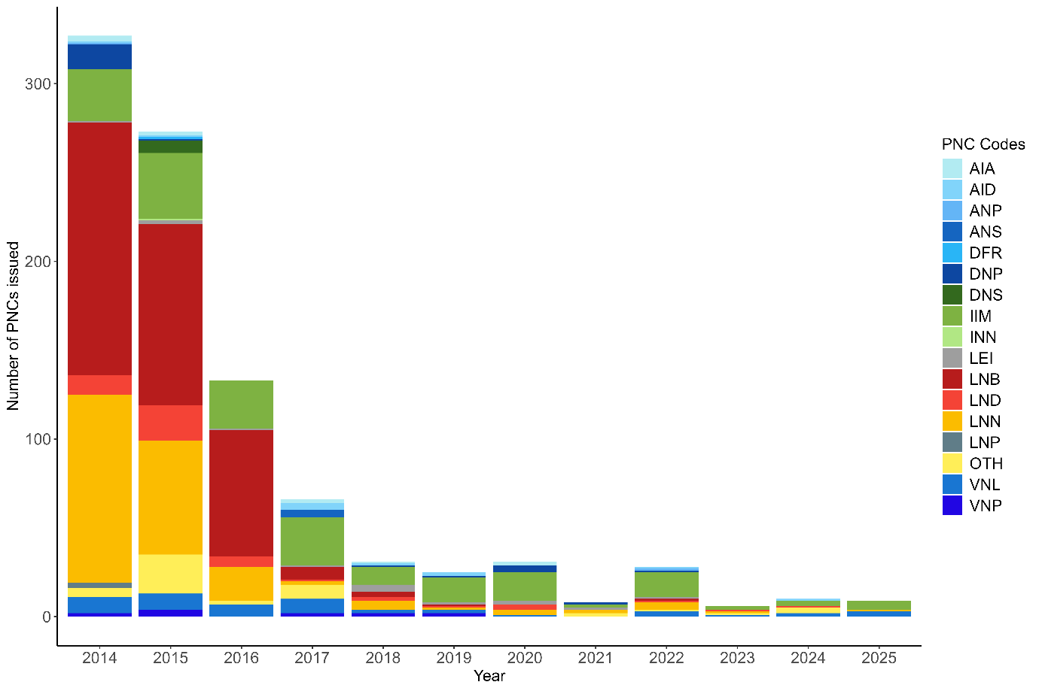
Figure 8. Number and proportion of PNCs issued since their introduction.

Table 5. PNCs issued in 2025.
Dep. No | T/S No. | CV Name | LSPLV Name | PNC Code
306 | 4 | Ibuki | KINEI MARU No.151 | LSPLV markings not displayed correctly
306 | 6 | Ibuki | YUH YEOU NO.668 | LSPLV markings not displayed correctly
306 | 17 | Ibuki | RYOAN MARU No. 15 | LSPLV markings not displayed correctly
306 | 21 | Ibuki | CHIYO MARU No. 28 | LSPLV markings not displayed correctly
306 | 39 | Ibuki | HUNG CHUAN NO.336 | Logbook sheets not numbered
307 | 6 | Harima | MAAN FWU NO.666 | LSPLV markings not displayed correctly
310 | 9 | Yachiyo | MAAN FWU NO.666 | No power light visible on the VMS unit
311 | 6 | Harima | MAAN FWU NO.666 | No power light visible on the VMS unit
311 | 21 | Harima | LU QING YUAN YU 199 | No power light visible on the VMS unit

10. Conclusions and Recommendations

As highlighted in Section 5, there has been no increase in the number of offloadings in port being monitored by ROP observers from last year.

The number of PNCs reported in 2025 (9) decreased from 2024 (10), although as there were less transhipments in 2025 than in 2024, the number of PNCs issued per transhipment has increased slightly. Overall, this continues the downwards trend in reported PNCs since the beginning of the programme which demonstrate the effectiveness of the vessel inspection programme at increasing compliance. The consortium would like to thank the CPCs for their timely response to all reported PNCs.

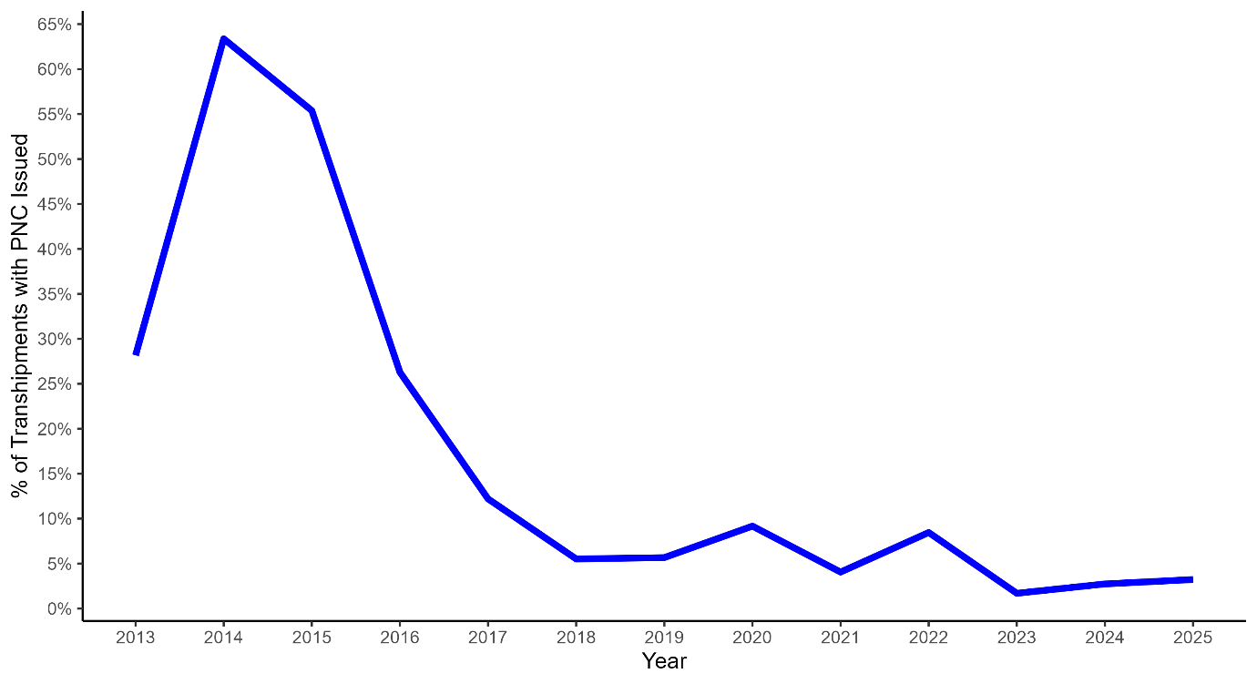

Figure 9. PNCs issued as a proportion of total transhipments by year.

Appendix 1

Potential non-compliance descriptions and codes
PNC Event | Code
General
Observer prevented from carrying out duties on board the LSPLV | GLV
Document / Verification
Transhipment Declaration not completed | DTD
Transhipment within EEZ without authorisation from coastal state | DEZ
Undocumented transhipments of fish received by the LSPLV | DFR
Prior authorisation to tranship not presented to the observer by the LSPLV | DNP
Prior authorisation to tranship not standard with Flag State | DNS
VMS
No VMS shown to the observer on board the LSPLV | VNP
No power light visible on the VMS unit | VNL
ATF
No Authorisation to fish presented to the observer by the LSPLV | ANP
Authorisation to fish not standard with Flag State | ANS
Authorisation to fish dates not valid | AID
Authorisation to fish not valid for ICCAT area | AIA
Logbook
No logbook presented to the observer by the LSPLV | LNP
Logbook entries incorrect | LEI
Logbook not bound | LNB
Logbook sheets not numbered | LNN
Logbook not up to date | LND
Identification
Vessel without an ICCAT number involved in transhipment operations | INN
LSPLV markings not displayed correctly | IIM
CCSBT
No CCSBT Catch document presented for SBT | CND
SBT not individually tagged | CNT
Other
Other event not elsewhere covered | OTH

