Original: English

Responses and recommendations from the SCRS relevant to Panel 2

The 2026 responses to the Commission and recommendations from the SCRS that are relevant to Panel 1 were compiled by the Secretariat directly from the 2026 SCRS Plenary meeting report (document PLE-104). The Recommendations with financial implications are not contained herein, as those are included in Appendix 2 of the ICCAT budget proposal (document STF-203).

Responses to the Commission

Northern Atlantic albacore

19.8 The SCRS shall assess the occurrence of exceptional circumstances (ECs) and the Commission shall act in accordance with the Exceptional Circumstances Protocol sets out in Annex 2, Rec. 21-04, para 4

Background: The SCRS shall assess the occurrence of exceptional circumstances (ECs) and the Commission shall act in accordance with the Exceptional Circumstances Protocol sets out in Annex 2.

According to the North Atlantic albacore Exceptional circumstances protocol in Rec. 21-04, indicators related to catch, CPUE, relative biomass and relative fishing mortality were revised.

Since the adoption of the MP, catches have been lower than the TAC in all years except in 2019, when it was exceeded by 3.5% (Figure 19.8.1).

Updated CPUE series fall within the 2.5-97.5 percentile of the normalized CPUE values used to run the closed-loop simulations in the MSE. The only exception is the 2018 value of the Spanish baitboat CPUE, which is slightly larger than the values used in the MSE (Figure 19.8.2).

The adopted MP was rerun in 2026. Relative stock biomass and fishing mortality of the re-run MP were compared against the 2.5 and 97.5 percentile range of values in any year from the 2.5 and 97.5 percentile range of values in any year produced by the accepted MP’s production model during MSE testing (Figures 19.8.3, 19.8.4). The estimates fall within the values (95% confidence interval (CI)) estimated in the MSE simulations.

In summary, the Committee concluded that no exceptional circumstance(s) were identified that preclude the application of the adopted MP to set the TAC for the period 2027-2029.

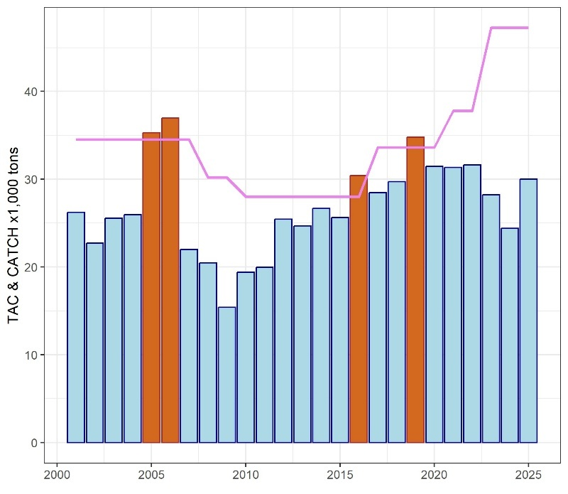

Figure 19.8.1 ALB-N reported catch (Task 1NC, bars) and TAC (solid line). Brown bars indicate years when the catch exceeded the TAC. Note that TAC established with the ALB-N harvest control rule or the MP started in 2018.

Figure 19.8.2 CPUE trajectories simulated in the MSE (boxplots) and standardized CPUEs (solid line) available in 2026.

Figure 19.8.3 Relative biomass (B/B_{MSY}) estimated in the MPs of the MSE (boxplot, boxes represent 50% CI and whiskers 95% CI) and estimates from the 2026 MP model (solid line).

Figure 19.8.4 Relative fishing mortality (F/F_{MSY}) estimated in the MPs of the MSE (boxplot, boxes represent 50% CI and whiskers 95% CI) and estimates from the 2026 MP model (solid line).

19.9 The SCRS shall continue the development of a new MSE framework to support the possible adoption of a new MP no later than 2026 and the setting of a TAC for the management period 2027-2030, Rec. 21-04, para 18

Background: The SCRS shall continue the development of a new MSE framework to support the possible adoption of a new MP by the Commission no later than 2026 and the setting of a TAC for the management period 2027-2030.

In this respect, the SCRS is also requested to explore the possibility of defining potential additional CPUE indices, to complement those reported in Appendix A of Annex 1, as well as to advise on how possible environmental changes will be taken into account in the development of this framework.

The adopted MP for northern albacore (Rec. 21-04) was re-run, this resulted in a 2027-2029 TAC of 50,000 t.

New MSE framework

The new Management Strategy Evaluation (MSE) framework builds on the 2023 benchmark stock assessment and subsequent methodological developments discussed by the SCRS. Technical details, including the operating models (OMs) and candidate management procedures (CMPs), are provided in Urtizberea et al. (SCRS/2026/190), together with the Trial Specification Document (TSD) and Shiny application (FLBEIA Shiny App).

Due to changes in the MSE framework the adopted MP had to be slightly revised. For clarity “updated-MP” is used to describe this updated version of the adopted MP in Rec. 21-04).

Testing under the new MSE framework indicates that the updated-MP is predicted to meet the management objectives of stock status and safety (Table 19.9.2, Figure 19.9.1). Robustness tests that simulated potential climate-change impacts, including reduced recruitment and increased recruitment variability, also showed satisfactory performance (Figure 19.9.2). In these scenarios, the updated-MP responded to substantial (20%) recruitment declines by reducing the TAC, thereby maintaining stock status and safety.

The new MSE was used to evaluate performance of seven CMPs, including variants of the updated-MP with an additional stability constraint (±10%) or a higher target fishing mortality (F_{MSY}), as well as empirical CMPs based on catch per unit effort (CPUE) ratio or a pseudo-constant catch approach (Table 19.9.1).

Table 19.9.1. Code and description of the seven CMP evaluated in 2026.
Code | Type | Description
25%_F0.8_B1 | Model-Based | Updated-MP: TAC from model-based HCR: F_tgt=0.8*F_{MSY}, B_thr=B_{MSY}. Maximum TAC increase of 25% and decrease of 20% between consecutive management periods. TAC cannot exceed 50,000 t
10%_F0.8_B1 | Model-Based | TAC from model-based HCR: F_tgt=0.8*F_{MSY}, B_thr=B_{MSY}. Maximum TAC change of 10% between consecutive management periods. TAC cannot exceed 50,000 t
25%_F1_B1 | Model-Based | TAC from model-based HCR: F_tgt=F_{MSY}, B_thr=B_{MSY}. Maximum TAC increase of 25% and decrease of 20% between consecutive management periods. TAC cannot exceed 50,000 t
10%_F1_B1 | Model-Based | TAC from model-based HCR: F_tgt=F_{MSY}, B_thr=B_{MSY}. Maximum TAC change of 10% between consecutive management periods. TAC cannot exceed 50,000 t
15%_PCCatch | Empirical | TAC is constant (42,000 t) if combined index above reference value. Maximum TAC change of 15% between consecutive management periods TAC cannot exceed 42,000 t
10%_Emp_W | Empirical | TAC from empirical HCR (combined index ratio). Maximum TAC change of 10% between consecutive management periods. TAC cannot exceed 50,000 t
25%_Emp_W | Empirical | TAC from empirical HCR (combined index ratio). Maximum TAC increase of 25% and decrease of 20% between consecutive management periods. TAC cannot exceed 50,000 t

All seven CMPs are predicted to meet the current management objectives (Figure 19.9.1), indicating scope to select an alternative CMP based on performance indicators for stock status, safety, yield and stability. Table 19.9.2 summarizes these trade-offs, with further detailed results available in the Shiny application (FLBEIA Shiny App). Figure 19.9.2 shows predicted trends of stock status under a 20% recruitment reduction scenario (Robustness scenario).

Table 19.9.2. Performance of the 7 CMPs evaluated in 2026 under the reference set of OMs. Indicators include PGK (probability of being in the green quadrant of the Kobe plot over 30 years), PB_{lim} (probability of being above the adopted Limit Reference Point (40% B_{MSY}), Tsrt (mean TAC in years 1-3), Tmed (mean TAC in years 5-10), Tlon (mean TAC in years 15-30) and Tc (mean absolute proportional change (%) in TAC). TAC1 is the TAC derived from the application of each CMP for 2027-2029. Values correspond to the mean over OM iterations across projection years (2027-2057).
CMP | PGK | PBlim | Tstr | Tmed | Tlon | Tc | TAC1
25%_F0.8_B1 | 0.97 | 1 | 48,455 | 43,019 | 38,092 | 7 | 50,000
10%_F0.8_B1 | 0.96 | 1 | 48,695 | 44,202 | 37,671 | 6 | 50,000
25%_F1_B1 | 0.86 | 1 | 49,838 | 47,471 | 39,924 | 9 | 50,000
10%_F1_B1 | 0.84 | 1 | 49,853 | 47,994 | 39,651 | 6 | 50,000
15%_PCCatch | 1 | 1 | 42,000 | 42,000 | 41,536 | 1 | 42,000
10%_Emp_W | 0.96 | 1 | 49,594 | 43,168 | 39,370 | 7 | 46,306
25%_Emp_W | 0.98 | 1 | 49,582 | 39,600 | 37,289 | 11 | 46,306

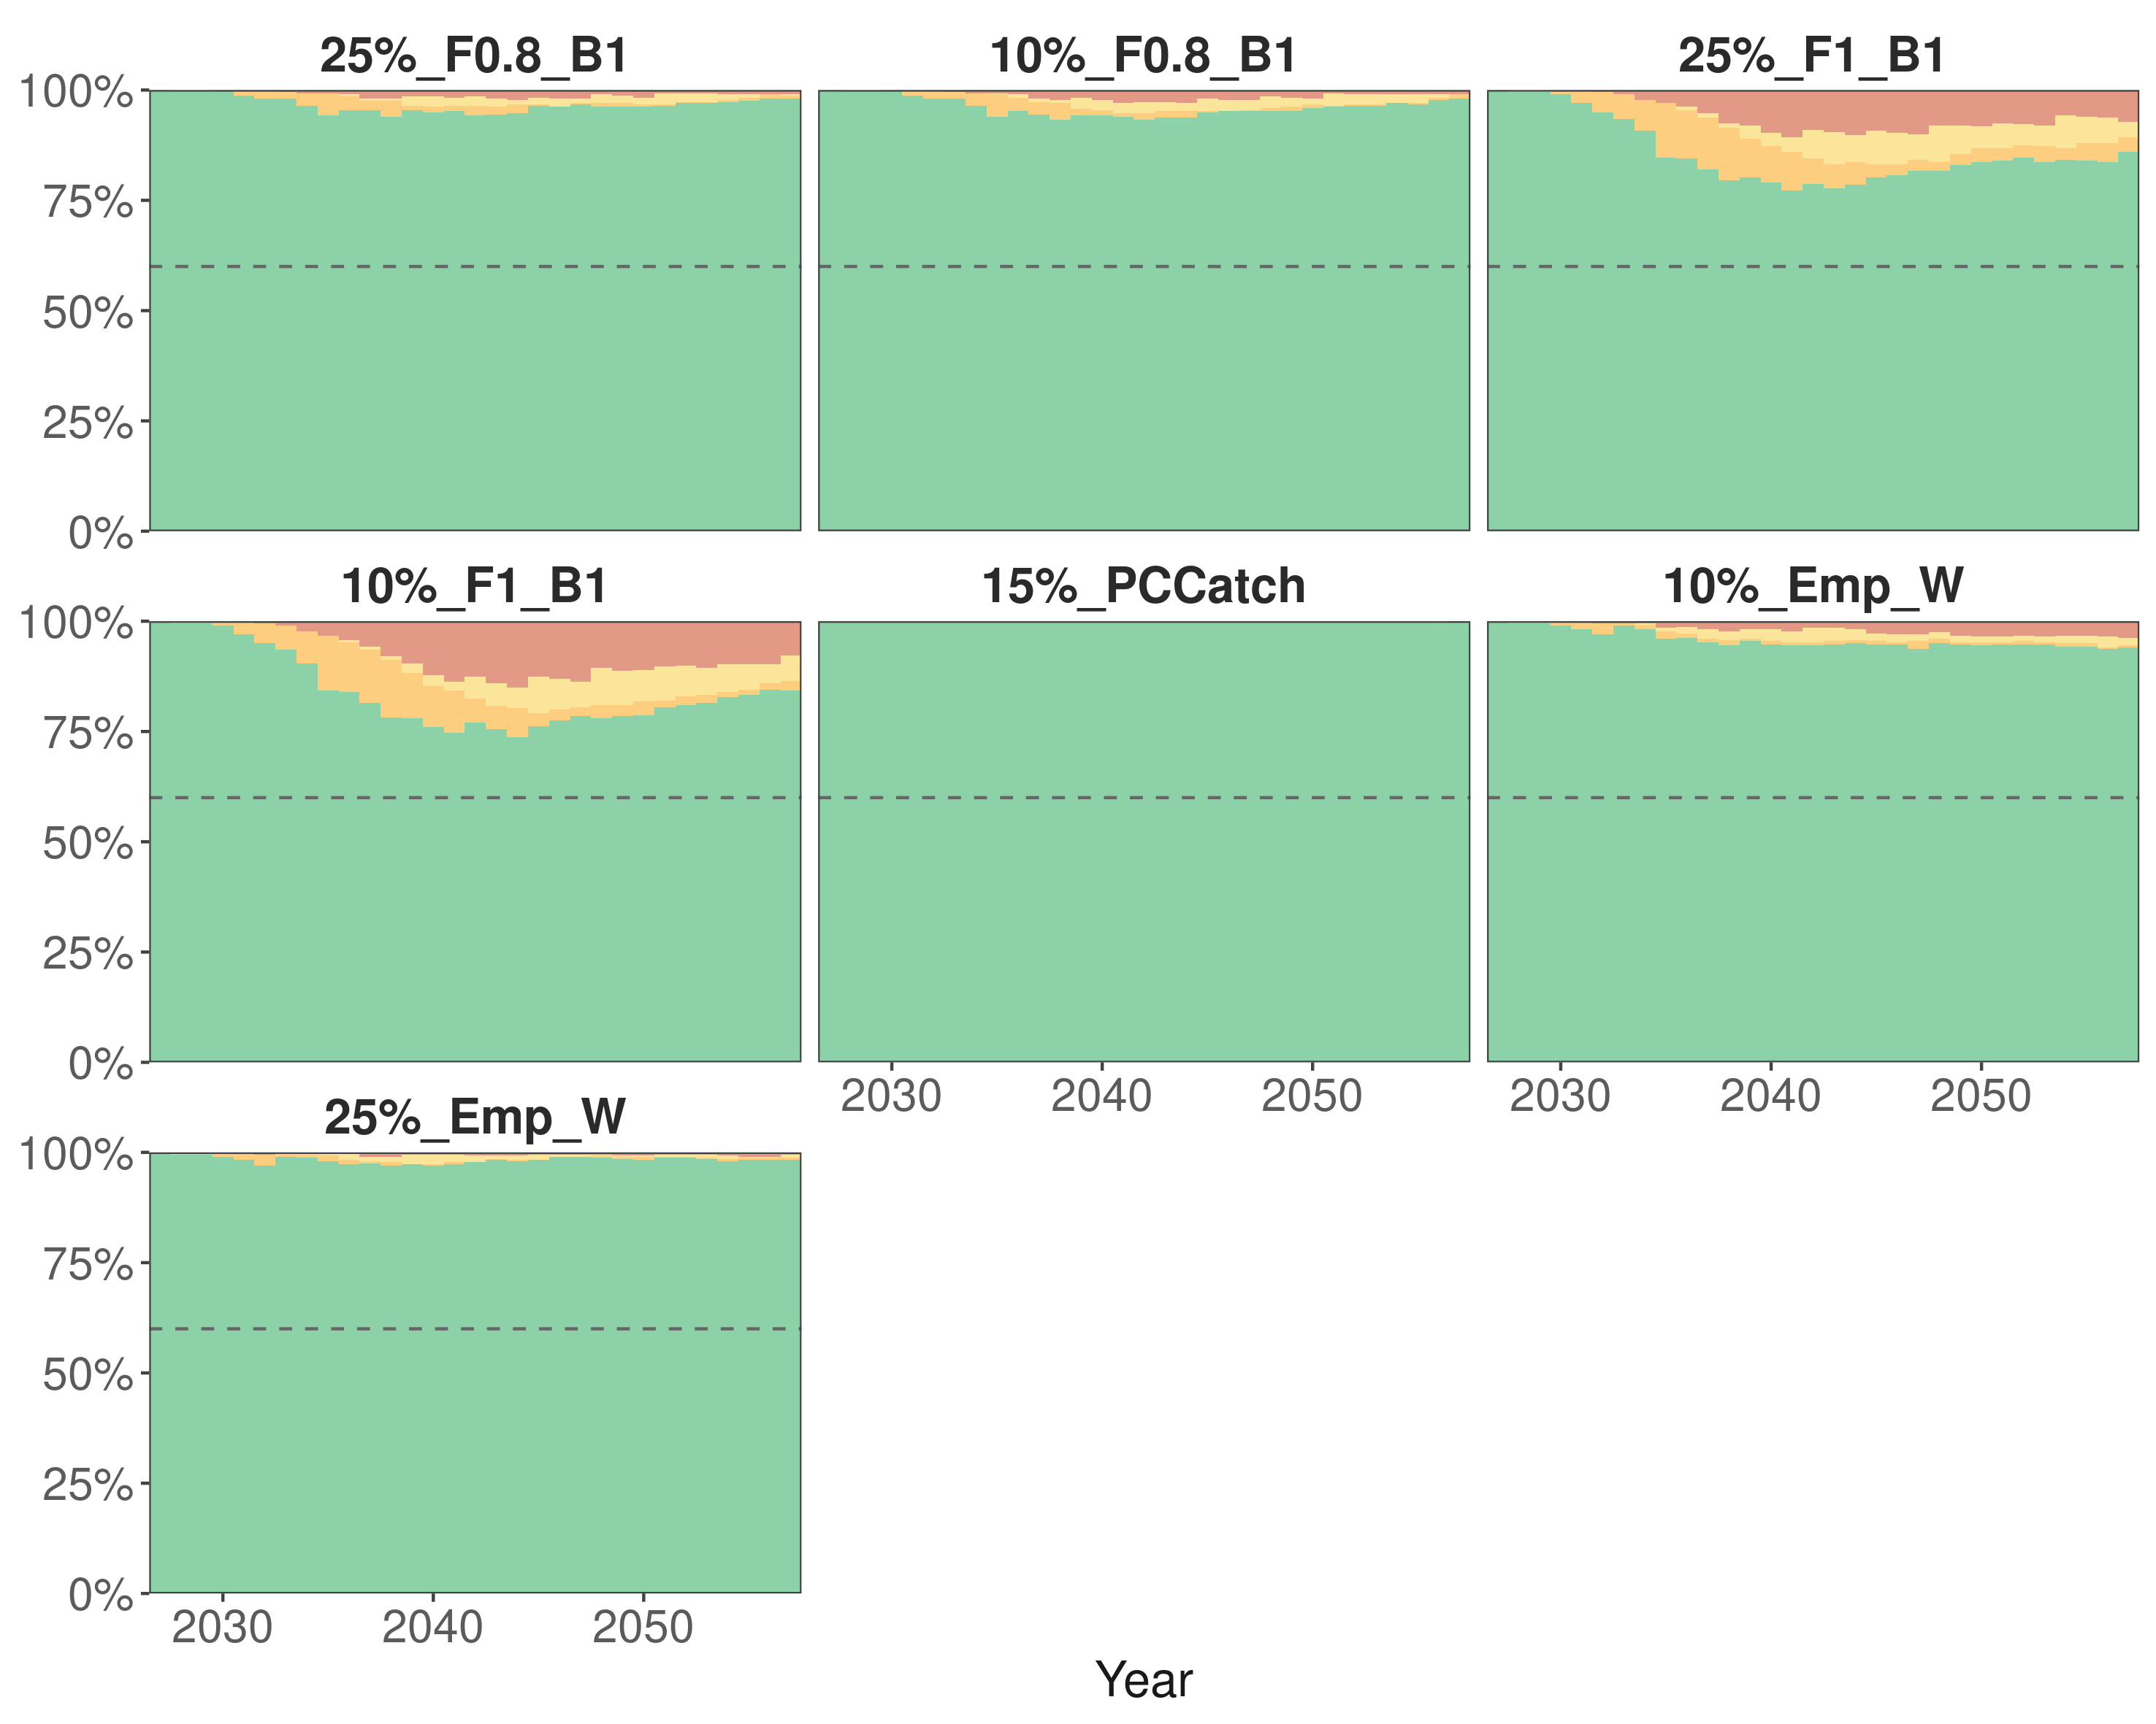
Figure 19.9.1. Time series of the estimated status of North Atlantic albacore under the seven CMPs evaluated in 2026 under the new MSE framework (reference set of operating models). For each year, colours indicate the probability of being in each of the Kobe quadrants. The dotted line indicates the 60% probability of being in the green quadrant of the Kobe Plot.

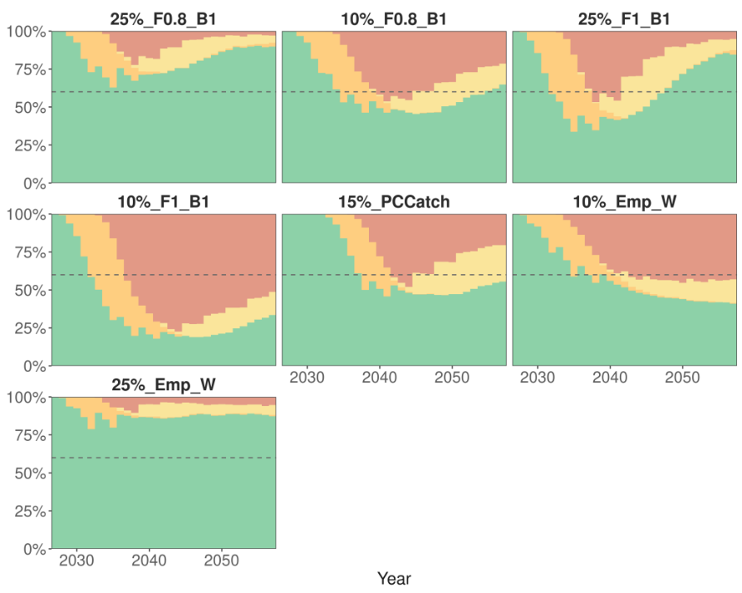

Figure 19.9.2. Time series of the estimated status of North Atlantic albacore under the seven CMPs evaluated in 2026 under the new MSE framework (robustness test in a scenario with a 20% reduction in recruitment due to climate change). For each year, colours indicate the probability of being in each of the Kobe quadrants. The dotted line indicates the 60% probability of being in the green quadrant of the Kobe Plot.

If the updated-MP, or a modified version of it, is selected, the group recommends updating the MP technical specifications in Appendix A of Annex 1 to Rec. 21-04 to reflect recent developments in production model software (Table 19.9.3) and the CPUE indices used in the latest benchmark assessment (Table 19.9.4) the proposed specifications are as follows:

Table 19.9.3. Specifications of the biomass dynamic model where “t” is the year of the Management Procedure iteration for the establishment of the TAC for the years t+1, t+2 and t+3.
Software | Model | Catch series
SPiCT | Surplus production model | Start in 1930  Final year: t-1

Table 19.9.4. CPUE indices and their starting years, where “t” is the year of the MP iteration for the establishment of the TAC for the years t+1, t+2 and t+3.
Index | First year | Final year
Venezuelan LL | 1991 | 2017
US LL North | 1987 | t-1
US LL South | 1987 | t-1
Chinese Taipei LL late North | 1999 | t-1
Chinese Taipei LL late South | 1999 | t-1
Japan LL late North | 1988 | 2009
Japan LL late South | 1988 | t-1
EU-Spain baitboat | 1981 | t-1

Mediterranean albacore

19.10 In 2026, or in any subsequent year identified by the SCRS in 2025 due to data limitations that prevent it from proceeding with its work, the SCRS shall provide an updated assessment of the state of the stock on the basis of the most recent data available, Rec. 24-08, para 11

Background: In 2026, or in any subsequent year identified by the SCRS in 2025 due to data limitations that prevent it from proceeding with its work, the SCRS shall provide an updated assessment of the state of the stock on the basis of the most recent data available. It shall assess the effectiveness of this rebuilding plan and provide advice on possible amendments to the various measures within this plan. The SCRS shall advise the Commission on the appropriate characteristics of the fishing gear, the closure period in paragraph 9, as well as the minimum size to be implemented for Mediterranean albacore.

The Committee recalled that the last stock assessment for Mediterranean albacore was conducted in 2024 using data up to 2022, and that despite recent progress made regarding catch data and the treatment of the larval index, major uncertainties (historical catches, life-history traits of the species) remain and continue to preclude a robust new assessment. It therefore advised that the next full assessment not be scheduled before 2028 and when these major uncertainties are addressed.

As stated in its 2024 response to the Commission (section 19.8 of the Report for Biennial Period 2024-2025, Part I (2024), Vol. 2), the Committee considered that changes to fishing gear would provide little benefit, as most catches are above the size at first maturity, and noted that the fall-winter closures adopted in 2022 may be contributing to reduced fishing effort, though their effect cannot yet be quantified. On minimum size, the Committee reiterated that such a measure would be of limited or no benefit given the current catch composition and resulted in potentially high discard mortality. The effectiveness of the rebuilding plan can optimally be evaluated through a full assessment of the stock.

Recommendations

Mediterranean Albacore

- In order to facilitate better management advice of the Mediterranean stock, the research programme should focus on key points:

- Improvement of fishery statistics through data recovery, an integrated growth analysis, improvement of r and K priors, development of a joint longline catch per unit effort (CPUE), and environmental effects.

- Given the success of the initiative to establish the Mediterranean Albacore Research Network, it is recommended that the necessary steps be taken to consolidate it, with the aim of defining research priorities and needs and identifying potential synergies to enhance the group’s capacity to respond to the Commission.

Bluefin tuna

- To support an AI-driven process for the collection and storage of length measurements at the first transfer of bluefin tuna (“Draft amendment of Recommendation 25-04” [IMM_03/i2026]), the SCRS recommends that the Commission considers establishing a technical Group that would include the SCRS and other relevant Commission bodies (PWG) with the aim to developing the technical criteria and specifications required under Rec. 25-04 paragraph 173 for the evaluation of AI-based systems at first transfer/caging.

- Acknowledging that important Task 2 size data (ST-04) from the Mediterranean purse seine have not been reported on time, the Committee reiterates the need for CPCs to comply with the data submission obligations adopted by the Commission. The Committee also acknowledged that some, but not all, CPCs have submitted their size data obtained in farm events (ST-06) and encouraged them to continue working with the Secretariat with the aim to ensure that these data are provided timely for the stock assessments.

