Original: English

Responses and recommendations from the SCRS relevant to Panel 1

The 2026 responses to the Commission and recommendations from the SCRS that are relevant to Panel 1 were compiled by the Secretariat directly from the 2026 SCRS Plenary meeting report (document PLE-104). The Recommendations with financial implications are not contained herein, as those are included in Appendix 2 of the ICCAT budget proposal (document STF-203).

Responses to the Commission

19.34 Maximum proportion of support vessels, Rec. 24-01, para 27

Background: Any CPC having vessels that operate, part-time or full-time, in support of purse seiners shall report the names and characteristics of all of their vessels to the ICCAT Secretariat, including which of those vessels were active in 2019 in the ICCAT Convention area, and the names of the purse seiner(s) that received the support of each support vessel. The ICCAT Secretariat shall compile this information and prepare a report for the Commission to be able to consider the type of limitation that support vessels shall be subject to in the future, including a phasing-out plan, where required. Notwithstanding this, CPCs shall not increase the number of support vessels from the number active in 2019; this does not apply to the new participants in purse seine fisheries, for which a maximum proportion of support vessels can be defined in 2025 based on an SCRS recommendation.

Appendix 5 of the Secretariat Report on Statistics and Research (PLE-SCRS_07/2026) provides a summary of the reported list of support vessels submitted by CPCs (ST07 form) from 2010 to 2025 (see Table 19.34.1 below). However, as indicated in previous responses, the Committee cannot correlate the activity of a given support vessel with the catch, effort or overall catch rates of the vessels receiving the support activities, as no link on total catch or effort (Task 2 CE ETRO) by vessel is provided by CPCs. Therefore, the Committee is not in a position to recommend a given number of support vessels or a proxy for an estimation of “limited support activity”. The Committee noted that the number of support vessels reported by CPC has decreased in recent years.

The Committee request that the Commission provide a clearer and more precise definition of the type of analysis being required.

Table 19.34.1 – Number of support vessels and total fishing vessels supported by them as reported by Flag CPC (form ST07) during the reporting period (Appendix 5 of Secretariat Report on Statistics and Research (PLE-SCRS_07/2026).
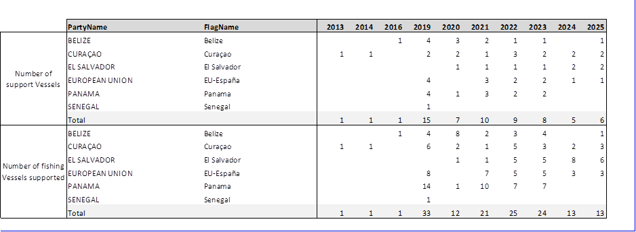

19.35 The SCRS shall conduct further analysis on the effect of support vessels on the catches of juvenile yellowfin and bigeye tuna, Rec. 24-01 para 36 (doc. TRO-10)

Background: Further analysis shall be conducted by the SCRS on the effect of support vessels on the catches of juvenile yellowfin and bigeye tuna to be considered in 2025.

The Committee cannot correlate the activity of a given support vessel with the catch, effort or overall catch rates of the vessels receiving the support activities, as no link on total catch or effort (Task 2 CE ETRO) by vessel is provided by CPCs. Therefore, the Committee is not in a position to analyze the effect of support vessels on catches of juvenile yellowfin and bigeye tunas.

19.36 In 2025 SCRS shall review the information reported by CPCs and shall provide recommendations on additional drifting FAD management options, including recommendations on improved drifting FAD designs, Rec. 24-01 para 51

Background: The SCRS and the IMM Working Group shall review the information reported by CPCs and shall, as necessary, provide recommendations on additional drifting FAD management options for consideration by the Commission, including recommendations on improved drifting FAD designs.

No new information was presented to the Committee in 2026, and the IMM Working Group made no specific recommendations. The Commission should be aware that there are continued industry-lead initiatives to adapt designs to the requirements set in Rec. 24-01. The Committee was informed of some difficulties in implementing the guidelines, therefore it continued suggesting that a dedicated science-industry workshop could be useful at some point to share experiences and seek synergies.

19.37 The SCRS shall refine the MSE process in line with the roadmap adopted by the Commission, Rec. 24-01, para 75

Background: The SCRS shall refine the MSE process in line with the roadmap adopted by the Commission. Based on input from Panel 1 on interim operational management objectives starting in 2025 in the Resolution by ICCAT on interim operational management objectives for Atlantic bigeye tuna, yellowfin tuna, and the eastern stock of skipjack tuna (Res. 24-02), the SCRS should continue testing the candidate management procedures. In 2026 or as soon as possible thereafter, the Commission shall review the candidate management procedures, including pre-agreed management actions to be taken under various stock conditions. These shall take into account the differential impacts of fishing operations (e.g. purse seine, longline and baitboat) on juvenile mortality and the yield at MSY, as well as other impacts of these fisheries, including impacts on bycatch, ecosystem impacts and socio-economic impacts.

Western Atlantic skipjack tuna MSE

The development of the Western Atlantic skipjack MSE proceeded entirely according to the SCRS Roadmap, requiring no rescheduling of stages or revision of the originally agreed timeline. The MSE was concluded in 2025 with the adoption of the MP at the Commission's annual meeting and the setting of the TAC for the 2026-2028 triennium. Consequently, the process transitioned from the development phase to the operational phase of the decision rule.

The subsequent stages were, therefore, operational in nature. In 2026, the SCRS was tasked with developing the special monitoring criteria to support the ECP, scheduled for adoption by the Commission at that year's annual meeting, and conducting the annual monitoring verification. The next major milestone occurs in 2028, when the MP is triggered to generate the TAC for the 2029-2031 period, for adoption by the Commission at that year's annual meeting. The review of the MP and the next stock status check remained scheduled for 2031, marking the completion of the first full cycle of the decision rule's application.

Tropical tunas multi-stock MSE

The workplan for the tropical tuna Multi-Stocks MSE process has been revised following the Committee’s recognition that several key elements of the MSE framework require further development before candidate management procedures (CMPs) can be submitted for consideration by the Commission. A central component of this work is the updated stock assessment for eastern Atlantic skipjack tuna (E-SKJ), the results of which are required to recondition the operating models (OMs) for this stock. Without this update, E-SKJ could not be represented within the joint framework on an appropriate analytical basis, and the technical interactions among the three stocks, including the potential effects associated with a limiting or choke species, would remain insufficiently characterized. As a result, the Committee now anticipates the completion of the technical work of multi-stock MSE not earlier than 2028, instead of 2027 as previously reported (Panel 1 intersessional meeting, 5-7 May 2026).

The revised approach is intended to maintain momentum in the overall process by allowing the development and evaluation of CMPs for yellowfin tuna (YFT) and bigeye tuna (BET) to proceed independently and in parallel while the E-SKJ OMs are being reconditioned. Accordingly, in 2027, the Committee will focus on refining the MSE framework and evaluating CMPs for BET and YFT, incorporating guidance provided by the SCRS Plenary and Panel 1 (including comparing CMP results using methods which either resample historic indices or use fixed historic indices). At the same time, the SKJ-E OMs will be reconditioned using the results of the updated stock assessment, while development of the Multi-Stocks framework will continue using BET and YFT CMPs to illustrate the consequences of technical interactions and the potential choke-species effect. By separating those components that can progress immediately from those that depend on an updated analytical basis, this approach facilitates continued development and understanding of the Multi-Stocks MSE without delaying progress on the remaining components.

In 2028, Management Procedures for BET, YFT, and E-SKJ will be evaluated individually and within the Multi-Stocks MSE framework. This work will be accompanied by the standardization and updating of the abundance indices required for CMP implementation, including the joint PLL, BAI, and PSFAD indices. The objective is to support consideration of MP adoption at the 2028 annual meeting, together with the corresponding TACs for the 2029-2031 management period. This would be preceded by an intersessional meeting of Panel 1 to provide guidance on CMP design, as well as an Ambassadors' meeting. The Committee will also conduct peer review of the Multi-Stock MSE framework in 2028.

In 2029, the Committee would develop and evaluate the exceptional circumstances criteria, followed by consideration of the Exceptional Circumstances Protocol (ECP) for possible adoption by the Commission at its annual meeting.

These revisions are accompanied by a deliberate strengthening of the communication and stakeholder-engagement components of the MSE process. This includes the continued development of graphical outputs and the Shiny application as tools for exploring and communicating MSE results, together with more intensive interaction with Panel 1 through intersessional meetings and Ambassadors' webinars. These are intended to communicate progress, planned activities, and preliminary results from both the single-stock and Multi-Stocks MSEs, while also providing opportunities for Panel 1 to guide the subsequent development of the process. Such engagement is particularly important given the nature of the management decisions involved. Demonstrating trade-offs among stock-specific yields within a framework that explicitly represents technical interactions requires prior agreement on operational management objectives.

19.38 SCRS shall explore the efficacy that full fishery closures might have to reduce the catches of tropical tunas to the agreed levels, Rec. 24-01, para 79a

Background:

- The SCRS shall explore the efficacy that full fishery closures along the lines of those proposed in PA1-505A/2019 might have to reduce the catches of tropical tunas to the agreed levels; and the potential of such scheme to reduce the catches of juvenile bigeye and yellowfin tunas, in line with recommendations from the SCRS.

SCRS/2026/185 updated the 2024 study (SCRS/2024/135) using the latest stock assessment models for bigeye, yellowfin, and eastern skipjack. Consistent with the earlier study, they concluded that a closure’s effectiveness could be jeopardized if catches are redistributed. The study also conducted an exploratory analysis of recent trends (2018–2024) in FAD fishery catch and effort using Task 2 data from the ICCAT database. FAD fishing effort, measured by the number of sets, decreased in the first quarter but remained relatively stable annually throughout the period analysed (Figure 19.38.1). Likewise, first-quarter catches declined for all three tropical tuna stocks during the period in which recent closures were implemented (Figure 19.38.2). However, trends in annual catches differed among stocks: annual catches declined notably for bigeye, which was subject to catch limits after 2020 but remained relatively stable for yellowfin and skipjack. These trends indicate that closures may have redistributed fishing effort among quarters rather than reducing annual effort. However, the effect of the closures on catches is not conclusive and the Committee recommends further analysis of catch and effort data to continue exploring the overall effectiveness of the closure.

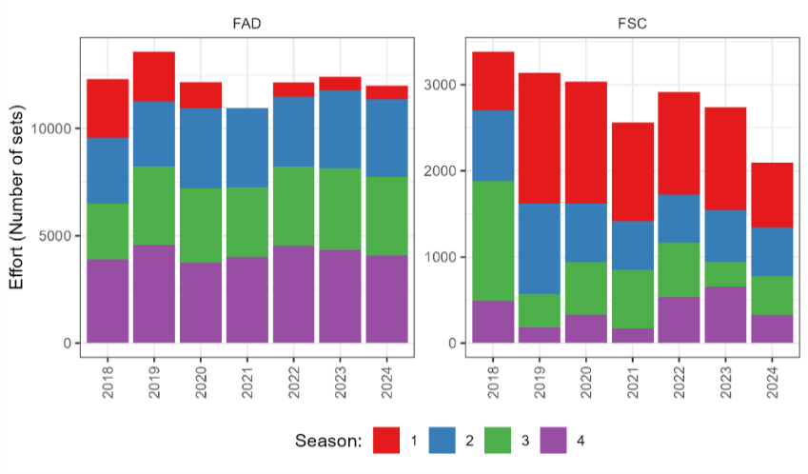
Figure 19.38.1 Recent trends in effort per season for the purse seine fishery operating on free schools (PSFS) and floating objects (PSLS).
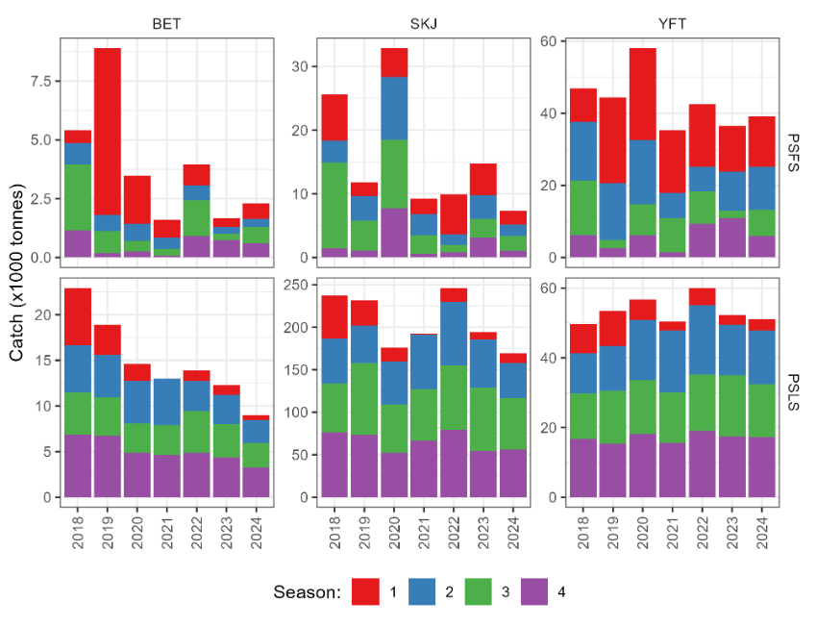
Figure 19.38.2 Recent trends in catch per season for the purse seine fishery operating on free schools (PSFS) and floating objects (PSLS) for each stock.

19.39 The SCRS shall estimate the capacity in the Convention area, to include at least all the fishing units that are large-scale or operate outside the EEZ of the CPC they are registered in, Rec. 24-01, para 79b

Background:

b) The ICCAT Secretariat shall work with the SCRS in preparing an estimate of capacity in the Convention area, to include at least all the fishing units that are large-scale or operate outside the EEZ of the CPC they are registered in. All CPCs shall cooperate with this work, providing estimates of the number of fishing units fishing for tuna and tuna-like species under their flag, and the species or species groups each fishing unit targets (e.g. tropical tunas, temperate tunas, swordfish, other billfish, small tunas, sharks, etc.). This work shall be presented to the next meeting of the SCRS in 2025 and forwarded to the Commission for consideration.

The Committee provided an initial response to this request in 2025, focusing on fishing activity during 2024. This year, Restrepo et al., 2026 (SCRS/2026/150) presented an updated estimation of the fishing capacity for tropical tunas in the ICCAT Convention area during the year 2025, focusing again on large-scale vessels (20 meters or larger in length overall) targeting tropical tunas using data primarily submitted via form ST01-T1FC. That study also used automatic identification system (AIS) data to infer fishing activity in the Atlantic Ocean, which is seen as complementary to CPC reports. The Committee prepared this updated response based on that document. It needs to be noted, however, that several CPCs expressed disagreement with the values related to their flagged vessels which form the basis of the analysis.

The Committee compared these estimates of vessel numbers and GT for vessels probably active in 2025, against those obtained last year for vessels probably active in 2024 (Table 19.39.1). The apparent 39% increase in the number of vessels and 22% increase in GT between 2024 and 2025 are not necessarily indicative of actual increases. There may have been more complete reporting of ST01 in 2025. Also importantly, AIS data was not used in last year's work to detect or confirm vessel activity in the ICCAT area, whereas AIS was used this year to complement ST01 reports in estimating the number of active vessels.

Table 19.39.1 Comparison of the estimates of active vessels and associated GT in 2024 and 2025 for vessels ≥20 m. The 2025 values are from this response, and the 2024 values are from the 2025 SCRS Annual Report.

 | 2024 |  | 2025
Gear | Vessels | GT | Vessels | GT
BB | 26 | 4721 | 191 | 39514
HL | 39 | 8387 | 3 | 232
LL | 342 | 115557 | 370 | 121393
PS | 54 | 74594 | 64 | 84647
RR | - | - | 6 | 837
UN | 22 | 2612 | 37 | 4779
Total | 483 | 205871 | 671 | 251401

The Committee concluded that, while VMS remains the most reliable and accurate source of positioning information for fishing vessels, AIS data could be a complement in support of CPCs efforts in tracking and studying vessel activity.

The Committee concluded that, where CPC reports on vessel activity are absent, AIS can be useful to identify fishing vessel activity at sea. However, there are potential limitations of AIS (e.g. not tamper-proof, manual data entry, etc.) that require careful consideration in its use.

19.40 The SCRS will advise on final LRPs for Atlantic bigeye tuna, yellowfin tuna and the eastern stock of skipjack tunas, Res. 24-02 para 2

Background: When assessing stock status and providing management recommendations to the Commission, the SCRS shall consider the interim limit reference point (LRP) of 0.4*B_{MSY} for Atlantic bigeye tuna, yellowfin tuna, and the eastern stock of skipjack tuna. The SCRS will advise on final LRPs for Atlantic bigeye tuna, yellowfin tuna, and the eastern stock of skipjack tunas.

The multi-stock MSE is built upon the interim limit reference point (LRP) of 0.4*B_{MSY} as indicated by the Commission in Resolution by ICCAT on interim operational management objectives for Atlantic bigeye tuna, yellowfin tuna, and the eastern stock of skipjack tuna (Res. 24-02).

19.41 SCRS to evaluate the differential impacts of fishing operations on the whole range of the stock, including on juvenile mortality and yield at MSY, as well as other impacts of these fisheries, including impacts on bycatch, ecosystem impacts and socio-economic impacts, Res. 24-02, para 4 (doc. TRO-17A)

Background: In the development of the operating models for the multi-stock tropical tunas MSE, the Commission calls on the SCRS, consistent with paragraph 75 of Recommendation by ICCAT replacing Recommendation 22-01 on a multi-annual conservation and management programme for tropical tunas (Rec. 24-01), to evaluate the differential impacts of fishing operations (e.g., purse seine, longline, and baitboat) on the whole range of the stock, including on juvenile mortality and yield at MSY, as well as other impacts of these fisheries, including impacts on bycatch, ecosystem impacts and socio-economic impacts.

While considering the single-species MSY results, the Committee noted the broader nature of the Commission request and in particular the multi-species nature of the tropical tuna fisheries. The Committee recognised that often all three species taken together in surface fisheries, and bigeye and yellowfin tuna commonly taken together in longline fisheries. Further, it was recognised that there are other species which are of concern to the Commission taken as bycatch in these fisheries. Measures considered for one species could have impacts on other species, including socio-economic impacts. This emphasizes the importance of considering both the single and multispecies impacts of fishing operations.

The evaluation of the differential impacts of fishing operations on the tropical tuna stocks, including juvenile mortality and yield at MSY will be evaluated with the multi stock tropical tunas MSE.

Lauretta et al., (in press) (SCRS/2026/239) evaluated the historical trends in MSY for seven Atlantic tuna stocks, including the four tropical tunas, based on the adopted stock assessments for each species. The analysis revealed long-term declines in MSY for bigeye and yellowfin tunas (Table 19.41.1), associated with increased proportion of juveniles in numbers on catches. Notably, juveniles comprised over 90% of yellowfin catches in number of fish in the recent years, resulting in a current MSY that is at a near-historic low, approximately 60% of the peak MSY estimate (Figure 19.41.1). Results showed that MSY is a shifting baseline that may be greatly reduced or increased over time, depending on the changes in fleet selectivity and overall age composition of the catches. It also indicated that current sustainable catch levels may be significantly different than historical averages, particularly for larger bodied species that grow rapidly over their first few years of life and have been subjected to high fishing mortality of juveniles, such as Atlantic yellowfin and bigeye. The Committee suggested conducting the same analysis for the full range of model configurations for each stock.

Table 19.41.1. Atlantic tuna stocks MSY summary statistics, estimated for the period 1975 to terminal year of the most recent reference case stock assessments.

Stock | Current Yield (t) | MSY Current (t) | MSY Minimum (t) | Year Min | MSY Maximum (t) | Year Max | Max MSY - Min MSY (t) | Current MSY: Max MSY (%)
BET | 51,052 | 88,889 | 84,684 | 2014 | 107,385 | 1977 | 22,701 | 83%
YFT | 109,526 | 124,274 | 122,029 | 2016 | 208,298 | 1987 | 86,269 | 60%
SKJE | 237,859 | 192,319 | 192,319 | 2020 | 207,712 | 1984 | 15,393 | 93%
SKJW | 23,005 | 33,497 | 31,695 | 1984 | 33,730 | 2017 | 2,035 | 99%
ALBN | 28,471 | 42,270 | 42,188 | 2016 | 42,687 | 1984 | 499 | 99%

The impact on bycatch and the ecosystem may be addressed with the development of an Ecopath with EcoSim model. Meléndez-Arteaga et al., (Anon., 2026) summarized preliminary developments towards an integrated and ecosystem-based model for the tropical Atlantic Ocean. At present the model is able to reproduce biomass and catch trends for several species and functional groups. However, further developments are required to improve model performance and to decrease uncertainty.

The Committee noted that the Commission may consider to devote funds to carry out a socio-economic study, which may explore the impacts of management scenarios for tropical tunas over the CPC that carry out or depend on ICCAT fisheries for tropical tunas, and agreed to prepare Terms of Reference and a budget estimate in 2027 to carry out this work, for the consideration of the Commission.
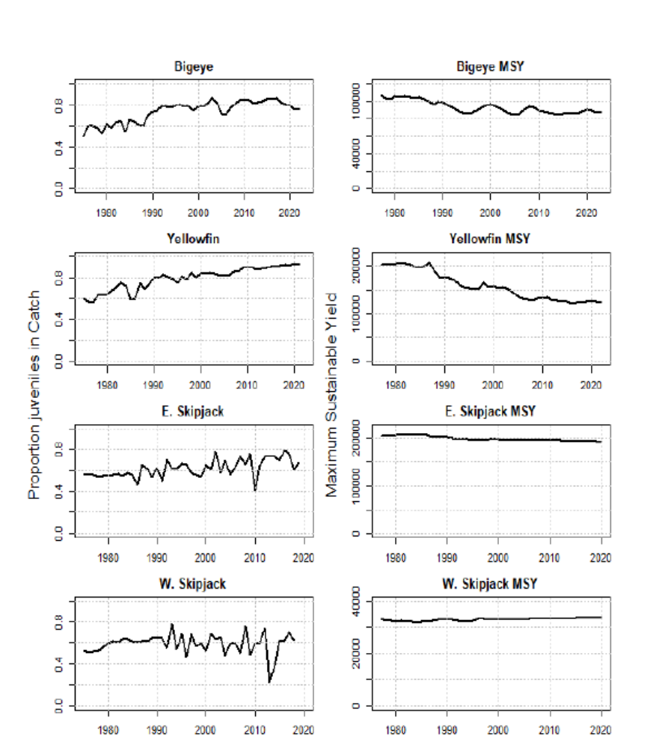

Figure 19.41.1. Estimated proportion (in numbers of fish) of juveniles in catches of Atlantic tropical tunas (left column plots) over time compared to time-dynamic estimates of MSY (right column plots).

19.42 Panel 1 will provide its recommendations to confirm or amend the management objectives for Atlantic bigeye tuna, yellowfin tuna, and the eastern stock of skipjack tuna, considering SCRS input, to the Commission for consideration as part of the selection of a management procedure at its 2026 Annual Meeting or as soon as possible thereafter. Panel 1 should consider whether the management objectives should be the same for the three stocks or if an asymmetric approach for each stock be more appropriate, Res. 24-02 para 6

Background: Panel 1 will provide its recommendations to confirm or amend the management objectives for Atlantic bigeye tuna, yellowfin tuna, and the eastern stock of skipjack tuna, considering SCRS input, to the Commission for consideration as part of the selection of a management procedure at its 2026 Annual Meeting or as soon as possible thereafter. Panel 1 should consider whether the management objectives should be the same for the three stocks or if an asymmetric approach for each stock be more appropriate.

Due to time limitations and the present status of the MSE multi-stock development, the Committee was not able to address this request in 2026.

19.43 SCRS shall assess the occurrence of Exceptional Circumstances annually, Rec. 25-02, para 8

Background: The SCRS shall assess the occurrence of exceptional circumstances annually and the Commission shall act in accordance with the exceptional circumstances protocol, developed based on scientific advice provided by the SCRS and adopted by the Commission.

Based on paragraph 9 in Rec. 25-02 the Committee provides its recommendations for an Exceptional Circumstances Protocol (ECP) for the Commission’s consideration. This draft ECP for SKJ-W is based on the ECP for SWO-N (Rec. 25-10), as well as those for BFT (Rec. 23-07) and ALB-N (Rec. 21-04).

Draft Exceptional Circumstances Protocol (ECP) for western Atlantic skipjack tuna

- Principles of Exceptional Circumstances (ECs)

The following three general principles should be considered as a signal indicating the possibility that ECs exist:

  - When there is evidence that the stock and/or fishery dynamics are in states (as defined in Table 19.43.1 a) outside the range of MSE Operating Models (OMs) and/or are no longer considered to be plausible in the context of the MSE, or when there is evidence that stock states or fishery dynamics included within the OMs for the MSE testing are no longer considered plausible.

  - When there is evidence that the data required to apply the MP are not available or sufficient, or are no longer appropriate (as defined in Table 19.43.1 b); and/or,

  - When there is evidence that total catch is meaningfully (as defined in Table 19.43.1 c) above the TAC set using the MP.

It is not possible to define all scenarios in which ECs may occur in this protocol. A protocol with general guidance for determining whether ECs exist and whether the implication(s) arising from them is sufficiently severe to warrant revising the advice from the MP is described below. The protocol should not be viewed as a definitive set of criteria/responses. Nor should it be viewed as a mechanism for making small adjustments. A finding of EC requires compelling scientific evidence, and EC actions should be taken only when maintaining the current MP is considered to be highly risky or highly inappropriate.

- Indicators for ECs and process to determine if ECs occur

In light of the principles specified in Section 1, the SCRS should use the general guidance provided in Table 19.43.1 and any other relevant information to determine annually whether ECs exist. If the SCRS determines that there is evidence of ECs, the SCRS will consider the direction and severity of the ECs (e.g., the degree to which CPUE values fall outside of their expected range and whether they are higher or lower than expected) and, where possible, examine its potential impacts on the performance of the MP.

Subsequently, the SCRS will inform the Commission of any such occurrence and the appropriate response. Triggering ECs does not immediately result in TAC advice from the MP being rescinded; rather, it means that the SCRS needs to consider the evidence from the indicators in Table 19.43.1, and any other relevant information, and determine if a change in advice is warranted and whether further research work or adjustments to the MSE schedule is required.

With respect to identified ECs, such evidence would need to be sufficiently consequential that it would meaningfully affect TAC advice from the MP.

Table 19.43.1. General guidance on indicators for western Atlantic skipjack ECs and timetable for conducting the evaluation.

Principle | Indicator | Criterion | Frequency
a) Stock and  fishery dynamics | Indices | If, in any year, the observed combined index values fall outside the range from the 2.5 to 97.5 percentile of the simulated combined index used in the projections  for testing the adopted MP. | Annually
a) Stock and  fishery dynamics | Abundance, life history and fishery dynamics | When there is evidence that the stock and/or fishery dynamics are in states not previously and/or no longer considered to be plausible in the context of the MSE, or when there is evidence that stock states or fishery dynamics included within the OMs for the MSE testing are no  longer considered plausible. | Whenever information is available and after completion,  presentation, and acceptance by the SCRS of a study as the new reference.
b) Data availability for the MP | Indices | If data from the Brazil or from both of the other two CPCs (Venezuela and United States of America) contributing to the combined index are missing. | Annually
c) Implementation of the TAC | Catch | If the total catch is 5% or more above the TAC set using the MP for 2 consecutive years. | Annually

- Actions to be taken in light of ECs

If the SCRS determines that ECs exist which preclude the application of the MP or make the application of the MP or the implementation of its results inadvisable based on the principles outlined in Section 1, the SCRS shall evaluate the nature of the EC and advise the Commission on:

  - Additional research which may bring more clarity on whether it is necessary to divert from the current MP revision schedule and TAC;

  - Alternative management options for the coming fishing year aimed at ensuring, at a minimum, stability in the stock status, including the implications of: (i) maintaining the TAC advice decided through the MP, (ii) reducing the TAC advice in light of indications of stock decline, (iii) increasing the TAC advice in light of indications of stock increase that was not considered plausible during the MSE testing, and (iv) any other appropriate conservation and management actions;

  - Whether the existing MP should be adjusted or whether development of a new MP is required; and

  - Whether a stock assessment or other SCRS-approved method of determining TACs is needed for providing management advice in the interim while a revised MP is developed.

Based on the SCRS advice on the above, the Commission shall decide on alternative management action(s). As needed and appropriate, the SCRS shall conduct a new stock assessment and/or provide advice on new candidate MPs as soon as possible.

See the flowchart below for a schematic representation of the above process:

The SCRS shall check if ECs exist using the indicators and criteria specified in Table 19.43.1 and according to the indicated frequency.

Year 1 & 2:
      - Update the Combined Index of abundance
    - Update catch
    - Consider evidence that stock states and fishery dynamics are in states not previously and/or no longer considered to be plausible in the context of the MSE, or when there is evidence that stock status or fisheries dynamics included within the OMs for the MSE testing are no longer considered plausible, and any other relevant information

Year 3:
      - Check that all datasets required in running the MP are available
      - Re-run MP
      - Same checks as conducted in Years 1 & 2
If ECs exist

If no ECs exist

The TACs calculated by the MP continues to be valid (in years 1-3) and the MP continues to be applied in year 3 to calculate the TACs for the next three-year management period.
SCRS determines that EC precludes the application of the MP or makes the application of the MP or the implementation of its results (i.e., TAC) unadvisable.
SCRS determines that ECs do not preclude the application of the MP and implementation of its results (i.e., TAC).


The SCRS shall advise the Commission on:

- Additional research which may bring more clarity on whether it is necessary to divert from the current MP revision schedule and TAC;

- Alternative management options for the coming fishing year aimed at ensuring, at a minimum, stability in the stock status, including the implications of: (i) maintaining the TAC decided through the MP, (ii) reducing the TAC in light of indications of stock decline, (iii) increasing the TAC in light of indications of stock increase that was not considered plausible during the MSE testing, and (iv) any other appropriate conservation and management actions;

- Whether the existing MP should be slightly adjusted or whether development of a new MP is required; and

- Whether a stock assessment or other SCRS-approved method of determining TACs is needed for providing management advice in the interim while a revised MP is developed.

Based on the SCRS advice on the above, the Commission shall decide on alternative management action(s). As needed and appropriate, the SCRS shall conduct a new stock assessment and/or provide advice on new candidate MPs as soon as possible.

The adopted management procedure (MP) was run in 2025 and provided total allowable catch (TAC) advice for the first management cycle (2026–2028). The Committee undertook analyses to support development of a draft Exceptional Circumstances Protocol (ECP) above. The protocol is scheduled to be adopted by the Commission in 2026, entering into effect in 2027. Final criteria associated with the three core principles of the protocol have not been formally adopted by the Commission. The Committee has, nevertheless, made an evaluation in accordance with the draft specifications of the present ECs.

The Committee has determined that ECs do not occur for the 2026 EC determination. This determination is based upon an evaluation of the draft criteria and elaborated here.

- Stock dynamics

  - Indices. For 2025, the combined index of abundance does not fall outside of the conventional 95% (i.e. 2.5 to 97.5 percentiles) prediction intervals (Figure 19.43.1).

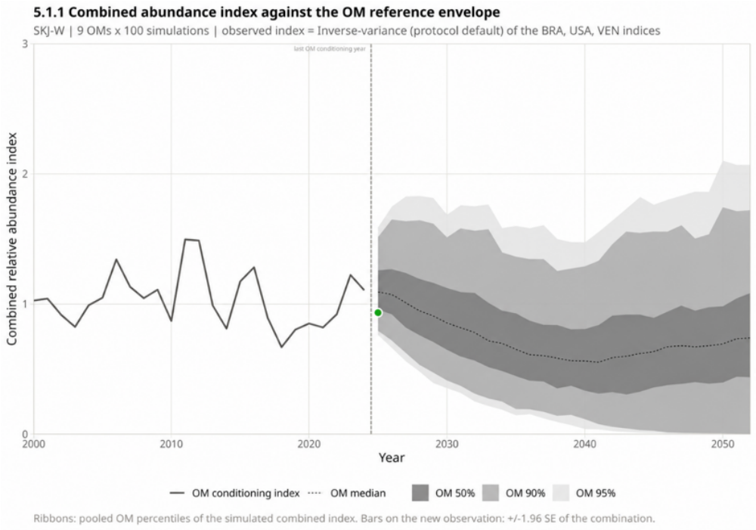

Figure 19.43.1. Plot shows the combined index against the OM reference envelope. The gray envelope gathers the percentiles of the 9 OMs * 100 simulations = 900 projected trajectories, the dashed line corresponds to the models’ conditioning index, and the green point is the 2025 observation.

  - Abundance and life history or fishery dynamics. There is no new evidence that abundance, life history or fishery dynamics are substantively different than those tested in the OMs.

- Data availability for the MP

The combined index of abundance was updated in 2026 with data to 2025. Data from Venezuela was available through 2024 but not 2025. Therefore, the 2025 index estimate is based on Brazil and U.S. data only, which is not considered to be an EC as defined in Table 19.43.1.

- Implementation of the TAC

There was no TAC for western skipjack in 2025, but 2025 landings were 23,004 t, below the 2026-28 MP-based TAC of 30,844 t. In 2027, the Committee will evaluate catch levels relative to this TAC.

19.44 SCRS shall report each year on the implementation of the port sampling programme broken down by CPCs, Rec. 24-01 para 73

Background: The port sampling programme developed by the SCRS in 2012 shall be continued for landing or transhipment ports. Data and information collected from this sampling programme shall be reported to ICCAT each year, describing, at a minimum, the following by country of landing and quarter: species composition, landings by species, length composition, and weights. Biological samples suitable for determining life history should be collected as practicable. SCRS shall report each year on the implementation of the port sampling programme broken down by CPCs.

In 2025, the Committee proposed that the ST-10 form for the submission of the port sampling fisheries data be discontinued. The SCRS and the Commission during the Annual Meeting approved the proposal which was implemented for the 2026 Statistics Data submission.

The Appendix 6 of the 2026 Secretariat’s Report on Research and Statistics [PLE-SCRS-07/2026]) (Table 19.44.1) presented a summary of the information provided under the ST10 or data in the port sampling database from 2018 to 2025.

It is important to note that the recommendation to discontinue ST10 port sampling data was based on the fact that the same information was already submitted by CPCs through Task 2 Size samples (T2SZ) and catch-at-size data (T2CS) and Task 3 biological sampling data. This includes CPCs with fisheries of tropical tunas in the eastern tropical area (which was the original intent of the ST10). As the same data was submitted in two different statistical forms, there was duplication, inefficiency and redundant work for statistical correspondents and CPCs.

Table 19.44.1. Number of individuals of tropical species (BET, YFT, SKJ) sampled at port and reported through the ST10 form, 2018-2025.
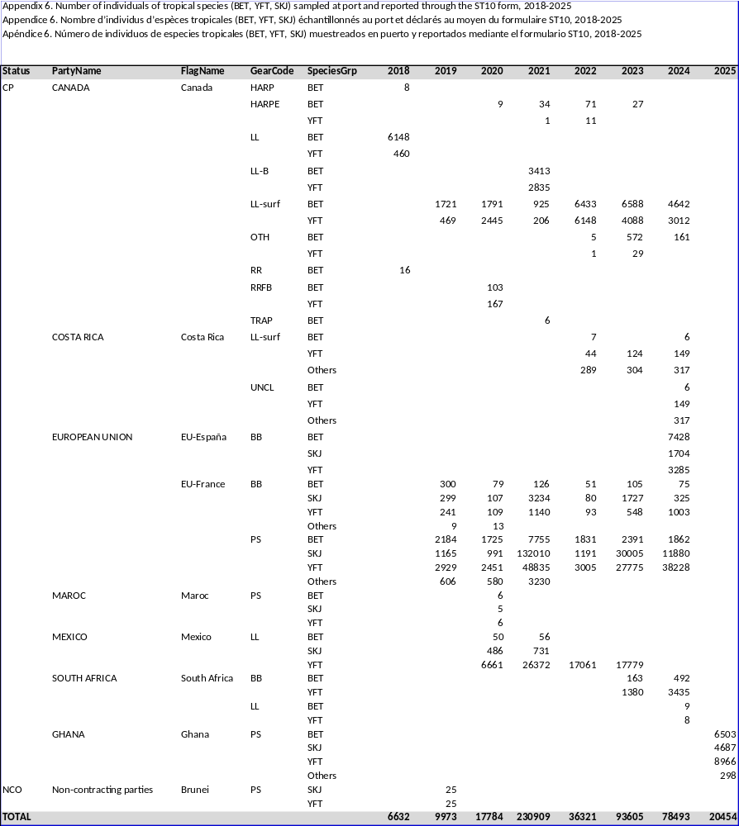

Recommendations

The Commission may wish to consider how authorized fishing vessels ≥20 m could improve reporting their activity by continuously broadcasting accurate and complete static AIS data, including the IMO number where assigned, MMSI, IRCS and registered vessel name in addition to the CPCs VMS reporting.

Available upon request from the ICCAT Secretariat or on the 2019 Commission meeting documents webpage.

