Original: English

Standing Committee on Finance and Administration (STACFAD)
Chair’s letter

29 October 2025
Dear CPCs,

Given the limited time available to STACFAD at the upcoming annual meeting and the need to focus on the key issues for decision, please be advised that I intend to limit discussion of the following agenda items that are primarily for information:

4.1 2025 Administrative Report

4.2 2025 Financial Report

4.3 Review of progress of the payment of arrears and voting rights

5.2 Funding mechanisms for other capacity building activities

7 Review of the outcomes of the Intersessional Meetings of the Virtual Working Group on Sustainable Financial Position for ICCAT (VWG-SF)

The documents for each of these agenda items have been posted and are available to review on the Annual Meeting page. CPCs are invited to send questions or comments directly to the Secretariat by 11 November 2025, or to provide a written statement that can be posted with the STACFAD meeting documents. I will work with the Secretariat to provide a brief summary report on each of these items in our first STACFAD session. Also, be assured that I intend to take up the substantive issues that were discussed by the VWG-SF under the appropriate agenda items.

In addition, the agenda has been further streamlined to recognize that consideration of the financial implications of SCRS requests is now reflected in the revised Draft Budget template and no longer requires a stand-alone agenda item. These adjustments are reflected in STF_200_REV_1/2025.

Thank you very much in advance for your flexibility and cooperation so that we can make the best use of our time and develop a full set of recommendations to the Commission in the time allotted.
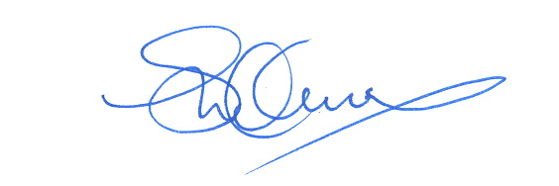
Best regards,

Deirdre Warner-Kramer

