Original: English

Report on the implementation of the derogation to validate BCDs
for trades of BFT between Member States of the EU in 2024
(paragraph 5b of ICCAT Recommendation 24-16)
(submitted by the European Union)

- Introduction

As other ICCAT Contracting Parties (CPCs), the European Union (EU) has implemented the eBCD system since 26 May 2016 for the bluefin tuna (BFT) caught by the purse seine vessels and traps, and since 1 July 2016 for the fish caught by other gears. All operators fully implement the system as from January 2017.

Paragraph 5b of Rec. 24-16 provides a derogation to validate BCDs for trades of BFT between Member States of the EU. The EU is required to report to the Commission on the implementation of this derogation by 1 October each year and while the statistics contained in this report cannot be generated by the eBCD system and made automatically available to all the ICCAT Commission and CPCs for their consultation.

- Derogation under paragraph 5b of ICCAT Recommendation 24-16

The data presented hereunder corresponds to the period 1 January 2024 to 31 December 2024. These data were partially extracted through the functionality in the eBCD system. Additional data on verification was received from the Member States administrations.

The scope of this report has been restricted to the trade events for bluefin tuna from seller in EU Member States, to avoid duplication, and because the selling Member State is responsible for the validation of the trade in eBCD.

In 2024, the EU Member States recorded 229,139 trade events in the eBCD system involving 49,506 t. Regulation (EU) 640/2010 provides the obligation to register trade events inside of the EU-Member States. Consequently, 71% of the trades recorded in the eBCD by the EU are internal trades inside single EU Member States’ territories (161,920 trades). The remaining trades include 26,826 exports to other non-EU countries (either ICCAT CPC or not) (12%), and 55,863 trades between EU Member States (24%).

The quantities involved amounted to 13,689 t (28%) for internal trades, and 30,956 t (63%) for exports. Trades between EU Member States amounted to 4,048 t, which represents 8% of the total weight traded (Figure 1).
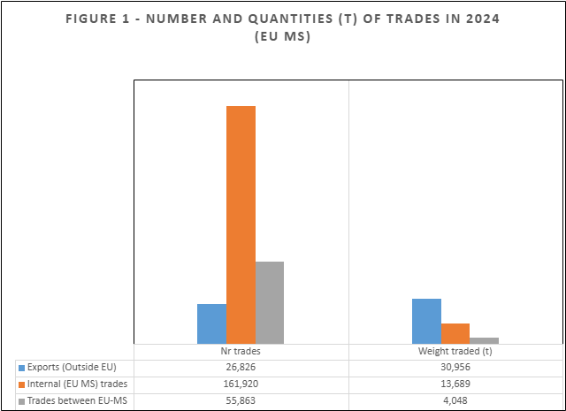

Exports: trades from the EU to other CPCs. Trades between EU-MS: trades between EU Member States. Internal trades: trades inside EU Member States territories.

Amongst the total trade, 47% (107,926) of the total trades were validated, and 54% (123,273) were exempted of validation, for a quantity of 40,140 t (81%) and 9,329 t (19%), respectively (Figure 2). In addition to the intra-Member State trade, the exemptions include both the derogation under paragraph 5b of Rec. 24-16 and the exemption for tagged fish according to para 5d of Rec. 24-16.

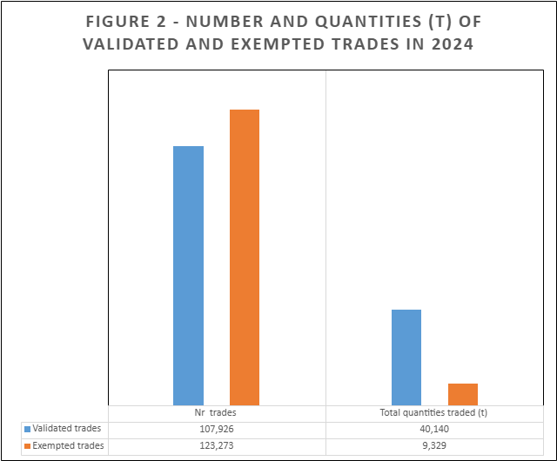

Regarding the trade events exempted from validation, 36,419 of them concerned trades between EU Member States (derogation under para 5b) (30%), with a quantity of 2,744 t. The remaining exempted events are related to internal trades (Figure 3).
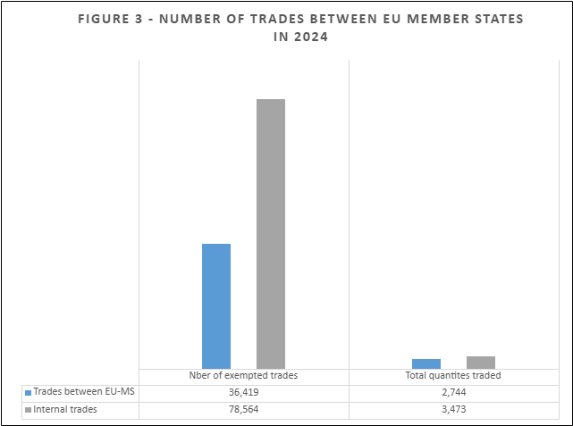

The average quantity by trade (by eBCD) was 80 kg for trades exempted of validation in line with the derogation 5b (Figure 4).

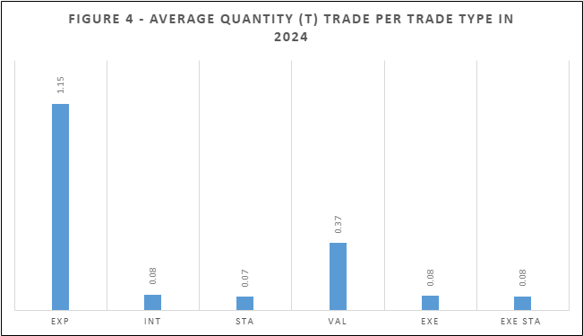

EXP (trades from the EU to other CPCs), STA (trades between EU Member States), INT (internal trades inside EU Member States territories), VAL (trades validated), EXE (trades exempted of validation), EXE STA (trades between EU Member States exempted of validation – derogation 5b).

Additional details by EU-Member State are provided in the Annex.

- Verifications

In terms of verifications of the information in the eBCD, as part of the standard procedure for validation, the control authorities perform verifications and crosschecks of all relevant documents including logbook data, landing declarations, sales notes, ICCAT authorizations, etc. Consistent with the EU legislation, the control authorities perform physical verifications and inspections at landing, in the market inside and at the entry in EU Member States based on risk assessment. All catches are weighed at landing using certified and calibrated scales.

At the point of exit and entry from and into EU, verifications include crosschecks of eBCDs with airbills and sales notes, as well as physical verifications. Imports into the European Union follow customs procedures.
All eBCD subject to validation were crosschecked. Even when validation is not required, the control authorities perform crosschecks with catch declarations and the eBCDs information in conjunction with other Member States concerned, which enables efficient monitoring of operations exempted from validation. In addition, the control authorities verify the validation of catch or tags details and analyse the coherence of the timing of the validation messages as well as the possible alert messages in eBCD.

Data extraction functionalities, crosschecks, and verifications through the eBCD system itself enable EU Member States to establish improved risk assessment procedures to specifically target trades events for crosscheck and verification.

Conclusion

The number of trades concerned by the derogation in para 5b of Rec. 24-16 is significant but involves in most of the cases small quantities of bluefin tuna as it involves fillet (FL) and other (OT) presentations only. Additionally, 71% of the trades recorded by EU are internal trades within EU Member States contributing to the traceability of the fish through the chain.

The derogation under para 5b of Rec. 24-16 removes a significant administrative burden related to validation and contributes towards achieving a more level playing field between the EU and the other ICCAT CPCs and is also consistent with the principle of a single market inside of the EU. It is important to note that since this derogation was granted to the EU there is no information on a possible negative impact of these measures on the traceability of BFT products, in particular bearing in mind that all first trade operations are validated.

Annex
Details by EU-Member State
 | CYP | ESP | FRA | GRC | HRV | ITA | MLT | PRT
Nb of trade events | 292 | 89,589 | 32,685 | 5,489 | 4,881 | 88,762 | 3,069 | 4,372
kg | 90,865 | 20,110,361 | 2,136,661 | 447,813 | 4,597,274 | 4,077,597 | 17,092,238 | 952,781
Exportation (CPCs) | 1 | 20,823 | 153 | 1,895 | 360 | 1,270 | 2,003 | 321
kg | 28 | 9,902,388 | 3,842 | 96,150 | 4,307,246 | 43,443 | 16,373,693 | 229,151
Inside Trade (INT MS) | 164 | 48,801 | 23,359 | 883 | 3,792 | 82,884 | 615 | 1,422
kg | 7,035 | 8,135,730 | 1,244,561 | 62,630 | 247,006 | 3,166,825 | 600,864 | 223,914
STA (between MS) | 166 | 22,520 | 10,263 | 1,861 | 484 | 17,280 | 507 | 2,782
kg | 83,802 | 2,072,242 | 88,258 | 289,033 | 30,333 | 867,329 | 117,681 | 499,716
VAL | 27 | 30,978 | 1,803 | 62 | 4,482 | 64,309 | 3,072 | 3,193
kg | 553 | 14,351,370 | 107,541 | 4,022 | 4,584,014 | 3,115,848 | 17,091,843 | 885,030
EXE | 263 | 58,558 | 31,293 | 5,432 | 288 | 26,230 | 3 | 1,206
kg | 89,871 | 5,751,919 | 2,021,523 | 443,773 | 8,299 | 946,269 | 167 | 67,568
EXE STA* | 106 | 15,151 | 8,452 | 2,771 | 86 | 8,959 | 3 | 891
kg | 83,249 | 1,073,068 | 780,341 | 284,993 | 2,700 | 481,060 | 167 | 38,184
*Number and amount of tonnage of trades between EU Member States exempted from validation, subject to the derogation in para. 5b (STA).

Include trades between EU Member States, trades of tagged fish and internal trades of non-tagged fish.
Regulation (EU) No 640/2010 of the European Parliament and of the Council of 7 July 2010 establishing a catch documentation programme for bluefin tuna Thunnus thynnus.
Tagged fish may concern both trades between EU Member States and internal trades inside an EU Member State; number of trade events equates to one or several tagged fish.

