Original: English
Report on the mission of ICCAT Port Inspection Needs Assessment and Training Missions
in Walvis Bay, Namibia

(submitted by ICCAT Secretariat/PIEG Experts)

Namibia being a CPC to ICCAT, is required to monitor compliance with ICCAT conservation and management measures, and in its capacity as a port CPC, shall have in place an effective scheme of port inspections with the capability to conduct inspections.

Under the auspices of the ICCAT Port Inspection Expert Working Group for Capacity Building (PIEG) and Assistance, a process was developed for an ICCAT CPC wishing to request assistance for the implementation of Port State control measures through completion of assessments forms and application. Namibia requested such assistance and was selected as a candidate for 2024. As a result, experts from Canada and the U.S. (Dion Browne and Ben Hughes) conducted a port State control needs assessment mission in Walvis Bay, Namibia, 10-12 December 2024, to determine potential gaps, deficiencies, and approaches for addressing requirements with respect to fisheries monitoring, control and surveillance specifically relating to port State control and inspection in an effort to improve and develop a more robust port inspection regime in the region.

As part of the mission, Namibian port inspectors were interviewed and visiting experts had the opportunity to monitor a port inspection of a foreign fishing vessel landing catch in a Walvis Bay port. During the assessment, Namibian port inspectors demonstrated basic experience in the core fundamental principles and understanding of the “administrative” inspection processes to exercise port CPC controls.

Namibian port inspectors are supported by a small, but well-developed Fishery Monitoring Center (FMC) which provides risk assessment and intelligence led briefing material to assist, facilitate and prioritize issues relating to the inspection of fishing vessels landing in Namibian ports. Recent training provided by the SADC ATLANTIC project was very evident in displaying the FMC ability to monitor, analyze and synthesize fishing related data, and triage surveillance information such as VMS and AIS, as well as global vessel searches to determine potential IUU activity.

There is a wide range of operational experience within the Namibian port inspector cadre, varying from formally trained new inspectors to seasoned inspectors nearing retirement. It was also encouraging to note the gender equities within the inspector ranks.

Main thematic areas in which there were noted gaps or deficiencies:

- Knowledge of conservation and management measures (CMM) and requirements of ICCAT: Inspectors did not understand their role as port inspector under ICCAT and also lacked the basic knowledge and understanding of ICCAT CMMs, in particular specifics of the actual inspection form requirements, which put them at an operational disadvantage during port inspections of vessels fishing under the authority of ICCAT.

  - Training in areas of ICCAT CCMs and familiarization of the CMM repository will create a more robust port inspection regime by providing port inspectors with operational knowledge of relevant ICCAT measures and therefore helping inspectors ensure that fishing activities comply with applicable ICCAT standards. This includes monitoring catch limits, gear restrictions, and protected species requirements and how they apply to a vessel when landing catch in port. Such familiarity with ICCAT measures will enable inspectors to identify and address potential instances of IUU fishing activities.

- Species identification (namely sharks): Inspectors stated that this was one main hindrance in their ability to effectively enumerate catch offloaded as well as identification and verification of species that could potentially be entering their ports (i.e. prohibited shark species).

  - This training will provide port inspectors with the ability to ensure that vessels comply with regulations regarding catch limits and protected species, in particular shark species. This helps in enforcing ICCAT measures designed to conserve and protect marine biodiversity. Accurate data on fish species caught and their quantities contribute to scientific research and data collection, therefore, this information is vital for making informed decisions about fishery management and conservation strategies.

- Operational elements of the inspection process: Port inspectors seemed to focus mainly on the “administrative” elements of the inspection process (i.e. verification checks for licenses, authorization to fish, fishing tracks, etc.).

  - Recommended guidance and training on how to inspect fish holds, monitor, and estimate catches being offloaded, as well and what to look for during more “operational” type elements of an inspection through tabletop exercises or guidance during an operational inspection.

- Observe, record and report: Basic note taking skills and documentation of events during the inspection process.

  - Providing tabletop training in these areas would assist port inspectors with a basic overview of note taking, evidence collection and creating a repository of the events which transpired during the inspection, making it a valuable source of information for future inspections and record of events.

As a result of the needs assessment mission, experts from Canada (Dion Browne and Jerry Walsh) delivered a tailored ICCAT port inspector training syllabus during the week of 24-26 March 2025, in Walvis Bay, Namibia.

The mission programme consisted of training in the following areas (inter alia):

- Why port State measures are necessary.
- Advance notice and port entry requirements under ICCAT (Port Entry or Denial).
- ICCAT website resources (IUU lists, record of vessels, authorizations, CMMs, etc.).
- Port inspection process and procedures.
- Evidence collection and notebook requirements.
- Infringement procedures.
- Health, safety, and security during an inspection.

Experts from Canada also arranged to have a scientist from the Namibian Ministry of Fisheries to deliver training on ICCAT species identification (sharks) during the programme. It was recommended that managers of Namibian fisheries inspectors work with Namibian scientists to further provide species training to inspectors to additionally assist with field identification of ICCAT billfish and large pelagic species.

The port inspector training was supplemented with tabletop breakout exercises and sharing of operational experiences from the Canadian experts to assist and supplement learning, encourage discussion and understanding of the topics, along with their operational applications in the field.

This training will further advance Namibia’s port State control capacity with the technical and operational assistance provided to strengthen and promote the development and implementation of an effective system of port inspections at the national, regional, and international level; including monitoring, control, surveillance, and enforcement, thereby allowing Namibia to conduct more effective and thorough ICCAT port inspections.

In total, 37 inspectors and observers from the Namibian Ministry of Fisheries participated in the training during the mission on 24-26 March 2025.

Namibia, and southern Africa in general, will benefit from this ICCAT capacity building training mission. This training and the subsequent sharing of knowledge with additional port inspectors pertaining to inspection strategies and methodologies will promote compliance with ICCAT conservation and management measures and assist in combatting elements of IUU fishing in the region.

Inspectors, supervisors, and mangers in attendance were very appreciative of the detailed training concerning ICCAT port inspection, which will assist with Namibia’s compliance with ICCAT conservation measures and abilities to carry out more effective port inspections. Participants were hoping for additional training in the future and possibly to expand the training syllabus to other colleagues that could not attend this session. Participants were encouraged to share the knowledge and lessons learned with their colleagues who could not attend the training programme due to other operational requirements.

Overall, both missions to Namibia were a large success. The training was very well received, and participation and engagement in the learning process and discussions by the group were quite high; the group had significant questions and shared experiences from their past inspections.

For consideration, some suggestions to potentially improve elements of future missions are:

- Mission travel logistics:

  - Depending on locations, travel itineraries can be somewhat complicated and require significant connections and layovers.
  - Booking travel mission segments, when possible, well in advance, is preferred to reduce costs and allow for greater flexibility in travel options.

- Non-MCS expert support:

  - Having subject matter experts to present on such foundational areas as species identification was an important pillar of the training mission. Securing such SMEs was somewhat difficult, however with some investigation, SMEs were found in-country and all details then quickly fell in place.

- Curriculum development:

  - Development of a “baseline” ICCAT training presentation that can be adjusted and tailored to meet the specific requirements of a CPC because of the needs assessment mission to ensure consistency in approach and delivery from an ICCAT perspective.
  - Trainers would be assisted to reduce the preparatory workload via a draft presentation based on the ICCAT Port Inspection Training Manual.

Needs Assessment Mission (10-12 December 2024):
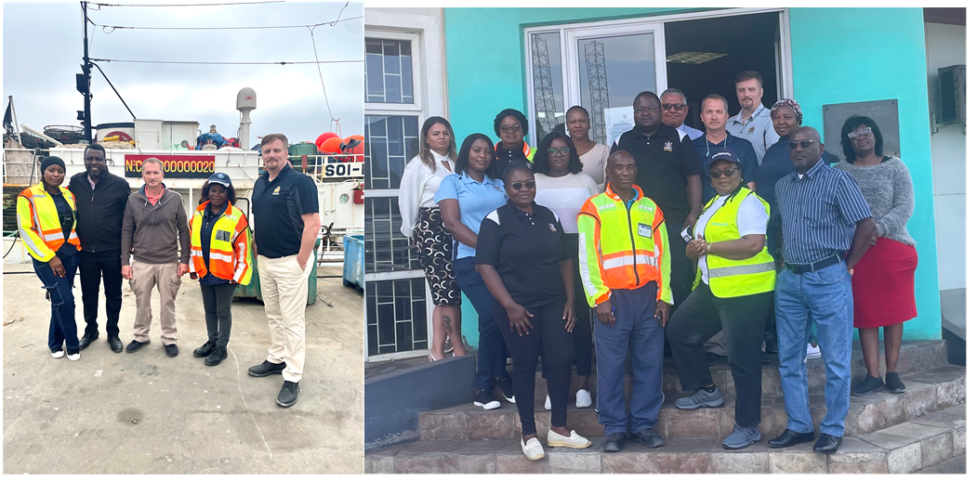
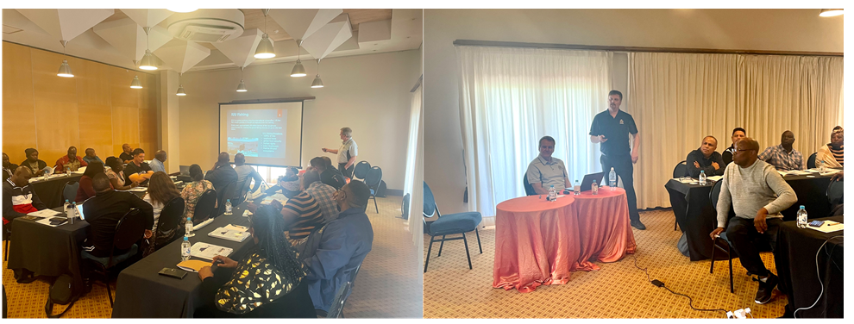
Port Inspector Training Mission (24-26 March 2025):

