Original: English

Appendix 1

A summary of the ICCAT Regional Observer Programme 2024 Report
(submitted by ROP-Transhipment implementing consortium)

Introduction

In 2006 ICCAT adopted Rec. 06-11, most recently updated by Rec. 21-15, to establish a Programme for Transhipment in response to concerns that at-sea transhipment operations constituted a gap in the enforcement scheme of the Commission. MRAG Ltd. and Capricorn Fisheries Monitoring cc (the Consortium) has been implementing the Regional Observer Program (ROP) since its inception in April 2007.

The ROP aims to address Member State concerns regarding laundering of Illegal, Unregulated and Unreported (IUU) tuna catches by monitoring transhipments at sea from large-scale pelagic longline fishing vessels (LSPLVs) operating in the Convention area. Rec. 21-15 states that all tuna, tuna like species and other species caught in association with these species in the Convention area must be transhipped in port. However, at sea transhipments can be authorised by Contracting Parties provided the Carrier Vessel (CV) has VMS capabilities and a trained ICCAT observer on board to monitor the process.

Deployments

This report provides a summary of the ROP’s eighteenth year, covering transhipments that occurred between the 1 January 2024 and 31 December 2024. This spanned transhipments across deployments 288/23 to 300/24. One deployment (290/24) was cancelled. The figures include all deployments, vessel transhipments, fish transhipped, and PNCs reported over this time period.

Summary of deployments

A total of 329 at-sea transhipments took place across 12 trips, all were monitored accounting for 675 sea days with an average deployment length of 56 days. The total observed weight of fish transhipped over the period was 24,503.323 tonnes. A summary of key figures from all deployments is given in Table 1.

Of the 329 transhipments, 42.55% were from Chinese Taipei flagged vessels, 27.96% were from Japanese flagged vessels, 26.14% were from Chinese flagged vessels, 2.13% were from Korean flagged vessels, and 1.22% were from Namibian flagged vessels (Figure 1). The location of transhipments conducted by vessels under the ROP are displayed in Figure 2. Transhipments were mainly located in the central Atlantic along the equator, with many around the EEZ of Ascension Island, and distributed along the length of the west coast of Africa.

Table 1. Summary of deployments 288/23 – 300/24 and weight of fish transhipped in 2024.

No. | Vessel Name | Observer Name | On Date | Off Date | Port On | Port Off | Days | No. of T/S | Observed | Declared
288 | Yachiyo | Eva María Vidal Cejuela | 10/12/2023 | 11/02/2024 | Valleta | Singapore | 64 | 15 | 997.49 | 982.01
289 | Taisei Maru No.24 | Schalk Visagie | 11/01/2024 | 30/03/2024 | Cape Town | Singapore | 80 | 28 | 2,061.72 | 2,071.68
291 | Taisei Maru No.15 | Rauf Berkay Eryericer | 10/02/2024 | 14/04/2024 | Cape Town | Port Louis | 65 | 30 | 2,493.23 | 2,555.50
292 | Tuna Princess | Julio Ocon | 28/01/2024 | 19/02/2024 | Porto Grande St Vincent | IOTC Cross Over | 23 | 12 | 754.60 | 759.97
293 | Ocean Star | Oguzhan Ayaz | 22/01/2024 | 05/03/2024 | Çeşme | Cape Town | 44 | 18 | 1,953.45 | 1,976.11
294 | Harima | Johannes Visagie | 28/01/2024 | 22/04/2024 | Cape Town | Singapore | 86 | 38 | 3,124.77 | 3,147.61
295 | Tuna Queen | Sami Yildiz | 19/02/2024 | 02/04/2024 | Çeşme | Port Louis | 44 | 4 | 510.24 | 502.74
296 | Ibuki | Johan Beets | 28/02/2024 | 04/05/2024 | Cape Town | IOTC Cross Over | 67 | 57 | 3,274.65 | 3,497.11
297 | Genta Maru | Llewellyn Lewis | 12/03/2024 | 22/03/2024 | Cape Town | IOTC Cross Over | 11 | 5 | 568.24 | 617.51
298 | Yachiyo | Cevher Ozbek/E D Higgins | 26/05/2024 | 23/07/2024 | IOTC Cross Over | IOTC Cross Over | 59 | 44 | 3,581.05 | 3,602.12
299 | Chikuma | Anita Vidovic | 18/08/2024 | 29/10/2024 | Port Louis | IOTC Cross Over | 73 | 42 | 3,531.72 | 3,516.84
300 | Harima | Levent Ali Erkal | 15/11/2024 | 12/01/2025 | Port Louis | IOTC Cross Over | 59 | 36 | 1,652.17 | 1,657.06
*Some deployments started prior to or ended after 2024, however the figures shown here are only representative of transhipments that took place during this reporting period.

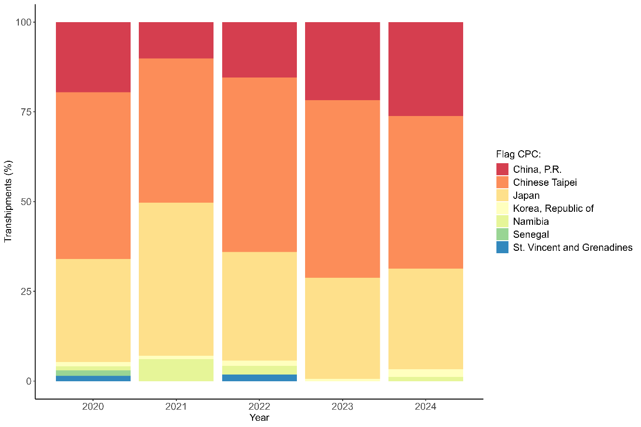

Figure 1. The percentage of transhipments during 2024 compared to the previous 4 years by large-scale pelagic longline vessels (LSPLVs) Flag State.
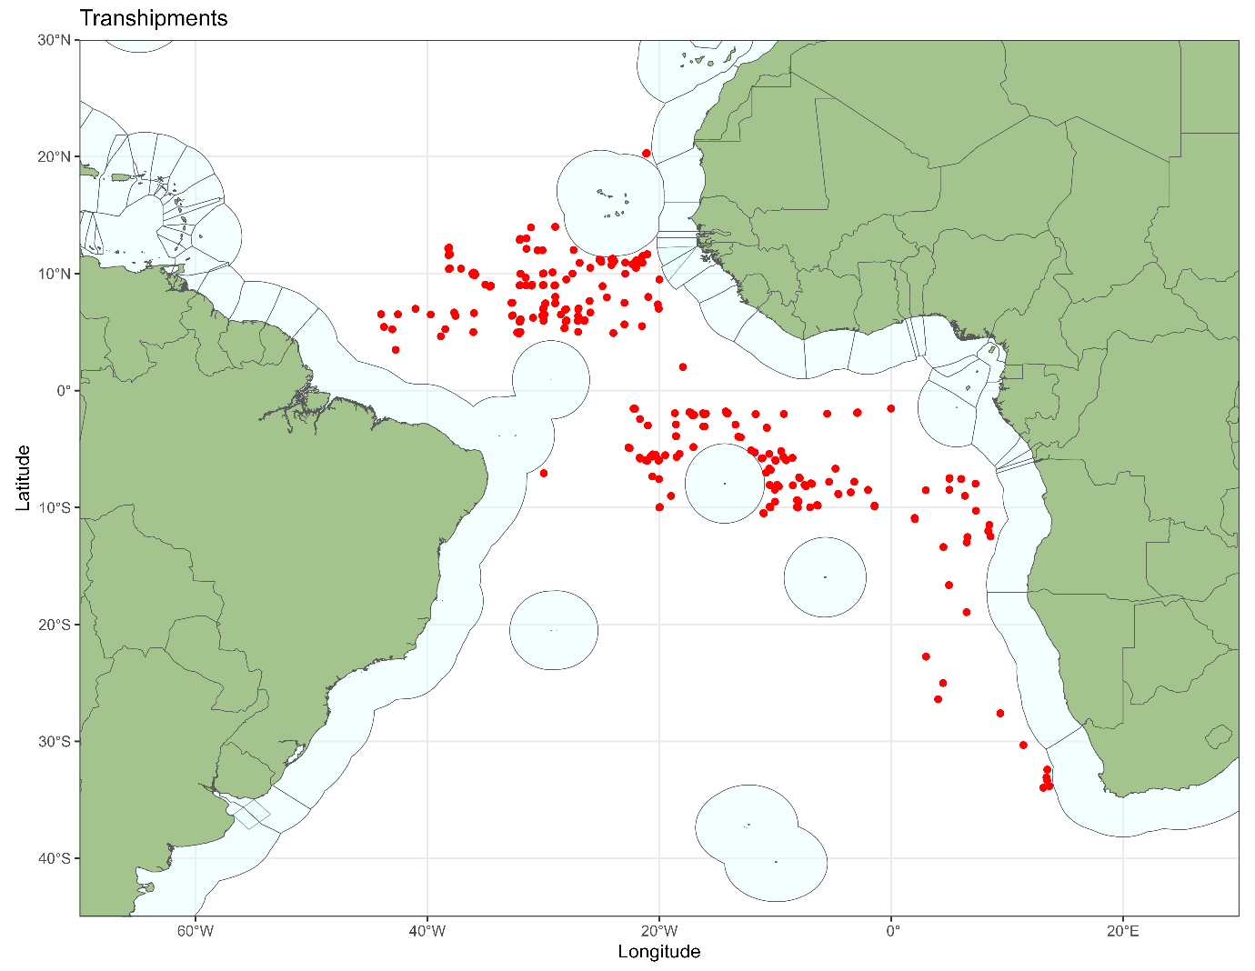
Figure 2. Locations of transhipments during 2024.
A summary of the number of ROP deployments by month for 2024 is shown in Figure 3. Figure 4 indicates the number of transhipments and the total weight transhipped each month. Figure 5, Figure 6 and Figure 7 show the duration of transhipments, the quantity of products transferred and the rates of products transhipped per hour, respectively, and they remain similar to previous years.
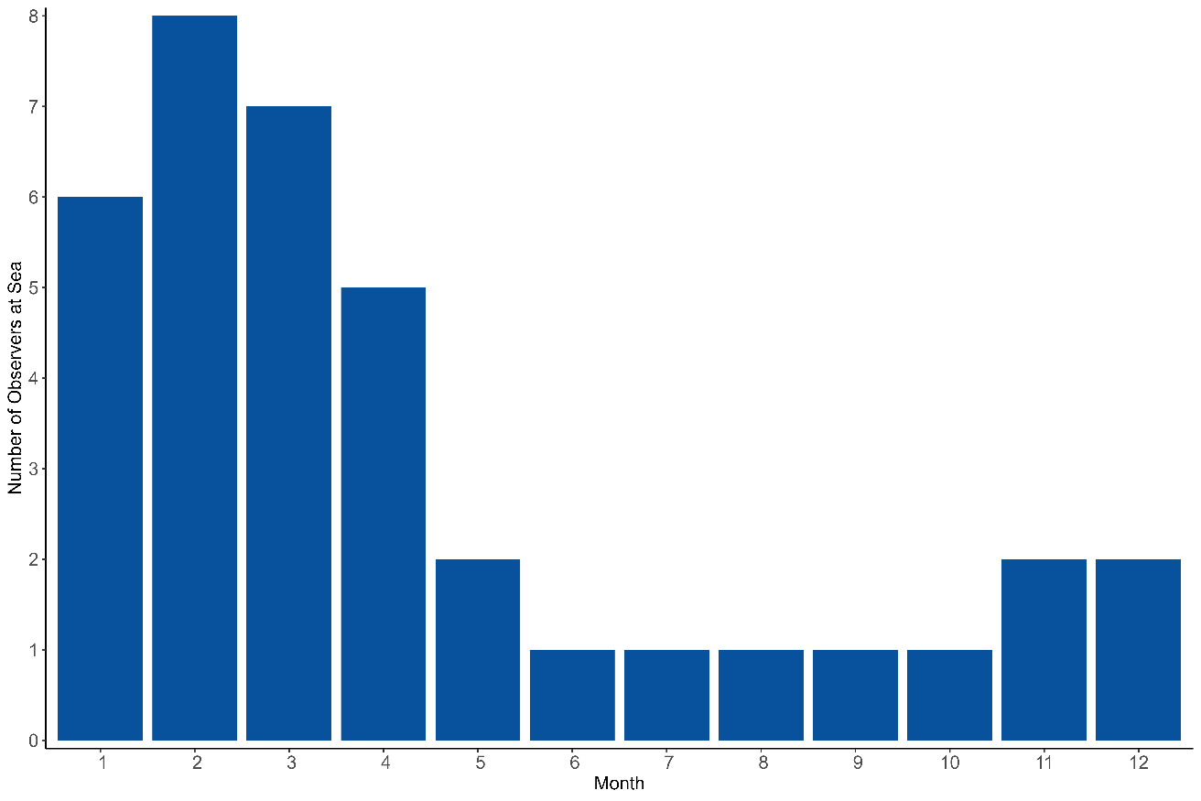
Figure 3 Number of observers at sea by month Figure 3 Number of observers at sea by month

Figure 3. Number of observers at sea by month.

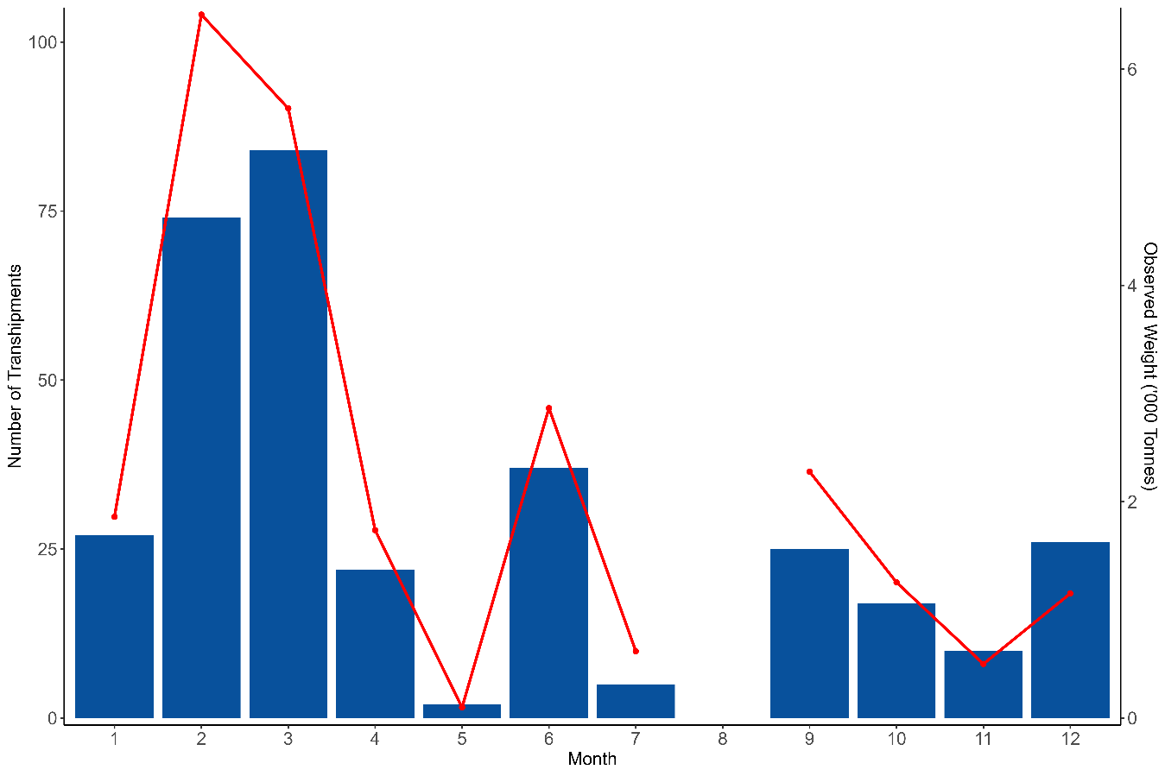

Figure 4. Number of transhipments and weights transferred (all fish, red line) by month.

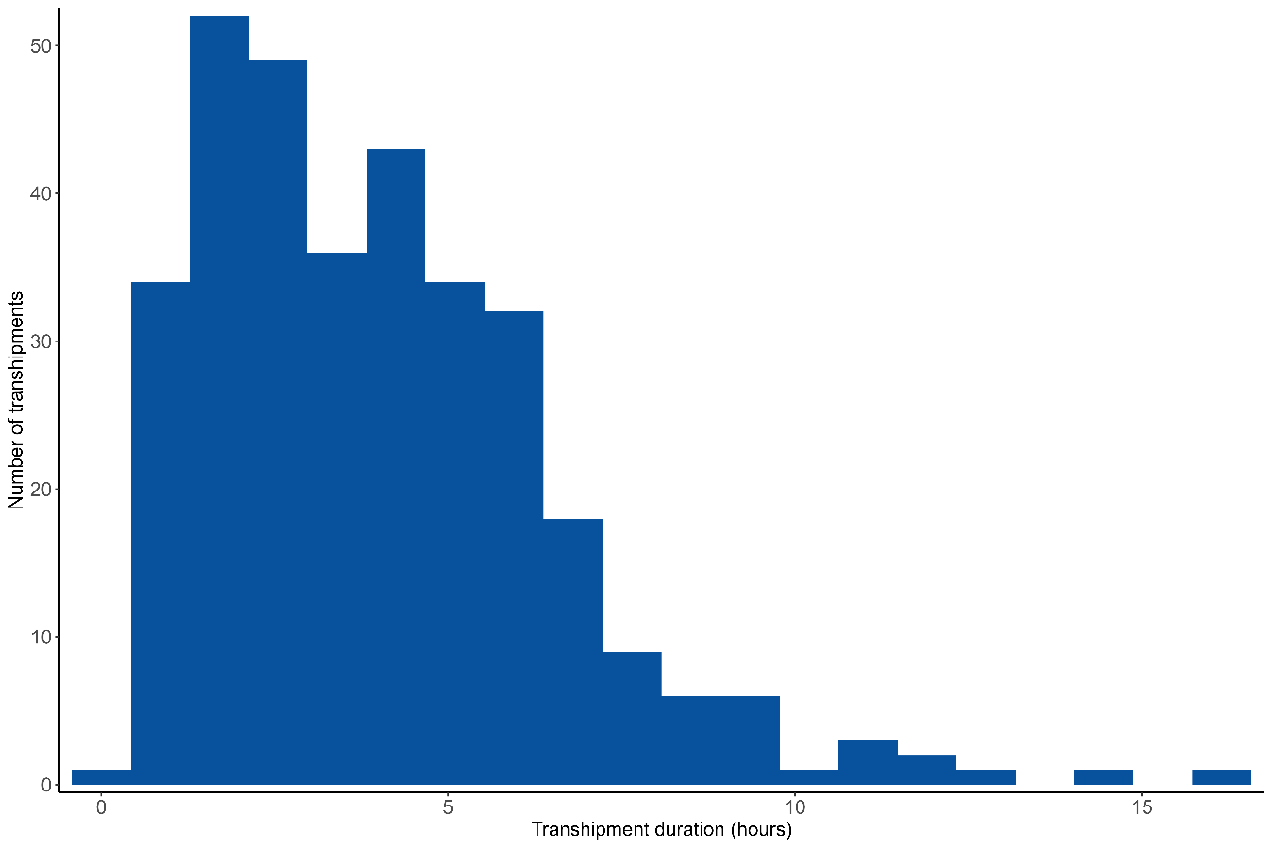
Figure 5. Duration of transhipments (hours).
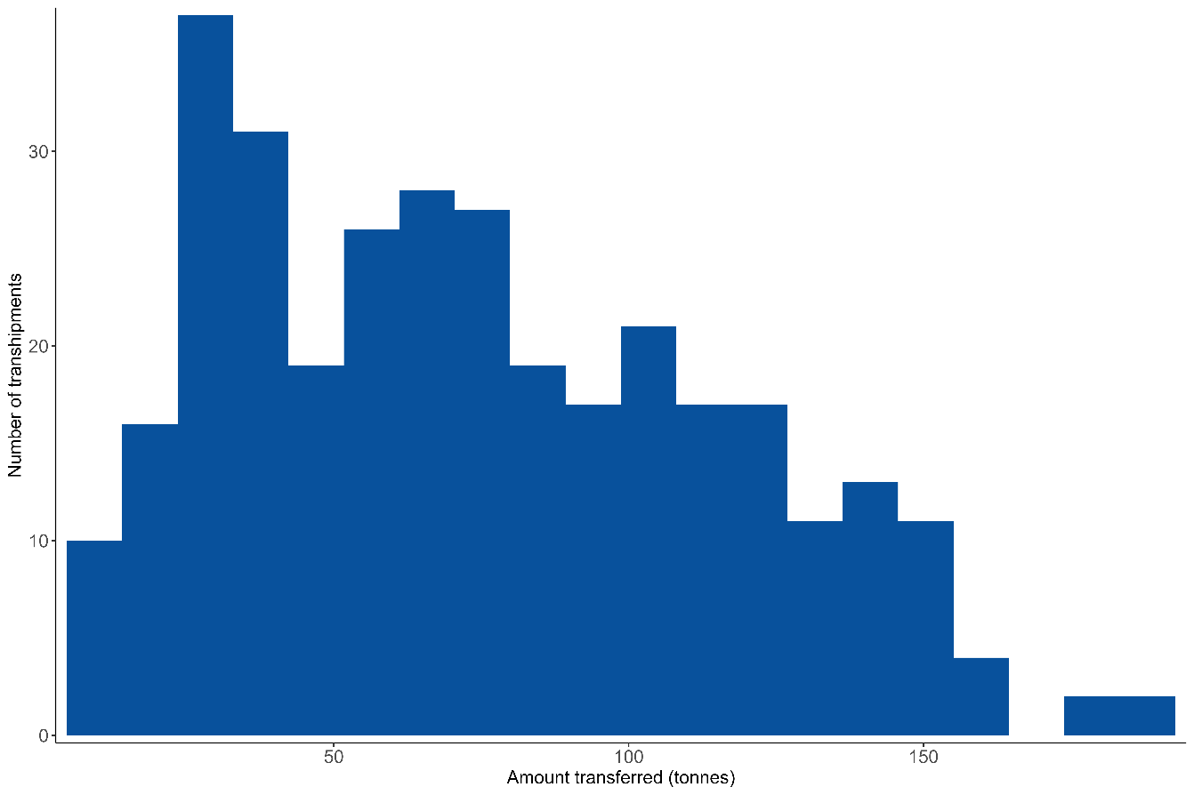
Figure 6. Quantities transferred per transhipment (t).
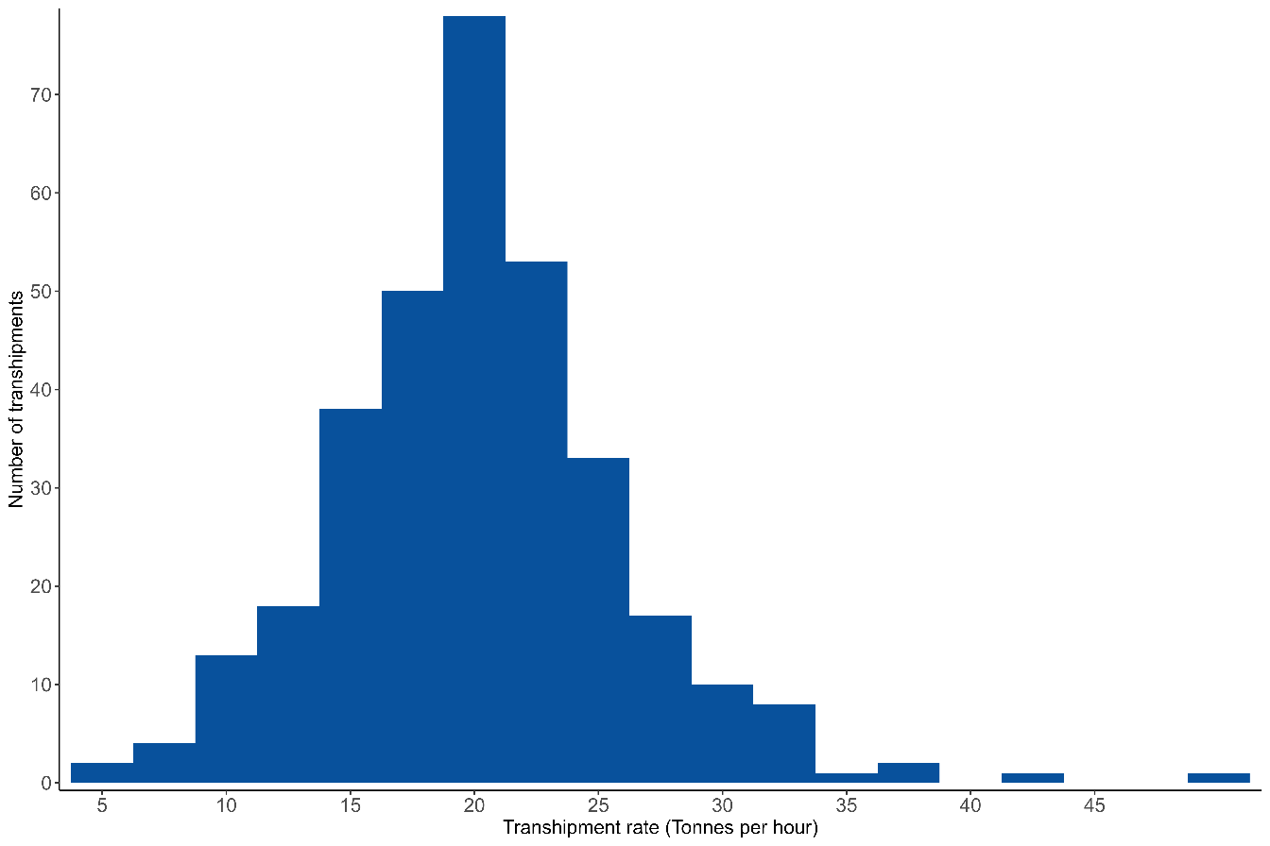
Figure 7. Rate of products transhipped.

Transhipments within EEZs

No transhipments were observed to be made within EEZs.

Procedures and logistics

The deployment request procedure has remained the same as previously described by the Consortium in annual reviews of the ICCAT ROP.

During the period covered by this report, three vessels crossed over from the Atlantic Ocean into the Indian Ocean on to an IOTC deployment without stopping at an Atlantic port first, no vessels crossed over from the IOTC area.

Species identification

The methods used by observers for species identification and reporting procedures have remained the same and are detailed in previous reports (ICCAT 2011).

Southern bluefin tuna

Since the adoption of the Resolution on the Implementation of a CCSBT Catch Documentation Scheme on 1 January 2010, any southern bluefin tuna (Thunnus maccoyii) transferred must be accompanied by a catch monitoring form (CMF) which should be countersigned by the observer. During the period covered by this report southern bluefin tuna were transhipped on 3 occasions on 1 deployment, with a total of 260.036 t observed (Table 2). Observers prepare a separate report for CCSBT on any trips where southern bluefin tuna are transhipped.

Table 2. Transhipments of southern bluefin tuna (Thunnus maccoyii) during 2023.

No. | CV | CV ICCAT No | T/S No | Date | Obs. Wt. | No. fish
298 | Yachiyo | AT000PAN00240 | 41 | 13/07/2024 | 82.30 | 1751
298 | Yachiyo | AT000PAN00240 | 43 | 19/07/2024 | 96.45 | 2192
298 | Yachiyo | AT000PAN00240 | 44 | 20/07/2024 | 81.29 | 1659

In-port fish transhipments

In 2022 ROP observers began monitoring offloading of the products from the CV at the end of each trip, where possible. As specified in Recommendation 21-15, Appendix 2, Paragraph 6.2 I, observers must:

‘…observe and estimate quantities of product by species when offloaded in the port where the observer is disembarked to verify consistency with quantities received during at sea transhipment operations.’

Ongoing issues with the implementation of these requirements were discussed in PWG_402_APP_1/2024. No in-port offloading was monitored in 2024.

Observers have been monitoring transhipments in port between vessels. This is normally midway through the deployment; these are shown in Table 3. Transhipments occurring in port.

Table 3. Transhipments occurring in port.

Port | Port State | Carrier Vessel Name | Carrier Vessel Flag | Number of Transhipments
Porto Grande St Vincent | Cabo Verde | Harima | Singapore | 11
Porto Grande St Vincent | Cabo Verde | Taisei Maru No.24 | Japan | 9
Porto Grande St Vincent | Cabo Verde | Tuna Queen | Panama | 1
San Vincent | Cabo Verde | Yachiyo | Panama | 1
Sao Vicente | Cabo Verde | Harima | Panama | 1
Sao Vicente | Cabo Verde | Ibuki | Panama | 1
Sao Vicente | Cabo Verde | Taisei Maru No.15 | Japan | 4

Weight estimation

The methodology used by observers for estimating transhipment weights remains the same as those previously described by the Consortium (ICCAT 2011).

Observer Training

Currently there are around 50 active ICCAT ROP observers, although not all are available all the time due to other commitments. Due to natural turnover of personnel, it is important to maintain training on a regular basis. 5 observers were trained in 2024 (Table 4).

With prior agreement from ICCAT, IOTC and CCSBT, observers trained under any of the programmes are available to work under all three RFMOs. This reduces costs and ensures a high standard of data integrity. It also allows observers to remain on the vessel if it crosses between RFMO areas in order to save on deployment costs.

To reflect this arrangement, observers are issued with a unique observer number and identification card, which is valid for all three RFMOs.

Table 4. ROP transhipment training conducted in 2024.

Observer name | Training location
Eduan Grobblelaar | Cape Town, South Africa
Neliseka Lawu | Cape Town, South Africa
Sarel Johannes Du Plessis | Cape Town, South Africa
Niel van Rooyen | Cape Town, South Africa
Stiaan Jaco Immelman | Cape Town, South Africa

Observer programme databases

The database continues to be updated as required and up to the end of 2024 contains data on 8,232 transhipments.

On request from ICCAT, continued developments in the database over the last year have included the capture of data pertaining to additional monitoring tasks outlined in Recommendation 21-15.

Potential Non-Compliances (PNCs)

Since 2012 ICCAT have required observers to board LSPLVs to carry out checks on vessels against various ICCAT Recommendations. Any potential non-compliances (PNCs) are then submitted to the flag State by the observer through the Consortium. The flag State then has the opportunity to respond. PNC codes and descriptions are summarised in Attachment 1.

Since the Recommendation came into force, 1046 PNCs have been reported by observers over 105 deployments, these are shown in Figure 8. It shows a steep decline in PNCs since 2014, although this will have been skewed in recent years due to COVID. 10 PNCs were issued during 2024 (Table 5), of which 6 were reported to the flag State at the time that the PNCs were issued, the flag States that were notified responded accordingly.
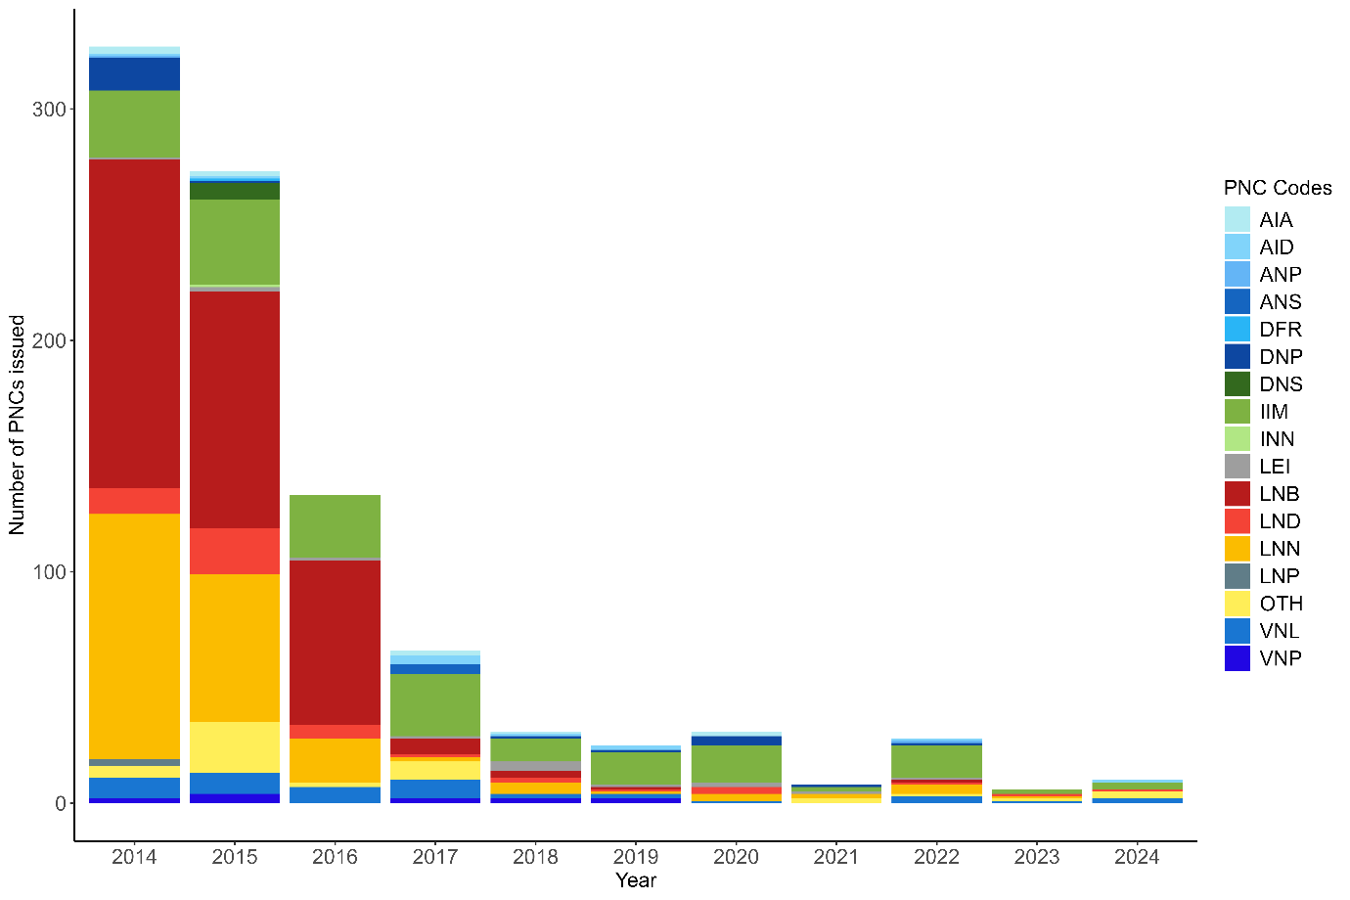
Figure 8. Number and proportion of PNCs issued since their introduction.

Table 5. PNCs issued in 2024.

Dep. No | T/S No. | CV Name | LSPLV Name | PNC Code
289 | 1 | Taisei Maru No.24 | SHOFUKU MARU No.58 | No power light visible on the VMS unit
289 | 1 | Taisei Maru No.24 | SHOFUKU MARU No.58 | Authorisation to fish dates not valid
289 | 27 | Taisei Maru No.24 | SHOFUKU MARU No.58 | No power light visible on the VMS unit
292 | 9 | Tuna Princess | LU QING YUAN YU 023 | LSPLV markings not displayed correctly
293 | 15 | Ocean Star | LU QING YUAN YU 028 | LSPLV markings not displayed correctly
297 | 5 | Genta Maru | WAKASHIO MARU No. 128 | Logbook not up to date
299 | 18 | Chikuma | CHIYO MARU No. 28 | LSPLV markings not displayed correctly
299 | 21 | Chikuma | YEUN HORNG NO.2 | Logbook lacked information on the vessel details, cruise information and gear configuration
299 | 27 | Chikuma | LU QING YUAN YU 022 | Logbook lacked information on the vessel details, cruise information and gear configuration
299 | 32 | Chikuma | HUNG CHUAN NO.336 | Logbook lacked information on the vessel details, cruise information and gear configuration

Conclusions and recommendations

As highlighted in Section 5, monitoring of offloadings in port continues to be a problem. We would recommend that a carrier vessel should indicate where and when it is planning to offload at the start of the trip, as part of the notification process so any monitoring can be more effectively planned.

While the number of PNCs reported in 2024 (10) has increased from 2023 (6), the total number issued is still very low, continuing the downwards trend in reported PNCs since the beginning of the programme. This stands even accounting for the lower number of transhipments that have occurred in the ICCAT ROP in recent years (326 in 2024 & 346 in 2023, compared to 495 in 2014 and 445 in 2015), as can be seen below in Figure 9 below, which shows the number of PNC reported as a proportion of total transhipments each year.

The type of PNCs reported have also changed over time. In 2014 80.43%, and in 2025 68.86%, of the total PNCs reported concerned issues with the vessel’s logbooks. While in 2023 logbook PNCs comprised 33.33% and in 2024 only 10.00%. PNCs relating to obscured or worn vessel markings are now generally among the most commonly reported PNCs, comprising 33.33% in 2023 and 30% in 2024.

These are very promising trends which demonstrate the effectiveness of the vessel inspection programme at increasing compliance. The consortium would like to thank the CPCs for their timely response to all reported PNCs.

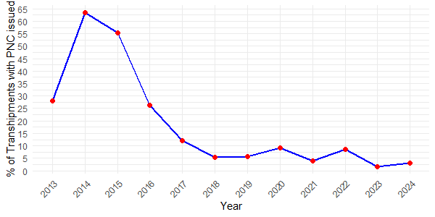

Figure 9. PNCs issued as a proportion of total transhipments by year.

Attachment 1

Potential non-compliance descriptions and codes

PNC Event | Code
General
Observer prevented from carrying out duties on board the LSPLV | GLV
Document / Verification
Transhipment Declaration not completed | DTD
Transhipment within EEZ without authorisation from coastal state | DEZ
Undocumented transhipments of fish received by the LSPLV | DFR
Prior authorisation to tranship not presented to the observer by the LSPLV | DNP
Prior authorisation to tranship not standard with Flag State | DNS
VMS
No VMS shown to the observer on board the LSPLV | VNP
No power light visible on the VMS unit | VNL
ATF
No Authorisation to fish presented to the observer by the LSPLV | ANP
Authorisation to fish not standard with Flag State | ANS
Authorisation to fish dates not valid | AID
Authorisation to fish not valid for ICCAT area | AIA
Logbook
No logbook presented to the observer by the LSPLV | LNP
Logbook entries incorrect | LEI
Logbook not bound | LNB
Logbook sheets not numbered | LNN
Logbook not up to date | LND
Identification
Vessel without an ICCAT number involved in transhipment operations | INN
LSPLV markings not displayed correctly | IIM
CCSBT
No CCSBT Catch document presented for SBT | CND
SBT not individually tagged | CNT
Other
Other event not elsewhere covered | OTH

