Original: English

Secretariat Report to the Permanent Working Group for the improvement of
ICCAT Statistics and Conservation Measures (PWG)

(ICCAT Secretariat)

- Trade and other relevant fishery information which may identify deficiencies in ICCAT statistics

The information submitted under Rec. 06-13 is available as COC_303_Annex1/2025. No specific elements were noted by the Secretariat as requiring review. Trade information on statistical and catch document programmes is given in section 2 below.

Other fisheries information, including catch information, shows that three Parties/entities or fishing entities (Dominica, Jamaica, and Gibraltar) reported catches of tuna or tuna-like species. However, several others, known to have previously taken such species, have not reported 2024 data in 2025. Table 1 shows catches reported by NCPs in the last 10 years.

2. Statistics document, bluefin catch documentation programmes and other trade data

A comparison between statistical documents data (bi-annual swordfish and bigeye reports) and Task 1 nominal catch data is provided in Tables 23 and 24 of the “2025 Secretariat Report on Research and Statistics” [PLE_105/2025].

Validation and other information required

Validation information on institutions and people authorized to validate the ICCAT statistical document is published on a password protected website: https://www.iccat.int/en/SDPsummary.asp.

In accordance with Recs. 01-21 and 01-22, data collected under the bi-annual Statistical Documents and/or
Re-export Certificates of swordfish and bigeye, which have been updated in several cases, covering the reporting period from the second semester of 2024 (S2/2024) to the first semester of 2025 (S1/2025), were received by the Secretariat from the following CPCs: Canada, China (P.R.), Côte d’Ivoire, El Salvador, EU (all flags combined), Japan, Korea (Rep.), Morocco, Mexico, Norway, Senegal, Türkiye, United Kingdom, United States, and Chinese Taipei.

China (P.R.) and Mexico confirmed no imports of these species to report.

These statistical document programme (SDP) bi-annual reports reveal that some quantities of both bigeye tuna and swordfish continue to be imported by CPCs from unclear/unknown fishing areas and unclassified fishing flags, making it difficult to distinguish whether these have submitted their validation information or not. They also show that bigeye imports were made from three fishing flags whose validation information has not yet been submitted to the Secretariat. To date, the validation information is still missing from Colombia and Papua New Guinea regarding bigeye only. The Secretariat has contacted these two countries to request them to consider adding SDP validation information for bigeye.

Information on bi-annual reports is published on the password protected website: https://www.iccat.int/en/SDPsummary.asp.

BCDs and BFTRC submission and processing

The number of electronic BCDs (eBCDs) and bluefin tuna re-export certificates (BFTRCs) recorded in the eBCD system for the period 1 October 2024 to 17 October 2025 is 22,939 BCDs (17,453 BFTE and 5,486 BFTW) and 2,316 BFTRCs.

There have been no new BFTRCs received since October 2022.
Two meetings of the Standing Catch Document Scheme Working Group (CDS WG) were held during 2025 (June); their reports are available as PWG_403/2025 and PWG_404/2025.

The first meeting, held on 5 June, focused on the technical issues of the eBCD system. Among other matters related to the eBCD system, addressed the need for a technological upgrade of the eBCD platform. The second meeting, held on 18 June, centered on the extension of the CDS.

The following developments were put into production:

eBCD System Version 1.45 (February 2025):

- Paragraph 102 of Rec. 21-08: ICCAT Regional Observer Programme (ROP).
- Reference 5.5.5.: Development of functionality to allow grouping of fish from the same flag origin/same joint fishing operation (JFO) [Second phase].
- Reference 3.4.: Interannual comparation of tag codes.
- Reference 5.5.6.: Mortality during towing voyage.
- “Tool tips” for product presentations.

The latest update of the eBCD system (version 1.45) was released on 11 February 2025, as shown on the ICCAT eBCD website https://etuna.iccat.int, under “See what’s new”.

3. Observer Programmes

ICCAT Regional Observer Programmes

Document PWG_402/2025 contains the “Report on the implementation of the ICCAT Regional Observer Programme (ROP) for Transhipment 2024/2025”, and document PA2_601/2025 contains a “Report on the implementation of the ICCAT Regional Observer Programme for East Atlantic and Mediterranean bluefin tuna (ROP-BFT)”.

National/Domestic Observer Programmes

National observers are currently required on certain percentages of eastern Atlantic and Mediterranean bluefin tuna catching vessels (other than purse seiners) and on all bluefin tuna towing vessels and traps (Rec. 24-05), as well as on tropical tuna vessels fishing in the Gulf of Guinea during the FAD closure (Rec. 24-01) for compliance purposes. No specific format for the information collected has been developed beyond the standard statistical data forms.

The Recommendation by ICCAT to establish minimum standards for fishing vessel scientific observer programs (Rec. 16-14) requires the submission of certain information; a summary of information received is contained in COC_318/2025, compiled by the ICCAT Secretariat.

4. At-sea and in-port transhipment requirements

See PWG_402/2025 above. CPC reports on transhipment (at sea and in port) have been published on the password protected website, together with the comprehensive reports assessing the content and conclusions of observer reports.

5. Rules for chartering and other fishing arrangements

Summary reports on chartering submitted by Namibia in 2025 are contained in Appendix 2 to the “Secretariat Report to the ICCAT Conservation and Management Compliance Committee” [COC_303/2025].

The information on chartering arrangements received by the Secretariat in accordance with paragraph 13 of Rec. 13-14 is presented in Table 10 to the “Secretariat Report to the ICCAT Conservation and Management Compliance Committee” [COC_303/2025].

In accordance with Rec. 14-07, the summary of access agreements reported by CPCs is available in Annex 6 to the “Secretariat’s Report to the ICCAT Conservation and Management Compliance Committee” [COC_303/2025].

6. At-sea vessel sighting and inspection programs

The reports from the Joint Inspection Scheme (JIS) carried out in accordance with Rec. 24-05 and Rec. 16-05 have been summarised in Table 2 of the “Secretariat Report to the ICCAT Conservation and Management Compliance Committee” [COC_303/2025].

Information has been received from the European Union regarding eight vessel sightings and from Algeria regarding nine vessel sightings. These, together with their respective responses where applicable, are contained in Appendix 5 of the “Secretariat Report to the ICCAT Conservation and Management Compliance Committee” [COC_303/2025]. Lists of agencies, means and inspectors are reported in Annex 4 to the “Secretariat’s Report to the ICCAT Conservation and Management Compliance Committee” [COC_303/2025]. Some inspection reports received included infringements, and some did not, but summaries were not sent in all cases. A summary of reports with infringements reported under the JIS, as well as their responses where available, is published as Appendix 4 of the “Secretariat Report to the ICCAT Conservation and Management Compliance Committee” [COC_303/2025].

The inspection reports with infringements are available in Annex 3 to the “Secretariat Report to the ICCAT Conservation and Management Compliance Committee” [COC_303/2025].

7. Port inspection schemes and other port State measures

The list of ports into which foreign vessels may enter has been published on the https://iccat.int/en/Ports.asp together with contacts and prior-entry request times.

A summary of port inspection reports received is contained in Table 3 of the “Secretariat Report to the ICCAT Conservation and Management Compliance Committee” [COC_303/2025]. Apparent infringements and responses are published on the password-protected website: https://www.iccat.int/en/portinspection.html.

A summary of annual reporting in port inspection activities submitted by CPCs is published on the password-protected website: https://www.iccat.int/en/portinspection.html.

In 2025, the port State control needs assessment mission, which was initially scheduled for July or August 2025 in Senegal, has been tentatively postponed to December 2025. Please see PWG_407/2025 for more information.

8. Vessel registration requirements

For the current state of the ICCAT Record of Vessels, please see the summary contained in Table 2.

The lists of vessels that have carried out fishing operations in the previous year in the tropical, Mediterranean swordfish and eastern Atlantic and Mediterranean bluefin tuna fisheries is presented in Annex 5 of the “Secretariat Report to the ICCAT Conservation and Management Compliance Committee” [COC_303/2025].

Some reporting issues persist, such as incomplete reporting of vessel characteristics, particularly those which are mandatory. Table 3 provides detailed information by CPC in this regard.

As can be seen from Table 4, a total of 345 vessels of 20 meters in length overall or greater were reported as being justified in not having an IMO number. Of these, 343 are not commercial vessels, all reported as recreational/sport, and hence are not required to have an IMO number. This year, a total of three (3) commercial vessels of 20 metres in length or greater were reported with unknown IMO numbers, which is not in accordance with ICCAT regulations (Rec. 21-14), The Secretariat will contact the concerned CPC in order to resolve this issue.

Since the Commission authorised the Secretariat to deactivate those vessels whose authorisations have expired, vessels with expired authorisations of 45 or more days are regularly moved to the ICCAT Record of Inactive Vessels.

9. Vessel Monitoring System requirements

Information on the VMS messages received at the Secretariat is contained in Tables 4, 5 and 6 of the “Secretariat Report to the ICCAT Conservation and Management Compliance Committee” [COC_303/2025].

10. Flag State responsibilities

Rec. 03-12 does not require the submission of specific information; the Secretariat has nothing to report.

11. Review and establishment of the IUU vessel list

The “Draft 2025 IUU list of vessels” presumed to have carried out IUU fishing activities, for consideration and possible adoption by the Commission, is contained in document PWG_405/2025.

Table 1. Catches by Non-CPCs, 2015-2024.
Non-CPC | Species | Catches by year (t)
Non-CPC | Species | 2015 | 2016 | 2017 | 2018 | 2019 | 2020 | 2021 | 2022 | 2023 | 2024
Dominica | ALB | 1.25 | 0.84 | 1.22 | 0.13 | 1.63 | 0.48 |  |  |  | 0.09
 | AMB | 1.89 | 0.08 | 0.07 |  | 0.03 | 0.32
 | AWI | 0.10 | 0.03 |  | 0.00 | 0.01
 | BAZ | 4.72 | 3.17 | 2.05 | 2.47 | 4.84 | 4.01
 | BEN | 10.33 | 8.85
 | BET | 0.14 | 0.19 | 0.39 |  |  | 0.20
 | BFT | 0.07 | 0.02
 | BLF | 23.95 | 33.69 | 33.59 | 17.48 | 23.82 | 8.24
 | BON | 2.32 | 6.76 | 1.31 | 0.44 | 2.06 | 6.14
 | BUM | 61.86 | 48.58 | 74.01 | 52.28 | 45.16 | 63.73
 | CER | 0.02 | 0.27 | 0.45 | 0.28 | 0.15 | 0.11
 | CVJ | 8.15 | 18.08 | 8.69 | 10.39 | 6.86 | 7.43
 | DOL | 294.54 | 185.98 | 250.46
 | FLY | 1.70 | 2.56 | 0.46 | 0.14 | 1.91 | 1.17
 | GBA | 3.87 | 4.05 | 5.42 | 2.45 | 5.19 | 5.76
 | KGM | 0.01 | 0.01 | 0.08 |  | 0.19 | 0.23
 | LTA | 0.64 | 1.15 | 1.32 | 0.61 | 0.87 | 0.05
 | OCS |  |  |  | 0.02 | 0.05
 | RRU | 17.97 | 11.02 | 8.45 | 5.20 | 8.36 | 10.17
 | RUB | 3.40 | 4.00 | 0.72 | 1.24 | 2.16 | 1.64
 | SAI | 2.97 | 2.60 | 2.78 | 2.11 | 1.36 | 1.71
 | SKJ | 16.10 | 26.62 | 21.25 | 10.58 | 10.39 | 4.24 |  |  |  | 118.37
 | SPF | 0.37 | 0.54 | 0.69 |  | 0.18
 | SSM | 0.10 | 0.31 | 0.11 | 0.15 | 0.01 | 0.24
 | STT |  |  |  | 0.07 | 0.11 | 0.09
 | SWO | 0.03 | 0.07 | 0.56 |  | 0.35 | 0.12
 | TRI | 2.95 | 2.02 | 0.75 | 0.52 | 1.38 | 1.20
 | TUN | 1.51 | 3.06
 | TUS |  |  | 9.67 | 3.89 | 8.06 | 1.41
 | USE | 0.06 | 2.03 | 2.00 | 1.22 | 3.33 | 1.12
 | WAH | 9.72 | 10.12 | 5.62 | 2.80 | 10.25 | 4.65 |  |  |  | 30.79
 | YFT | 193.51 | 178.53 | 145.33 | 110.37 | 179.03 | 307.02 |  |  |  | 112.10
 | YTL | 17.79 | 5.12 | 5.67 | 23.28 | 26.26 | 17.26
Gibraltar | BFT | 12.75 | 13.89 | 16.11 | 14.60 | 17.38 | 20.02 | 21.58 | 24.90 | 27.74 | 24.52
Jamaica | AMB |  |  | 0.00 | 0.05
 | BIL |  |  |  | 0.59 | 1.03
 | BLF |  |  |  |  |  | 0.71 | 0.02 | 0.07 | 0.09 | 1.86
 | BUM |  |  | 0.03 |  |  |  |  |  | 0.13 | 1.19
 | CER |  |  | 0.00 | 0.01
 | CVJ |  |  | 0.89 | 3.37 | 6.27
 | DOL |  |  |  |  |  |  |  |  | 0.05 | 0.28
 | FLY |  |  |  | 0.01
 | GBA |  |  |  |  | 1.42
 | KGM |  |  | 0.20 | 1.39 |  |  |  | 0.02 |  | 0.34
 | RUB |  |  |  | 0.45
 | SKJ |  |  | 0.67 | 4.70 | 4.35 | 2.30 | 0.00 | 0.03 |  | 1.40
 | SSM |  |  | 0.01 | 0.10 | 4.35
 | TRG |  |  | 0.30 | 0.19
 | TUN |  |  |  |  |  |  | 0.04 | 0.05 | 0.61 | 0.07
 | TUS |  |  |  |  | 0.44
 | WAH |  |  | 0.06 | 0.12
 | YFT |  |  |  | 0.08 | 0.07 |  | 0.03 | 0.00 | 0.07 | 0.02
 | YTL |  |  | 0.09 | 0.21
Saint Kitts and Nevis | ALB |  | 0.07
 | BET | 0.05 | 3.59 | 0.57
 | BLF | 0.38 | 0.25 |  | 0.18 |  | 0.28
 | BON |  |  | 4.08 | 2.39 |  | 1.46
 | BUM | 1.99 | 1.69 | 8.46 | 12.42 |  | 2.18
 | DOL | 26.57 | 63.27 | 64.31 | 67.58 |  | 21.94
 | KGM | 0.14 | 0.09 | 0.44 | 0.46 |  | 1.23
 | SAI | 0.09 | 0.37 | 0.10 | 0.57
 | SKJ |  | 1.45 | 0.08 | 0.34 |  | 0.04
 | SSM |  |  | 0.19 |  |  | 0.42
 | SWO | 0.14 |  | 0.28 | 1.97 |  | 1.17
 | WAH | 6.28 | 8.80 | 14.15 | 13.03 |  | 9.30
 | YFT | 0.73 | 4.55 | 29.45 | 12.90 |  | 5.94
Sta Lucia | ALB | 0.19 | 1.99 | 1.36 |  | 0.66 | 0.30 | 0.32 | 0.26 | 2.39
 | BET | 6.04 | 9.51 | 24.50 |  | 12.89 | 8.56 | 3.17 | 2.80 | 2.17
 | BLF | 79.95 | 155.81 | 119.35 |  | 127.48 | 84.37 | 73.57 | 75.29 | 60.45
 | BLR |  | 0.06 | 0.03
 | BLT |  | 0.01
 | BON |  |  |  |  |  |  | 0.02 |  | 0.01
 | BUM | 53.24 | 91.45 | 133.90 |  | 81.87 | 78.04 | 60.69 | 84.99 | 0.04
 | CER | 0.75 | 0.12 | 0.15 |  | 0.69 | 0.09 | 0.11 | 0.12 | 0.11
 | DOL | 505.44 | 435.34 | 403.09 |  |  | 302.39 | 276.27 | 288.34 | 236.18
 | FAL |  |  |  |  |  |  |  | 0.08
 | GNC |  | 0.50 | 1.08
 | KGM | 0.16 | 0.33 | 0.08 |  | 0.17 | 0.11 | 0.06 | 1.09 | 1.22
 | LTA | 2.34 | 0.15 | 1.06 |  | 1.43 | 0.14 | 0.23 | 0.01 | 0.37
 | NGB |  | 0.07
 | OCS | 0.30 |  | 0.44 |  | 0.02 |  | 0.10
 | RSK |  |  |  |  |  | 0.17 | 0.33 | 0.12
 | SAI | 1.22 | 1.46 | 4.48 |  |  | 0.00 |  | 0.68 | 0.00
 | SKH |  | 0.40 | 1.10 |  | 1.95 | 2.17 | 5.21 | 5.56 | 2.26
 | SKJ | 87.18 | 137.96 | 141.75 |  | 77.66 | 44.47 | 83.30 | 73.42 | 93.83
 | SMA |  |  |  |  |  | 0.13 | 1.42
 | SPF |  |  |  |  |  |  |  | 0.03 | 0.00
 | SPK | 1.04 | 0.25 | 1.27 |  |  | 0.68 | 1.65 | 1.30
 | SPN |  |  |  |  | 0.25
 | SSM | 0.09 | 0.02 | 0.08 |  | 0.14 | 0.01 | 0.29 | 0.26 | 0.09
 | SWO | 0.05 | 0.05 | 0.53 |  |  |  |  | 0.03 | 0.00
 | THR |  |  |  |  |  |  |  |  | 0.32
 | TIG |  | 0.43 | 1.19
 | TUN | 22.66 | 15.18 | 17.28 |  | 15.60 | 7.58 | 4.54 | 1.79 | 0.79
 | WAH | 86.96 | 146.59 | 109.78 |  | 126.64 | 69.94 | 76.96 | 70.81 | 58.14
 | WHM | 0.52 | 0.47 | 0.97 |  | 0.15 | 0.55 |  | 0.14 | 0.00
 | YFT | 174.64 | 190.88 | 232.19 |  | 171.85 | 189.54 | 156.28 | 173.80 | 156.11
TOTAL |  | 1753.91 | 1847.40 | 1919.23 | 385.84 | 998.76 | 1304.99 | 766.19 | 805.99 | 643.18 | 291.04

Table 2. Number of vessels registered (total, active, inactive, inoperative) by flag CPC and number of vessels authorised in each list (source: ICCAT vessel record in IOMS, as of 29 October 2025).

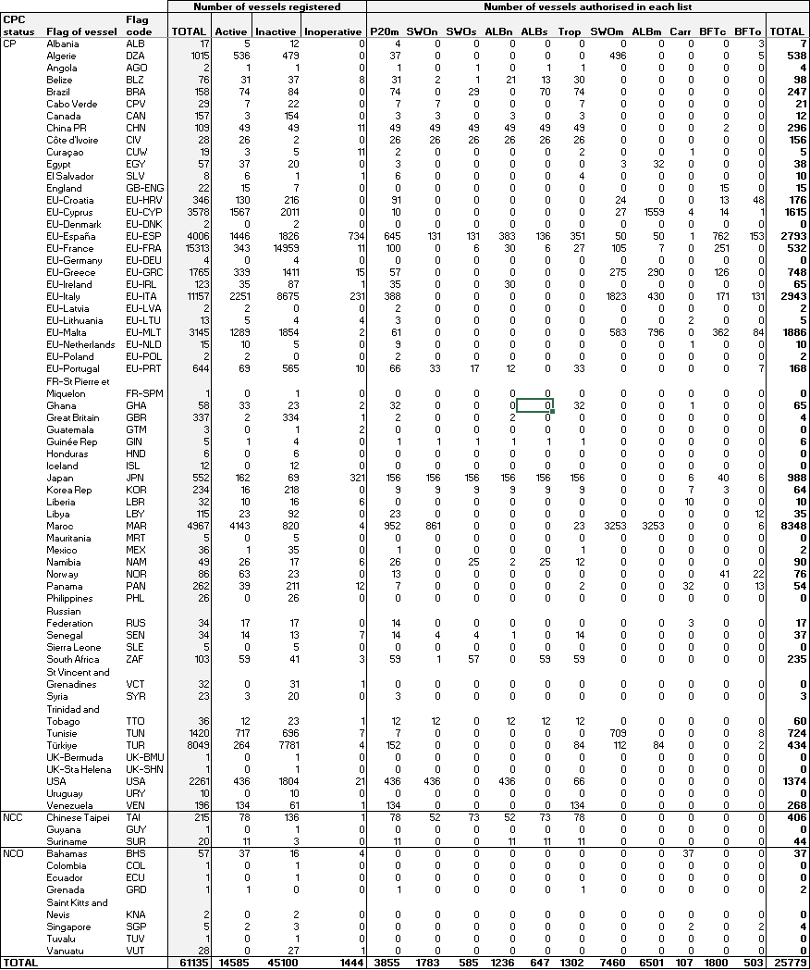

Table 3. Number of vessels registered in the ICCAT vessel record (by flag CPC) with the ratio (%) of incompleteness in important vessel attributes (source: ICCAT vessel record in IOMS, as of 29 October 2025).

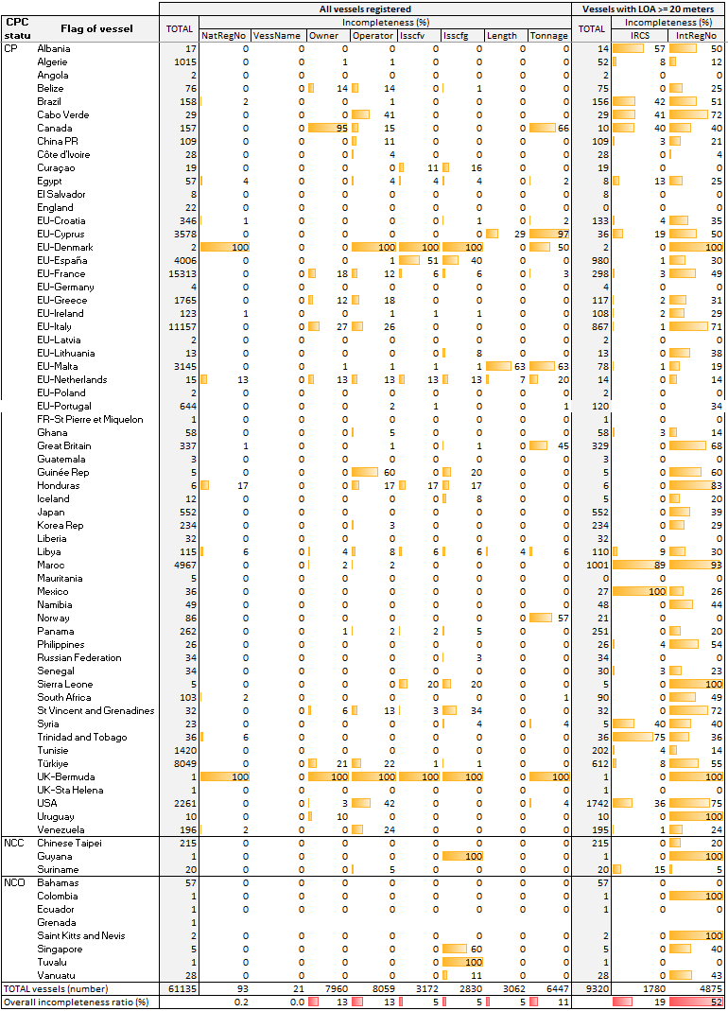

Table 4. Number of vessels registered, active in the positive list (P20m) with International registry number (IntRegNo) type, active in the carrier list (all with IMO number), by flag CPC (source: ICCAT vessel record in IOMS, as of 29 October 2025).
