Original: English
Letter from the Commission Chair
(ICCAT Circular 10828/25)

3 November 2025

Subject: Priorities for discussions at the 29th Regular Meeting of the Commission

Dear Delegates,

As our annual meeting approaches, I would like to highlight some main priorities that will require our collective attention, in-depth discussion and usual spirit of cooperation for ICCAT to keep moving and achieving its goals.

Firstly, within Panel 1, progress on multi-stock tropical tuna MSE will be essential. We must move forward with determination, namely regarding the yellowfin tuna total allowable catch (TAC) and a possible quota allocation key, given that the TAC has been persistently overshoot in recent years, before we put this stock at risk as advised by the SCRS.

Similarly, within Panel 2, discussions on Eastern Atlantic bluefin tuna quota allocations will be crucial to ensure the sustainable management of this species, which is our most exciting success with its recovery that has shown the Commission capacity to deliver when we join our efforts. The recovery of bluefin tuna in recent years is ICCAT’s most significant success story, and we need to keep the high standard of management on this stock as the best demonstration of what the Commission can achieve. We will also continue to strengthen our compliance, a key element of our progress, as well as discussions to improve our conservation and management measures.

Sharks are an increasingly important issue for us. This year, we will consider possible measures to address the problem of shark finning. Furthermore, to provide a clearer basis for our initiatives on sharks, we need to speed up the ratification of the 2019 Palma protocol.

The Standing Committee on Finance and Administration (STACFAD) will also have a very busy schedule this year, with, among other key elements, the adoption of the next biannual budget in a difficult financial context, the consideration of administrative issues of the Secretariat which need urgent solutions to allow the optimal continuation of its work, as well as deliberations on streamlining of some of our main expenditures such as meetings.

This year, we must elect the Commission’s Officers. To this end, I call for a strong consensus on the process to elect these Officers and support them in their mission to lead our work during the next biennium.

As I have consistently emphasized over the past few years, our contribution to marine biodiversity conservation is an essential part of our mandate. In this regard, the entry into force of the BBNJ Agreement is a historic step forward that will require our attention and alignment with the global agenda. One of the pillars that will enable us to better fulfil our role is science, whose new strategic plan deserves our utmost attention for its adoption as soon as practicable.

Furthermore, I believe it is time to consider our third performance review as the annual review of the second one’s recommendations has been fully concluded in 2023. This will give us a further opportunity to assess and strengthen our governance and performance, in particular with a view to possible new challenges such as our possible contribution to the implementation of BBNJ.

I am confident that with our joint commitment; while noting the very busy agenda, we will be able to respond effectively to these priorities and continue to ensure the sustainability of our fisheries.

I am looking forward to working closely with you aiming a successful meeting.

Yours sincerely,

Ernesto Penas
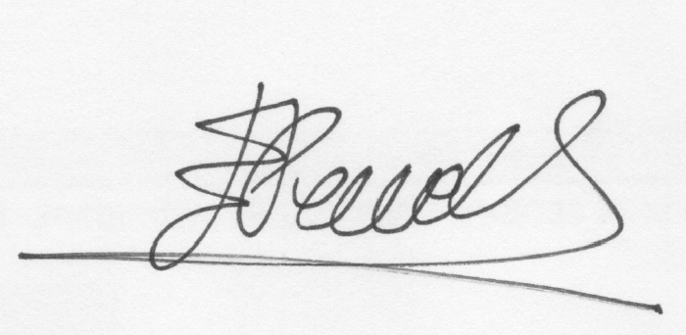
ICCAT Commission Chair

