Original: English

UK Bluefin Tuna Fisheries Development Plan 2026-2028
(submitted by United Kingdom)

- Summary

This Fisheries Development Plan is submitted in support of a request for an increased allocation of eastern Atlantic and Mediterranean bluefin tuna (BFT) to the United Kingdom.

The Plan firstly summarises results of two tagging studies commissioned by the UK Government which have provided information on the abundance and behaviour of BFT in UK waters (including Jersey). It then describes how the UK Government has taken a phased approach to opening both commercial and recreational BFT fisheries. After tracing the steady development of these fisheries, information is provided on the economic benefits the fisheries deliver for our coastal communities, and on the monitoring, control and surveillance regime that is used to ensure their sustainability.

Finally, the Plan looks ahead to the 2026-2028 Total Allowable Catch (TAC) cycle. It sets out the UK’s intention to further develop BFT fisheries over that period and the quota that the UK needs to do that. The conclusion is that the UK needs an annual allocation of 350 tonnes to implement its planned development of BFT fisheries.

- 2014-2022: Scientific studies on bluefin tuna in UK waters

Year | Key events
2014 | Increasing reports of BFT in UK waters (via scientific programmes and other sources).
2018 | In response to increasing reports of BFT sightings ‘Thunnus UK’ scientific study is commissioned.
2021 | ‘One fish per trip’ limit on the sale of bycaught fish in commercial fisheries introduced.  Catch and Release Tagging (CHART) programme commissioned.
2023 | Trial commercial BFT fishery begins.  CHART and Thunnus UK conclude.
2024 | Catch and release recreational fishery (CRRF) begins.
2025 | Commercial rod and reel BFT fishery trial successfully concludes, and it becomes a regular fishery.

Figure 1. Timeline of UK BFT management.

Sightings of BFT in UK waters have been frequently reported by members of the public and fishing vessel crews since at least 2014. Initial anecdotal reports were corroborated by the findings of scientific surveys such as the pelagic ecosystem survey in the Western Channel and Celtic Sea (PELTIC) (Van der Kooij et al, 2015).

The significant interest generated by these sightings led the UK Government to commission two scientific projects to investigate the resurgence of BFT in UK waters. The first project, the Thunnus UK satellite tagging programme, commenced in 2018 and was delivered by the Centre for Environment, Fisheries and Aquaculture Science (Cefas) in collaboration with the University of Exeter. It was followed in 2023 by the Catch and Release Tagging (CHART) programme, which was delivered via a Cefas-led project steering group and in collaboration with charter boat skippers.

The results of these two projects provide a clear picture of the abundance and behaviour of BFT in UK waters. The projects tagged a total of 3,276 BFT and demonstrated that BFT are present in UK waters in every month of the year, with the highest frequency of sightings between August and November. The high level of interest among charter boat skippers in participating in the CHART programme also evidenced the strong socioeconomic potential of recreational fisheries for BFT in the UK.

A summary of the results of both projects was submitted to ICCAT Panel 2 in 2024 (“Bluefin tuna in the waters of the United Kingdom and the case for an allocation increase” [PA2-025/2024], attached as Annex 2). The results were also submitted and presented to the SCRS BFT Species Group, again in 2024. They provide a significant contribution to ICCAT’s body of knowledge on BFT.

Based on these results, the UK Government decided to open a small-scale trial commercial BFT fishery in 2023 and, in 2024 catch-and-release recreational fisheries in England. Welsh Government opened a catch-and-release recreational fishery in Wales in 2024 limited to charter vessels only.

- 2023-2025: The opening of fisheries for bluefin tuna in UK waters

2023-2024

A trial commercial fishery was conducted in the UK in 2023 and 2024. Participants in the trial fished from small-scale vessels utilising rods and reels. This gear type was selected for sustainability as it maximises the possibility of safe release of undersized fish.

The trial was limited to 10 licensed vessels in 2023 and 13 vessels in 2024. This was determined to be the maximum number of licences that could be issued with the quota available. Demand for commercial licences far exceeded the number available:

- In 2023, 47 applications were received, and 10 licences were issued.
- In 2024, 104 applications were received, and 13 licences were issued.

Each vessel was assigned a 3.9 t quota in 2023 and 3 t quota in 2024. Despite this being a new fishery uptake of quota was good, with 87% of quota utilised in 2024.

Following the conclusion of CHART in 2023, recreational catch-and-release fisheries were opened in 2024. Again, demand for permits in the fishery outstripped supply, with 168 applications received and 102 permits issued.

Economic analysis

Coastal communities are among some of the most deprived in the UK (ONS, 2020). For example, Cornwall, where the UK’s BFT fisheries are currently concentrated, is more deprived than two thirds of the local authorities in England (English Indices of Deprivation, 2019).

Economic analysis commissioned by the UK Government made clear that both the commercial and recreational fisheries provide important social and economic benefits to these communities, such as investments in new boats, improved processing facilities and community events. Additionally, the commercial fishery provides an opportunity for UK inshore fishers to land high value fish with a growing market, at a time when some key target stocks are under pressure. Equally, the recreational fishery has provided a valuable diversification opportunity. Growth in these fisheries will strengthen economic resilience in coastal communities and add value to the economy.

Key findings from the economic analysis were that:

- In 2024, the commercial fishery generated approximately £0.5m through revenue. When also considering downstream impacts, the fishery added £0.8m in value to the UK economy (Pollett and Walmsley, 2025, p16).
- In 2024, the recreational fishery generated approximately £0.7m through skippers’ expenditure, rising to £2.6m when including expenditure by paying anglers (Riley and Brooks, 2025, p28).

Based on the success of the commercial trial in 2023 and both fisheries in 2024, the UK Government decided to continue with the fisheries in 2025, with a transition from a commercial trial to a regular commercial fishery.

2025

The 2025 BFT commercial fishery opened on 1 July. The 2025 commercial fishery is limited to 15 licences and 3 t quota per vessel. Once again demand has far outstripped supply, with 132 applications received. Several fishers have also indicated that they want to fish more than 3 t but, again due to the limited quota available, it has not yet been possible to fulfil meet fishers’ requests.

The 2025 English recreational fishery opened on 18 July. Demand for permits has again outstripped supply, with 246 applications for permits received and 153 permits issued.

Given the success of the commercial trial in 2023 and of both fisheries in 2024, combined with the strong demand for more licences and more quota by fishers, it is the UK Government’s intention to facilitate further sustainable development of UK BFT fisheries over the next three-year TAC cycle (2026-2028).

- 2026-28: Further development of UK BFT fisheries

The further development of commercial and recreational UK BFT fisheries in 2026-2028 will be guided by the following three principles:

- Expand both commercial and recreational BFT fisheries in UK waters by building on the fisheries we have established.
- Improve BFT fisheries by continually evaluating our management and operation against the policies in the UK Joint Fisheries Statement, the objectives in the UK Fisheries Act and our international obligations, and through engagement with stakeholders and interested parties in the fishery.
- Maximise environmental, social and economic benefits for UK coastal communities by sustainably managing our BFT fisheries.

The following development of these fisheries is planned for the 2026-28 period:

- To better meet demand for commercial licences, the UK intends to increase the number of licences available annually from 15 to 70 by 2028. This is to cater to the increasing interest across the UK. Indications are that BFT are now spreading throughout UK waters, creating potential for sustainable expansion of the fishery in other parts of the UK. It is intended that the gear type used in the fishery remains limited to rod and reel.
- To allow each licensed fisher to undertake increased fishing for BFT, it is intended to increase quota available to each vessel from 3t to 4t.
- The UK intends to increase the number of permits available for recreational fishing to a maximum of 500 by 2028, to better meet demand and to allow for the development of recreational fishing across the UK. The UK intends to allocate 50t to this activity, to account for the risk of accidental mortality.
- The UK expects some tagging programmes to continue and intends to continue to allocate 1t to cover all tagging activities.
- The UK intends to continue to allocate 5-10t to account for bycatch in fisheries that do not target BFT.
- The UK intends to continue its careful management of these fisheries by ensuring that fishers receive training on using the electronic Bluefin Catch Document (eBCD) scheme, handling best practices to ensure maximum survivability of any fish that are released, and by allocating sufficient monitoring, control and surveillance resource commensurate with the level of activity and risk, including port and market inspections and inspection of both fisheries at sea. See Section 6, below.
- If funding becomes available, the UK will also consider commissioning further research programmes to contribute to ICCAT’s body of knowledge on Atlantic BFT.

To facilitate the planned development of UK fisheries during the 2026-28 TAC cycle, the UK needs an annual quota of 350t.

The UK’s annual quota during the 2023-25 period was 63t, or 0.16% of the TAC – the lowest of all eastern BFT coastal State ICCAT members. If the UK was limited to this level in future, it would be unable to meet the increasing demand by our commercial fishers to diversify into and expand their BFT fishing and would be unable to further develop recreational fisheries. The UK would therefore be unable to maximise the social and economic benefits of this abundant and sustainable resource in its Exclusive Economic Zone.

- Market demand and onshore facilities

Current quota levels have resulted in limited investment in supply chain facilities such as flash freezers. This is because there is limited return on such investment without a sufficient quantity of BFT landings. The requested increase in UK quota would ensure an increased and more consistent quantity of BFT entering the supply chain. This would in turn enable more confident investment into the supply chain, allowing the market to be managed more effectively and encouraging more buyers to enter the market. To summarise: an increased BFT quota will enable the market to grow and mature. The UK government is considering whether grants can be used to develop these onshore facilities to support the fishery.

- Monitoring, control and surveillance

UK fisheries administrations focus inspection activity on BFT landings into designated BFT landing ports and monitor any landings of bycatches into other commercial ports.

Inspections are risk-based and intelligence-led, and annual target rates are reviewed on a regular basis. Monitoring, control and surveillance activities cover recreational and commercial fishing activity and downstream market activity, ensuring that no unauthorised marketing takes place and that catches are fully documented. Fisheries officers focus efforts on the compliant landing and traceability of fish.

In the first year and second years of the commercial fishery, 2023 and 2024, inspection rates of BFT landings were 30% and 15% respectively. These figures demonstrate that the UK is committed to careful management, with inspection rates decreasing in line with a risk-based approach as the fishery is developing.

Mandatory training is delivered to all commercial BFT vessel operators. The training covers reporting requirements including eBCD, minimum fish sizes, gear requirements, and selling only to registered buyers. Skippers are also provided with a wheelhouse instruction card with all relevant requirements as well as fisheries administration contact details to report landings.

The UK Government intends to continue its effective management of these fisheries by ensuring that fishers receive training on using eBCD and on best practice in fish handling to ensure maximum survivability of any fish that are released. We will continue to allocate sufficient monitoring, control and surveillance resource commensurate with the level of activity and risk – including port and market inspections and inspection of both fisheries at sea.

Recreational fishers in England are strongly encouraged to comply with a BFT Code of Conduct which sets out best practice for the fishery. This has been developed via close collaboration between the UK Government, Cefas, Natural England and stakeholder representatives. Mandatory training on the Code of Conduct is currently under development.

- Benefits beyond fisheries – BFT and ecotourism

Tourism is a significant contributor to coastal economies throughout the UK, with ecotourism becoming an increasingly important component of the sector.

The resurgence, and increasingly frequent sightings, of BFT in UK waters have generated huge interest in the UK media and among the public more widely. Opportunities to observe this charismatic species via ecotourism activities are likely already contributing to coastal economies, with potential for this to further contribute to growth in the sector in future.

The careful management of both recreational and commercial fisheries will contribute to the overall protection afforded to the species, ensuring compliance with the policies set out in the UK’s Joint Fisheries Statement. This will in turn ensure an ecosystem-based approach to the management of BFT fisheries, allowing these non-fisheries community benefits to be maximised.

- Conclusion

BFT has been demonstrated to be an abundant resource in UK waters that can, through careful development and management of both recreational and commercial fisheries, bring substantial and sustainable economic benefits to fishers and coastal communities in the UK where other economic opportunities are often very limited.

This has been clearly demonstrated by the gradual development of the commercial BFT fishery in the UK since 2023. Fishers have expressed a strong and increasing interest in participating in the fishery, while buyers and markets have shown a strong and increasing interest sourcing high-quality BFT products sourced from a sustainable small-scale UK fishery.

There has been, and continues to be, a strong demand for licences that far outstrips supply. Similarly, many fishers are hitting their individual quota limits and would like to be able to undertake more fishing for BFT each year. However, the further development of the fishery is prevented by the very limited amount of quota currently available to the UK.

The development of recreational fisheries for BFT has also been highly successful, with many coastal communities benefitting from tuna-related tourism since 2024. Again, demand for permits has far outstripped supply. The UK intends to develop these fisheries further and make more permits available, but once again this has been limited by the quota available to the UK.

Securing a sufficient UK quota allocation for 2026-2028 will be the priority for the UK at the Regular Meeting of the Commission in November 2025. The UK needs 350 t to implement its Fisheries Development Plan for the period. We are confident that through open and honest dialogue between ICCAT members it will be possible to agree a sustainable management framework for eastern Atlantic BFT for 2026-2028, including quotas for individual members that align with their legitimate needs and aspirations. The UK looks forward to working collaboratively with all interested ICCAT members to achieve this.

References

ONS. (2020). Coastal towns in England and Wales - Office for National Statistics. Available at: https://www.ons.gov.uk/businessindustryandtrade/tourismindustry/articles/coastaltownsinenglandandwales/2020-10-06
(Accessed: 14 October 2025).

Pollett, J. and Walmsley, S. (2025). Impact Evaluation: 2024 Eastern Atlantic Bluefin Tuna Commercial Trial Fishery - MB5111. Available at: https://sciencesearch.defra.gov.uk/ProjectDetails?ProjectId=21830 (Accessed: 19 September 2025).

Riley, W. and Brooks, H. (2025). Impact Evaluation: 2024 Eastern Atlantic Bluefin Tuna Catch-and-Release Recreational Fishery (CRRF) - MB5112.
Available at: https://sciencesearch.defra.gov.uk/ProjectDetails?ProjectId=21831
(Accessed: 19 September 2025).

The English indices of deprivation (2019)
Available at: https://assets.publishing.service.gov.uk/media/5d8e26f6ed915d5570c6cc55/IoD2019_Statistical_Release.pdf
(Accessed: 13 October 2025).

Van der Kooij, J., Capuzzo, E., Silva, J., and Symes, N. (2015). CEND20_14 Cruise Report PELTIC14: Small Pelagic Fish in the Coastal Waters of the Western Channel and Celtic Sea PELTIC14: Small Pelagic Fish in the Coastal Waters of the Western Channel and Celtic Sea. Lowestoft, England.

Annex 1
Expanded timeline
Year | Key events | UK Quota | Quota split | Number of applications for licences received versus the total issued | Commercial quota uptake
2021 | ‘One fish per trip’ limit on the sale of bycaught fish in commercial fisheries introduced.  CatcH And Release Tagging (CHART) programme commissioned. | 48.40 t | Bycatch: 20 t  CHART: 10 t | N/A | N/A
2022 | N/A | 48.40 t | Bycatch: 20 t  CHART: 10 t | N/A | N/A
2023 | Trial commercial BFT fishery begins.  CHART and Thunnus UK conclude. | 63 t | Bycatch: 14t  CHART: 10 t  Commercial trial: 39 t | Number of applications received for the commercial trial: 44  Number of licences issued for the commercial trial: 10 | Commercial trial uptake: 17.88 t
2024 | Catch and release recreational fishery (CRRF) begins. | Adjusted quota: 66.15t | Bycatch: 9.15t  Tagging activities other than CHART: 1t  Commercial trial: 39t  CRRF: 16t | Number of applications received for the commercial trial: 104  Number of licences issued for the commercial trial: 13  Number of applications received for the recreational fishery: 168  Number of permits issued in the UK: 102 | Commercial trial uptake: 35.20 t
2025 | Commercial BFT fishery trial successfully concludes and it becomes a regular fishery. | Adjusted quota: 66.15t | Bycatch: 7.15 t  Tagging activities other than CHART: 1 t  Commercial fishery: 45 t  CRRF: 13 t | Number of applications received for the commercial fishery: 132  Number of licences issued for the commercial fishery: 15  Number of applications received for the recreational fishery: 256  Number of permits issued in the UK: 153 | N/A

Annex 2
Information on BFT abundance in UK waters

Bluefin tuna in the waters of the United Kingdom and the case for an allocation increase

(Document submitted by the United Kingdom, and to be read in conjunction with PA2_24/i2024 also submitted by the United Kingdom)

Summary

- This paper provides evidence and information in support of an increased allocation of eastern Atlantic and Mediterranean bluefin tuna (BFT-E) to the United Kingdom.

- Since 2014 there has been a huge resurgence of bluefin tuna (BFT) in the UK’s exclusive economic zone (EEZ). The success of our BFT tagging programmes, which have been in place since 2017, evidences this resurgence and contributes to ICCAT’s body of knowledge on the stock.

- The UK has ambitions to develop BFT fisheries in our waters, but our current allocation of just 0.16% of the BFT-E total allowable catch (TAC) (the second lowest of all ICCAT CPCs) does not properly reflect the stock’s abundance in UK waters. This in turn prevents us from developing fisheries beyond a minimal level of ambition.

- This paper is submitted in support of the UK’s continued request for a quota increase.

Historical context

- There are historic records of Atlantic bluefin tuna (BFT) in UK waters from at least the 19th century (Bennema, 2018). The UK had a flourishing recreational fishery for BFT in the central North Sea, off the English east coast, between the 1930s and 1960s (Berry, 2010) and a commercial fishery developed in the same area from 1946 onwards, including activity by Germany and other European countries (Tiews, 1975). The stock then seemingly disappeared from UK waters after 1963. This disappearance was probably due to a combination of factors including fishing pressure and environmental factors (Fromentin, 2009). The reappearance of BFT in the northeast Atlantic in the last ten years is well documented (McKenzie et al., 2014, Nottestad et al., 2020; Jansen et al., 2021; Horton et al., 2021; Aarestrup et al., 2022; McKenzie et al., 2023) and was discussed in detail at the ICCAT BFT e-tagging workshop in July 2023 (Anon, 2023).

The resurgence of BFT in UK waters

- Since 2014 BFT have been reported increasingly frequently off the southwest coast of the UK and have been present in UK waters every subsequent year. Since their initial documented reappearance in 2014, the numbers observed (via scientific programmes and other sources) have increased substantially each year and they have been observed in every month of the year with the highest frequency of observations between August and November. This reappearance, documented in the UK pelagic ecosystem surveys (PELTIC) and other sources of information (Horton et al., 2021) underlines the UK’s status as a coastal State for BFT-E. Spatial coverage of scientific studies that have produced evidence of bluefin in and around the UK are shown in the Annex (Figure 1).

- The return of BFT to UK waters appears to be part of a wider reappearance of the stock across a greater area of the North Atlantic, including a return to Norwegian waters from around 2012 (Nøttestad et al., 2020), appearing off east Greenland at about the same time (Jansen et al., 2021) and more recently reappearing in the Skagerrak and Kattegat off Denmark and Sweden (Aarestrup et al., 2021). Aarestrup's study indicates a migration route in UK waters to the north and west of Scotland and also a feeding ground in the central North Sea (Figure 2).

UK scientific programmes for BFT

- The UK has commissioned two successful tagging programmes for bluefin tuna: Thunnus UK and CHART (‘CatcH and Release Tagging’). Both projects have been designed to collect high quality scientific data on the demographics and abundance of BFT in UK waters. Pop-up satellite tags provided by ICCAT have been deployed as part of the Thunnus UK programme. The data from the programmes have been presented to, and discussed at, ICCAT workshops and therefore contribute to the ICCAT Grand Bluefin Tuna Year Programme (GBYP).

- Thunnus UK was established in 2017 and 82 adult BFT (>141 cm) were tagged with pop-up archival satellite tags to the end of 2023 (Table 1). A further 17 tags were deployed in 2023. The data transmitted to date show that after leaving UK waters the fish spent most of their time in the Atlantic before moving to the Mediterranean Sea and areas in the Bay of Biscay, possibly to spawn. The majority of individuals show fidelity to UK waters after one and two years at liberty, and all return to northerly shelf locations after June/ July after either spawning in the Mediterranean or foraging in the wider Atlantic. Detailed results from the Thunnus UK programme were presented to the GBYP workshop on e-tagging in July 2023. A summary of the first two years of tracking data is shown in Figure 3. Data collection and analysis from the most recent tags is ongoing; however, publication of the results in peer review publications is expected in 2024 and beyond.

CHART was established in 2021 and continued into 2022. The English CHART programme, the largest of the UK’s CHART programmes, tagged 704 fish in 2021, increasing to 1,090 fish in 2022, and 1,383 in 2023. The English programme is run by the Centre for Fisheries and Aquaculture Science (Cefas) and tagging has primarily been carried out off the southwest coast of England; Figure 4 shows where the BFT were caught and tagged. In 2021, the UK CHART programme was responsible for ~55% of the tags deployed on BFT in the NE Atlantic (NB: it is not possible to provide the same statistic for 2022 or 2023 until the public version of the database is updated). The tags deployed in the programme are provided as part of ICCAT GBYP, and therefore the data are provided directly to the SCRS and the return of tags is managed by GBYP (ICCAT, 2023, Ford et al., 2023).

- The data from these two successful programmes, and of other tagging programmes in EU Member States, indicate an abundance of large BFT in the UK’s EEZ and suggest ongoing increases in numbers of fish present (Phillips et al., 2022).

The UK’s approach to managing BFT in our waters

- The UK has always taken a cautious approach to managing BFT. While the UK was represented by the European Union as a Member State, the UK took the unilateral decision to ban the sale of bycaught BFT. This was to ensure that there was no commercial profit to be made from fish landed as bycatch, to contribute to recovery of the stock.

- The UK has continued to apply the same level of caution as an independent ICCAT CPC following EU exit:

- In the implementation of our successful tagging programmes: for CHART we have applied strict training criteria for skippers wanting to take part in the programme, which has minimised incidental mortality to less than 1% of fish tagged. Thunnus UK followed ICCAT GBYP protocols which cover inter alia handling, return to water etc.

- We have not yet developed commercial fisheries and have put a ‘one fish per trip’ limit on the sale of bycaught fish in commercial fisheries. This is to avoid incentivising targeting in any fishery that is not authorised to target BFT.

- Having taken this cautious approach for several years and now being sufficiently assured of the stock’s recovery and good health, we now consider there to be scope for the UK to develop commercial fisheries for BFT-E, in accordance with our rights under UNCLOS to exploit resources within our EEZ. To explore the potential for commercial fishing further we launched a trial of a small-scale fishery in 2023, details of which were set out in our 2023 BFT-E Fishing Plan. We intend to continue the trial in 2024 and again the details are set out in our Fishing Plan.
Current situation regarding quota/allocation

- Despite the well-evidenced resurgence of the BFT-E stock in UK waters, the UK currently has just 0.16% of the available TAC. This is the lowest of all coastal States and is the second lowest of all ICCAT CPCs and results in a quota of 63 t from a TAC of 40,570 t. This prevents us from realising anything other than a minimal level of ambition to develop commercial BFTE fisheries. The situation is particularly acute given that each UK Administration (England, Wales, Scotland, Northern Ireland) manages its fisheries separately and their fishing industries can be considered largely independent of each other. Carving up 63 t between these four administrations would provide little benefit to any of them.

UK plans and ambitions

- The UK’s BFT-E Fishing Plan for 2024 includes a catch and release tagging (CHART) programme, a bycatch allowance, continuation of the trial commercial fishery that commenced in 2023 and new catch-and-release recreational (CRRF) fisheries.

- The commercial fishery trial involves small (<15 m) vessels using highly selective gears to target BFT-E. The trial is the first targeted commercial BFT-E fishing by UK vessels for several decades. By continuing the trial into a second year, the UK is continuing to explore the potential for future development of high-value commercial fisheries based around sustainable, highly-selective, low-impact fishing in order to bring social and economic benefits to coastal communities across the UK.

- The UK also plans to build on the success of the CHART programme through the introduction of catch-and-release recreational fisheries (CRRF) for BFT in 2024, thus further increasing the socioeconomic benefits to coastal communities.

- However, the further development of such fisheries will require additional quota. This is particularly the case taking into account the potential future needs of UK administrations and UK Crown Dependencies (the UK is in the process of extending its membership of ICCAT to its Crown Dependencies).

The case for an increased share

- The UK, like neighbouring coastal State CPCs, has seen large numbers of bluefin tuna reappearing in our EEZ. But whilst those neighbouring CPCs and many others have been able to benefit from the return of these fish, the UK has not had the same opportunities. The UK’s low quota (63 t in 2023 - the second lowest of all CPCs) restricts our fishing opportunities and does not provide us with sufficient scope to further develop BFT-E fisheries.

- Other northeast Atlantic CPCs have considerably higher allocations (Norway has 0.91% and Iceland has 0.55%). As a coastal State with increasing numbers of BFT in our EEZ, the UK’s allocation should be at least comparable to those CPCs. Such an allocation would provide scope for the UK to realise its ambitions of developing small-scale, highly-selective commercial fisheries, alongside catch-and-release recreational fisheries, and provide valuable diversification opportunities to coastal communities in the UK that rely upon fishing.

- Furthermore, we do not consider such a small UK share to be consistent with our rights to exploit resources in our EEZ as established by UNCLOS, nor with the approach to allocation established by Resolution by ICCAT on Criteria for the Allocation of Fishing Possibilities (Res. 15-13).

Conclusion

- Bluefin tuna have returned to UK waters in significant numbers over the last decade. We have ambitions to further develop BFT fisheries in future years to bring socioeconomic benefits to coastal communities in the UK, but are limited by the fact that we have just 63 t quota. Based on available evidence and our stated ambitions, we consider that the UK should receive an BFT-E allocation at least comparable to that of neighbouring CPCs. We urge that this is taken into account in the development of new allocation keys for the stock.
Annex

Table 1. Summary of BFT tagging in the UK to end of 2022. Figures in parentheses show the number of ICCAT-provided PSAT deployed in the programme.

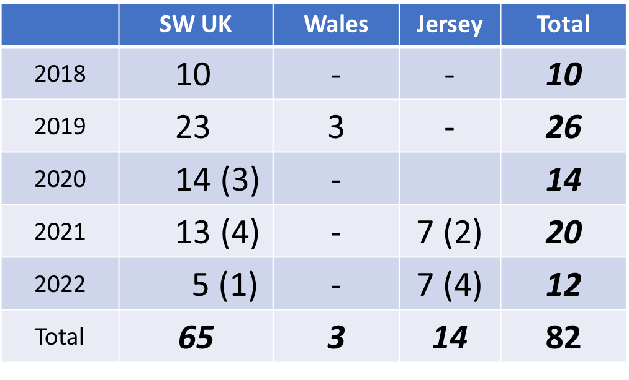

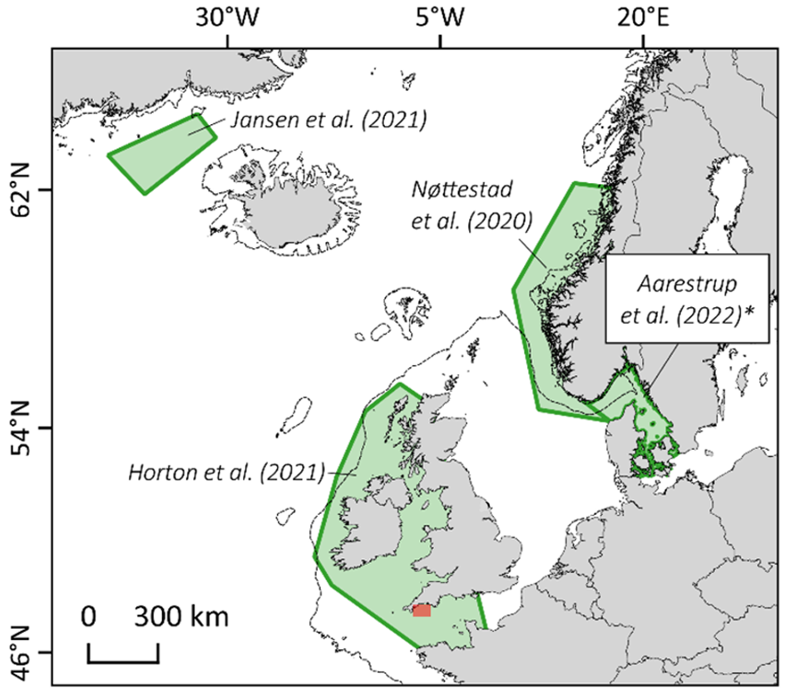
Figure 1. The Northeast Atlantic showing locations of recent studies of Atlantic bluefin tuna as green polygons.

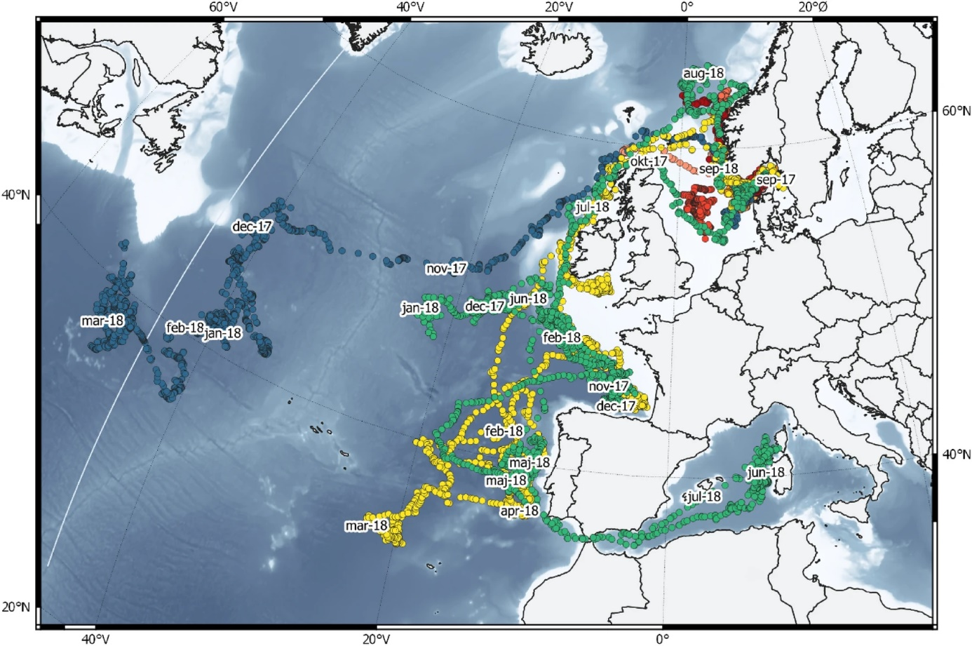

Figure 2. Tracks of 11 BFT fitted with electronic tags in Danish/Swedish waters. From Aarestrup et al. (2022). * Different colours indicate different individual fish, tracks for fish where the tag remained attached for less than seven months are indicated in shades of red.

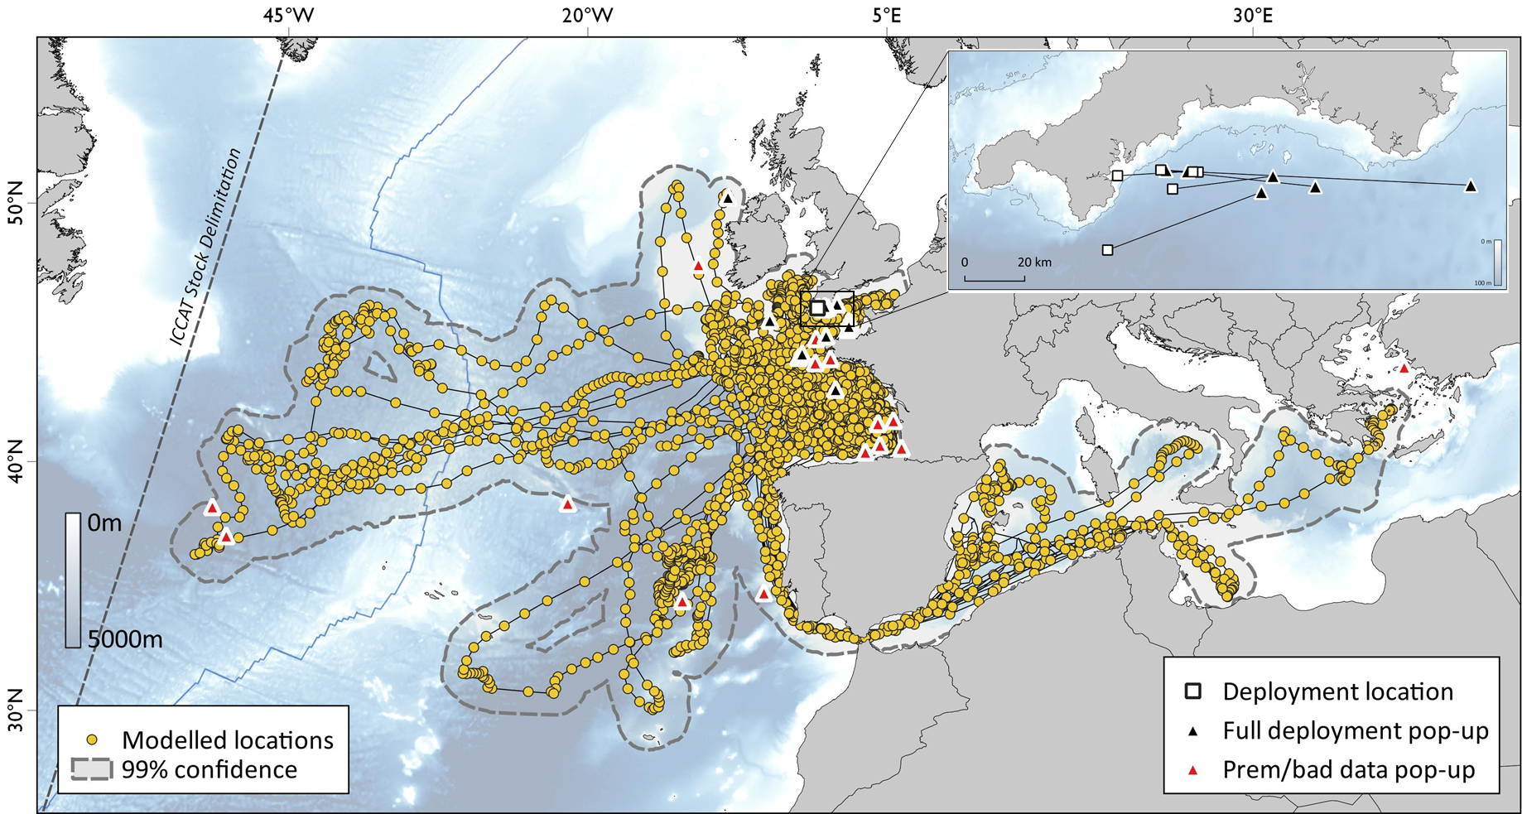

Figure 3. Combined tracks (circles joined by lines) of 13 Atlantic bluefin tuna tagged off the SW of the UK in 2018 and 2019 that were at liberty for a year before their tags popped up. Pop-up positions are shown by triangles; pop-up positions of other tagged tuna that were not at liberty for a full year are shown as red triangles. Some tuna returned to their place of tagging (inset). Further details at: https://www.thunnusuk.org/post/thunnus-uk-the-first-two-years-of-atlantic-bluefin-tuna-tracking.

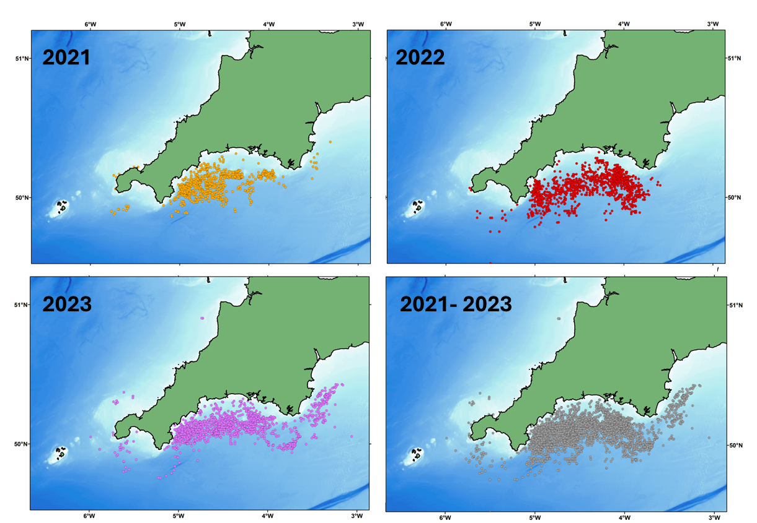

Figure 4. Locations of tagged captured BFT during the 2021 and 2022 CHART programme.

References

Aarestrup, K., Baktoft, H., Birnie-Gauvin, K., Sundelöf, A., Cardinale, M., Quilez-Badia, G., Onandia, I., Casini, M. Eg Nielsen, E., Koed, A., Alemany, F. and MacKenzie, B.R. 2022. First tagging data on large Atlantic bluefin tuna returning to Nordic waters suggest repeated behaviour and skipped spawning. Nature Scientific Reports 12:11772.

Anonymous. 2023. Report of the 2023 ICCAT GBYP Workshop on Atlantic bluefin tuna electronic tagging. Collect. Vol. Sci. Pap. ICCAT, 80(9): 89-115.

Bennema, F.P. 2018. Long-term occurrence of Atlantic bluefin tuna Thunnus thynnus in the North Sea: contributions of non-fishery data to population studies. Fish. Res. 199, 177-185.

Berry C. 2010. Tunny, the Rise and Fall of Britain’s Biggest Fish. Medlar Press, Ellesmere, UK. 192pp.

Ford, J., Righton, D. Ribeiro Santos, A., Murphy, S., McMaster, J., Thomas, S., Duffy, M., Davis, S., Arris, M., Phillips, S. 2023. Summary of the 2022 catch and release tagging (CHART) programme in southwest England. Collect. Vol. Sci. Pap. ICCAT, 80(9): 167-171.

Fromentin, J.-M. 2009. Lessons from the past: investigating historical data from bluefin tuna fisheries. Fish and Fisheries, 10, 197-216.

Horton, T.W., Block, B.A., Davies, R., Hawkes, L.A., Jones, D., Jones, H., Leeves, K., Maoiléidigh, Ó, Righton, D., van der Kooij, J., Wall, D., Witt, M.J. 2021. Evidence of increased occurrence of Atlantic bluefin tuna in territorial waters of the United Kingdom and Ireland. ICES J. Mar. Sci.

ICCAT. 2023. Access to ICCAT statistical databases - Tagging - Conventional tagging data - Bluefin tuna (20230131). https://www.iccat.int/en/accesingdb.html

Jansen, T., Nielsen, E., Rodriguez-Ezpeleta, N., Arrizabalaga, H., Post, S., MacKenzie, B. 2021. Atlantic bluefin tuna (Thunnus thynnus) in Greenland—Mixed-stock origin, diet, hydrographic conditions, and repeated catches in this new fringe area. Can. J. Fish. Aquat. Sci. 78, 400–408 (2021).

MacKenzie, B., Payne, M., Boje, J., Høyer, J., Siegstad, H. 2014. A cascade of warming impacts brings bluefin tuna to Greenland waters. Global Change Biology, 20, 2484-2491. https://doi.org/10.1111/gcb.12597Citations: 69.

MacKenzie, B., Aarestrup, K., Asthorsson, O., Birnie-Gauvin, K., Brereton, T., Boge, E., Cardinale, M., Casini, M., Ferter, K., Hawkes, L., Horton, T., Jansen, T., Jones, D., Jones, H., Nøttestad, L., Jeppesen, JP., Ridao, L., Righton, D., Sundelöf, A., van der Kooij, J., Wall, D., Witt, M. 2023. Time-space Documentation of the Recovery / Expansion of Summer Feeding Habitat in the Northeast Atlantic by Bluefin Tuna. ICES CM:2023/ J.

Nøttestad, L., Boge, E., Ferter, K. 2020. The comeback of Atlantic Bluefin Tuna (Thunnus thynnus) to Norwegian waters. Fish. Res. 231, https//doi.org/10.1016/j.fishres.2020.105689.

Phillips, S., Ford, J., Murphy, S., McMaster, J., Thomas, S., Duffy, M., Davis, S., Arris, M., Righton, D. 2022. Summary of the 2021 Pilot Year Catch and Release Tagging (CHART) Programme in Southwest England. Collect. Vol. Sci. Pap. ICCAT, 79(3): 945-951.

Tiews, K. 1975. On the disappearance of bluefin tuna in the North Sea and its ecological implications on North Sea fish stocks. ICES CM 1975/J:3.

