Original: English/French

Vessel sightings reported under Recommendation by ICCAT on vessel sightings (Rec. 19-09)

The Recommendation by ICCAT on vessel sightings (Rec. 19-09) provides that CPCs should report to the ICCAT Secretariat any vessels sighted that could possibly be engaged in fishing or fishing-related activities presumed to be illegal, unreported, and unregulated (IUU), as defined under paragraph 1 of the Recommendation by ICCAT amending Recommendation 21-13 on establishing a list of vessels presumed to have carried out illegal, unreported and unregulated fishing activities (Rec. 23-16).

Vessel sighting sheets (CP18 forms) and/or related documents have been submitted by Algeria and the European Union, pertaining to seventeen (17) flagged vessels, as follows:

CPC | Number of vessels
Albania | 3
Senegal | 1
Morocco | 4
European Union | 3
Algeria | 6

This document comprises the following:

Submissions under Rec. 19-09 received:
- European Union on Senegal, circulated as ICCAT Circular # 02372/2025.

- European Union on Morocco, circulated as ICCAT Circular # 04940/2025.

- Algeria on Algeria and the Europea Union, circulated as ICCAT Circular # 09349/2025.

Responses to Submissions under Rec. 19-09 received:

- Response from Senegal to the European Union (document A above), circulated as ICCAT Circular #02686/2025.

- Response from Morocco to the European Union (document B above), circulated as ICCAT Circular #09347/2025.

- Response from the European Union to Algeria (document C above), circulated as ICCAT Circular #10178/2025.

  - Response from Algeria to European Union (document 3 above), circulated as ICCAT Circular # 10294/2025.

      - Submissions under Rec. 19-09 received from European Union on Senegal
(ICCAT Circular # 02372/2025)

European Commission
Directorate-general for
Maritime affairs and fisheries
International Ocean Governance
and Sustainable Fisheries
Regional Fisheries Management Organisations

Brussels
MARE.B.2/SH

Mr Camille Jean Pierre Manel
Executive Secretary
ICCAT
Corazón de María, 8 E
28002 Madrid

Subject: ICCAT - potential non-compliance - FAD closure

Dear Camille,

In accordance with paragraph 2 of the ICCAT Recommendation 19-09 “Recommendation by ICCAT on vessel sightings”, I wish to notify you of a potential non-compliance with the FAD closure period by the Senegalese-flagged vessel “Sea Breeze” (AT000SEN00036, IMO number 7817323). Please see the evidence submitted by the EU fleet in annex to this letter. In line with paragraphs 62 to 64 of the ICCAT Recommendation 24-01 “Recommendation by ICCAT replacing Recommendation 22-01 on a multi-annual conservation and management programme for tropical tunas”, I would ask that immediate follow-up action be taken in relation to the vessel, an investigation be opened, a report produced and additional measures taken if necessary.

Where non-compliance is identified, the EU would request that in line with paragraph 6 of the ICCAT Recommendation 19-09 and paragraphs 63 and 64 of the ICCAT Recommendation 24-01 the results of the investigation and the corresponding measures taken be submitted for consideration by the ICCAT Commission. Depending on the outcome of the investigation the EU may also pursue this matter in accordance with the ICCAT Recommendation 08-09 “Recommendation by ICCAT to establish a process for the review and reporting of compliance information” and the ICCAT Recommendation 23-16 “Recommendation by ICCAT amending Recommendation 21-13 on establishing a list of vessels presumed to have carried out illegal, unreported and unregulated fishing activities”.

Yours sincerely,

Stijn BILLIET Head of Unit

Annex to submission A: Notification of potential non-compliance with the FAD closure

c.c.: S. Howard, C. Ribeiro, L. Marot, B. Marcoux, F. Galetti, F. Miranda, J. Broche, M. Serna, M. Bigorgne, R. Cesari, L. Molledo.

Annex to submission A
Notification of illegal fishing activity - tuna vessel "sea breeze"
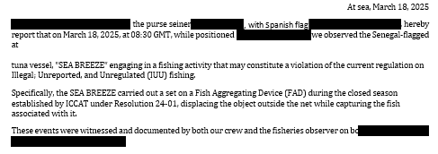
As this activity may be in violation of ICCAT regulations and other international conservation laws, we respectfully request that a formal investigation be conducted into these events and, if warranted, that appropriate measures be taken against the possible violation.
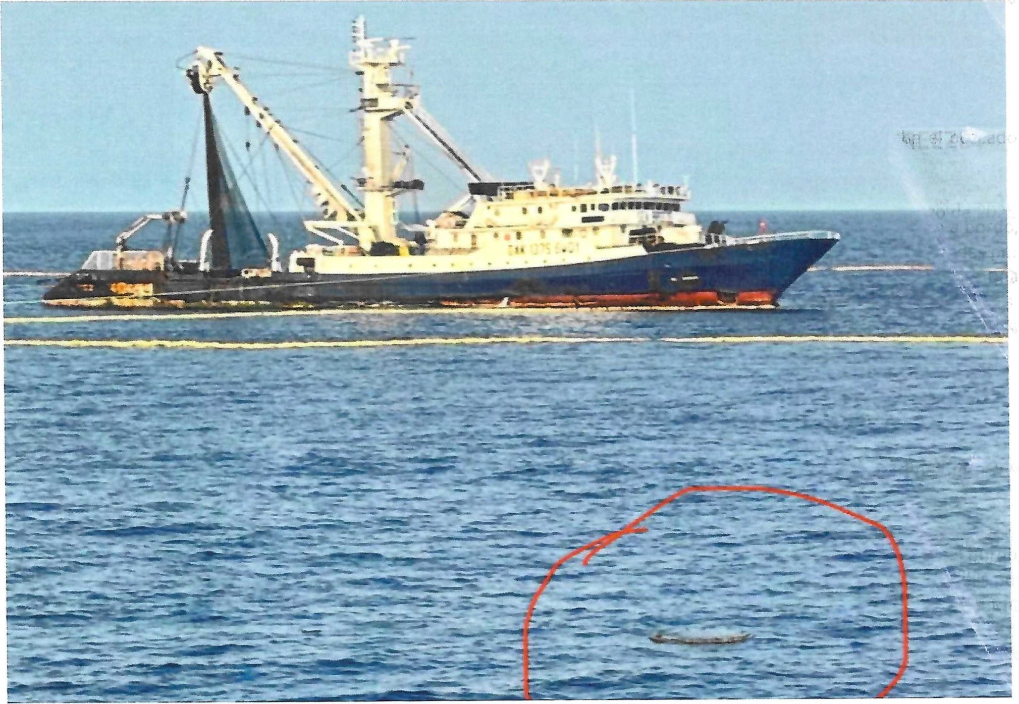

- Submissions under Rec. 19-09 received from European Union on Morocco
(ICCAT Circular # 04940/2025)
Vessel sightings information (Annex 1 to 4 to submission B) submitted by the EU summarised in the table below:
Date | Report type | Suspected infringement | Flag | FV type | Name | ICCAT  registration number
21/05 | Sighting | Y | MAR | GND | ANNOUR | AT000MAR04927
21/05 | Sighting | Y | MAR | GND | ABOUDAOUD | AT000MAR01569
22/05 | Sighting | Y | MAR | GND | NOUR KAMAR | AT000MAR02726
22/05 | Sighting | Y | MAR | GND | TILILA-4 | AT000MAR04387

Annex 1 to submission B
SIGHTING INFORMATION SHEET
1. Date of Sighting: Time 0735UTC Day 21 Month 05 Year 2025
2. Position of Vessel Sighted:
Latitude N35°49’33” Longitude W002°41’37”
3. Name of the Vessel Sighted: ABOUDAOUD
4. Flag Country: MAR
5. Port (and Country) of Registry: -
6. Type of Vessel: GND
7. International Radio Call Sign: -
8. Registration Number: 1-2406
9. ICCAT Serial Number: AT000MAR01569
10. IMO Number: -
11. Estimated Length Overall and Gross Tonnage: 6 m 2 GT
12. Fishing Gear Description (if applicable):
Type: Driftnets (GND) Estimated quantity (units)
13. Nationality of Captain: - Officer: - Crew: -
14. Vessel Situation (Please check):
[X] Fishing [ ] Cruising [ ] Drifting
[ ] Supplying [ ] Transshipping [ ] Other (Specify)
15. Type of Activities of the Vessel Sighted (Please describe):
Fishing vessel engaged in the retrieval of the fishing gear (driftnets). Large pelagic species (SWO) observed.
Driftnets used to fish for large pelagic species in contravention of ICCAT Rec 03-04 Para 3.
16. Description of vessel:
See attached pictures.
17. Other Relevant Information:
The fishing vessel was linked by a rope to another fishing vessel:
- MAR GND ANNOUR (AT000MAR04927)
18. THE ABOVE INFORMATION WAS COLLECTED BY:

NAME: José Déniz / Carlos Couce TITLE: ICCAT Inspectors EU-ES 0226/2021; EU-XFA 0035/2022

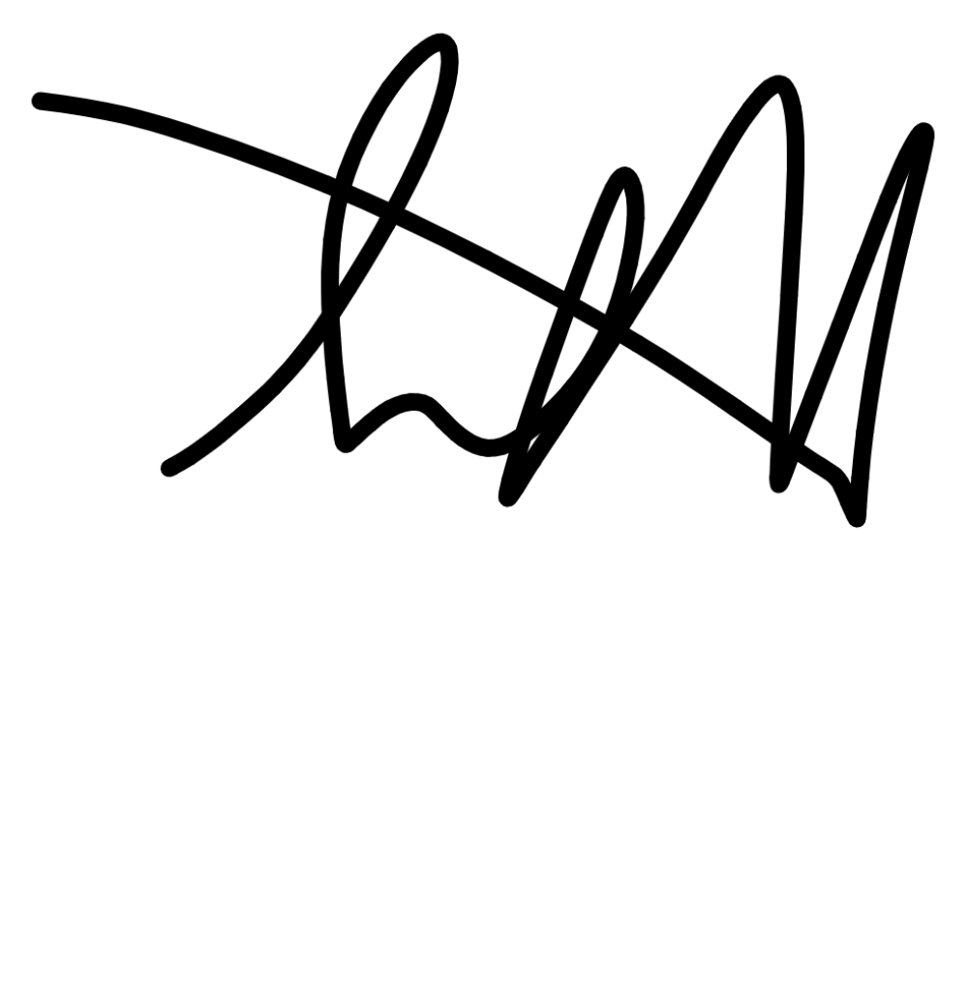
MEANS OF SIGHTING (including vessel/aircraft name, where appropriate): EFCA FWA BLUE KNIGHT
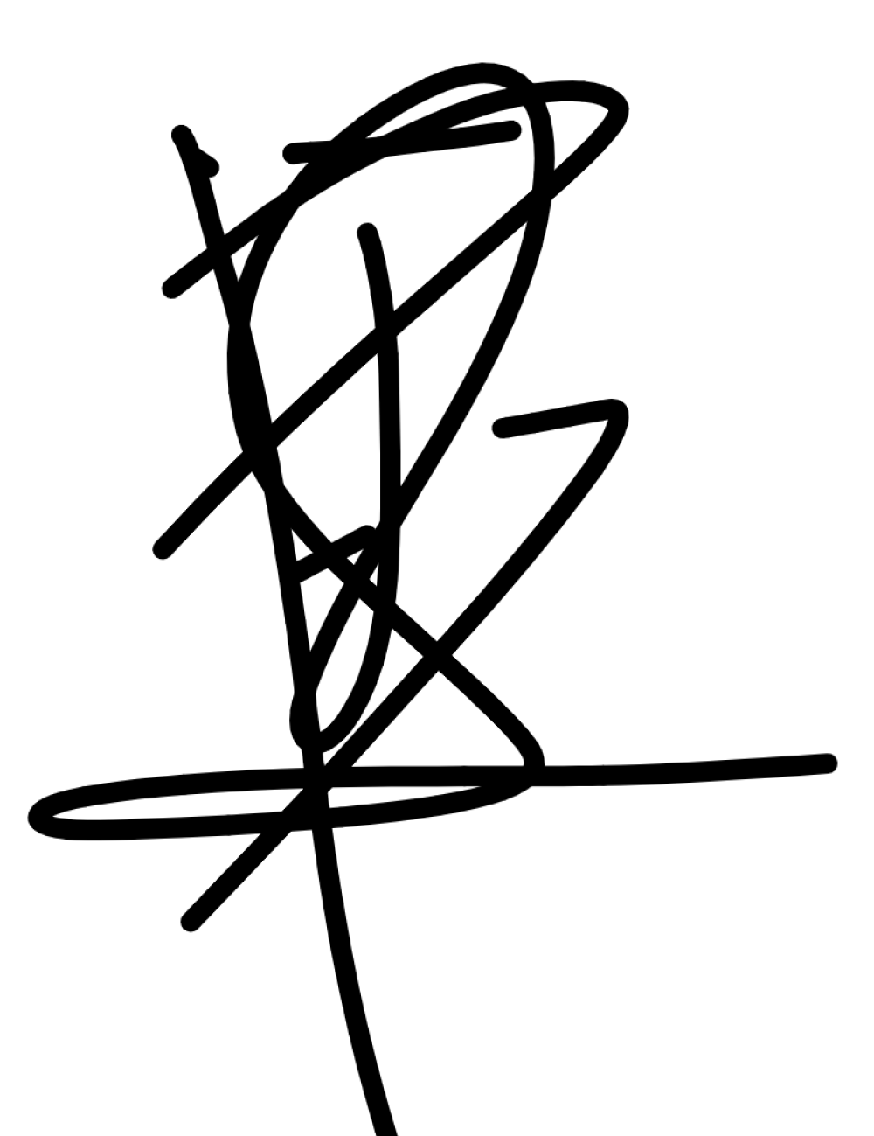
DATE: May 21 2025 SIGNATURE:

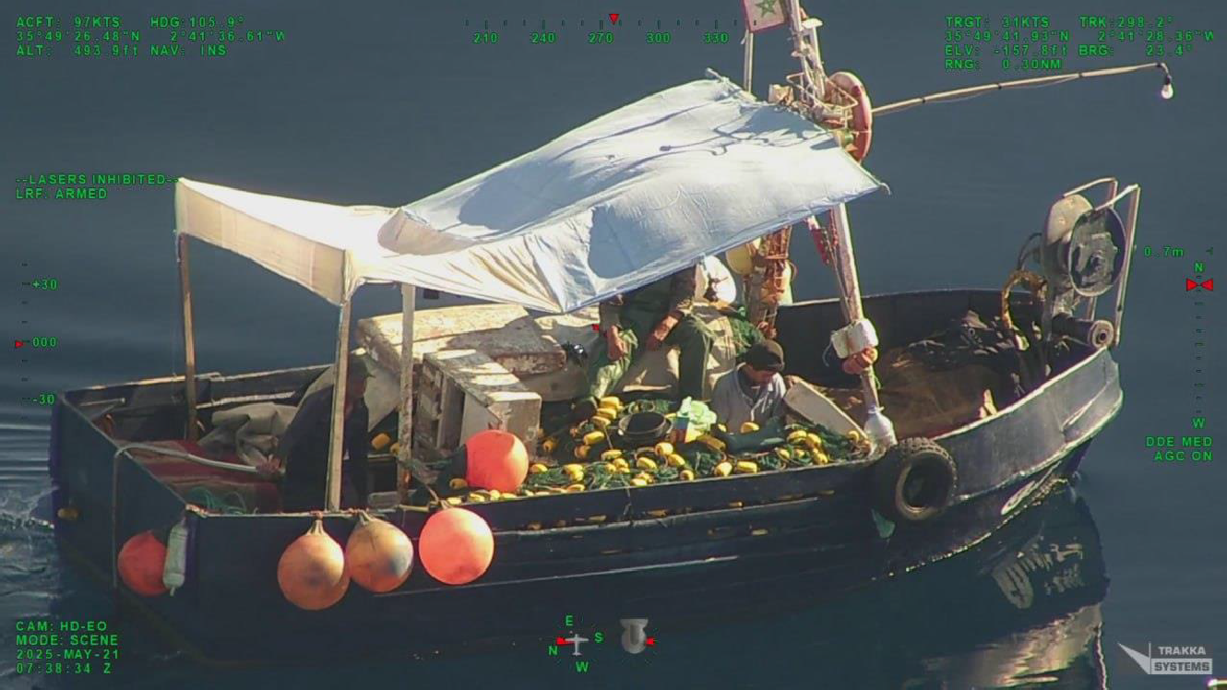
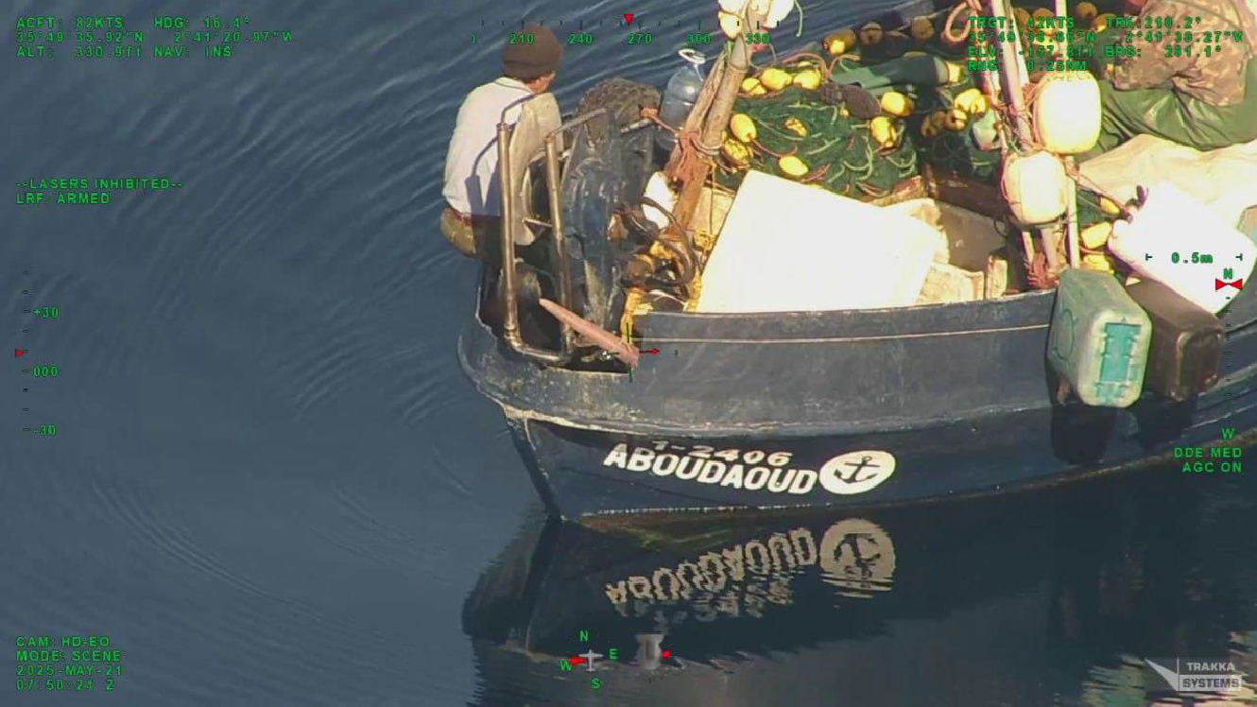

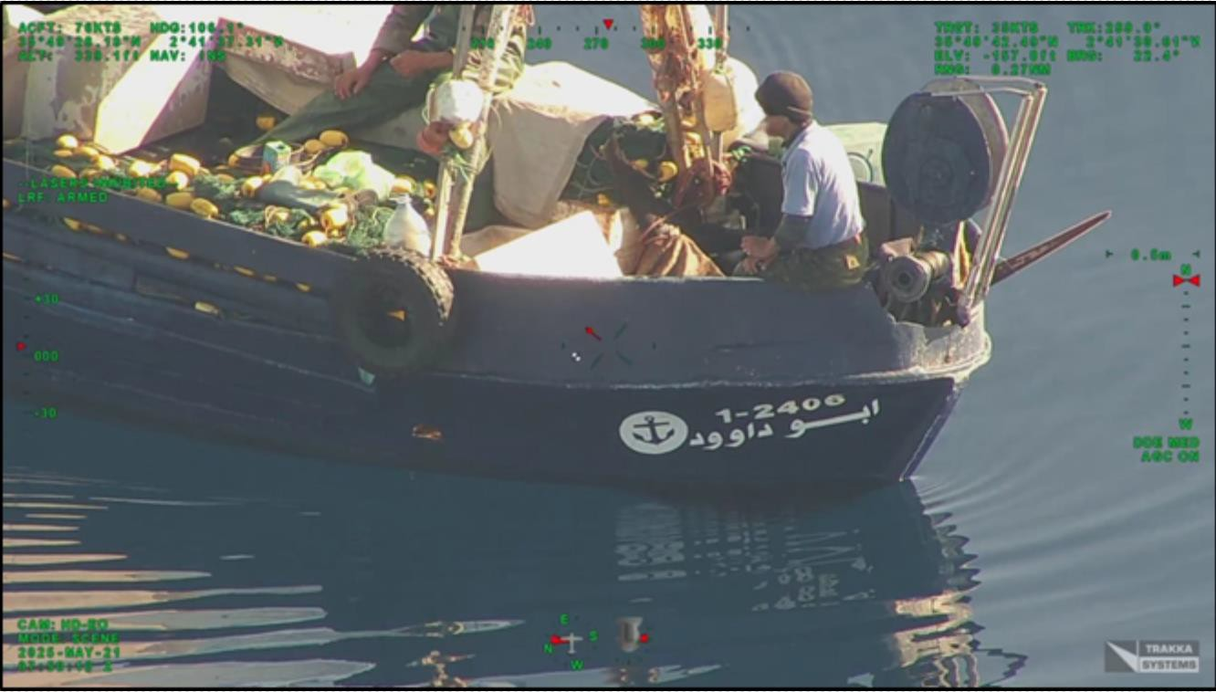
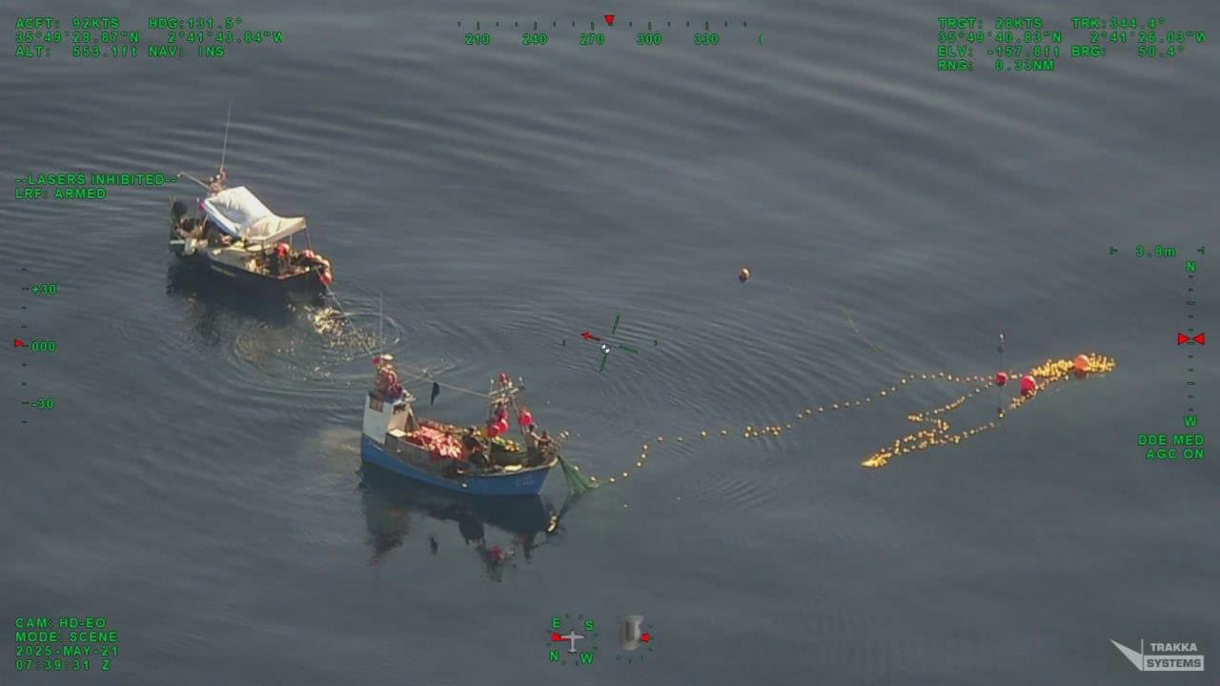

SIGHTING INFORMATION SHEET
1. Date of Sighting: Time 0735UTC Day 21 Month 05 Year 2025
2. Position of Vessel Sighted:
Latitude N35°49’40” Longitude W002°41’33”
3. Name of the Vessel Sighted: ANNOUR
4. Flag Country: MAR
5. Port (and Country) of Registry: -
6. Type of Vessel: GND
7. International Radio Call Sign: -
8. Registration Number: 1-5416
9. ICCAT Serial Number: AT000MAR04927
10. IMO Number: -
11. Estimated Length Overall and Gross Tonnage: 6 m 3 GT
12. Fishing Gear Description (if applicable):
Type: Driftnets (GND) Estimated quantity (units) -
13. Nationality of Captain: - Officer: - Crew: -
14. Vessel Situation (Please check):
[X] Fishing [ ] Cruising [ ] Drifting
[ ] Supplying [ ] Transshipping [ ] Other (Specify)
15. Type of Activities of the Vessel Sighted (Please describe):
Fishing vessel engaged in the retrieval of the fishing gear (driftnets). Large pelagic species (SWO) observed.
Driftnets used to fish for large pelagic species in contravention of ICCAT Rec 03-04 Para 3.
16. Description of vessel:
See attached pictures.
17. Other Relevant Information:
The fishing vessel was linked by a rope to another fishing vessel:
- MAR GND ABOUDAOUD (AT000MAR01569)
18. THE ABOVE INFORMATION WAS COLLECTED BY:
NAME: José Déniz / Carlos Couce TITLE: ICCAT Inspector EU-ES 0226/202; EU-XFA 0035/2022
MEANS OF SIGHTING (incl. vessel/aircraft name, where appropriate): EFCA FWA BLUE KNIGHT

DATE: May 21 2025 SIGNATURE: 

Annex 2 to submission B

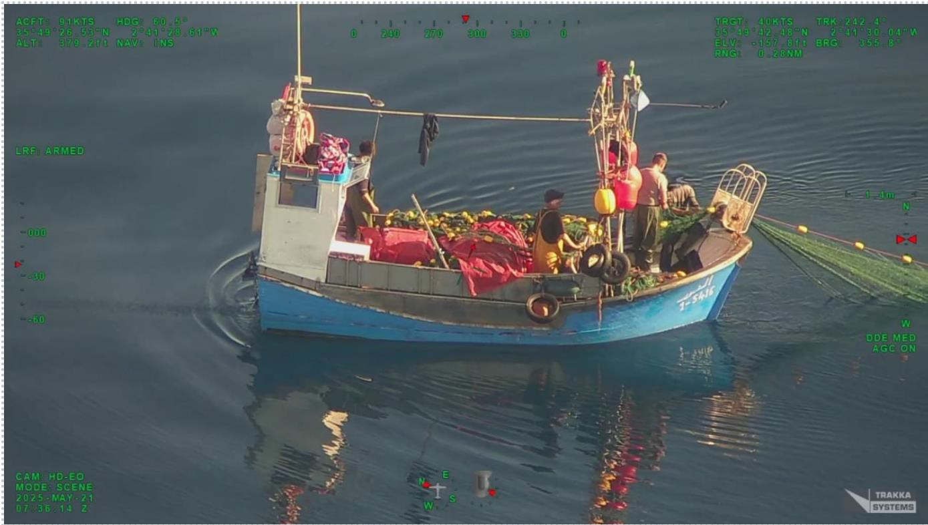

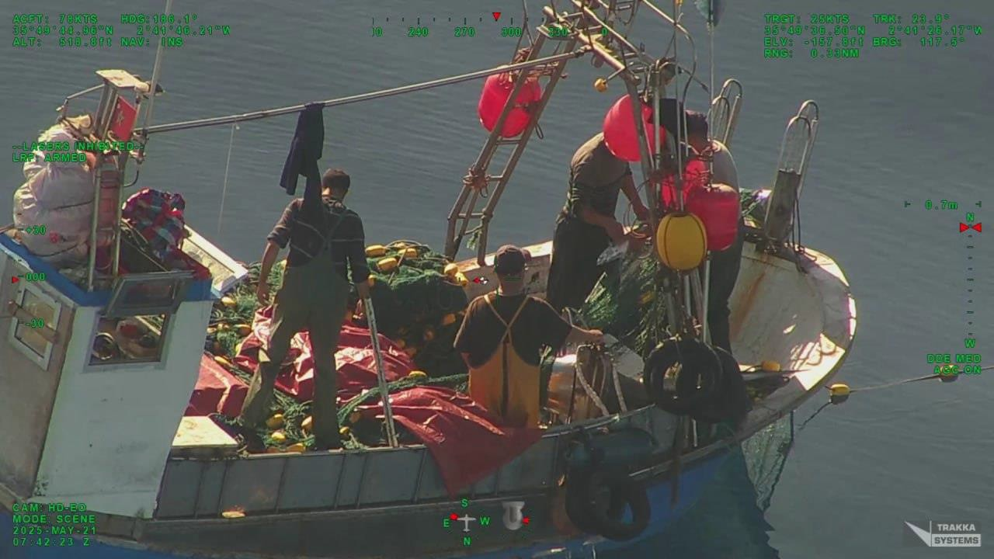

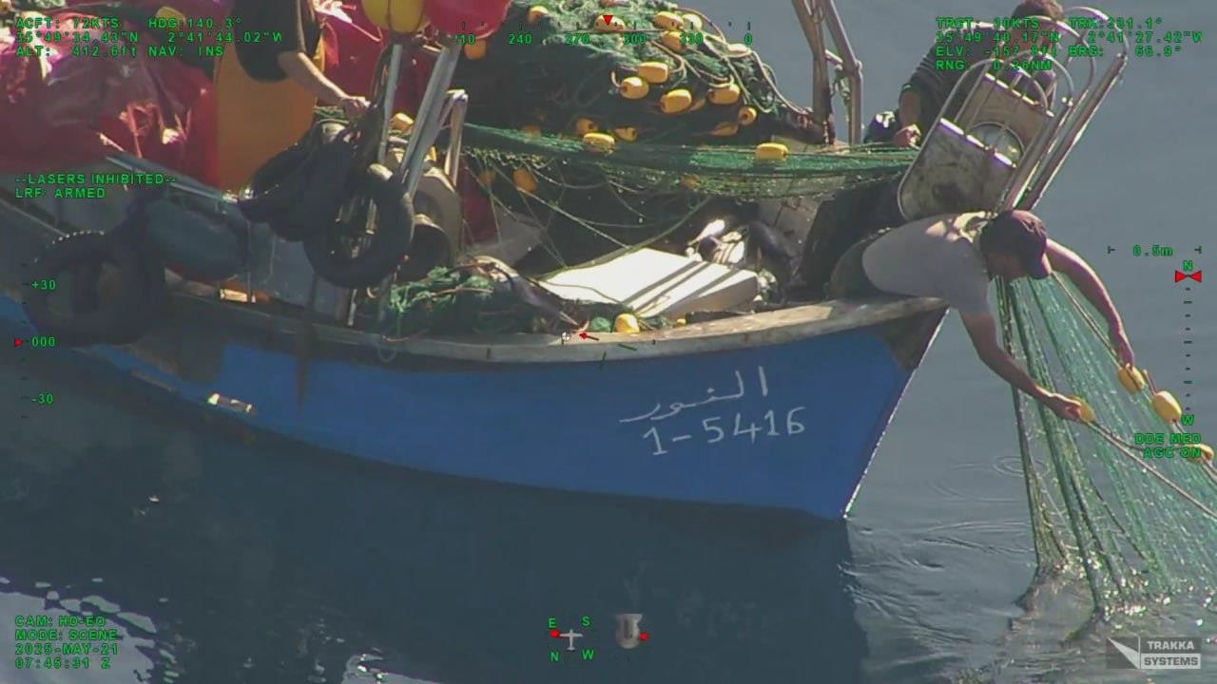
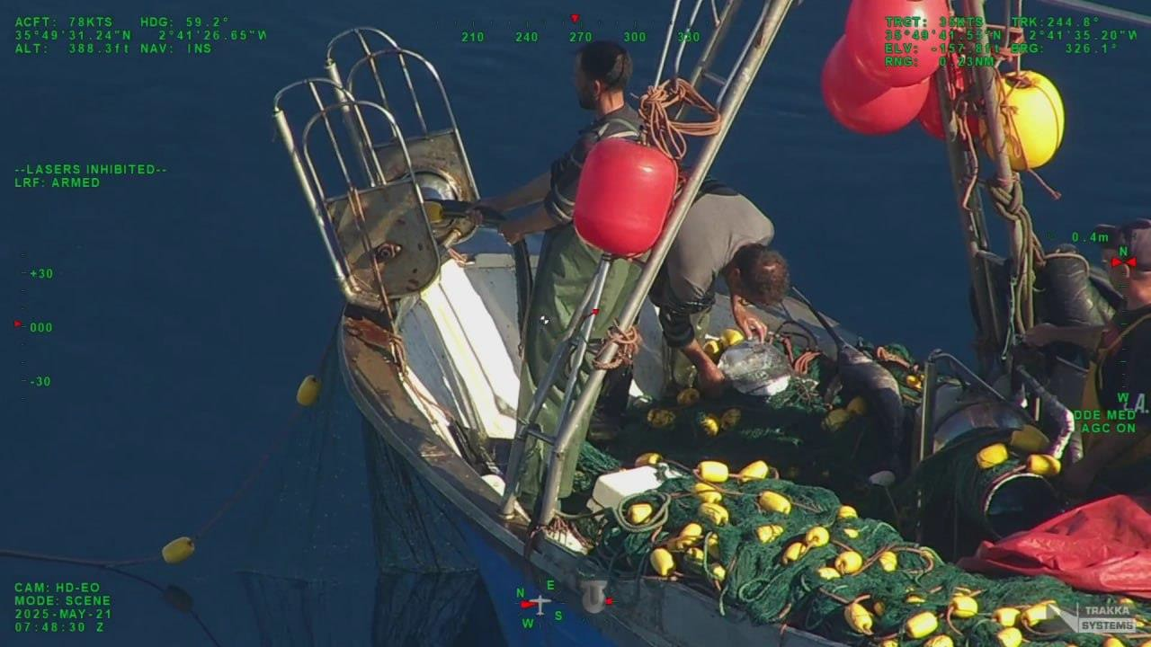

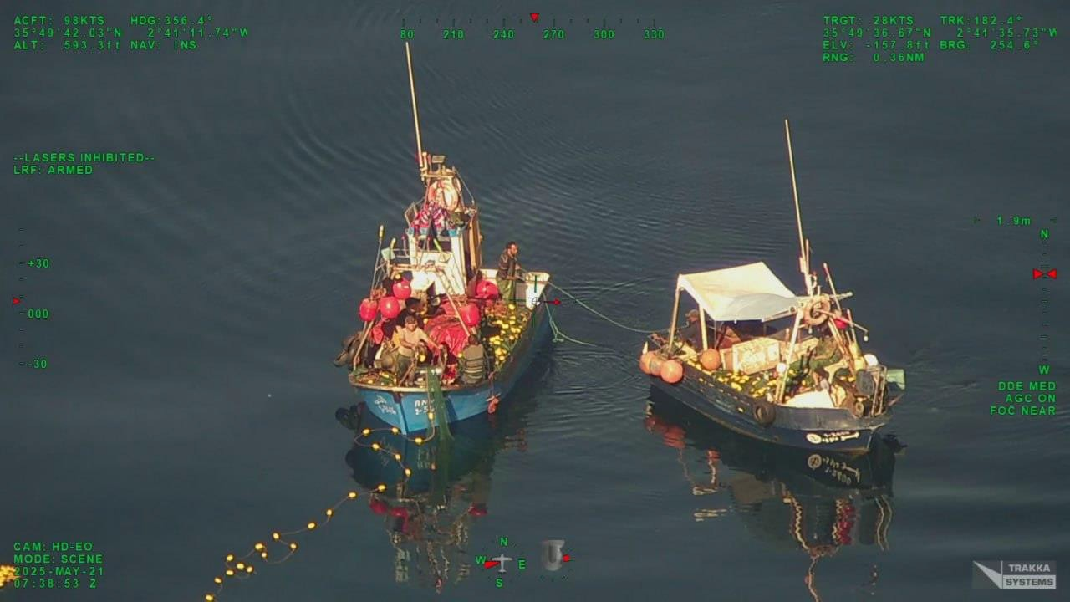
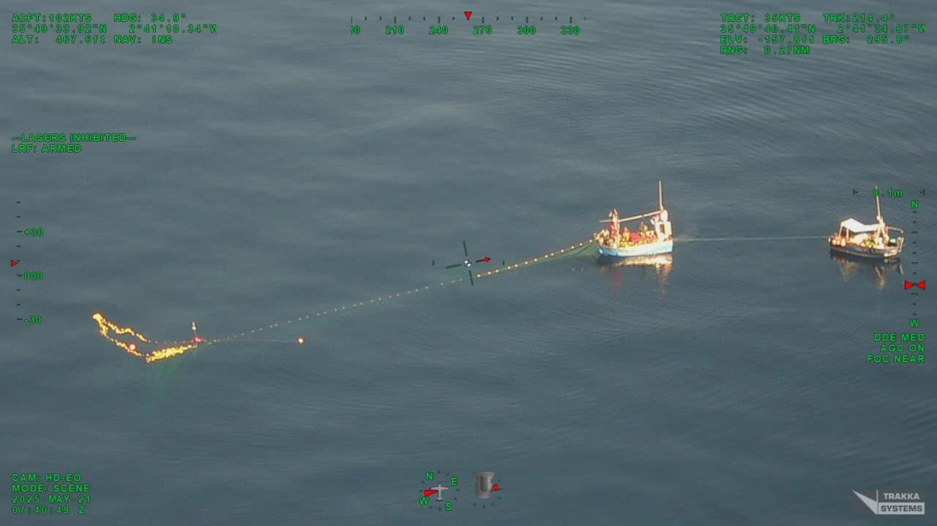

Annex 3 to submission B
SIGHTING INFORMATION SHEET
1. Date of Sighting: Time 0700UTC Day 22 Month 05 Year 2025
2. Position of Vessel Sighted:
Latitude N35°51’07” Longitude W003°26’35”
3. Name of the Vessel Sighted: NOUR KAMAR
4. Flag Country: MAR
5. Port (and Country) of Registry: -
6. Type of Vessel: GND
7. International Radio Call Sign: -
8. Registration Number: 2-2420
9. ICCAT Serial Number: AT000MAR02726
10. IMO Number: -
11. Estimated Length Overall and Gross Tonnage: 6.5 m 2.99 GT
12. Fishing Gear Description (if applicable):
Type: Driftnets (GND) Estimated quantity (units)
13. Nationality of Captain: - Officer: - Crew: -
14. Vessel Situation (Please check):
[X] Fishing [ ] Cruising [ ] Drifting
[ ] Supplying [ ] Transshipping [ ] Other (Specify)
15. Type of Activities of the Vessel Sighted (Please describe):
Fishing vessel engaged in the retrieval of the fishing gear (driftnets). Large pelagic species (SWO) observed.
Driftnets used to fish for large pelagic species in contravention of ICCAT Rec 03-04 Para 3.
16. Description of vessel:
See attached pictures.
17. Other Relevant Information:
18. THE ABOVE INFORMATION WAS COLLECTED BY:

NAME: José Déniz / Carlos Couce TITLE: ICCAT Inspectors EU-ES 0226/2021; EU-XFA 0035/2022

MEANS OF SIGHTING (including vessel/aircraft name, where appropriate): EFCA FWA BLUE KNIGHT
DATE: May 22 2025 SIGNATURE:

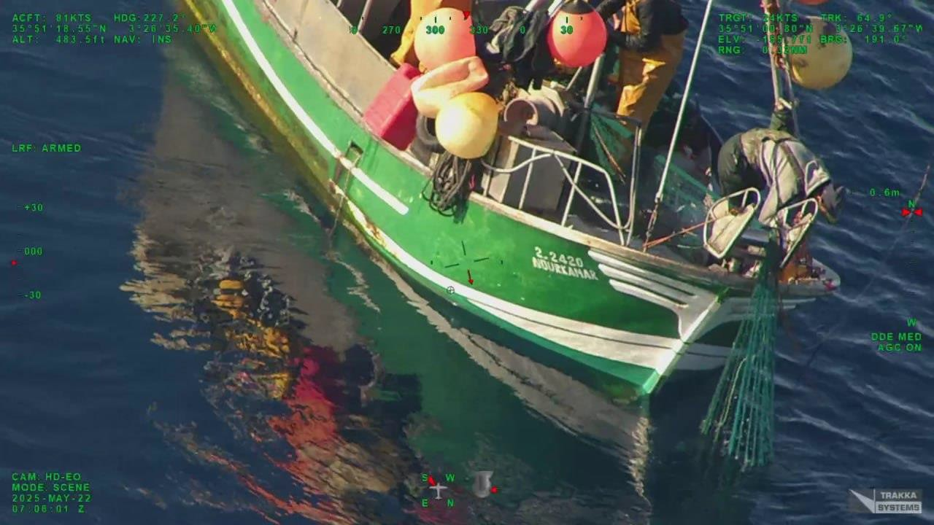
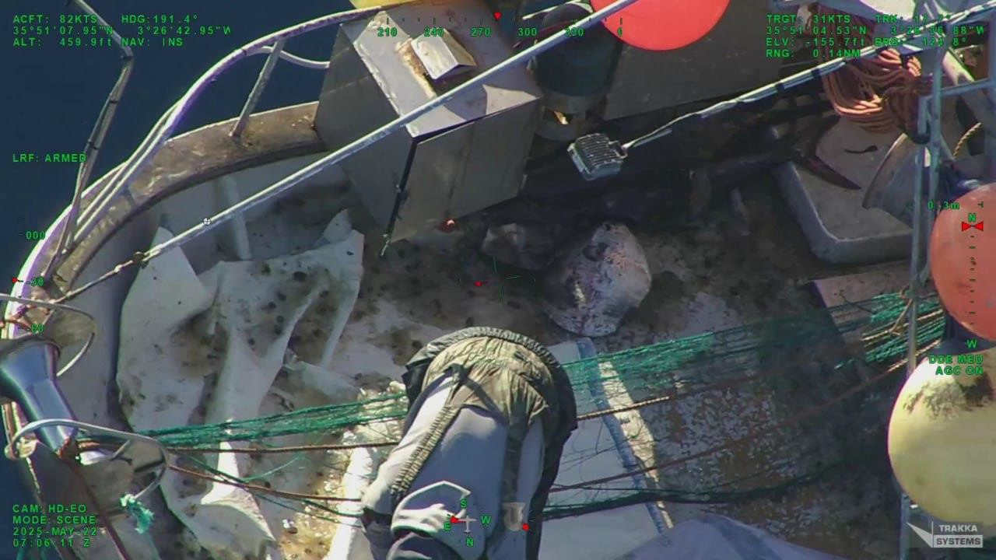

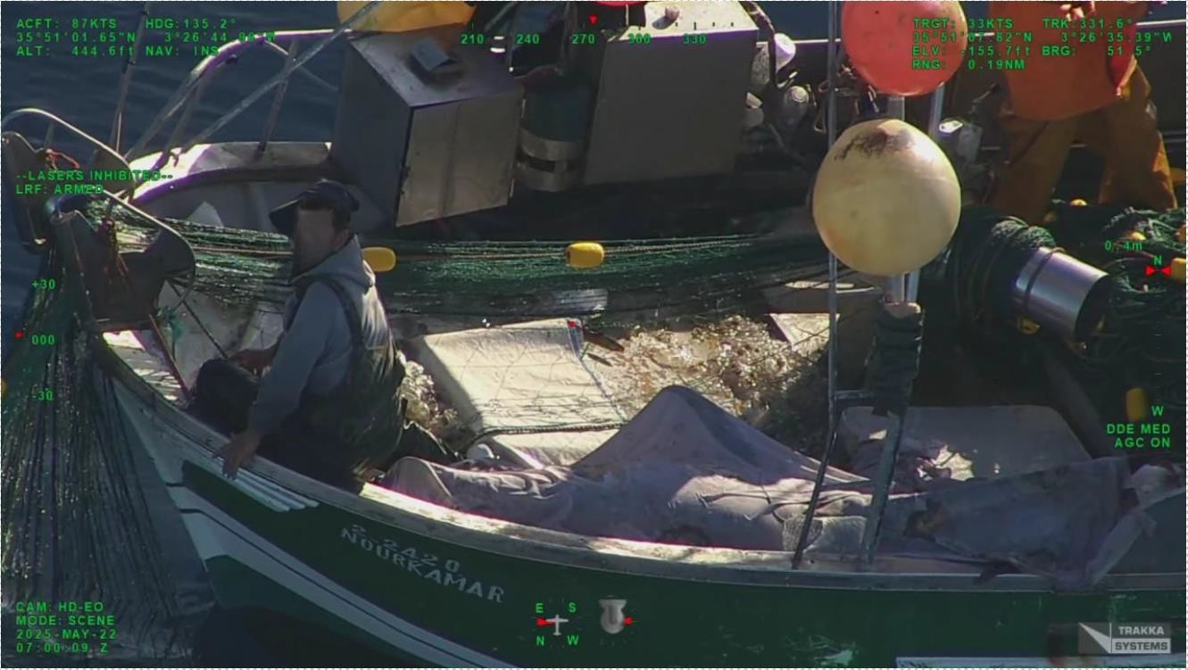
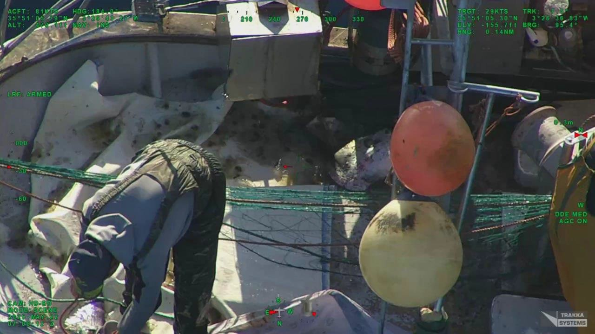

Annex 4 to submission B
SIGHTING INFORMATION SHEET
1. Date of Sighting: Time 0711UTC Day 22 Month 05 Year 2025
2. Position of Vessel Sighted:
Latitude N35°55’28” Longitude W003°26’34”
3. Name of the Vessel Sighted: TILILA-4
4. Flag Country: MAR
5. Port (and Country) of Registry: -
6. Type of Vessel: GND
7. International Radio Call Sign: -
8. Registration Number: 1-5285
9. ICCAT Serial Number: AT000MAR04387
10. IMO Number: -
11. Estimated Length Overall and Gross Tonnage: 6.7 m 3 GT
12. Fishing Gear Description (if applicable):
Type: Driftnets (GND) Estimated quantity (units) -
13. Nationality of Captain: - Officer: - Crew: -
14. Vessel Situation (Please check):
[X] Fishing [ ] Cruising [ ] Drifting
[ ] Supplying [ ] Transshipping [ ] Other (Specify)
15. Type of Activities of the Vessel Sighted (Please describe):
Fishing vessel engaged in the retrieval of the fishing gear (driftnets). Large pelagic species (SWO, SKJ) observed.
Driftnets used to fish for large pelagic species in contravention of ICCAT Rec 03-04 Para 3.
16. Description of vessel:
See attached pictures.
17. Other Relevant Information:
18. THE ABOVE INFORMATION WAS COLLECTED BY:

NAME: José Déniz / Carlos Couce TITLE: ICCAT Inspector EU-ES 0226/202; EU-XFA 0035/2022


MEANS OF SIGHTING (including vessel/aircraft name, where appropriate): EFCA FWA BLUE KNIGHT
DATE: May 22 2025 SIGNATURE:

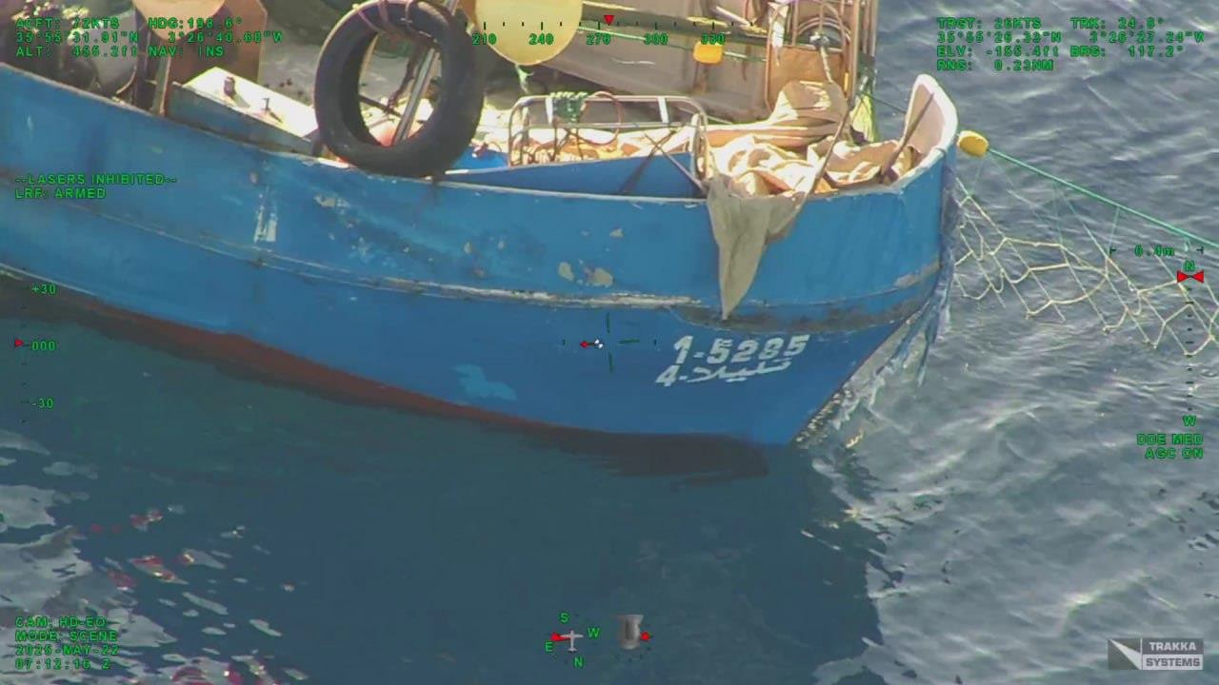

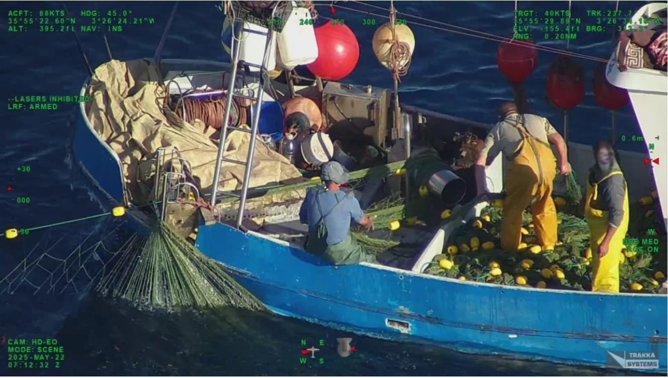

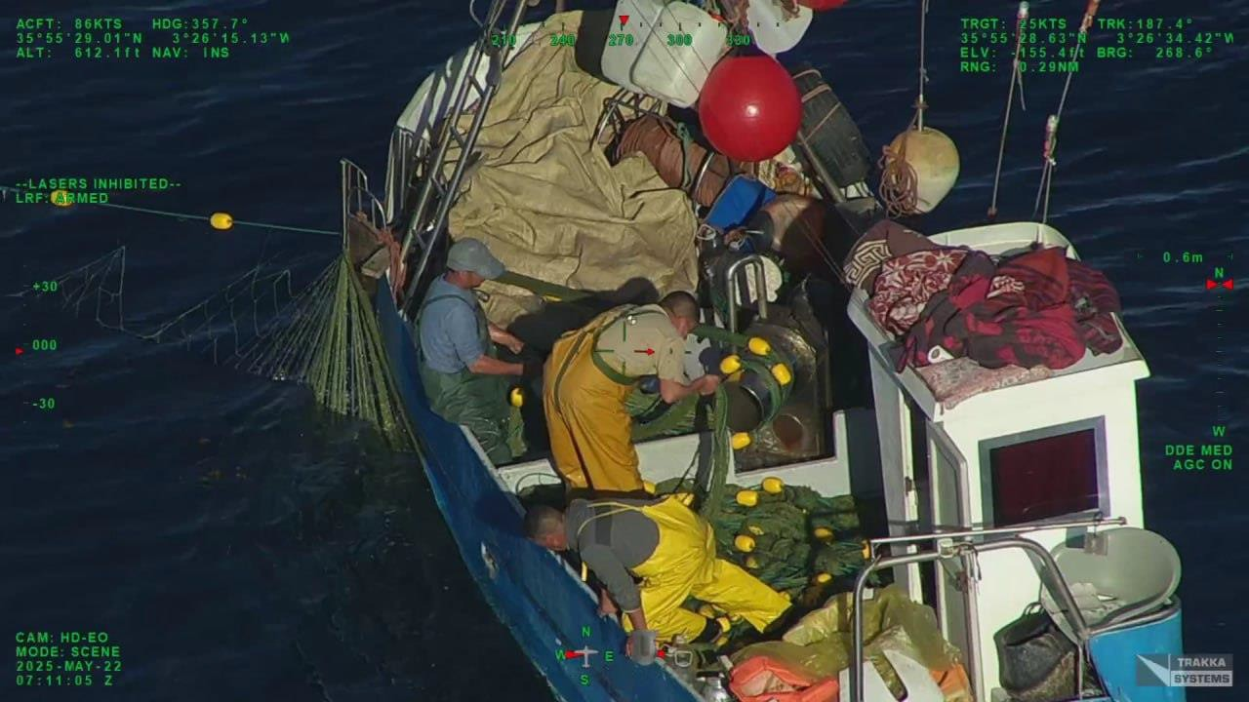

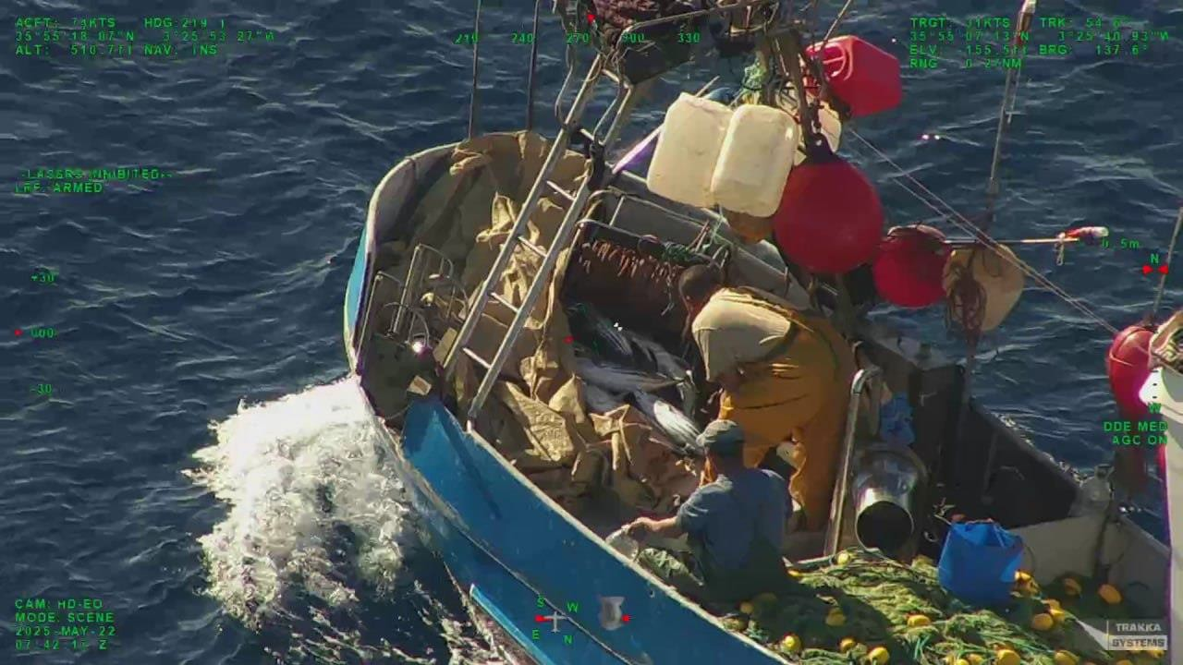

- Submissions under Rec. 19-09 received from Algeria on Algeria and the Europea Union
(ICCAT Circular # 09349/2025)
(9 sighting information sheets)

Sighting Information Sheet 1
CP18-VessSight
SIGHTING INFORMATION SHEET FICHE D'INFORMATION D'OBSERVATION
1. Date of Sighting: (1. Date de l’observation : ) Time Day Month Year
12 H 49 UTC 06 JULY 2025
2. Position of Vessel Sighted: (2. Position du navire repéré :)
Latitude 36 ° 18 ’N Longitude 12 ° 07 ’E
3. Name of the Vessel Sighted: (3. Nom du navire observé :) CALLORE
4. Flag Country: (4. Pays de pavillon : EU- ITA
5. Port (and Country) of Registry: (5. Port (et pays) du Registre : EU- ITA
6. Type of Vessel: (6. Type de navire :) TW
7. International Radio Call Sign: (7. Indicatif international d’appel radio :) ITDN
8. Registration Number: (8. Numéro de registre :) MV1142
9. ICCAT Serial Number: (9. Numéro de série ICCAT :) ATEU0ITA00104
10. IMO Number: (10. Numéro OMI :) 8794724
11. Estimated Length Overall and Gross Tonnage: (11. Longueur hors-tout et tonnage brut estimés :)
26.2 M / 101 GT
12. Fishing Gear Description (if applicable): (12. Description de l'engin de pêche (le cas échéant) :) TRAWL
Type Estimated quantity (units) Quantité estimée (unité) :
13. Nationality of Captain: (13. Nationalité du capitaine :) /
Officer: (Officier :) / Crew: ( Équipage:) /
14. Vessel Situation (Please check): (14. Situation du navire (cocher) :)
[X ] Fishing (Pêche) [ ] Cruising (Drifting ) [ ] Croisière (Dérivant)
[ ] Supplying (Ravitaillement) [ ] Transshipping (Transbordement) [ ] Other (Specify) Autre (préciser)
15. Type of Activities of the Vessel Sighted (Please describe):(15. Type d'activités du navire repéré (description) :)
/
- Description of vessel: (16. Description du navire :)
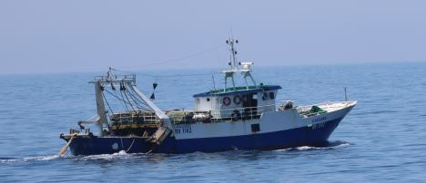
  - hull with two stripes, lower stripe blue and upper stripe white
  - Bridge colour white
  - Equipped for trawling
17. Other Relevant Information: (17. Autres informations pertinentes :
- Vessel is trawl fishing
18. THE ABOVE INFORMATION WAS COLLECTED BY:(18. L'INFORMATION SUSMENTIONNÉE A ÉTÉ RECUEILLIE PAR :)
NAME: (NOM): MEHANAOUI Zouleikha TITLE: (TITRE:) DZA INSPECTEUR ICCAT N° 05 / 2025
MEANS OF SIGHTING (including vessel/aircraft name, where appropriate): (MOYENS EMPLOYÉS POUR L’OBSERVATION (y compris nom du navire/de l’aéronef, le cas échéant))
GRINE BELKACEM AL405
DATE: (Month) (Day) (Year) DATE : SIGNATURE :
2025

Sighting Information Sheet 2
 | CP18-VessSight
SIGHTING INFORMATION SHEET FICHE D'INFORMATION D'OBSERVATION
1. Date of Sighting: (1. Date de l'observation : ) Time Day Month Year
17 H 25 UTC 07 July 2025
2. Position of Vessel Sighted: (2. Position du navire repéré :)
Latitude 36 ° 02 ’ N Longitude 13 ° 23 ’ E
3. Name of the Vessel Sighted: (3. Nom du navire observé :) LELI
4. Flag Country: (4. Pays de pavillon :EU-MLT
5. Port (and Country) of Registry: (5. Port (et pays) du Registre :) EU- MLT
6. Type of Vessel: (6. Type de navire :) AUXILARY
7. International Radio Call Sign: (7. Indicatif international d’appel radio :) 9BH4326
8. Registration Number: (8. Numéro de registre :) VLTMFA7011
9. ICCAT Serial Number: (9. Numéro de série ICCAT :) ATEU0MLT01018
10. IMO Number: (10. Numéro OMI :) 9089221
11. Estimated Length Overall and Gross Tonnage: (11. Longueur hors-tout et tonnage brut estimés :)
20. 4 m / 128 GT
12. Fishing Gear Description (if applicable): (12. Description de l'engin de pêche (le cas échéant) :)
Type NONE Estimated quantity (units) Quantité estimée (unité) :/
13. Nationality of Captain: (13. Nationalité du capitaine :) /
Officer: (Officier :) / Crew: ( Équipage:) /
14. Vessel Situation (Please check): (14. Situation du navire (cocher) :)
[ ] Fishing (Pêche) [ ] Cruising (Drifting ) [ ] Croisière (Dérivant)
[ ] Supplying (Ravitaillement) [ ] Transshipping (Transbordement) [X ] Other /Autre (AUXILARY)
15. Type of Activities of the Vessel Sighted (Please describe):(15. Type d'activités du navire repéré (description) :)
TOWING OF CAGE N° EU-MLT049-FF
16. Description of vessel: (16. Description du navire :)
- Red vessel with a small white upper stripe  - Bridge colour white  - Red crane |  |  | 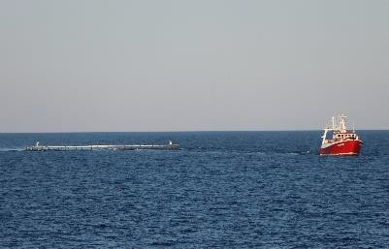 |  | 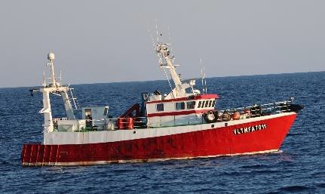
17. Other Relevant Information: (17. Autres informations pertinentes :)
/
18. THE ABOVE INFORMATION WAS COLLECTED BY:(18. L'INFORMATION SUSMENTIONNÉE A ÉTÉ RECUEILLIE PAR :)
NAME: (NOM : CHELAGHMA Mohammed Amine TITLE: (TITRE:) DZA INSPECTEUR ICCAT N° 04 /2025
MEANS OF SIGHTING (including vessel/aircraft name, where appropriate): (MOYENS EMPLOYÉS POUR L’OBSERVATION (y compris nom du navire/de l’aéronef, le cas échéant))
GRINE BELKACEM AL405
DATE: (Month) (Day) (Year) DATE : SIGNATURE :
July 07 2025

Sighting Information Sheet 3

 | CP18-VessSight
SIGHTING INFORMATION SHEET FICHE D'INFORMATION D'OBSERVATION
1. Date of Sighting: (1. Date de l'observation : ) Time Day Month Year
05 H 50 UTC 08 July 2025
2. Position of Vessel Sighted: (2. Position du navire repéré :)
Latitude 36 ° 09 ’ N Longitude 13 ° 11 ’ E
3. Name of the Vessel Sighted: (3. Nom du navire observé :) BENI LOUMA
4. Flag Country: (4. Pays de pavillon : DZA
5. Port (and Country) of Registry: (5. Port (et pays) du Registre :) DZA
6. Type of Vessel: (6. Type de navire :) CATCHING
7. International Radio Call Sign: (7. Indicatif international d’appel radio :) 7T6265
8. Registration Number: (8. Numéro de registre :) ARZ 5154
9. ICCAT Serial Number: (9. Numéro de série ICCAT :) AT000DZA00015
10. IMO Number: (10. Numéro OMI :) 8687804
11. Estimated Length Overall and Gross Tonnage: (11. Longueur hors-tout et tonnage brut estimés :)
26 m / 143 GT
12. Fishing Gear Description (if applicable): (12. Description de l'engin de pêche (le cas échéant) :)
Type PS Estimated quantity (units) Quantité estimée (unité) :/
13. Nationality of Captain: (13. Nationalité du capitaine :) /
Officer: (Officier :) / Crew: ( Équipage:) /
14. Vessel Situation (Please check): (14. Situation du navire (cocher) :)
[X ] Fishing (Pêche) [ ] Cruising (Drifting ) [ ] Croisière (Dérivant)
[ ] Supplying (Ravitaillement) [ ] Transshipping (Transbordement) [ ] Other /Autre
15. Type of Activities of the Vessel Sighted (Please describe):(15. Type d'activités du navire repéré (description) :)
BFT research
16. Description of vessel: (16. Description du navire :)
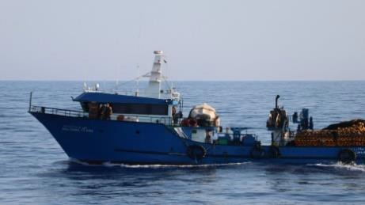  - Blue ship hull  - White bridge with blue roof  - A crane  - On board dinghy  - Equipped with a fishing net and skiff |  |  | 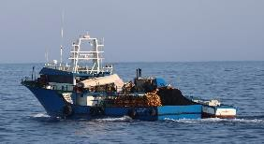
17. Other Relevant Information: (17. Autres informations pertinentes :)
The vessel has actively sought BFT with several vessels from its JFO
18. THE ABOVE INFORMATION WAS COLLECTED BY:(18. L'INFORMATION SUSMENTIONNÉE A ÉTÉ RECUEILLIE PAR :)
NAME: (NOM ): BOUHAMAR Ahmed TITLE: (TITRE:) DZA INSPECTEUR ICCAT N° 01/2024
MEANS OF SIGHTING (including vessel/aircraft name, where appropriate): (MOYENS EMPLOYÉS POUR L’OBSERVATION (y compris nom du navire/de l’aéronef, le cas échéant))
GRINE BELKACEM AL405
DATE: (Month) (Day) (Year) DATE : SIGNATURE :
July 08 2025
Sighting Information Sheet 4
CP18-VessSight
SIGHTING INFORMATION SHEET FICHE D'INFORMATION D'OBSERVATION
1. Date of Sighting: (1. Date de l'observation : ) Time Day Month Year
5 H 30 UTC 08 July 2025
2. Position of Vessel Sighted: (2. Position du navire repéré :)
Latitude 36 ° 09 ’ N Longitude 13 ° 13 ’ E
3. Name of the Vessel Sighted: (3. Nom du navire observé :) CHAHID HASNI SAIDI
4. Flag Country: (4. Pays de pavillon : DZA
5. Port (and Country) of Registry: (5. Port (et pays) du Registre :) DZA
6. Type of Vessel: (6. Type de navire :) CATCHING
7. International Radio Call Sign: (7. Indicatif international d’appel radio :) 7T7227
8. Registration Number: (8. Numéro de registre :) BS0776
9. ICCAT Serial Number: (9. Numéro de série ICCAT :) AT000DZA00009
10. IMO Number: (10. Numéro OMI :) 8536407
11. Estimated Length Overall and Gross Tonnage: (11. Longueur hors-tout et tonnage brut estimés :)
31.7 m / 170.2 GT
12. Fishing Gear Description (if applicable): (12. Description de l'engin de pêche (le cas échéant) :)
Type None. / Estimated quantity (units) Quantité estimée (unité) :/
13. Nationality of Captain: (13. Nationalité du capitaine :) /
Officer: (Officier :) / Crew: ( Équipage:) /
14. Vessel Situation (Please check): (14. Situation du navire (cocher) :)
[X ] Fishing (Pêche) [ ] Cruising (Drifting ) [ ] Croisière (Dérivant)
[ ] Supplying (Ravitaillement) [ ] Transshipping (Transbordement) [ ] Other /Autre ()
15. Type of Activities of the Vessel Sighted (Please describe):(15. Type d'activités du navire repéré (description) :)
- Description of vessel: (16. Description du navire :)
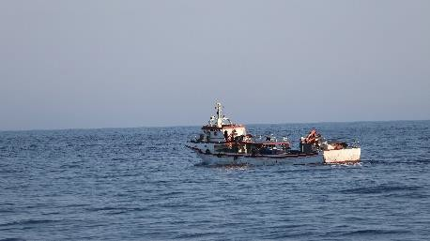
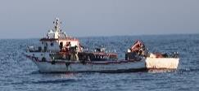
* Vessel with white hull and red stripes
  - White bridge
* Two red cranes
* Fibreglass hull
  - Two on board dinghies
17. Other Relevant Information: (17. Autres informations pertinentes :)
The vessel has sought BFT with its JFO
18. THE ABOVE INFORMATION WAS COLLECTED BY:(18. L'INFORMATION SUSMENTIONNÉE A ÉTÉ RECUEILLIE PAR :)
NAME: (NOM) : MEHANAOUI Zouleikha TITLE: (TITRE:) DZA INSPECTEUR ICCAT N°05/2025
MEANS OF SIGHTING (including vessel/aircraft name, where appropriate): (MOYENS EMPLOYÉS POUR L’OBSERVATION (y compris nom du navire/de l’aéronef, le cas échéant))
GRINE BELKACEM AL405
DATE: (Month) (Day) (Year) DATE : SIGNATURE :
July 08 2025

Sighting Information Sheet 5

CP18-VessSight
SIGHTING INFORMATION SHEET FICHE D'INFORMATION D'OBSERVATION
1. Date of Sighting: (1. Date de l'observation : ) Time Day Month Year
09 H 43 UTC 08 July 2025
2. Position of Vessel Sighted: (2. Position du navire repéré :)
Latitude 36 ° 09 ’ N Longitude 13 ° 12 ’ E
3. Name of the Vessel Sighted: (3. Nom du navire observé :) EL BACHIR
4. Flag Country: (4. Pays de pavillon : DZA
5. Port (and Country) of Registry: (5. Port (et pays) du Registre :) DZA
6. Type of Vessel: (6. Type de navire :) CATCHING
7. International Radio Call Sign: (7. Indicatif international d’appel radio :) 7 T5423
8. Registration Number: (8. Numéro de registre :) AN 1533
9. ICCAT Serial Number: (9. Numéro de série ICCAT :) AT000DZA00997
10. IMO Number: (10. Numéro OMI :) 9943785
11. Estimated Length Overall and Gross Tonnage: (11. Longueur hors-tout et tonnage brut estimés :)
35.4 m / 360.7 GT
12. Fishing Gear Description (if applicable): (12. Description de l'engin de pêche (le cas échéant) :)
Type PS Estimated quantity (units) Quantité estimée (unité) :/
13. Nationality of Captain: (13. Nationalité du capitaine :) /
Officer: (Officier :) / Crew: ( Équipage:) /
14. Vessel Situation (Please check): (14. Situation du navire (cocher) :)
[ X] Fishing (Pêche) [ ] Cruising (Drifting ) [ ] Croisière (Dérivant)
[ ] Supplying (Ravitaillement) [ ] Transshipping (Transbordement) [ ] Other /Autre ()
15. Type of Activities of the Vessel Sighted (Please describe):(15. Type d'activités du navire repéré (description) :)
- Description of vessel: (16. Description du navire :)
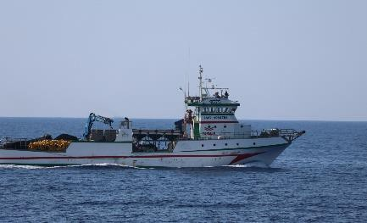
* Vessel with white hull and red and green stripes
  - White bridge with red and green stripes
  - Fibreglass hull (PVRT)
  - Fishing net on board
  - Two blue cranes
* Three on board dinghies and a skiff
17. Other Relevant Information: (17. Autres informations pertinentes :)
The vessel has sought BFT with the vessels of its JFO
18. THE ABOVE INFORMATION WAS COLLECTED BY:(18. L'INFORMATION SUSMENTIONNÉE A ÉTÉ RECUEILLIE PAR :)
NAME: (NOM) : CHELAGHMA Mohammed Amine TITLE: (TITRE:) DZA INSPECTEUR ICCAT N° 04/2025
MEANS OF SIGHTING (including vessel/aircraft name, where appropriate): (MOYENS EMPLOYÉS POUR L’OBSERVATION (y compris nom du navire/de l’aéronef, le cas échéant))
GRINE BELKACEM AL405
DATE: (Month) (Day) (Year) DATE : SIGNATURE :
July 08 2025

Sighting Information Sheet 6

 | CP18-VessSight
SIGHTING INFORMATION SHEET FICHE D'INFORMATION D'OBSERVATION
1. Date of Sighting: (1. Date de l'observation : ) Time Day Month Year
8 H 50 UTC 08 July 2025
2. Position of Vessel Sighted: (2. Position du navire repéré :)
Latitude 36 ° 04 ’ N Longitude 12 ° 57 ’ E
3. Name of the Vessel Sighted: (3. Nom du navire observé :) EURIKA
4. Flag Country: (4. Pays de pavillon :EU-ITA
5. Port (and Country) of Registry: (5. Port (et pays) du Registre :) EU-ITA
6. Type of Vessel: (6. Type de navire :) SUPPORT
7. International Radio Call Sign: (7. Indicatif international d’appel radio :)
8. Registration Number: (8. Numéro de registre) : MV407
9. ICCAT Serial Number: (9. Numéro de série ICCAT :) ATEU0ITA00006
10. IMO Number: (10. Numéro OMI :) 8690497
11. Estimated Length Overall and Gross Tonnage: (11. Longueur hors-tout et tonnage brut estimés :)
29.2 m / 133GT
12. Fishing Gear Description (if applicable): (12. Description de l'engin de pêche (le cas échéant) :)
Type NONE Estimated quantity (units) Quantité estimée (unité) :/
13. Nationality of Captain: (13. Nationalité du capitaine :) /
Officer: (Officier :) / Crew: ( Équipage:) /
14. Vessel Situation (Please check): (14. Situation du navire (cocher) :)
[ ] Fishing (Pêche) [ ] Cruising (Drifting ) [ ] Croisière (Dérivant)
[ ] Supplying (Ravitaillement) [ ] Transshipping (Transbordement) [X ] Other /Autre (SUPPORT BFT)
15. Type of Activities of the Vessel Sighted (Please describe):(15. Type d'activités du navire repéré (description) :)
Support BFT
16. Description of vessel: (16. Description du navire :)
- Vessel with blue hull with white upper stripe  - Three on board dinghies  - A red crane  - Steel hull |  |  | 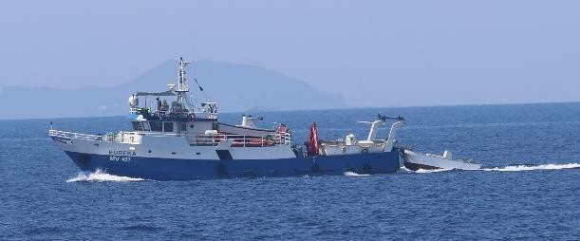 | 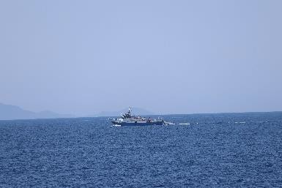
17. Other Relevant Information: (17. Autres informations pertinentes :)
Vessel has been in the BFT research area
18. THE ABOVE INFORMATION WAS COLLECTED BY:(18. L'INFORMATION SUSMENTIONNÉE A ÉTÉ RECUEILLIE PAR :)
NAME: (NOM): BOUHAMAR Ahmed TITLE: (TITRE:) DZA INSPECTEUR ICCAT N° 01 /2024
MEANS OF SIGHTING (including vessel/aircraft name, where appropriate): (MOYENS EMPLOYÉS POUR L’OBSERVATION (y compris nom du navire/de l’aéronef, le cas échéant))
GRINE BELKACEM AL405
DATE: (Month) (Day) (Year) DATE : SIGNATURE :
July 08 2025

Sighting Information Sheet 7
CP18-VessSight
SIGHTING INFORMATION SHEET FICHE D'INFORMATION D'OBSERVATION
1. Date of Sighting: (1. Date de l'observation : ) Time Day Month Year
05 H 25 UTC 08 July 2025
2. Position of Vessel Sighted: (2. Position du navire repéré :)
Latitude 36 ° 08 ’ N Longitude 13 ° 15 ’ E
3. Name of the Vessel Sighted: (3. Nom du navire observé :) HABIB ALLAH I
4. Flag Country: (4. Pays de pavillon :DZA
5. Port (and Country) of Registry: (5. Port (et pays) du Registre :) DZA
6. Type of Vessel: (6. Type de navire :) CATCHING
7. International Radio Call Sign: (7. Indicatif international d’appel radio :) 7T7120
8. Registration Number: (8. Numéro de registre :) GZ 1493
9. ICCAT Serial Number: (9. Numéro de série ICCAT :) AT000DZA00818
10. IMO Number: (10. Numéro OMI :) 8537671
11. Estimated Length Overall and Gross Tonnage: (11. Longueur hors-tout et tonnage brut estimés :)
33 m / 187.9GT
12. Fishing Gear Description (if applicable): (12. Description de l'engin de pêche (le cas échéant) :)
Type PS Estimated quantity (units) Quantité estimée (unité) :/
13. Nationality of Captain: (13. Nationalité du capitaine :) /
Officer: (Officier :) / Crew: ( Équipage:) /
14. Vessel Situation (Please check): (14. Situation du navire (cocher) :)
[X ] Fishing (Pêche) [ ] Cruising (Drifting ) [ ] Croisière (Dérivant)
[ ] Supplying (Ravitaillement) [ ] Transshipping (Transbordement) [ ] Other /Autre ()
15. Type of Activities of the Vessel Sighted (Please describe):(15. Type d'activités du navire repéré (description) :)
Research on fish
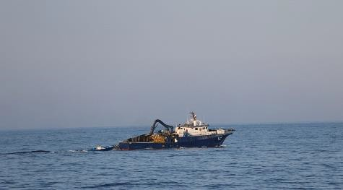
- Description of vessel: (16. Description du navire :)
  - Vessel with blue hull and white bridge
  - Purse seine on board
  - Two cranes colour blue
  - Fibreglass vessel (PVRT)
17. Other Relevant Information: (17. Autres informations pertinentes :)
/
18. THE ABOVE INFORMATION WAS COLLECTED BY:(18. L'INFORMATION SUSMENTIONNÉE A ÉTÉ RECUEILLIE PAR :)
NAME: (NOM) : MEHANAOUI Zouleikha TITLE: (TITRE:) DZA INSPECTEUR ICCAT N°05/2025
MEANS OF SIGHTING (including vessel/aircraft name, where appropriate): (MOYENS EMPLOYÉS POUR L’OBSERVATION (y compris nom du navire/de l’aéronef, le cas échéant))
GRINE BELKACEM AL405
DATE: (Month) (Day) (Year) DATE : SIGNATURE :
July 08 2025

Sighting Information Sheet 8
CP18-VessSight
SIGHTING INFORMATION SHEET FICHE D'INFORMATION D'OBSERVATION
1. Date of Sighting: (1. Date de l'observation : ) Time Day Month Year
05 H 45 UTC 08 July 2025
2. Position of Vessel Sighted: (2. Position du navire repéré :)
Latitude 36 ° 09 ’ N Longitude 13 ° 12 ’ E
3. Name of the Vessel Sighted: (3. Nom du navire observé :) MADINET BENI SAF
4. Flag Country: (4. Pays de pavillon : DZA
5. Port (and Country) of Registry: (5. Port (et pays) du Registre :) DZA
6. Type of Vessel: (6. Type de navire :) CATCHING
7. International Radio Call Sign: (7. Indicatif international d’appel radio :) 7T7491
8. Registration Number: (8. Numéro de registre :) BS 2256
9. ICCAT Serial Number: (9. Numéro de série ICCAT :) AT000DZA01034
10. IMO Number: (10. Numéro OMI :) 8463416
11. Estimated Length Overall and Gross Tonnage: (11. Longueur hors-tout et tonnage brut estimés :)
40 m / 270.2 GT
12. Fishing Gear Description (if applicable): (12. Description de l'engin de pêche (le cas échéant) :)
Type PS Estimated quantity (units) Quantité estimée (unité) :/
13. Nationality of Captain: (13. Nationalité du capitaine :) /
Officer: (Officier :) / Crew: ( Équipage:) /
14. Vessel Situation (Please check): (14. Situation du navire (cocher) :)
[X ] Fishing (Pêche) [ ] Cruising (Drifting ) [ ] Croisière (Dérivant)
[ ] Supplying (Ravitaillement) [ ] Transshipping (Transbordement) [ ] Other /Autre ( )
15. Type of Activities of the Vessel Sighted (Please describe):(15. Type d'activités du navire repéré (description) :)
Research on BFT
- Description of vessel: (16. Description du navire :)
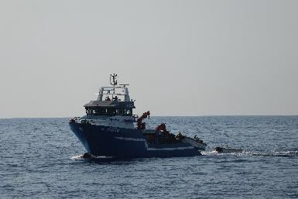
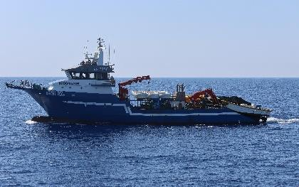
  - Hull colour blue with a white stripe
  - Bridge colour white with a grey roof
  - Carries three dinghies on board
  - Two cranes colour red
  - Steel hull
17. Other Relevant Information: (17. Autres informations pertinentes :)/
18. THE ABOVE INFORMATION WAS COLLECTED BY:(18. L'INFORMATION SUSMENTIONNÉE A ÉTÉ RECUEILLIE PAR :)
NAME: (NOM) : CHELAGHMA Mohammed Amine TITLE: (TITRE:) DZA INSPECTEUR ICCAT N° 04/2025
MEANS OF SIGHTING (including vessel/aircraft name, where appropriate): (MOYENS EMPLOYÉS POUR L’OBSERVATION (y compris nom du navire/de l’aéronef, le cas échéant))
GRINE BELKACEM AL405
DATE: (Month) (Day) (Year) DATE : SIGNATURE :
July 08 2025

Sighting Information Sheet 9

CP18-VessSight
SIGHTING INFORMATION SHEET FICHE D'INFORMATION D'OBSERVATION
1. Date of Sighting: (1. Date de l'observation : ) Time Day Month Year
06 H 07 UTC 08 July 2025
2. Position of Vessel Sighted: (2. Position du navire repéré :)
Latitude 36 ° 08 ’ N Longitude 13 ° 08 ’ E
3. Name of the Vessel Sighted: (3. Nom du navire observé :) SID AHMED
4. Flag Country: (4. Pays de pavillon : DZA
5. Port (and Country) of Registry: (5. Port (et pays) du Registre :) DZA
6. Type of Vessel: (6. Type de navire :) CATCHING
7. International Radio Call Sign: (7. Indicatif international d’appel radio :) 7T 7466
8. Registration Number: (8. Numéro de registre :) BS1726
9. ICCAT Serial Number: (9. Numéro de série ICCAT :) AT000DZA00549
10. IMO Number: (10. Numéro OMI :) 8536419
11. Estimated Length Overall and Gross Tonnage: (11. Longueur hors-tout et tonnage brut estimés :)
32.1 m / 98.3GT
12. Fishing Gear Description (if applicable): (12. Description de l'engin de pêche (le cas échéant) :)
Type PS Estimated quantity (units) Quantité estimée (unité) :/
13. Nationality of Captain: (13. Nationalité du capitaine :) /
Officer: (Officier :) / Crew: ( Équipage:) /
14. Vessel Situation (Please check): (14. Situation du navire (cocher) :)
[X ] Fishing (Pêche) [ ] Cruising (Drifting ) [ ] Croisière (Dérivant)
[ ] Supplying (Ravitaillement) [ ] Transshipping (Transbordement) [ ] Other /Autre ()
15. Type of Activities of the Vessel Sighted (Please describe):(15. Type d'activités du navire repéré (description) :)
BFT research
- Description of vessel: (16. Description du navire :)
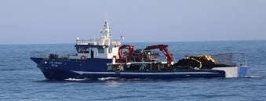
  - Vessel colour blue with white stripe
  - Two cranes colour red
  - Bridge colour white
  - Fibreglass vessel (PVRT)
17. Other Relevant Information: (17. Autres informations pertinentes :)
18. THE ABOVE INFORMATION WAS COLLECTED BY:(18. L'INFORMATION SUSMENTIONNÉE A ÉTÉ RECUEILLIE PAR :)
NAME: (NOM) : BOUHAMAR Ahmed TITLE: (TITRE:) DZA INSPECTEUR ICCAT N°01/2024
MEANS OF SIGHTING (including vessel/aircraft name, where appropriate): (MOYENS EMPLOYÉS POUR L’OBSERVATION (y compris nom du navire/de l’aéronef, le cas échéant))
GRINE BELKACEM AL405
DATE: (Month) (Day) (Year) DATE : SIGNATURE :
July 08 2025

- Response to submissions under Rec. 19-09 received from Senegal to the European Union (Document A above)
(ICCAT Circular #02686/2025)

Republic of Senegal
Ministry of Fisheries, and Maritime and Port Infrastructures Directorate of Maritime Fisheries
Ref: 00351

To:
Mr Camille Jean Pierre Manel
ICCAT Executive Secretary
Corazón de María 8 –Madrid

Dakar, 28 March 2025

Subject: Information on the sighting of the vessel Sea Breeze

Executive Secretary,
I acknowledge receipt of your circular 02372 of 21 March 2025 transmitting information from the European Union on alleged non-compliant fishing activities by the Senegal-flagged vessel Sea Breeze (AT000SEN00036, IMO number 7817323), in accordance with paragraph 2 of the Recommendation by ICCAT on vessel sightings (Rec. 19-09).

These activities, if proven, could constitute a non-compliance with the ICCAT measure on FAD fishery closure from 17 March to 30 April 2025.

Having examined the photograph provided by the European Union and the declaration signed by the Master of the vessel Monteraiola and the Sea Eye observer, we cannot affirm that FAD fishing activity, as described by the Master, has been established. The photograph does not show either fishing on a FAD, or an operation to move the FAD, as reported by the Master.
Investigations by our services are therefore underway to shed light on this matter, the preliminary conclusions of which will soon be available.

However, if the European Union has more substantial evidence that could shed light on the alleged activity, it would be most welcome.

Please accept, Executive Secretary, the assurances of my highest consideration.

(signed and sealed)
Ismaïla NDIAYE

- Response to submissions under Rec. 19-09 received from Morocco to the European Union (Document B above)
(ICCAT Circular #09347/2025)

Ministry of Agriculture, Maritime Fisheries, Rural Development and Water and Forests
Secretary of State for Maritime Fisheries
Kingdom of Morocco

DCAPM-DirPM 0039/21
To
Head of Fisheries Control and Inspections Unit (MARE.D.4)
Directorate-General for Maritime Affairs and Fisheries (DG MARE)

Rabat, 25 August 2025
Subject: Allegations concerning the use of driftnets by artisanal fishing boats flying the Moroccan Flag
Ref: Email dated 23 May 2025

Further to your abovementioned correspondence concerning the alleged use of driftnets by the artisanal fishing boats ANNOUR (1-5416), ABOUDAOUD (1-2406), NOUR KAMAR (2-2420) and TILILA-4 (1-5285), I have the honour of providing you with the following information:

Upon receipt of your information, the regional authorities of the Department of Maritime Fisheries were instructed to carry out the necessary inquiries and investigations regarding the artisanal fishing boats concerned. These boats were boarded at the dock, they were inspected and investigated, and their captains questioned.

It should be noted that the investigations considered the observations and inspections transmitted in the abovementioned email. However, difficulties were encountered to conclusively prove the prohibited use of driftnets (FMD) reported and their ‘drifting’ nature from the photographs provided. Despite these difficulties, and the resulting risk of legal inadmissibility, these artisanal fishing boats were fined and sanctioned by the maritime fisheries administration.

It should also be noted that when an infringement of maritime fisheries regulations is detected - whether by Moroccan or foreign control authorities - the legal procedures relating to fines and sanctions are immediately applied to the boat or vessel concerned, provided that the evidence is sufficiently robust and cannot be contested before any court. This ensures strict compliance with the rules established with regard to the detection of infringements, the imposition of fines and sanctions, and their ethics.

The vessels concerned were fined a flat rate and immobilized at the dock for a period of roughly one month.
Furthermore, it should also be recalled that Moroccan and Spanish control authorities cooperate closely and effectively in combating IUU fishing, particularly in the Mediterranean. Likewise, the official channels for this purpose operate continuously and are highly effective.

Additionally, the Department of Maritime Fisheries highlights the following measures adopted by the Kingdom of Morocco to ensure the effective implementation of the national programme for the elimination of driftnets:

- In legal terms:

The Kingdom of Morocco enacted Law (19-07) on 2 August 2008, permanently banning the use of driftnets (FMD). Its implementing decree, published on 11 April 2011, established that the prohibition would take effect one year after its publication, i.e. from 10 April 2012;

The current Moroccan regulation (Dahir of 23 November 1973), the use of such nets is subject to severe sanctions;

The Kingdom of Morocco has reinforced control at sea of its vessels to prohibit driftnets along its Mediterranean and Atlantic coasts, as established under national regulations.

Since 2013, the Kingdom of Morocco has also implemented a management and development plan for the swordfish fishery in the Mediterranean and Atlantic by adopting Ministerial Order N°1176-13 of 8 April, which was replaced by Order No. 1112-22 of 12 Ramadan 1443 (14 April 2022) relating to the management and development plan for the swordfish (Xiphias gladius) fishery. This plan establishes a series of management measures for this fishery, in particular a fishing prohibition for this species using gears other than longlines and drifting surface lines. This is in line with the Recommendations 16-05 and 17-02.

The Kingdom of Morocco has also adopted a management and development plan for Mediterranean albacore, which is caught incidentally with swordfish (Order No. 1980-23 of 31 July 2023 on the management and development plan for the albacore (Thunnus alalunga) fishery). This is in line with the Recommendations 22-05 and 21-04.

- In terms of support towards the fishing sector:

In 2010, the Kingdom of Morocco implemented the Action Plan for abandoning driftnets, offering compensation to users of these nets through two options. Of these, 175 chose to destroy the driftnets, while 86 vessels opted to permanently and voluntarily withdraw from fishing activities, receiving a total compensation of 256 million Moroccan Dirhams;

The fishermen who had previously worked on these vessels were able to participate in a retraining programme on selective swordfish fishing techniques (surface longline and handline). In total, 1,857 fishermen who met the eligibility criteria established by their associations completed these retraining sessions and received a fixed compensation of 40 million Moroccan Dirhams;

It should be noted that the financing of this compensation operation for vessel owners and fishermen has been provided primarily by the Moroccan government's general budget and the funds allocated under the maritime fisheries partnership agreement between the Kingdom of Morocco and the European Union. No other source of funding has been requested.

In conclusion, the Kingdom of Morocco wishes to reaffirm that it has acted with firmness and rigor in addressing the infringements committed by the reported vessels. The immobilization of these vessels and imposition of flat rate fines levied as strict and severe penalties, particularly given their category as “artisanal boats” engaged in small-scale fishing and their scale of income.

This strict approach to establishing infringement statements is justified by the following:

- The primary evidence consists of photographs, which could be legally contested as proof of the net’s ‘drifting’ nature;
- The written statements of infringement, drafted by the national official responsible for recording the infringement, may also be legally challenged, as it is based on photographic evidence that is subject to legal dispute.

This illustrates the difficulty of classifying infringements involving the use of FMD, except in cases of clear infringements that has been duly recorded at sea by sworn officers.

Likewise, to strengthen the effectiveness of control authorities to fight against the use of FMDs, it is strongly recommended to implement stricter measures that clearly define the characteristics of driftnet prohibitions. In addition, the term “large pelagic” must be clarified in a measure adopted within ICCAT.

The definition and characteristics of the driftnet ban have not been sufficiently elaborated in any ICCAT resolution or recommendation to formally differentiate them from other gillnets. Moreover, the gear referred to in the relevant United Nations resolutions is described as “large pelagic driftnets”, noting that these resolutions provided the basis for prohibiting driftnets for fisheries of large pelagics in the Mediterranean (Rec. 03-04).

This need for precise characterization of driftnet bans is essential. A more precise definition of their characteristics would also make it possible to involve fishing gear exporting States in their control so as to fight against the use of this gear.

With this in mind, the GFCM envisaged holding a joint ICCAT-GFCM workshop (Resolution CGPM/46/2023/10) to discuss the issue of banning driftnets and defining their characteristics.

The issue of driftnets was also discussed at the last annual meeting in Cyprus, particularly with regard to the gaps identified in the current ICCAT rules and potential improvements, based on the document presented by the European Union with reference PWG-420.

Following on from this work, and in accordance with the decisions taken in Cyprus, intersessional discussions have been initiated, in particular within the IMM Working Group, to continue to draw up provisions that define prohibited driftnets and large pelagics more precisely.

The delegation of the Kingdom of Morocco actively participated in these exchanges, with the aim of contributing to the development of solutions (ICCAT Recommendations) to facilitate control operations, based on a clear definition of the driftnets to be banned and establishment of the list of species constituting the large pelagics group.

Through the content of this response, the Kingdom of Morocco wishes to demonstrate its commitment to the fight against the use of prohibited driftnets in the Mediterranean and its firmness with regard to the intercepted boats which are the subject of the report received. The Kingdom of Morocco also expresses its wish for adoption of clear ICCAT provisions that better define the prohibited driftnets, their prohibited use and the species constituting the large pelagics group.

Please accept the assurance of my highest consideration.
(signed)
Zakia Driouich
The Secretary of State at the Ministry for Agriculture,
Maritime Fisheries, Rural Development and Water and Forests
Responsible for Maritime Fisheries

CC: for information purposes: ICCAT Executive Secretary

- Response to submissions under Rec. 19-09 received from the European Union to Algeria
(Document C above)
(ICCAT Circular #10178/2025)
European Commission
Directorate-general for
Maritime affairs and fisheries
International Ocean Governance
and Sustainable Fisheries
Regional Fisheries Management Organisations

Brussels
MARE.B.2/SH

ICCAT Secretariat
Corazón de María, 8.
28002 Madrid, España
info@iccat.int

Subject: Vessel sighting information (ICCAT Circular #09349/2025)

Dear Camille, Dear Derek,

In response to the ICCAT circular 09349/2025 regarding sightings made by the Algerian authorities, we would like to point out that the EU does not consider the sightings of the three EU vessels to be in breach of any ICCAT rules.
First, one of the sightings refers to a bottom trawler (EU-Italy - CALLORE), which is outside the scope of ICCAT (catch of demersal species). The other two are bluefin tuna tugboats or auxiliary vessels that were duly authorised for the bluefin tuna campaign (one of them sailing and the other towing a cage). The relevant authorities of the tugboat (EU- Malta - LELI) have confirmed that they have correctly received all the information relating to the transfer and the cage it is towing. We understand that there may be a misunderstanding and that sightings have been sent without infringement.
Second, it also leads us to believe that there may be a further misunderstanding insofar as sightings have been reported for fishing vessels of the same flag as that of the contracting party who has made the sighting, in this case Algeria. Paragraph 1 of the ICCAT Recommendation 19-09 only requires sightings with infringements to be reported in relation to foreign-flagged vessels or vessels without nationality.
We are open to receiving further input on the matter in question in the event that it is still considered that there may be an infringement by EU vessels. Otherwise, we will consider that there has been a mistake in the interpretation of the Recommendation 19-09 and that no further action is needed.

Yours sincerely,
Stijn BILLIET

- Response from Algeria to European Union
(document 3 above)
(ICCAT Circular # 10294/2025)

People's Democratic Republic of Algeria

Ministry of Agriculture,
Rural development and fisheries

General directorate of fisheries and aquaculture

Subject: Information on Vessel Sightings (Circular No. 09349/2025)

Dear Camille,

Further to the Circular referred to above and to the response of the European Union, we should like to inform you of the following elements of response:

The mission of the Algerian patroller Grine Belkacem was carried out within the context of strengthening compliance with the relevant recommendations on bluefin tuna fishing in the Mediterranean Sea.

Nevertheless, the onboard inspectors were responsible for carrying out inspections on vessels involved in the bluefin tuna fishery and performing observations in the area. The sightings were to be shared with the Secretariat for the purpose of potential cross checking to strengthen the control of this fishery.

The reason for transmittal of the list of vessel sightings during the 2025 fishing season was to share data on deployment and do not constitute events of potential non-compliance. Therefore, we confirm that the sightings of vessels - in particular, those of the European Union - transmitted to the ICCAT Secretariat do not qualify under the category of vessels presumed to have carried out IUU activities.

It should be noted that we have used the form in question by default, as it is the only sighting form template available.

In this regard, we request that the Secretariat inform the parties concerned of the contents of this clarification.

Signed by HENTOUR ABDERRAHMANE – DCATAPA Signed by OUCHELLI AMAR – Focal Point - Algeria,

Algiers, 14 October 2025

